Additional file 1

Genotyping primers
Primer | Sequence
HuNOTCH3ex 4F | 5’-CTGACTGCTCCCTGCCAGAT-3’
HuNOTCH3ex 4R | 5’-TAAGTGAGGTCGCCACTCTG-3’
SYDE1Dex2 F | 5’-AATTGCACAGGGCTGCTC-3’
SYDE1Dex2 R | 5’-AGGTACCCCAGGCCCTAAA-3’
ILVBLex2 F | 5’-AGGGGCGCGATTTCTTC-3’
ILVBLex2 R | 5’-AGGCCCCTCCCTCTTTG-3’
EPHX3ex5 F | 5’-GTAGGGGTGCAGGTGTATGG-3’
EPHX3ex5 F | 5’-TGGCTTCAGTGCCCAGC-3’

RT-PCR primers
Primer | Sequence
HuNOTCH3ex 2F | 5’-GTGTGCAAATGGAGGTCGT-3’
HuNOTCH3ex 4R | 5’-TAAGTGAGGTCGCCACTCTG-3’
HuNOTCH3ex 14F | 5’-GCGATGGAATGGGTTTCCA-3’
HuNOTCH3ex 16R | 5’-GCCAGGTTGGTGCAGATACCATGA-3’
HuNOTCH3ex 30F | 5’-TCTCCGACCTGATCTGCCAG-3’
HuNOTCH3ex 32R | 5’-TTGAGCAGGGCCAAAGTGGCT-3’
HuNOTCH3ex 32F | 5’-AGCCACTTTGGCCCTGCTCAA-3’
HuNOTCH3ex 33R | 5’-GTTGATCCAGCAAGCGCACG-3’
HuNOTCH3ex 32-33F | 5’-GGACATGCAGGATAGCAAGGAG-3’
HuNOTCH3ex 33R_3UTR | 5’-CGGTCACGCTGCAAGGCAAGG-3’

qPCR primers
Primer | Sequence
HuNOTCH3ex 7F | 5’-GGACGAGTGCTCTATCGGC-3’
HuNOTCH3ex 9R | 5’-GTTCCTGTGAAGCCTGCCATA-3’
MsNotch3ex 6F | 5’- TTCTACTGTGCCTGCCCT-3’
MsNotch3ex 8R | 5’-CACACCGACCCAAATGTTCA-3’
MsGAPDH F | 5’-TGCACCACCAACTGCTTAGC-3’
MsGAPDH R | 5’-GGCATGGACTGTGGTCATGAG-3’

Table S1 Primers used for mouse genotyping and NOTCH3 expression analysis.
Figure S1 Validation of NOTCH3 protein quantification in transgenic human NOTCH3 mice. No differences in NOTCH3 score were seen upon image selection by two independent observers (score tgN3^{MUT}350: 1572 ±448 vs. 1394 ±318 p=0.54, unpaired t-test). Data represents the mean ±SD of 4 images.

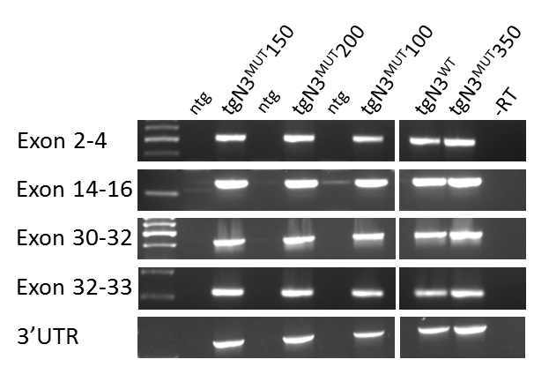

Figure S2 NOTCH3 RNA expression in transgenic human NOTCH3 mice. RT-PCR analysis using primers spanning the NOTCH3 gene showed that the complete NOTCH3 transcript is expressed in all transgenic mouse strains.

Figure S3 Endogenous Notch3 RNA expression in transgenic human NOTCH3 mice. qPCR analysis shows similar Notch3 expression levels in brain tissue of transgenic and non-transgenic mice.
Figure S4 Brain MRI of transgenic human NOTCH3 p.Arg182Cys mice. (A-F) T2 weighted brain MRI images of mice aged 20 months. Six tgN3^{MUT} mice, five tgN3^{WT} mice and four non-transgenic littermates were analysed. Brain MRI abnormalities (indicated by the arrows) were detected in two of the six tgN3^{MUT}350 mice, and in one of the four non-transgenic mice. All mice with hyperintensities also had enlarged ventricles, which is a common finding in C57Bl/6J mice (The laboratory mouse, 2nd edition) (A-B) Representative pictures of one of the two tgN3^{MUT}350 mice with brain MRI abnormalities. T2 weighted brain MRI showed hyperintensities cranial to the corpus callosum, and in the frontal lobe around the ventricles. (C-D) Similar hyperintensities, although less severe, were seen in one of the non-transgenic littermates. (E-F) No MRI abnormalities were seen in tgN3^{WT} mice.
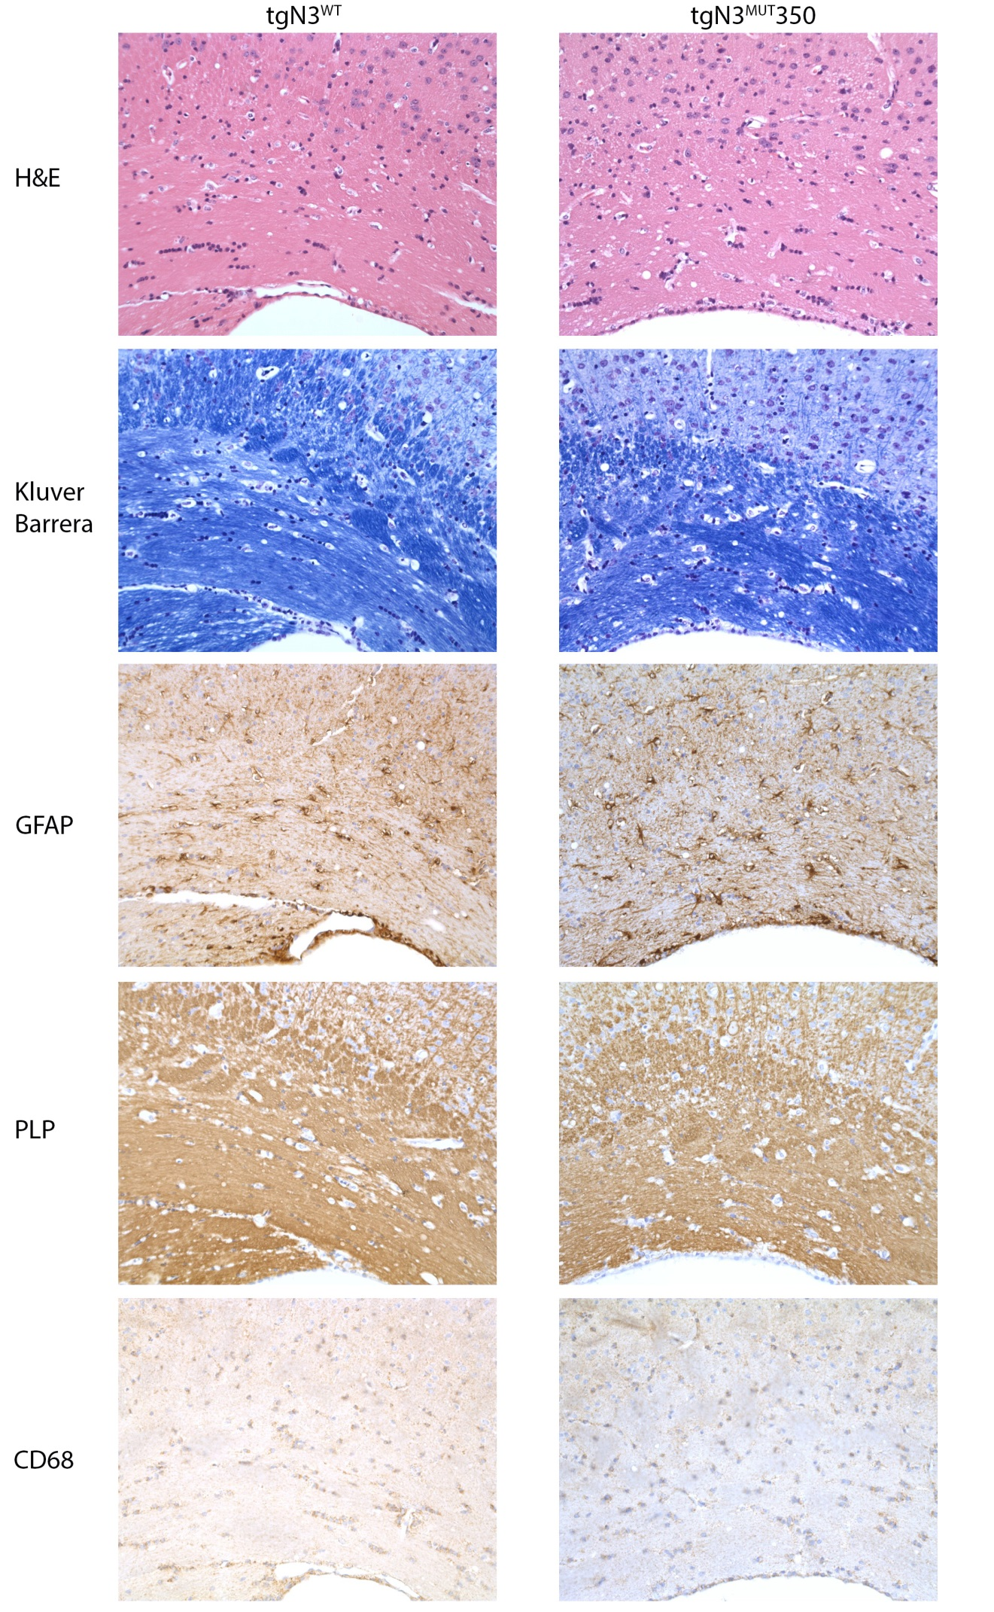

Figure S5 Brain parenchyma stainings of tgN3^{MUT}350 and tgN3^{WT} mice. No consistent differences were seen for any of the stainings analysed. Moreover, no histopathologic substrate for the observed MRI abnormalities was seen. All images are obtained at a 200x magnification.

