Electronic supplemental materials
Supplemental table. Postmortem tissues
Brain Bank  ID | Age at death  (years) | Sex | Postmortem delay (h) | Neuropath. diagnosis | Sample area
1432 | 83 | Female | 21 | Control | Striatum
14 | 65 | Male | 24 | Control | Cingulate cortex
172 | 70 | Male | 15 | Control | Striatum & cingulate cortex
1903 | 64 | Male | 68 | MSA | Striatum
1860 | 63 | Female | 13 | MSA | Striatum
1841 | 57 | Male | 21 | MSA | Striatum
1836 | 61 | Male | 5 | MSA | Striatum
1665 | 66 | Male | 15 | DLB without AD | Cingulate cortex
1076 | 82 | Female | 10 | DLB without AD | Cingulate cortex
824 | 86 | Male | 10 | PD | Cingulate cortex
125 | 81 | Male | 16 | PD | Cingulate cortex

Supplemental figures

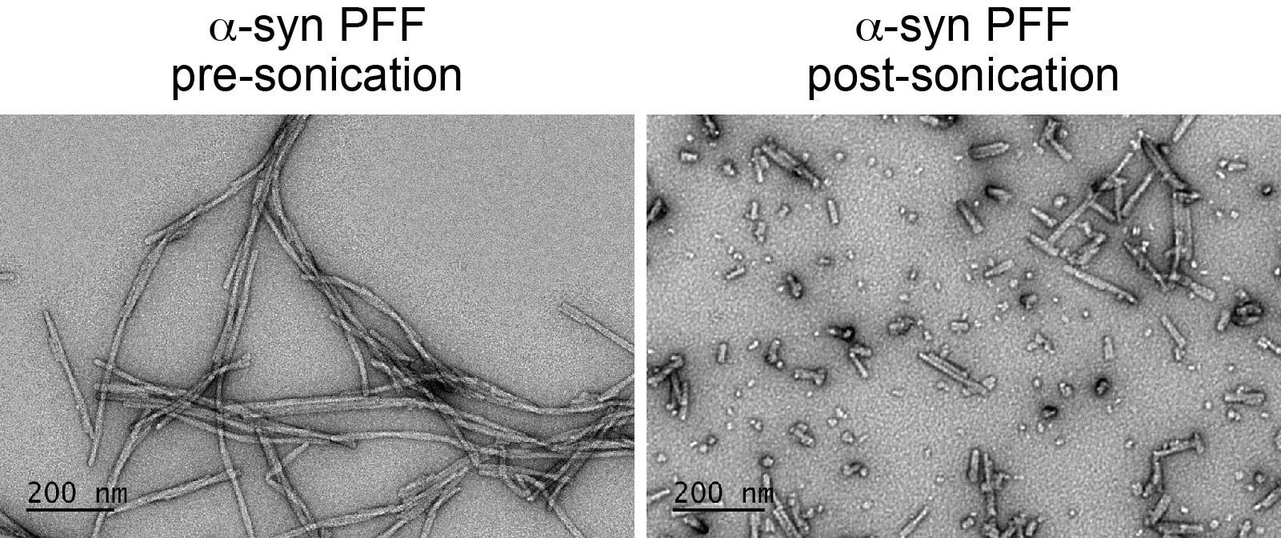

Figure S1. Electron microscopic images of αSyn PFF before and after sonication.

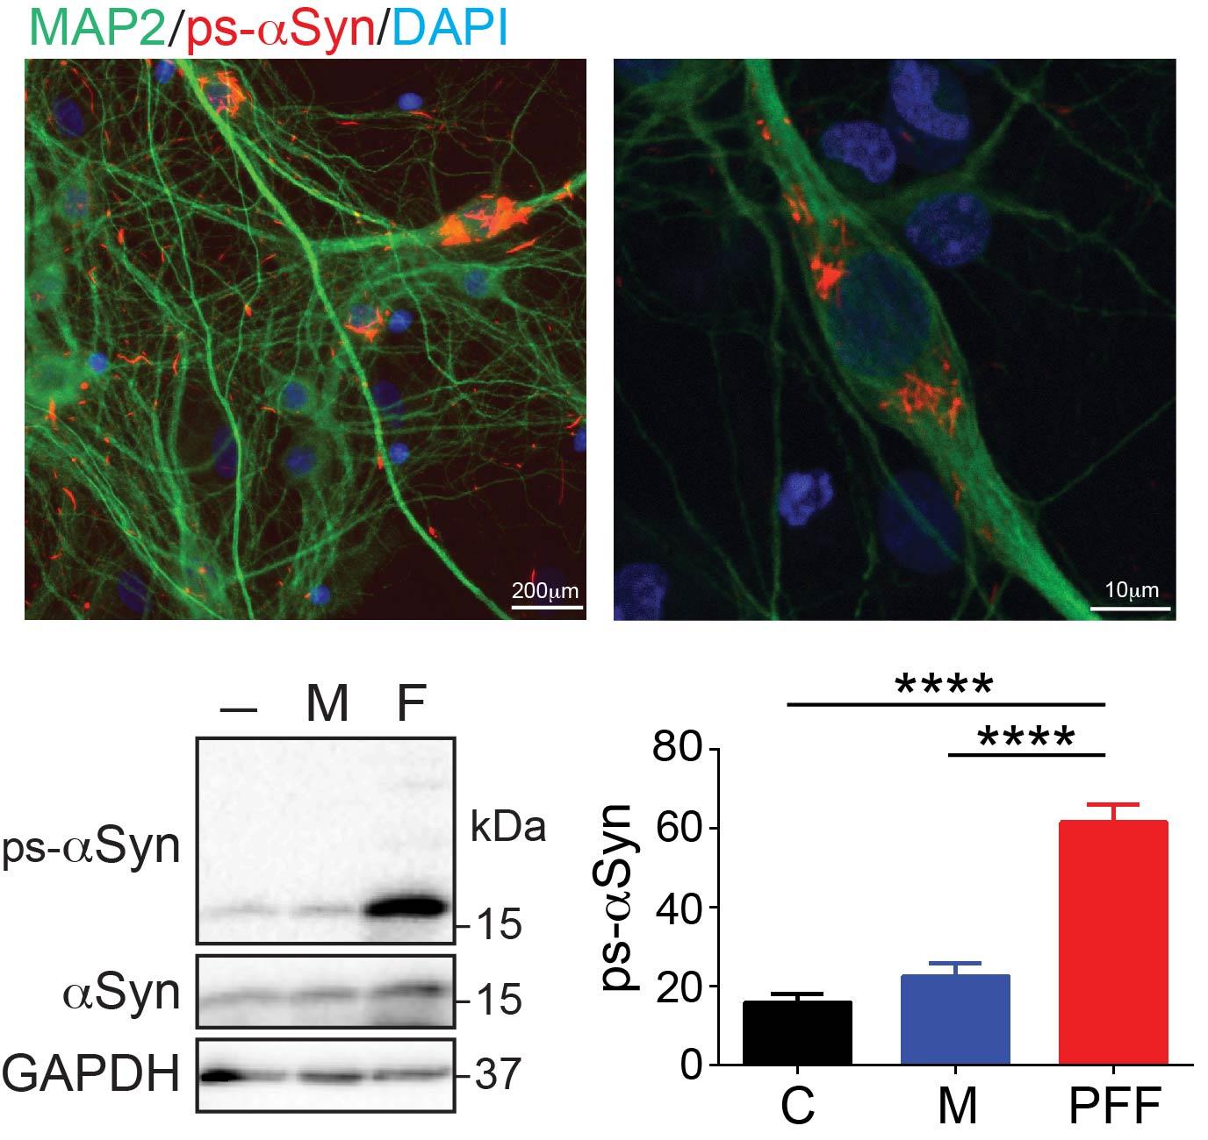

Figure S2. PFF-induced ps-αSyn in rat neurons. Primary cortical neurons were untreated (–) or treated with αSyn monomer (M) or PFF (F) as indicated. The presence of ps-αSyn was detected by immunofluorescence staining (red), and MAP2 stain (green) was used as a neuronal marker. Nuclei were stained with DAPI. The lower left panel shows a representative immunoblot of ps-αSyn and total αSyn; immunoblot analysis of GAPDH was performed to verify equal loading. The bar graph represents the average ± standard error of five independent experiments. Statistical significance was determined by one-way ANOVA followed by a Dunnett’s multiple comparison test (F = 51.21, n =5, p < 0.0001).
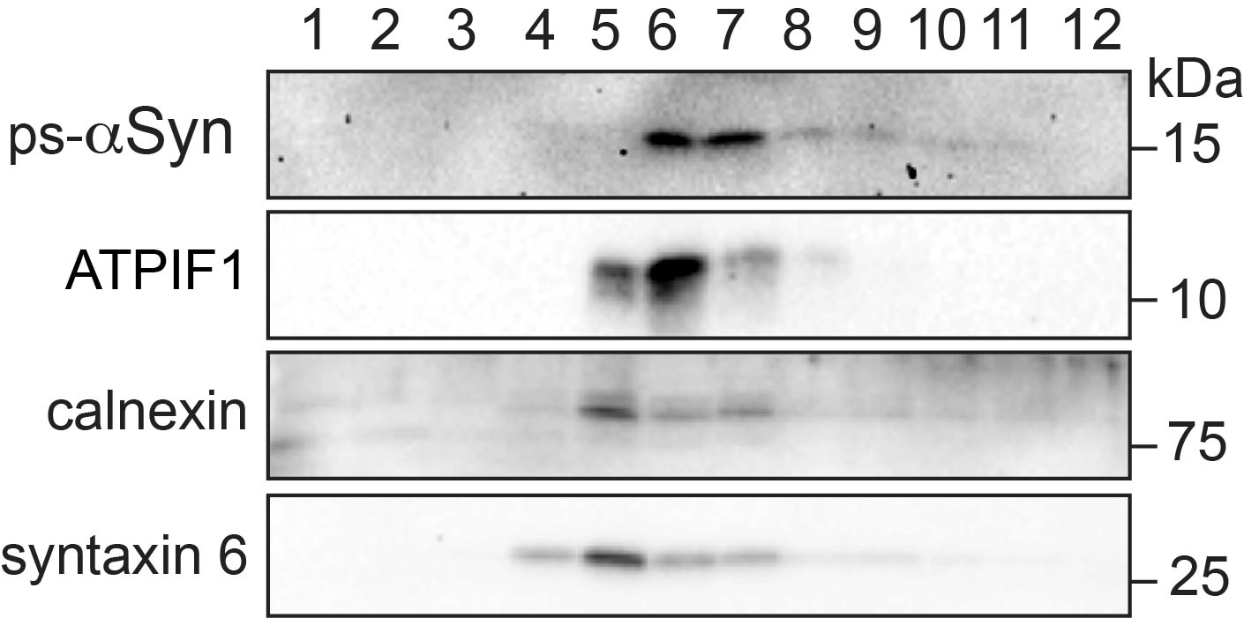

Figure S3. Postnuclear supernatant (PNS) prepared from PFF-treated primary neurons was separated using a discontinuous sucrose gradient, and fractions were collected from the top to the bottom. The presence of ps-αSyn, mitochondrial ATPIF1, calnexin (endoplasmic reticulum), and syntaxin 6 (Golgi) in each fraction were detected by immunoblot analysis.

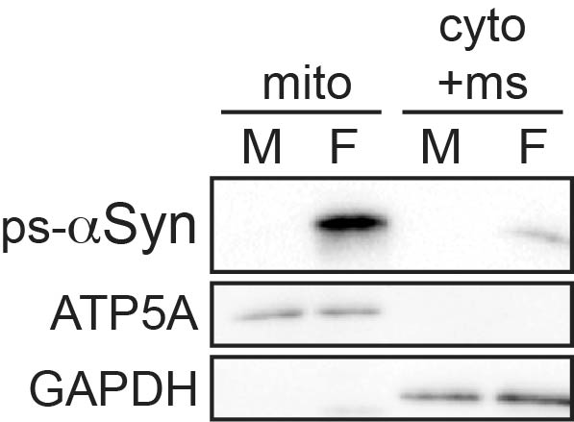

Figure S4. PFF-induced ps-αSyn accumulated in the mitochondria of mouse primary neurons. PNS of mouse primary neurons treated with either αSyn monomer (M) or PFF (F) were separated into mitochondrial (mito) and cytosolic/microsomal (cyto+ms) fractions. The presence of ps-αSyn, mitochondrial ATP synthase (ATP5A), and cytosolic GAPDH was detected by immunoblot analysis.

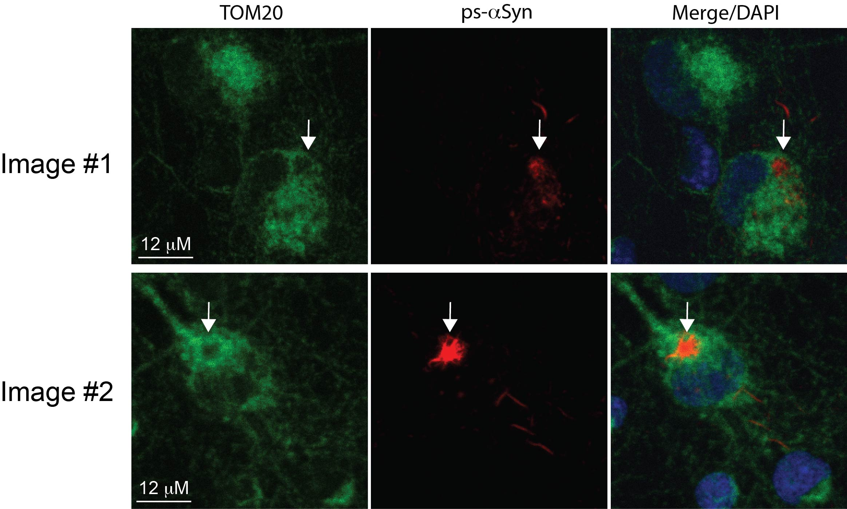

Figure S5. Immunofluorescence staining was performed on PFF-treated rat primary neurons with antibodies against ps-αSyn and TOM20 as indicated. Arrows indicate cellular areas with strong ps-αSyn stain, but weak TOM20 stain. The top and bottom panels are two separated images.

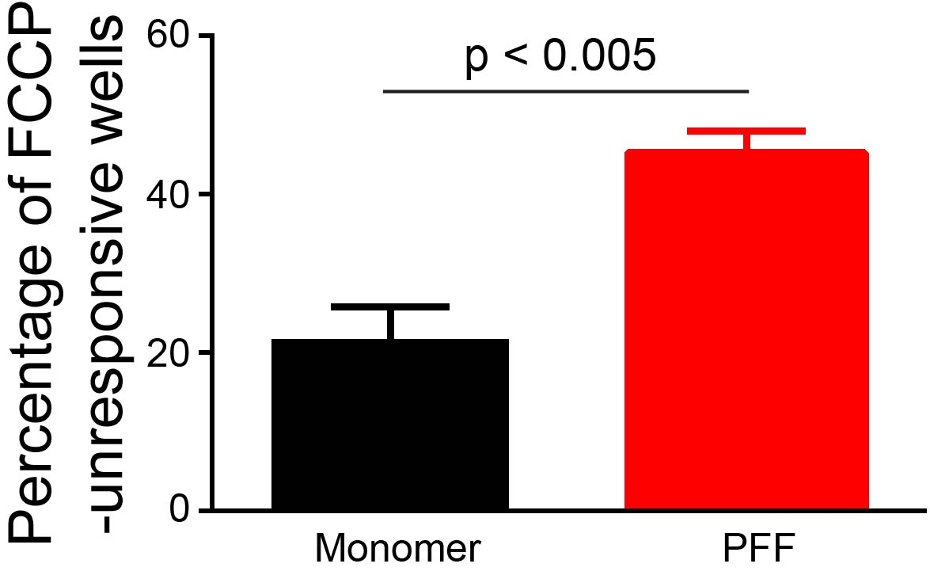

Figure S6. PFF-treated neurons were less responsive to FCCP treatment. The graph represents the average ± standard error of four independent experiments. The statistic difference was determined by paired t-test (p = 0.0029; n = 4).

