Additional File 1
Figure S1. Whole organoid PrP staining at 96dpi. Upper panels display whole organoid images; left panels per condition show 6H4 PrP staining (brown) and right panels showing positive pixel counts (PPC), blue signifies low and yellow-orange denotes high pixel staining intensity. Scale bars = 500 µm. Lower graph shows PrP positive pixel counts. Each data point represents an individual organoid with the mean indicated as a line.
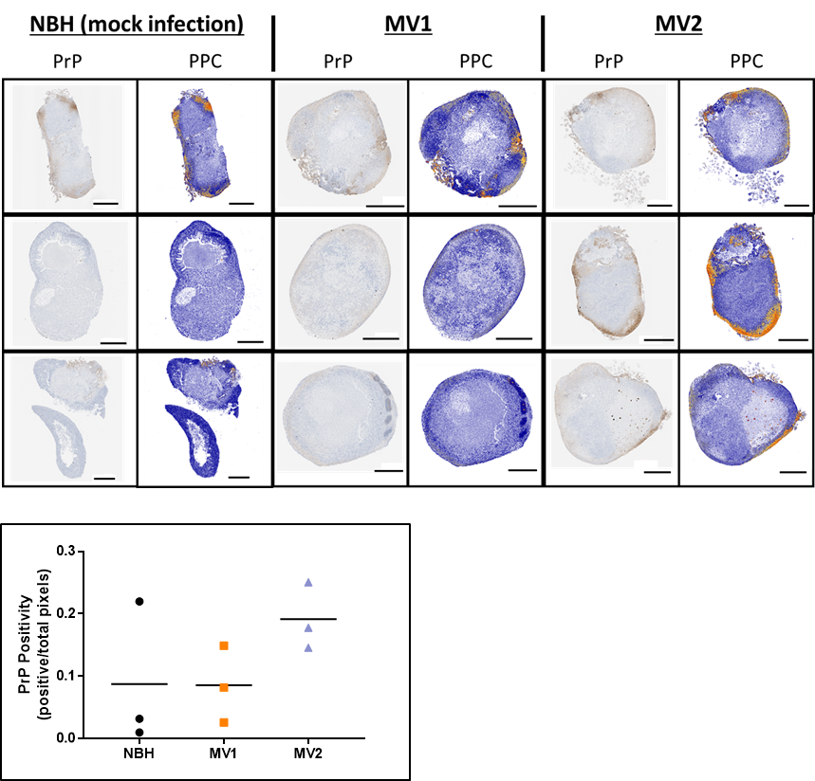

Figure S2. GFAP staining of organoids. A. Panels display whole organoid (left) and 20× magnified images of regions of interest (right) of organoids harvested at 169 dpi. B. Positive pixel counts (PPC) at 96 and 169 dpi, blue signifies low and yellow-orange denotes high pixel staining intensity. Scale bars = 500 µm. C. GFAP positive pixel count quantification at 169 dpi. Each data point represents an individual organoid with the mean indicated as a line.

