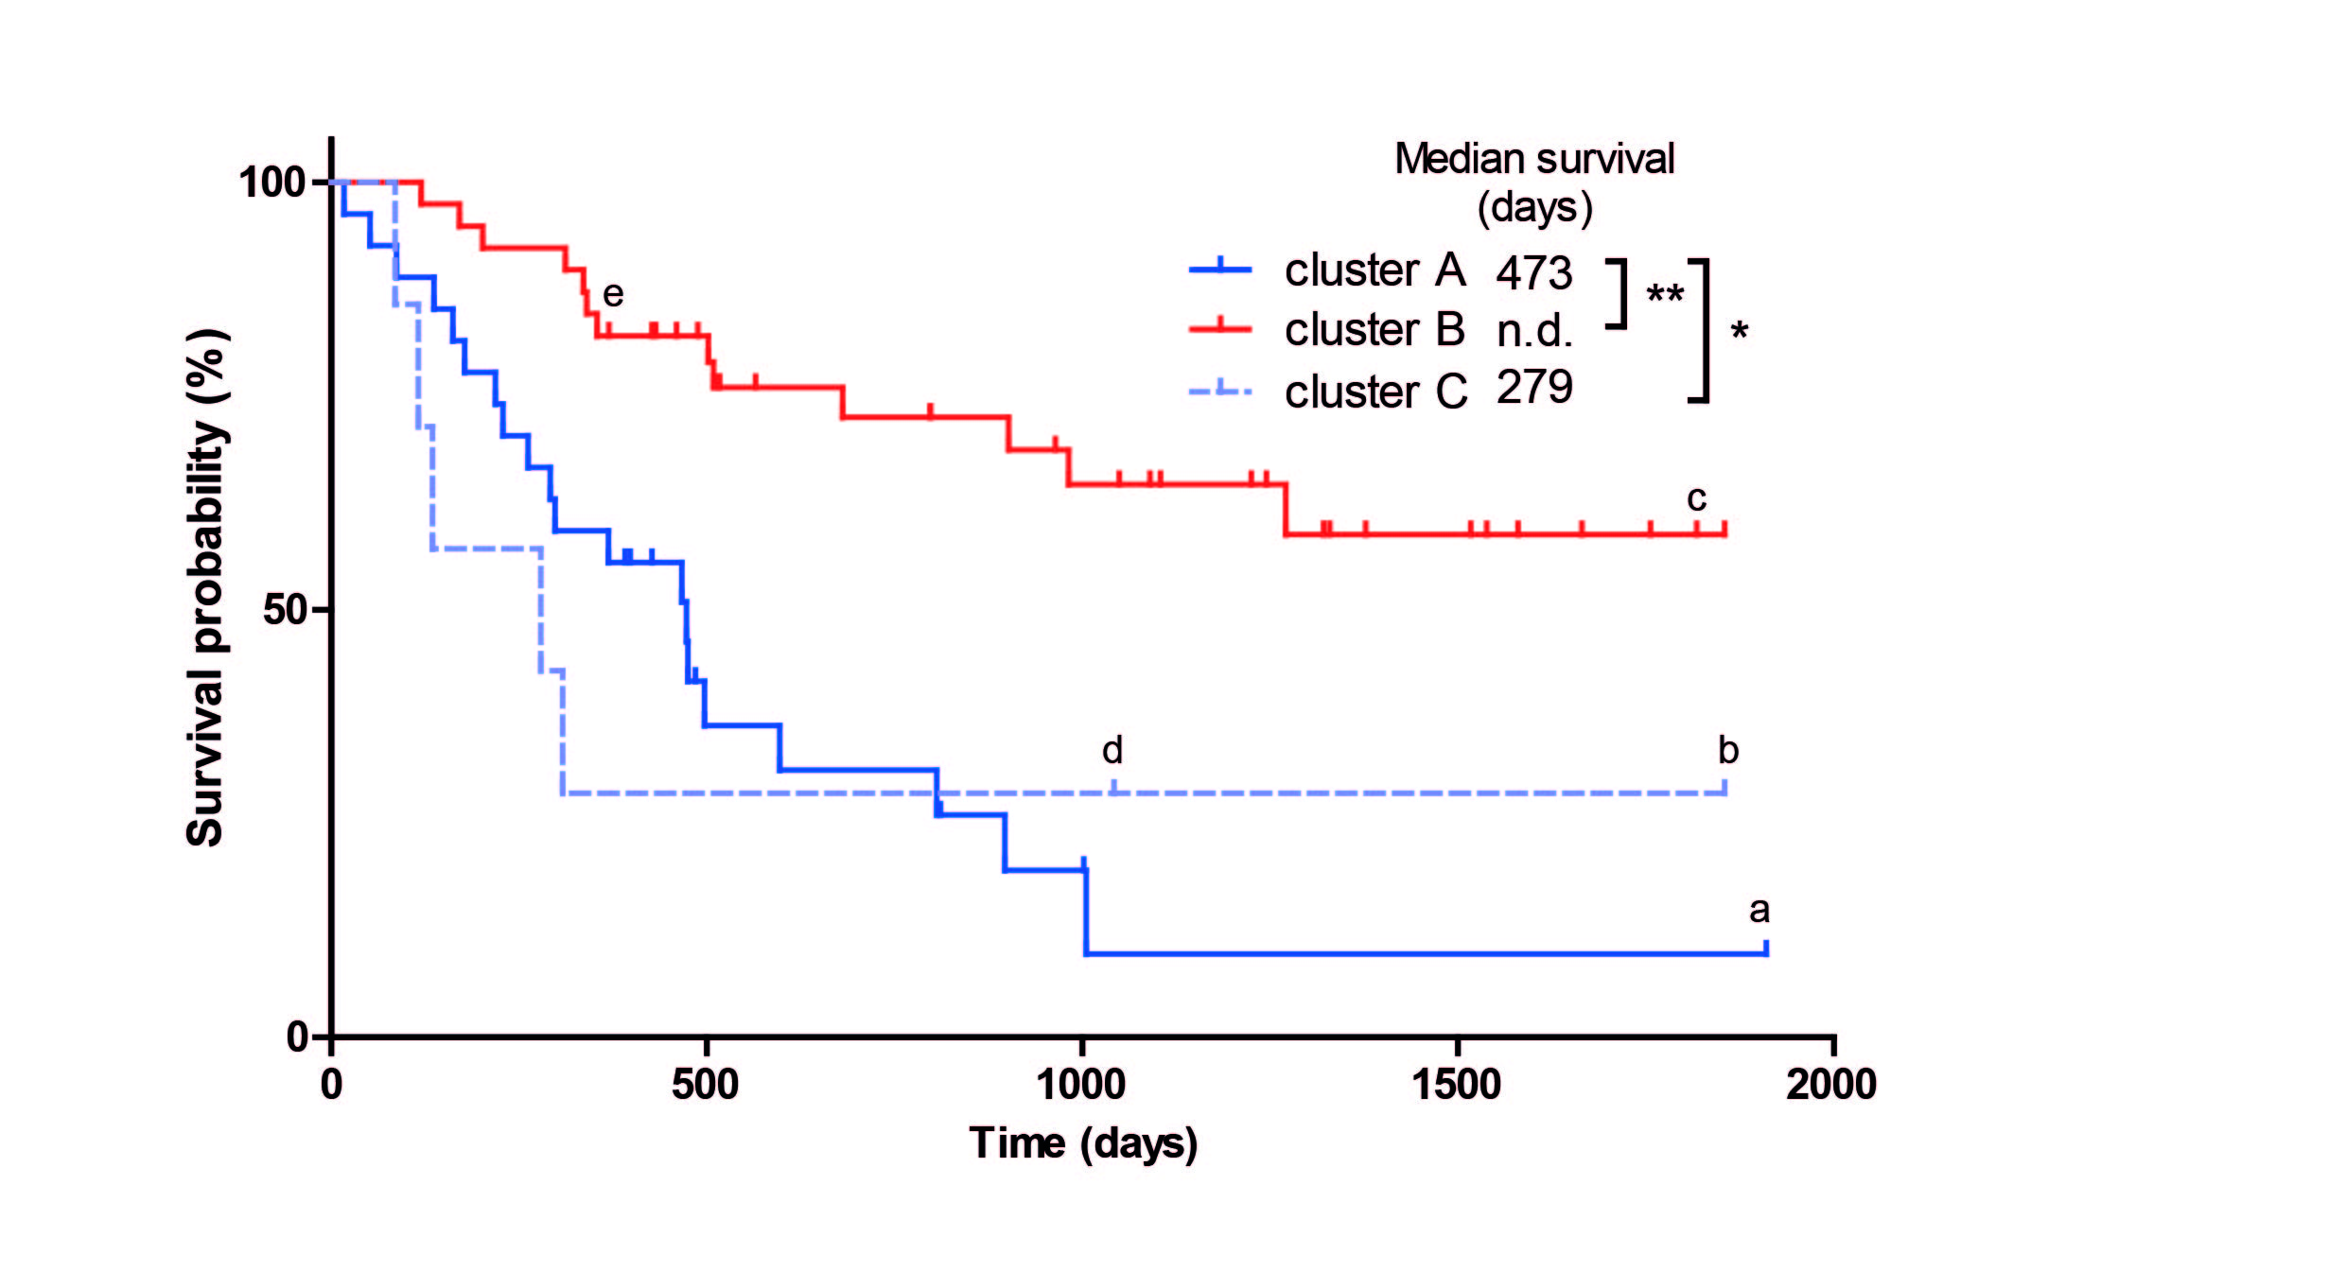
Figure S1: Kaplan-Meier analysis of unsupervised clusters of the entire cohort. Indicated in the figure are (a) ependymoma, (b) lung metastasis, (c) DNET, (d) LPD, and (e) variant glioma.

