Title: KLF4^{K409Q}–mutated meningiomas show enhanced hypoxia signaling and respond to mTORC1 inhibitor treatment
Authors: Niklas von Spreckelsen^{1,2,3, †}, Natalie Waldt^{1†}, Rebecca Poetschke^{4†}, Christoph Kesseler¹, Hildegard Dohmen⁷, Hui-Ke Jiao⁷, Attila Nemeth⁷,Stefan Schob⁹, Cordula Scherlach⁹, Ibrahim Erol Sandalcioglu¹⁰, Martina Deckert⁵, Frank Angenstein⁶, Boris Krischek³, Pantelis Stavrinou³, Marco Timmer³, Marc Remke⁸, Elmar Kirches¹, Roland Goldbrunner³, E. Antonio Chiocca², Stefan Huettelmaier⁴, Till Acker⁷, and Christian Mawrin^{1*}

Affiliations:
¹Department of Neuropathology, Otto-von-Guericke University, Magdeburg; Germany.
²Department of Neurosurgery, Brigham and Women’s Hospital, Harvard Medical School, U.S.A.
³Department of Neurosurgery, Center for Neurosurgery, Faculty of Medicine and University Hospital, University of Cologne, Cologne, Germany.
⁴Institute of Molecular Medicine, Martin Luther University, Halle/Saale, Germany.
⁵Department of Neuropathology, University Hospital Cologne, Germany.
⁶Laboratory for Non-invasive Imaging, Magdeburg, Germany.
⁷Department of Neuropathology, University Giessen, Germany.
⁸Pediatric Neuro-Oncology, Duesseldorf, Germany.
⁹Department of Neuroradiology, University Hospital Leipzig.
¹⁰Department of Neurosurgery, Otto-von-Guericke University, Magdeburg; Germany

* Correspondence to:
Christian Mawrin, MD
Department of Neuropathology
Otto-von-Guericke University Magdeburg, Germany
Tel: +49 391 6715825
Fax: +49 391 6713300
e-mail: christian.mawrin@med.ovgu.de
†co-first authors

Supplementary Materials and Methods:

Targeted Sanger Sequencing
Sequencing was performed on an ABI-Prism-310C capillary sequencer (Applied Biosystems, Foster City, CA, USA), using Big-Dye-Terminator technology (Applied Biosystems).
Primers:
KLF4 forward: GCTCATGCCACCCGGTTC
reverse: CTGTGTGGGTTCGCAGGTG
AKT1 forward: CTGGCCCTAAGAAACAGCTCC
reverse: CGCCACAGAGAAGTTGTTGA

Sample preparation and isolation of RNA for RNA sequencing
Frozen tumor samples were shredded in liquid nitrogen with a mortar and allotted into 1.5ml Eppendorf tubes. For isolation of tissue RNA, ceramic beads were added to the frozen tissue pulver and supplemented with 1ml TRIzol. The vessel content was homogenized for 20 seconds with Precellys® 24 and stored for 5min on ice. RNA was isolated via TRIzol/Chloroform extraction. Total RNA Sequencing was performed by Novogene. NEB Next® Ultra™ RNA Library Prep Kit was used for RNA library preparation.

Real-time reverse transcription (RT)-qPCR
The RT reaction was performed by using Maxima H Minus First Strand cDNA synthesis Kit (Thermo Scientific). 1µg total RNA was incubated with oligo primer, random primer and dNTPs at 65 ºC for 5 minutes. RT buffer and Maxima H Minus enzyme were added and reaction was incubated at 25 ºC for 10 minutes followed by incubation at 50 ºC for 30 minutes and then inactivation of the enzyme by heating at 85 ºC for 5 minutes. The cDNAs were amplified using the primers listed below. PowerUp SYBR Green Master mix (Applied Biosystems) and a thermal cycler Quantstudio3 (Applied Biosystems). The reaction conditions were initial denaturation at 95 ºC for 2 minutes, 45 cycles of denaturation for 30s at 95 ºC, annealing for 30s at 60 ºC.

Primers for Real-time reverse transcription (RT)-qPCR
KLF4, forward: GCTCATGCCACCCGGTTC
reverse: CTGTGTGGGTTCGCAGGTG
HK II, forward: GGAACCCAGCTGTTTGACCA
reverse: CAGGGGAACGAGAAGGTGAAA
GLUT3, forward: CTTCCTGCTATCCTACAAAGTGC
reverse: ACTCTCATCTTTCATCTCCTGG
PGK1, forward: ATGGATGAGGTGGTGAAAGC
reverse: CAGTGCTCACATGGCTGACT
VEGF1, forward: GTCTATCAGCGCAGCTACTGC
reverse: GCCTTGGTGAGGTTTGATCCG
β2-microglobulin, forward: CCAGCAGAGAATGGAAAGTC
reverse: GATGCTGCTTACATGTCTCG
The real-time PCR was performed using ABI Prism 7000 Sequence Detection System (Applied Biosystems, Foster City, CA, USA)

Primers for Real-time reverse transcription (RT)-qPCR for experiments involving hypoxic conditions

HIF1α, forward: CCATTAGAAAGCAGTTCCGC
reverse: TGGGTAGGAGATGGAGATGC
HIF2α, forward: CGAACACACAAGCTCCTCTC
reverse: GTCACCACGGCAATGAAAC
VEGFA, forward: AGCCTTGCCTTGCTGCTCTA
reverse: GTGCTGGCCTTGGTGAGG
GLUT1, forward: GATTGGCTCCTTCTCTGTGG
reverse: CAGGATCAGCATCTCAAAGG
CAIX, forward: AAGAAGAGGGCTCCCTGAAG
reverse: TAGCGCCAATGACTCTGGTC
KLF4, forward: TACACAAAGAGTTCCCATCTCAAG
reverse: GTAGTGCCTGGTCAGTTCATC
HPRT, forward: TATGGCGACCCGCAGCCC
reverse: GCAAGACGTTCAGTCCTGTCCAT
Tissue microarray (TMA)
Antibodies:
p70S6K (Life Span Biosciences, 1:100)
Pho-P70S6K (Cell Signaling, 1:1000)
Hexokinase 2 (Cell Signaling, 1:200)
CD31 (Dako, 1:50).

Immunoblotting
Primary Antibodies:
anti-KLF4 (1:400, R&D Systems), anti-HK II (1:1000, Cell Signaling), anti-GLUT3 (1:500, LSBio), anti-PGK1 (1:1000, LSBio), anti-VEGFA (1:2000, LSBio) and anti-β-actin (1:5000, Sigma-Aldrich).
Secondary Antibodies:
HRP-Conjugated (1:5000, Cell Signaling)
Buffers:
Cell Lysis buffer: 10 mM Tris-HCl, 150 mM NaCl, 50 mM NaF, 1 mM EDTA, 1% Triton X-100, 0.1% SDS, 0.5% deoxycholate, supplemented with sodium vanadate, dithiothreitol (DTT) and protease inhibitor cocktail.

Hypoxia experiments:
Primary Antibodies:
HIF-1α (Becton Dickinson, 610958; Cayman Chemical, 10006421), HIF-2α (Novus Biologicals, NB-100-122), p70 S6 Kinase (Cell Signaling, 9202), phospho-p70 S6 Kinase (Thr389) (Cell Signaling, 9205) and Tubulin (Dianova, DLN09992) as loading controls.
Secondary Antibodies:
HRP-Conjugated (1:5,000, Dianova)

Buffer:
Cell Lysis buffer: 10 mM Tris.HCl (pH 7.5), 2% SDS, 2 mM EGTA, 20 mM NaF.

Cell viability assay
500 cells in 100 µl cell culture medium were seeded into 96-well plate (Sarstedt, Nümbrecht, Germany). To obtain a background luminescence signal 100 µl cell culture medium without cells were used as reference. Plate and the CellTiter-Glo® reagent were equilibrated at room temperature, and 100 µl CellTiter-Glo® reagent was added to each well and the plate was shaken for 2 min. Luminescence was measured using a TD-20/20 Luminometer (Turner Designs, Sunnyvale, CA) at indicated time points.

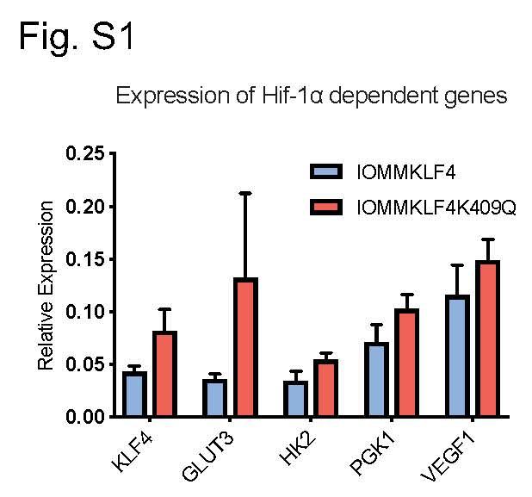
Fig. S1 RT-qPCR analysis of HIF-1α-dependent genes in KLF4^{wt/K409Q} transfected cells (n=4)

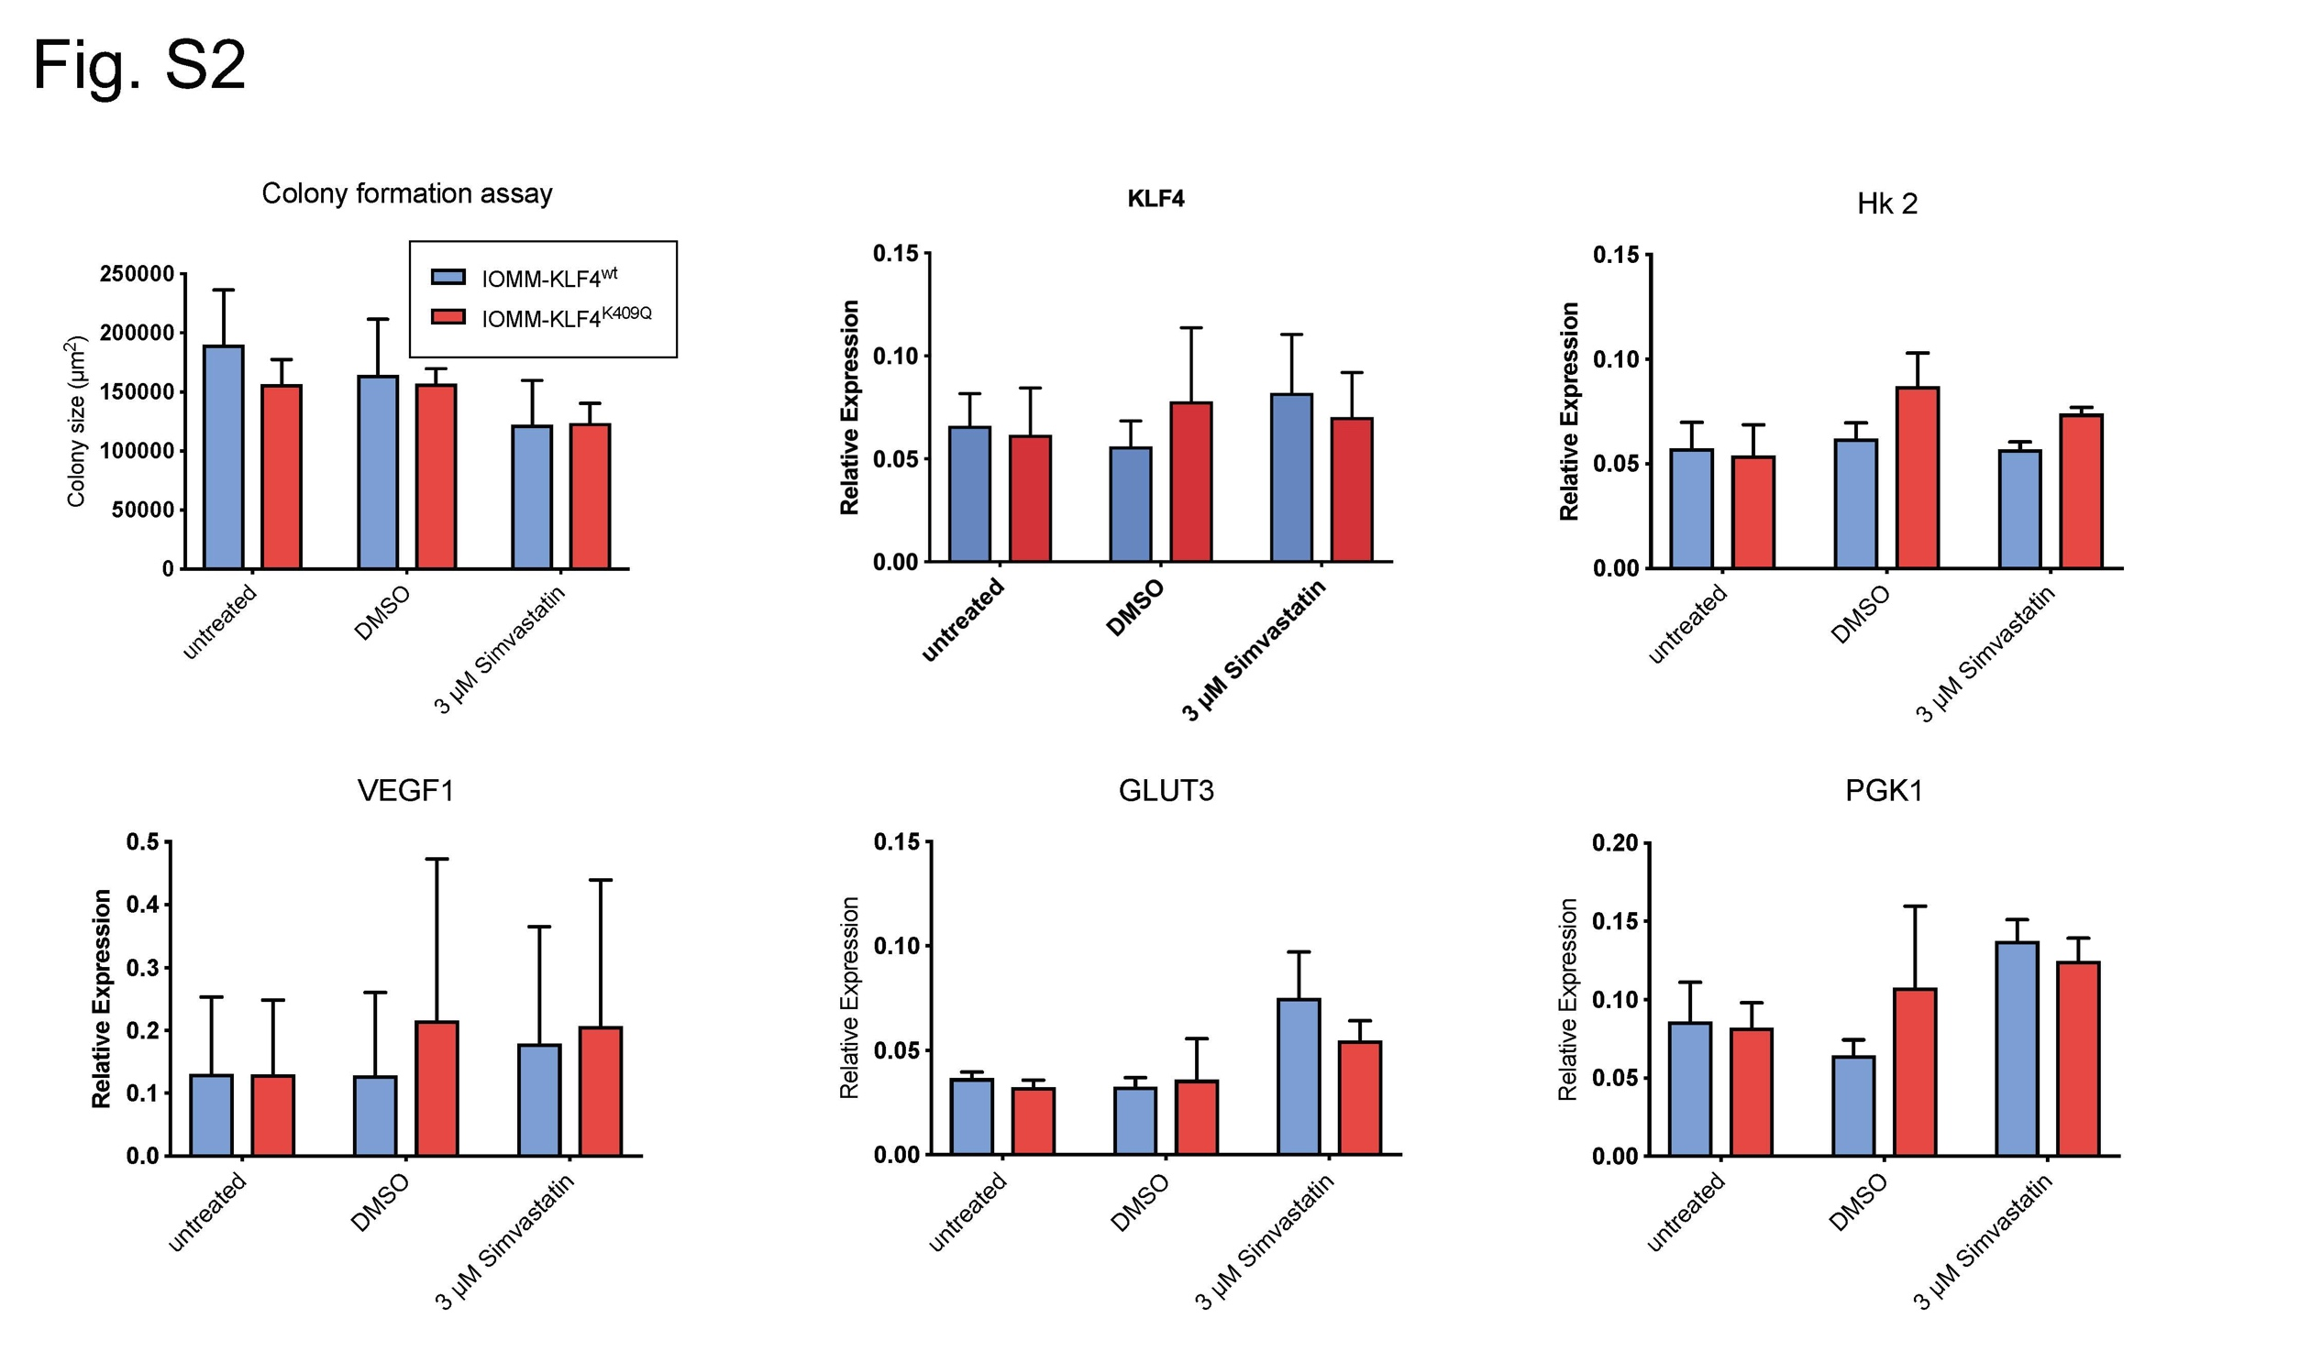Fig. S2 Evaluation of Simvastatin treatment in IOMM-KLF4 cell lines
At a concentration of 3µM Simvastatin did not alter colony formation or KLF4/hypoxia dependent gene expression (measured through RT-qPCR) in IOMM-KLF4^{wt/K409Q} cells (n=3)

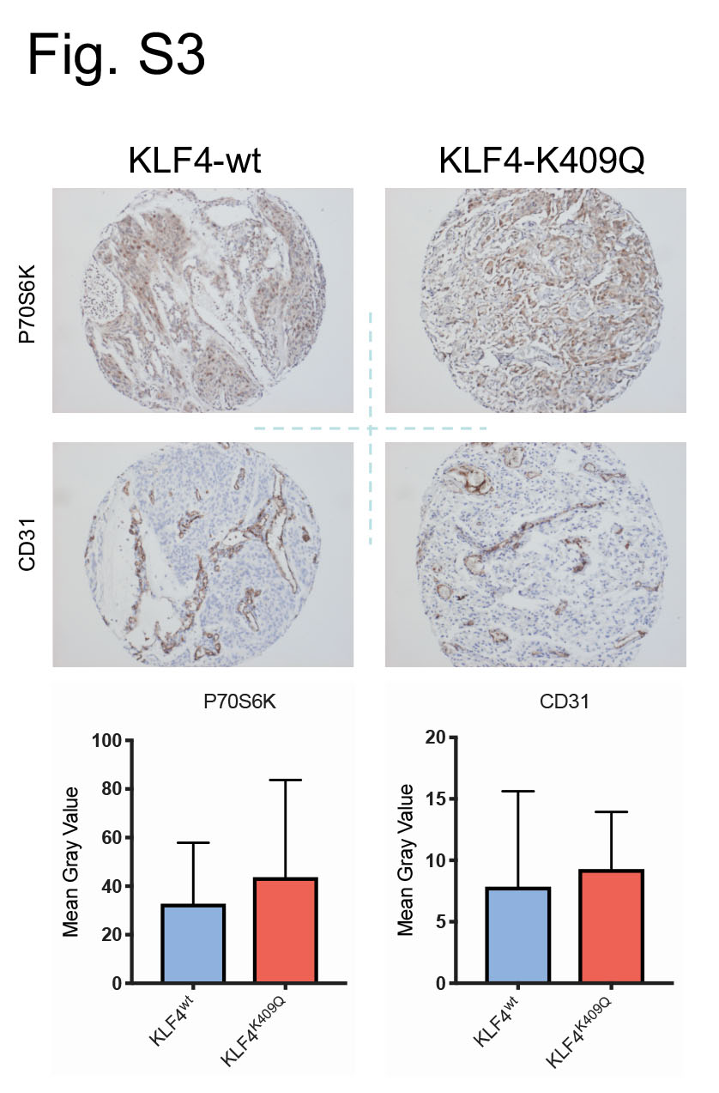
Fig. S3 TMA-staining for p70S6K and CD31
(n=23)

