Supplementary Data. Results of LD-RT-PCR for EGFRvIII detection.
Plots are showing three columns as horizontal axis for exon 1 – exon 2 ligation (EGFR1_2), exon 1 – exon 8 (EGFR1_8) and exon 7 – exon 8 (EGFR7_8). In case of EGFRvIII variant ligations are represented in the three columns.
Patient #02 | Patient #04 | Patient #07
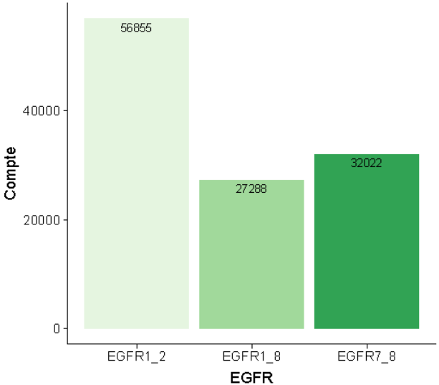 | 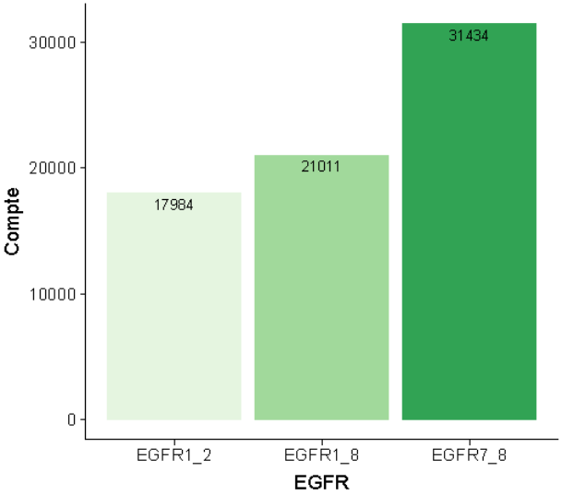 | 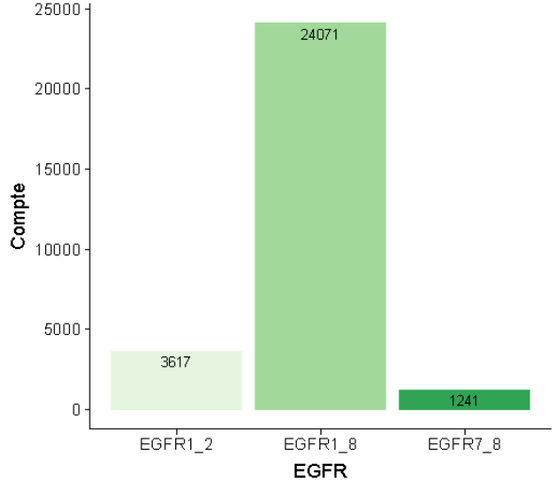

Patient #08 | Patient #10 | Patient #60
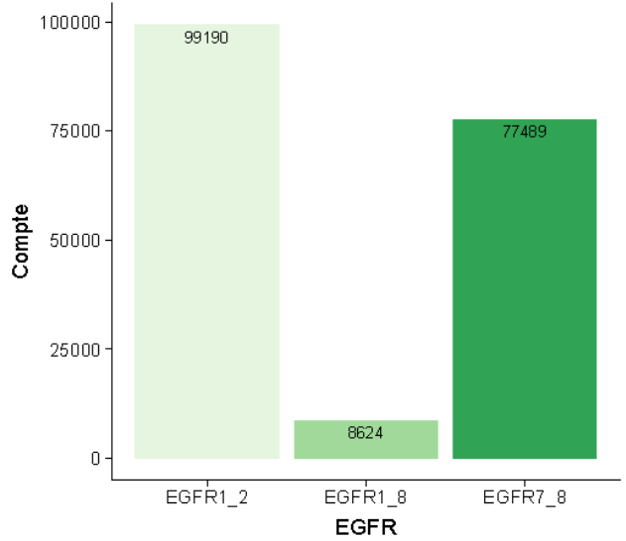 | 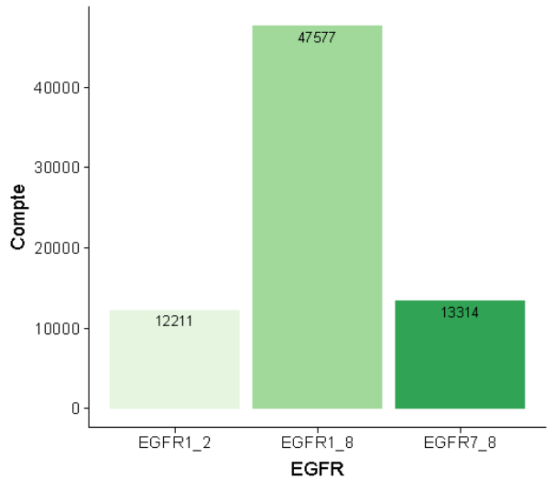 | 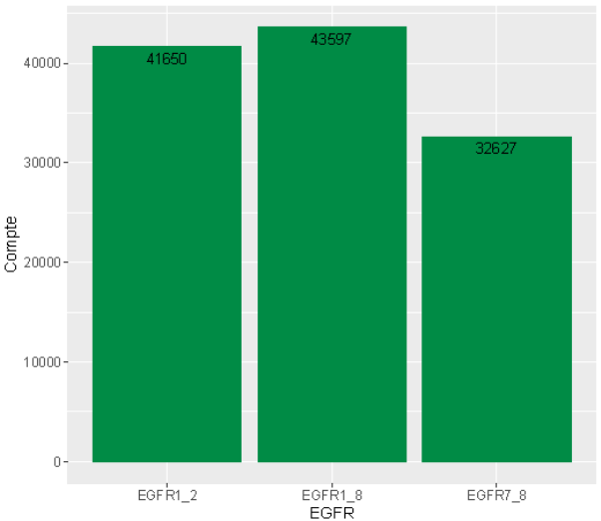
Patient #62 | Patient #63 | Patient #70
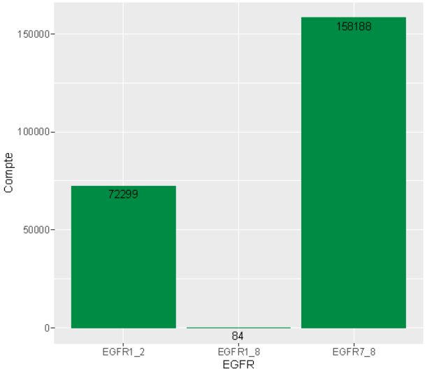 | 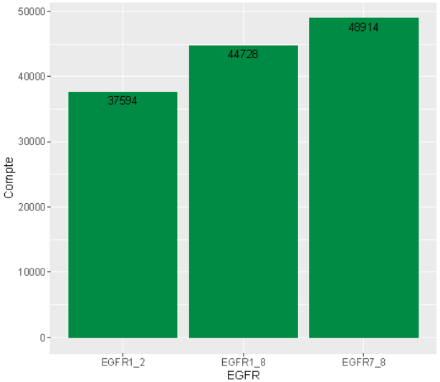 | 