Supplemental Data
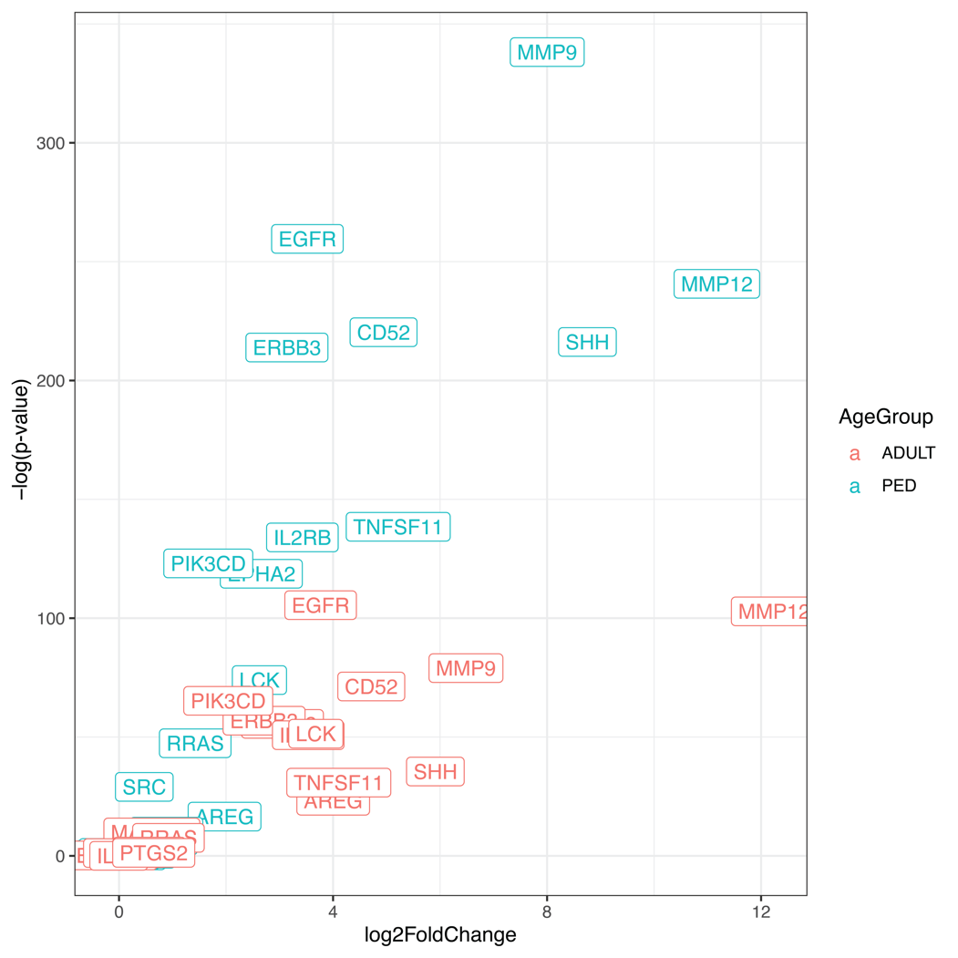
Figure S1. Log fold change versus p-value for therapeutic targets across ACP age groups compared to GTEx normal pituitary dataset.

Table S1. Dataset Demographics and CTNNB1 Mutation Status. Hyphen values indicate data not available. WT: Wild Type; Age at Dx: Age at Diagnosis.
