Additional file figures
a b
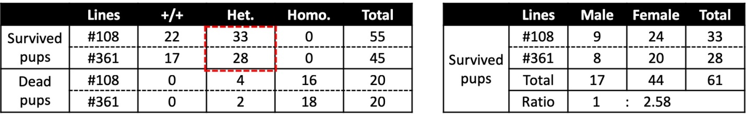
c

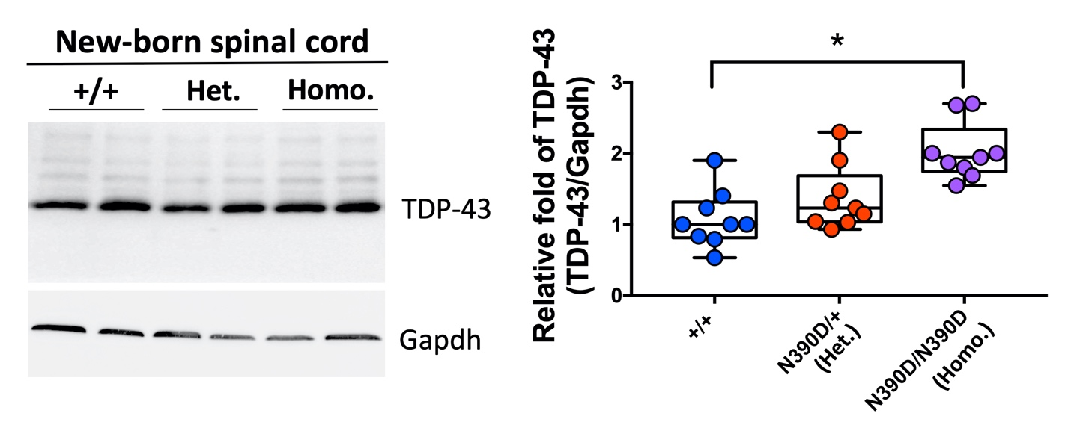
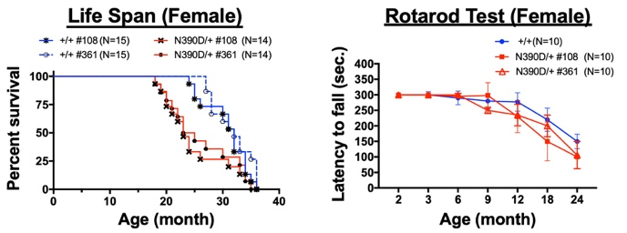
d

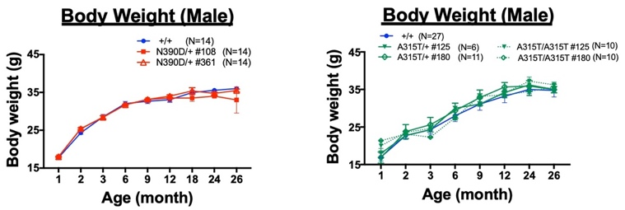
e

Figure S1. Effects of N390D mutations on the survival of newborn pups and on motor function/ lifespan of N390D/+ female mice.

(a) Comparison of the numbers of the survived and dead pups of different genotypes from intercrosses #108× #108 and #361× #316, respectively. Note the lethality effect of the N390D mutation on the homozygous N390D/N390D pups (Homo.) but not frequently on the heterozygous N390D/+ pups (Het.). (b) Gender distribution of the survived offspring from the red dashed box in (a). (c) Comparison of the levels of TDP-43 in the new-born spinal cord of +/+, N390D/+ (Het.) and N390D/N390D (Homo.) mice, as analyzed by Western blotting. The blots are exemplified on the left and the statistical analysis is shown on the right. Note the significant increase of TDP-43 in the spinal cord of male N390D/N390D mice in comparison to +/+ littermates. (d) Survival curves (left panel) and rotarod test (right panel) of heterozygous N390D/+ knock-in female mice in comparison to the +/+ female mice. Note the relatively high variations of motor capabilities of the individual female N390D/+ mice in comparison to the +/+, and around 30% of the N390D/+ female mice have similar life span curves as their +/+ littermates. Mean ± SEM. The numbers of analyzed mice (N) are listed in the figure. (e) The body weight of N390D/+ male mice (left panel) as well as A315T/+ plus A315T/A315T male mice (right panel) were measured at different ages and compared to the +/+ male mice. Mean ± SEM. The number of mice analyzed per group are listed in the figure.

