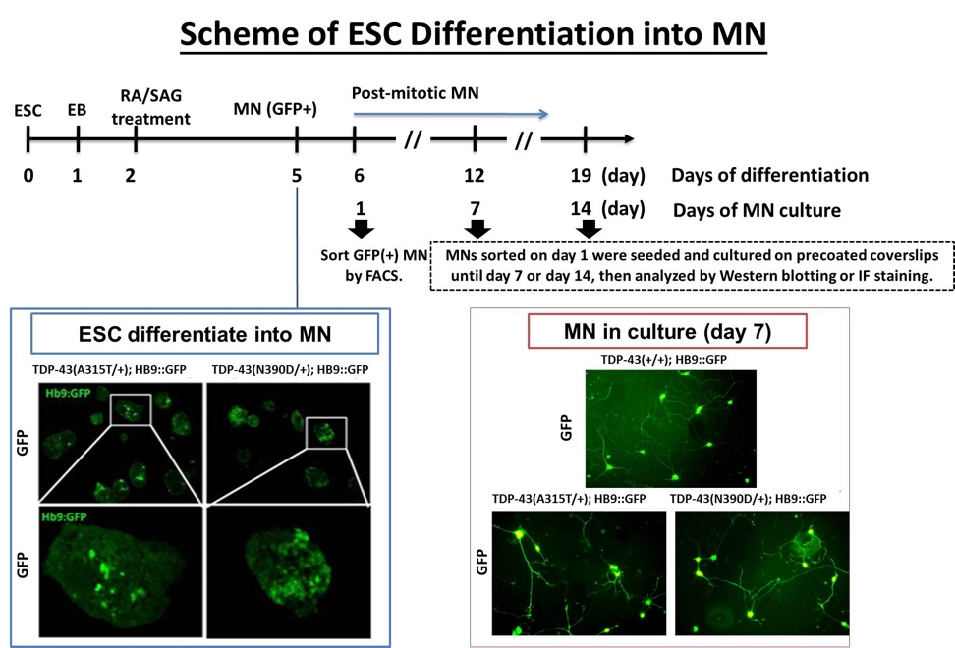

Figure S8. Scheme of MN differentiation. ESC from TDP-43 (+/+); Hb9:GFP, TDP-43 (A315T/+); Hb9:GFP and TDP-43 (N390D/+); Hb9:GFP mice were differentiated into spinal MN as described in Materials and Methods. Day 6 of the differentiation process would be day 1 of MN in culture when most (>65%) of the ESC were differentiated into GFP (+) MNs.

