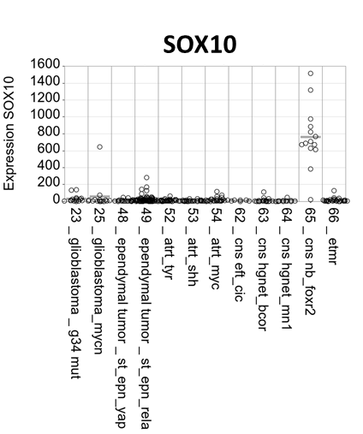
Supplementary Figure 1. Expression of SOX-10 in various CNS tumors detected by Affymetrix platform.

