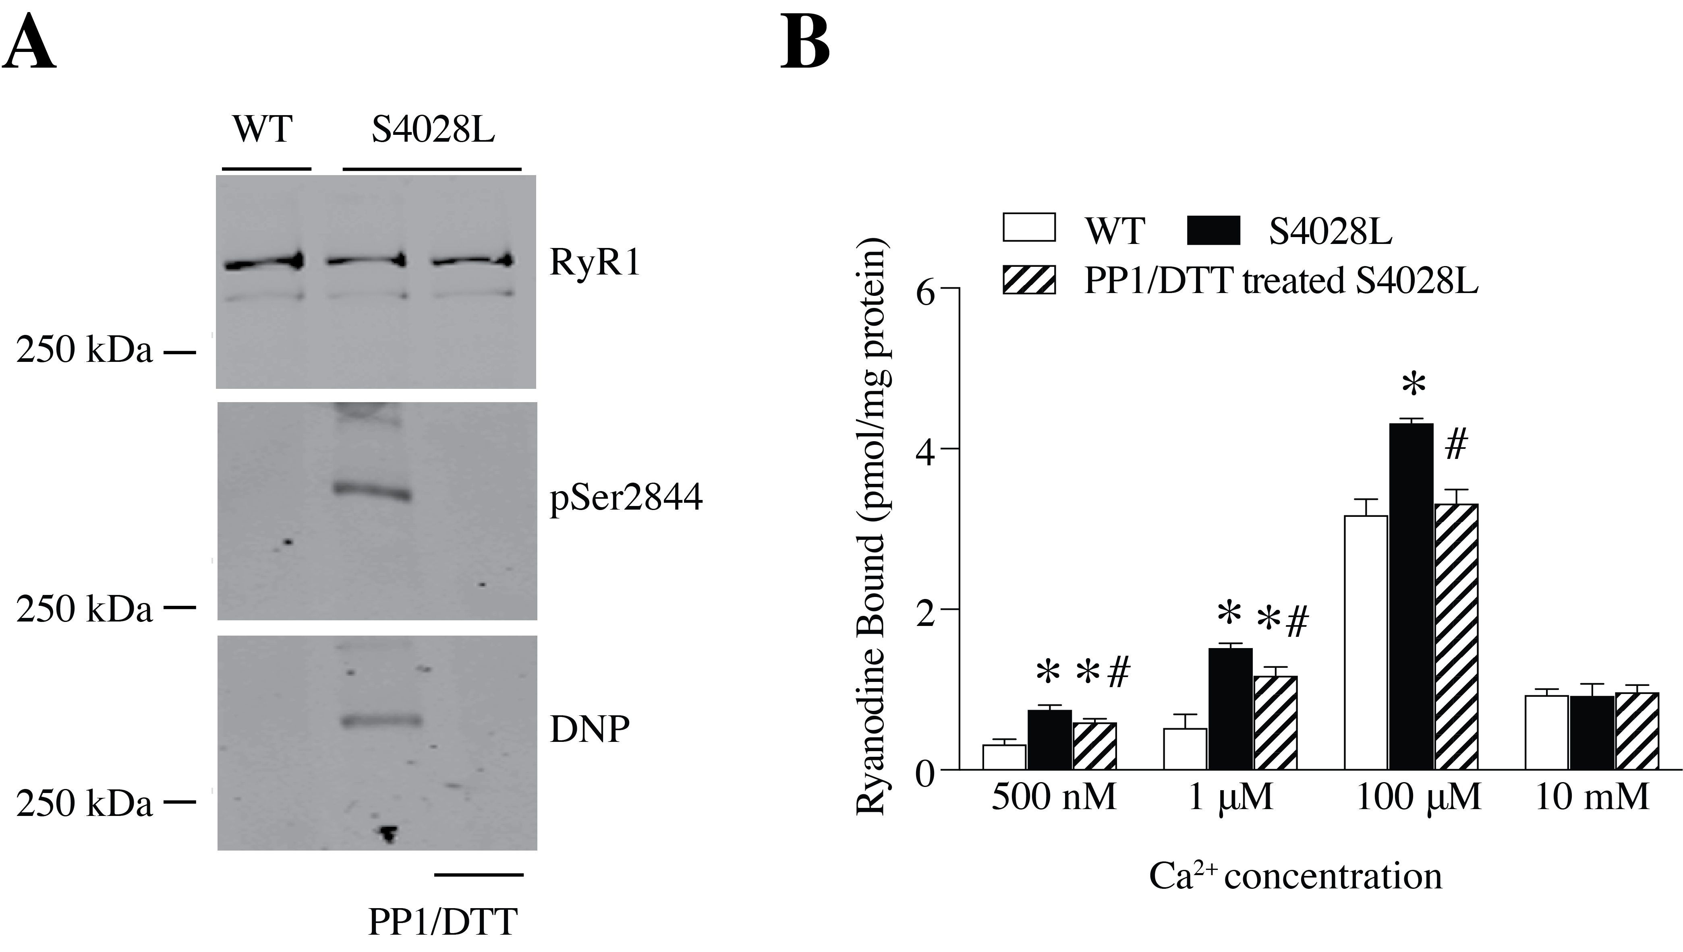
Supplemental Figure 1. RyR1-S4028L patient mutation causes RyR1 channel leak. (A) The mutant RyR1-S4028L channel was PKA phosphorylated at Ser2844 and oxidized (DNP) compared to control. PP1 and DTT were used to reverse the oxidation and phosphorylation. (B) The mutant RyR1-S4028L channels exhibited increased sensitivity to Ca²⁺-dependent activation consistent with channel leak as determined by ³[H]-ryanodine binding at the indicated [Ca²⁺]_{cyt}. Data are presented as mean ± S.E.M from 4 for each group *P < 0.05 vs. WT; #P < 0.05 vs. RyR1-S4028L, ANOVA, Tukey-Kramer with post hoc correction.

