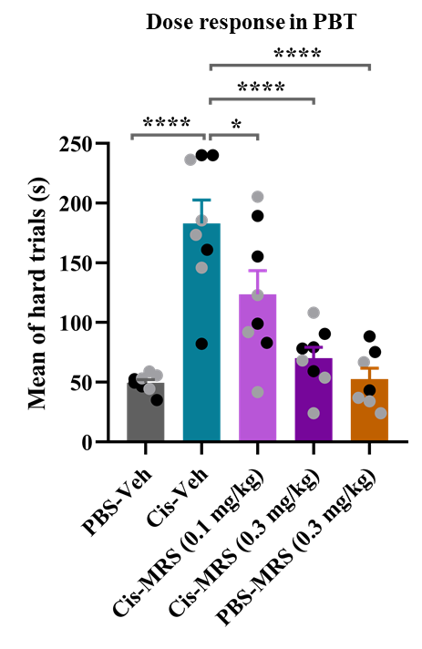
Supplementary figure S1: Dose finding experiment for the effect of the A3AR agonist MRS5980 on chemobrain. Dose response in puzzle box test (PBT). Effect of two doses of MRS5980 (0.1 and 0.3 mg/kg) on cisplatin-induced deficits in executive function as assessed using the puzzle box test (PBT) (black circles: male mice, n= 4 and grey circles: female mice, n= 4 per group). The results are expressed as mean± SEM and were analyzed with one-way ANOVA followed by Tukey's multiple comparisons test; *p < 0.05, ****p < 0.0001.

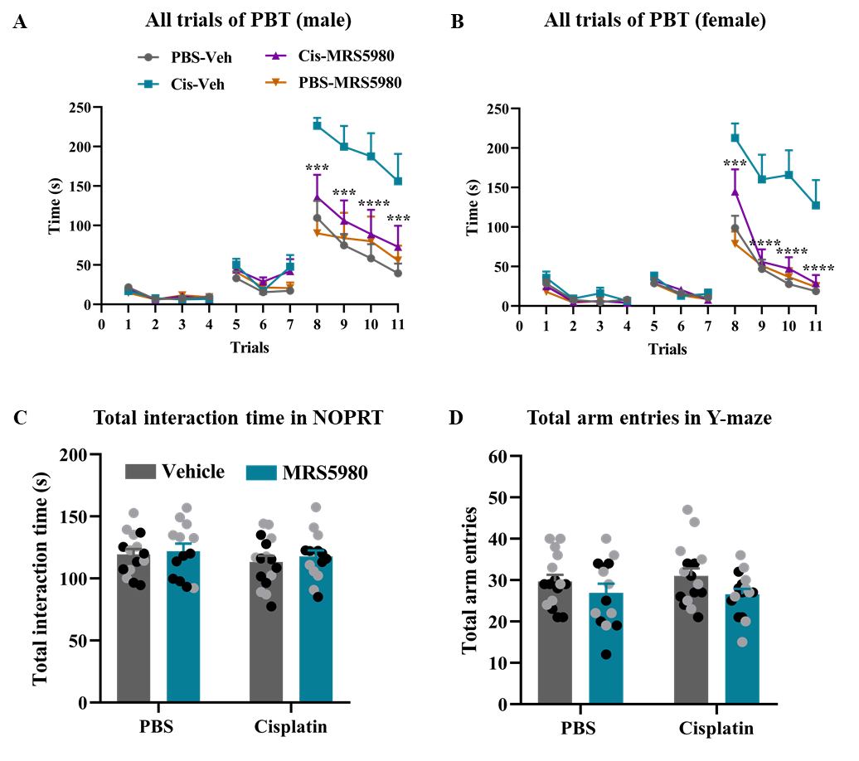
Supplementary figure S2: No effect of treatments on performance in easy and intermediate PBT trials, total interaction time in the NOPRT, and total arm entries in the Y-maze.
Effect of MRS5980 in cisplatin-treated (A) male mice and (B) female mice in all trials of the PBT. Results are expressed as mean ± SEM. (C) Total interaction time in NOPRT expressed as time spent with the novel plus time spent with the familiar object during test. (D) Total number of arm entries in Y-maze. Results are expressed as mean ± SEM. Black circles (male mice) and grey circles (female mice).

