Supplementary Tables
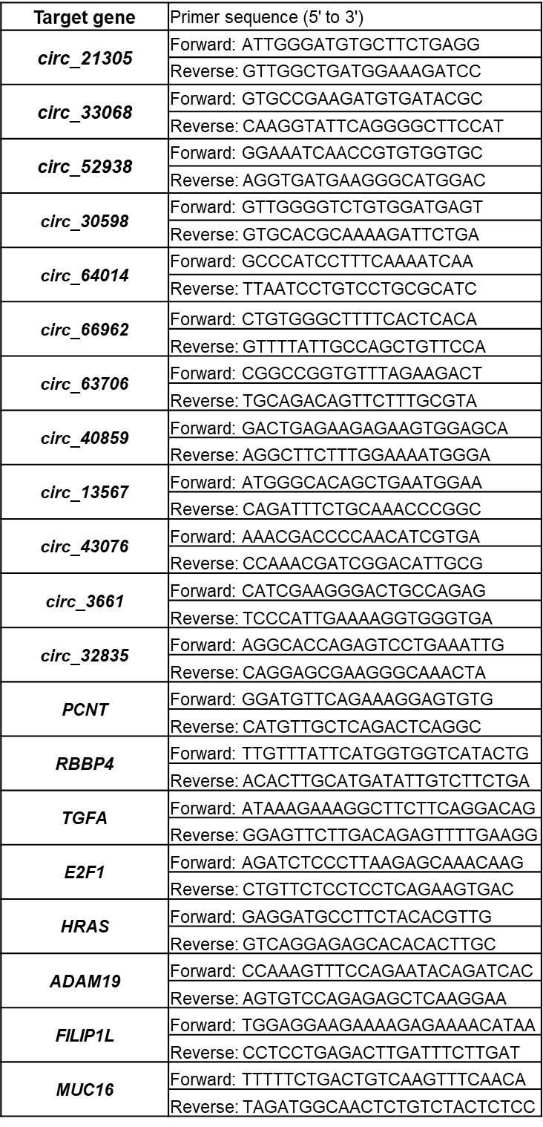
Supplementary Table 1. Primer sequences for qRT-PCR
Supplementary Table 2. The 65 medulloblastoma subgroup-specific circRNAs in patient samples.
WNT |  |  |  | SHH |  |  |  | Group3 |  |  |  | Group4
circRNA | logFC | adj.P.Val |  | circRNA | logFC | adj.P.Val |  | circRNA | logFC | adj.P.Val |  | circRNA | logFC | adj.P.Val
circ_71350 | 6.55 | 9.31E-32 |  | circ_30598 | 5.62 | 6.29E-23 |  | circ_13567 | 5 | 1.10E-35 |  | circ_21305 | 3.07 | 5.75E-12
circ_51087 | 6.18 | 1.32E-28 |  | circ_64014 | 5.3 | 2.06E-30 |  | circ_40859 | 4.4 | 2.50E-13 |  | circ_72082 | 3.07 | 2.90E-09
circ_55605 | 6.1 | 1.18E-17 |  | circ_45001 | 5.23 | 9.85E-20 |  | circ_43076 | 4.37 | 3.86E-33 |  | circ_56936 | 2.62 | 4.82E-12
circ_78614 | 5.94 | 1.99E-32 |  | circ_4097 | 4.89 | 2.51E-22 |  | circ_32835 | 3.39 | 2.31E-12 |  | circ_29196 | 2.48 | 8.15E-07
circ_39796 | 5.85 | 4.19E-29 |  | circ_66962 | 4.79 | 1.91E-24 |  | circ_30459 | 2.57 | 1.09E-07 |  | circ_74145 | 2.42 | 6.03E-07
circ_42444 | 5.56 | 4.52E-12 |  | circ_9649 | 4.46 | 2.17E-18 |  | circ_60461 | 2.57 | 4.11E-07 |  | circ_77438 | 2.42 | 1.12E-06
circ_50345 | 5.48 | 1.42E-23 |  | circ_28243 | 4.25 | 1.98E-17 |  | circ_62787 | 2.48 | 3.97E-06 |  | circ_33068 | 2.4 | 3.93E-06
circ_68037 | 5.28 | 1.10E-19 |  | circ_63706 | 4.05 | 2.32E-15 |  | circ_7624 | 2.4 | 1.25E-09 |  | circ_52938 | 2.39 | 3.96E-09
circ_62407 | 5.22 | 2.29E-17 |  | circ_1701 | 3.75 | 1.06E-11 |  | circ_68493 | 2.31 | 3.94E-07 |  | circ_63166 | 2.34 | 6.44E-08
circ_76616 | 5.19 | 1.42E-23 |  | circ_11342 | 3.62 | 5.57E-14 |  | circ_28884 | 2.29 | 1.24E-05 |  | circ_61700 | 2.32 | 7.61E-06
circ_44532 | 5.06 | 6.57E-23 |  | circ_38659 | 3.54 | 2.32E-15 |  | circ_3661 | 2.23 | 4.89E-05 |  | circ_71440 | 2.3 | 7.12E-06
circ_66175 | 5 | 1.89E-20 |  | circ_78110 | 3.42 | 3.37E-13 |  | circ_30848 | 2.11 | 1.69E-05 |  | circ_104 | 2.29 | 7.98E-07
circ_42912 | 4.97 | 1.99E-19 |  | circ_17346 | 3.4 | 2.16E-15 |  | circ_77823 | 2.04 | 7.85E-06 |  | circ_65941 | 2.27 | 0.0001307
circ_41600 | 4.94 | 1.66E-19 |  | circ_61423 | 3.34 | 2.09E-12 |  |  |  |  |  | circ_63542 | 2.25 | 5.33E-06
circ_56467 | 4.91 | 4.13E-17 |  | circ_30078 | 3.34 | 3.42E-14 |  |  |  |  |  | circ_39940 | 2.25 | 1.09E-07
circ_74804* | 1.55 | 4.14E-20 |  | circ_74154* | 1.27 | 3.41E-14 |  |  |  |  |  | circ_11865* | 1.26 | 3.13E-13
circ_77990* | 1.59 | 4.55E-22 |  | circ_30078* | 1.39 | 2.74E-18 |  |  |  |  |  | circ_7196* | 3.12 | 4.76E-06
 |  |  |  |  |  |  |  |  |  |  |  | circ_73901* | 1.27 | 5.25E-07
*; CircRNAs from RF Classifier analysis
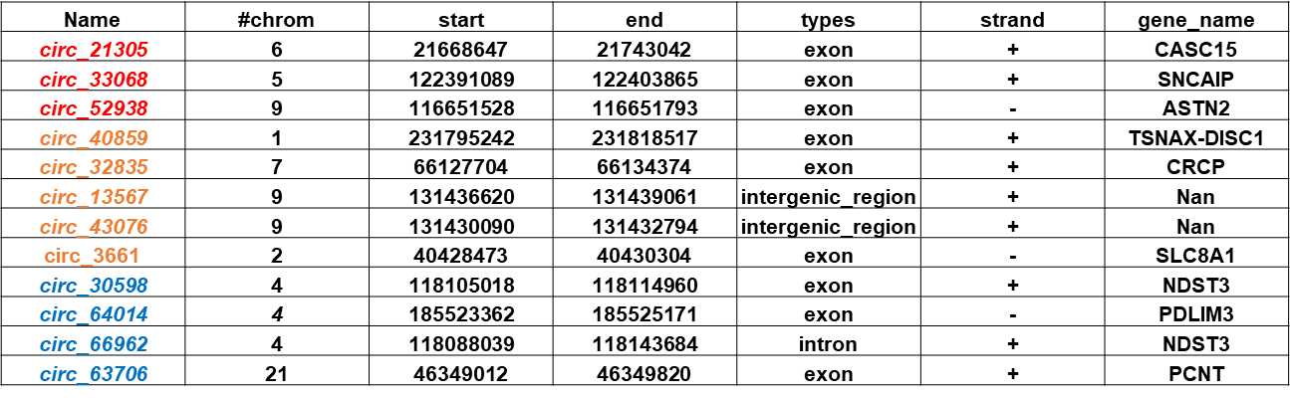
Supplementary Table 3. Top twelve circRNAs for RT-qPCR validation

Supplementary Table 4. CT values for circular RNAs in cell line and PDX samples.
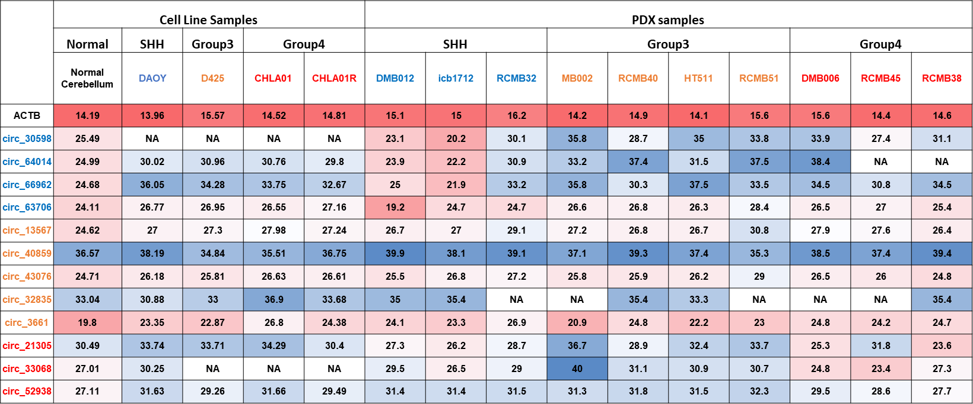

Supplementary Table 5. Coding potential of circRNAs predicted by RNAsamba.
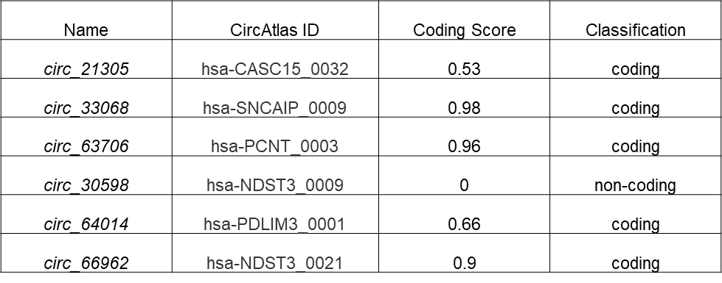

Supplementary Table 6. List of miRNAs that can potentially bind with circ_63706, along with their binding energies and the binding sites.
