Supplementary Material

Determinants of Astrocytic Pathology in Stem Cell Models of Primary Tauopathies

Kimberly L. Fiock PhD^{1,2}, Jordan Hook BS^{1,4}, Marco M. Hefti MD*^{1,2,3}

¹Department of Pathology, University of Iowa, Iowa City, IA
²Experimental Pathology Graduate Program, University of Iowa, Iowa City, IA
³Iowa Neuroscience Institute, University of Iowa, Iowa City, IA
⁴Carver College of Medicine, University of Iowa, Iowa City, IA

*To whom correspondence should be addressed:
Marco M. Hefti, MD
25 S Grand Ave MRC-108-A
Iowa City, IA 52240
(319)-335-8427
marco-hefti@uiowa.edu

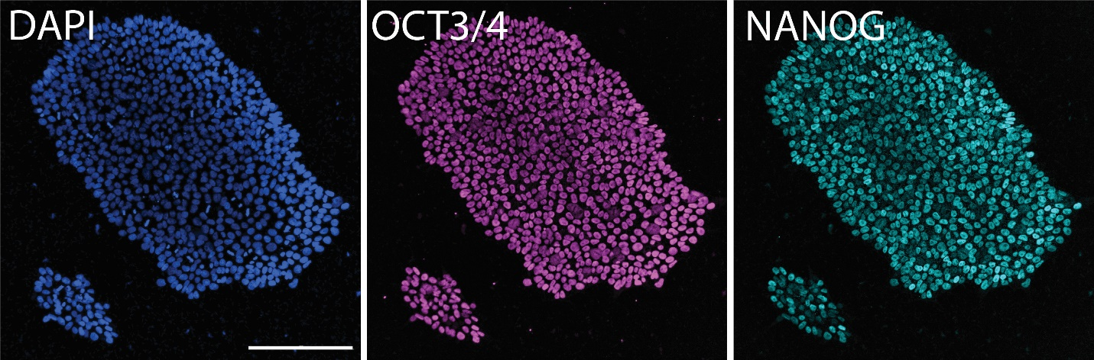
Figure S1. Validation of stem cells by immunocytochemistry. Channels shown separately for image in Fig. 3. Scale bar = 200 μm

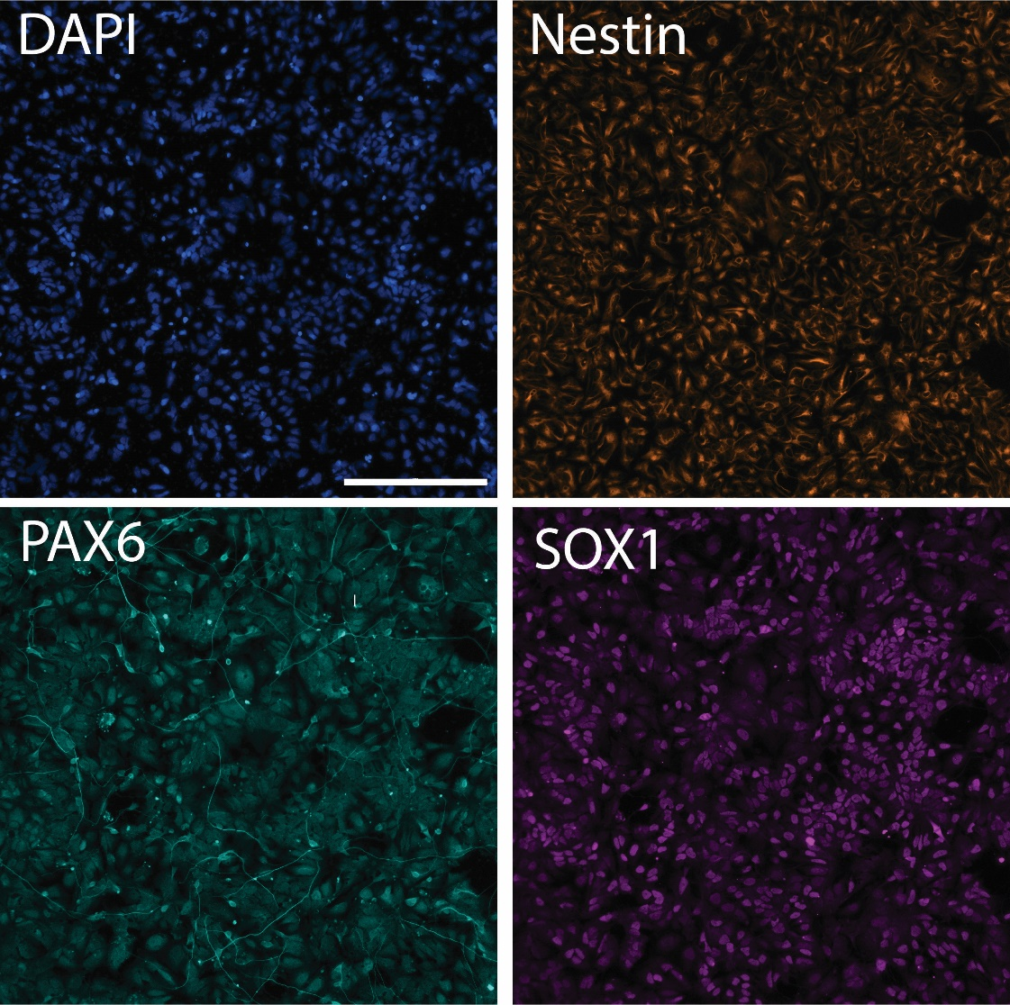
Figure S2. Validation of neural progenitor cells by immunocytochemistry. Channels shown separately for image in Fig. 3. Scale bar = 200 μm

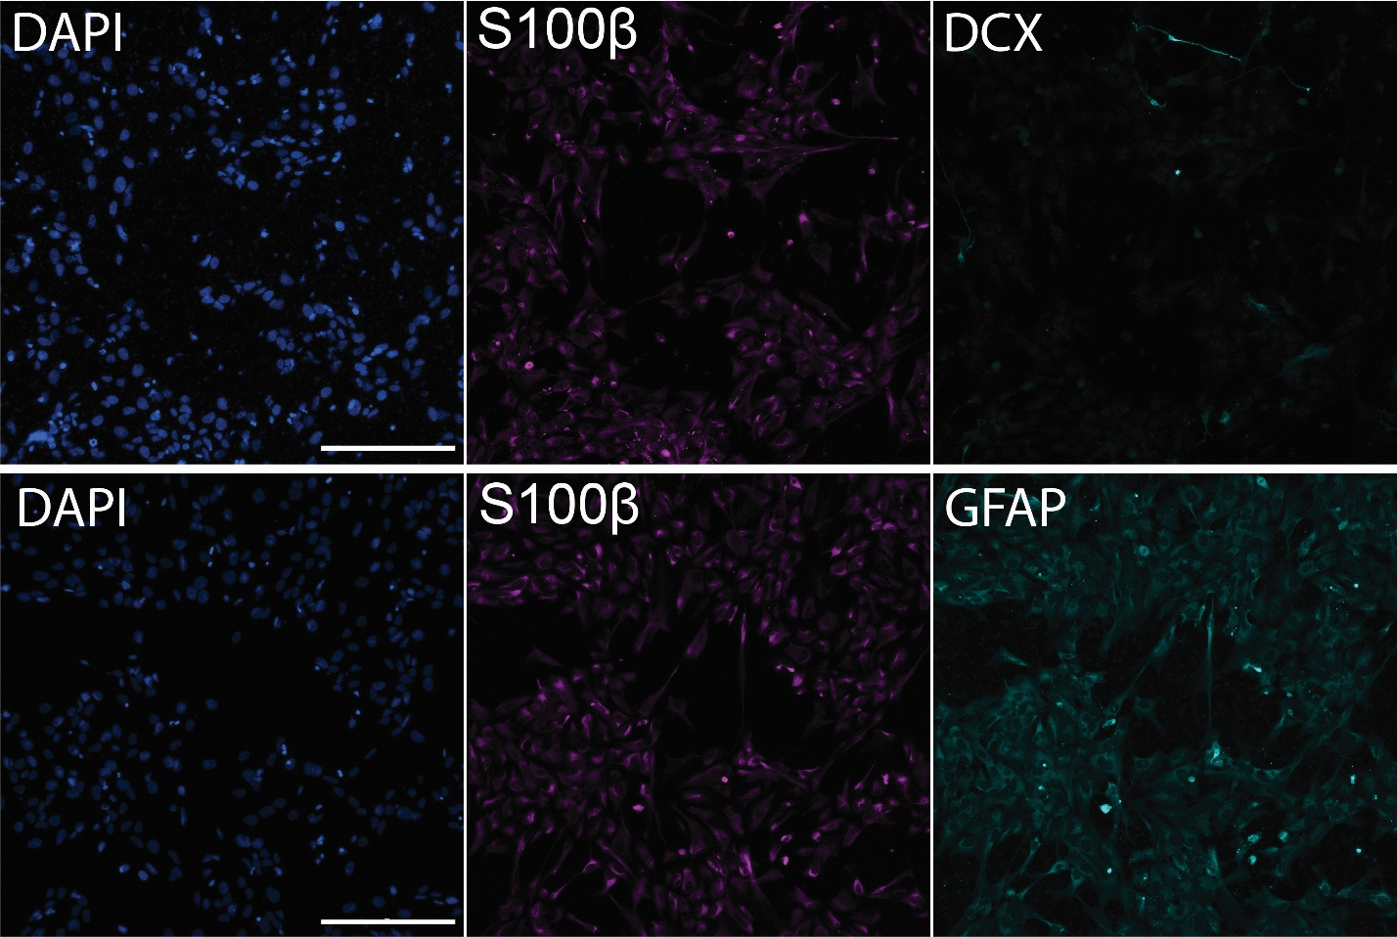
Figure S3. Validation of astrocyte differentiation by immunocytochemistry. Channels shown separately for image in Fig. 3. Scale bar = 200 μm

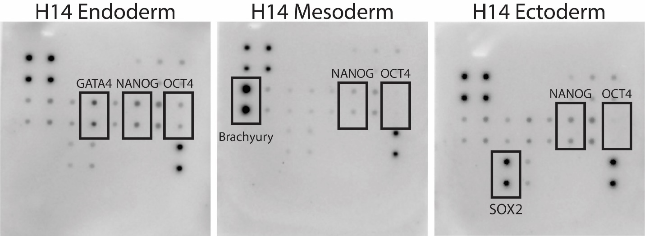
Figure S4. Additional validation of stem cell pluripotency by trilineage differentiation.

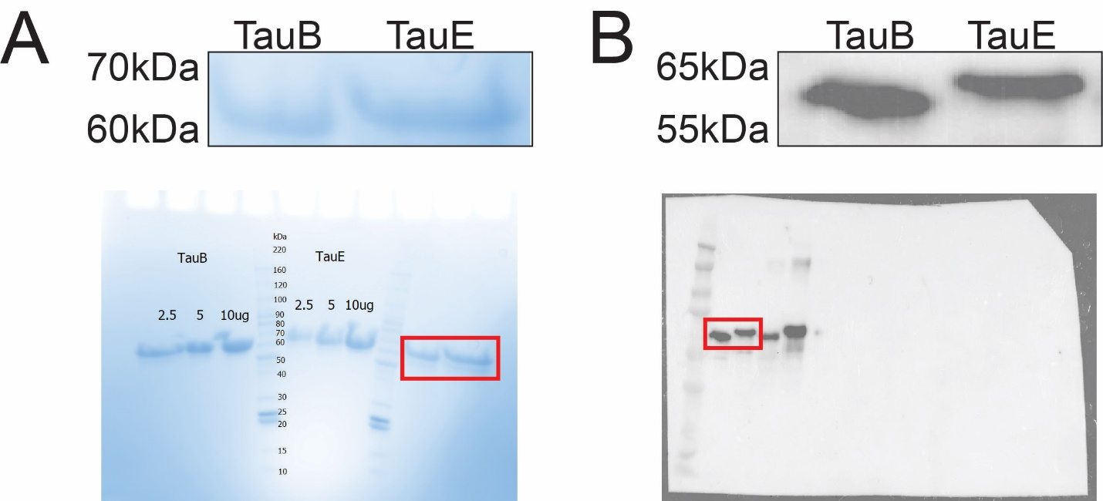
Figure S5. Validation of recombinant tau. (A) Recombinant TauE (1N4R) and TauB (1N3R) was run on an SDS-PAGE gel and stained with Coomassie Blue to assess for purity. Red box on whole gel represents magnified region shown above. (B) TauE and TauB were run on an SDS-PAGE gel, transferred to PVDF membrane and probed with anti-tau (HT7). Red box indicates relevant area magnified above

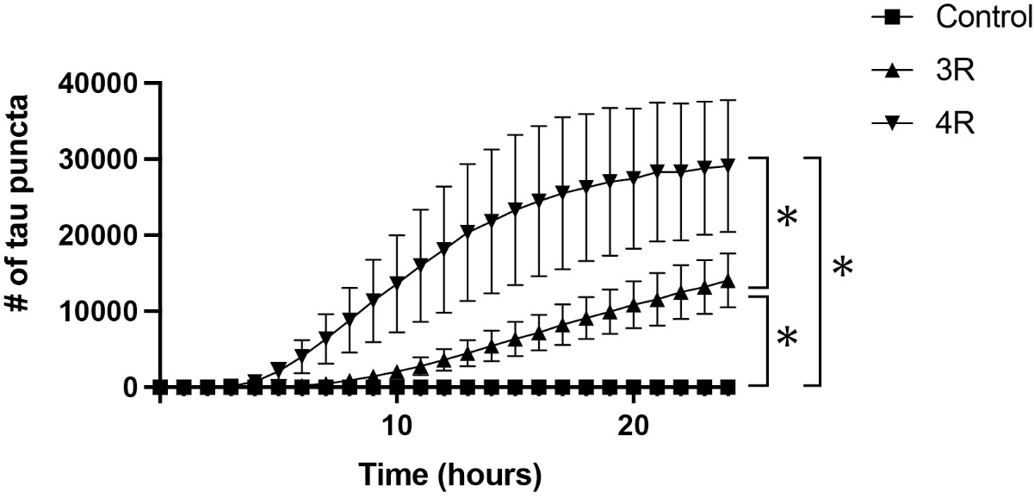
Figure S6. Replication of Figure 3. N=3 technical replicates per condition; *p<10-4

