Supplementary Figure 1: An Overview of Lipoxins Biosynthesis
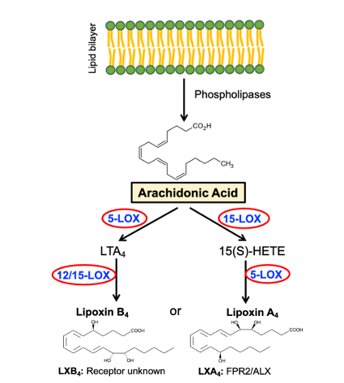

Suppl. Fig. 1: LXA₄ and LXB₄ are synthesized from arachidonic acid through sequential oxygenation by actions of 5-LOX and 12/15-LOX enzymes. LOX-Lipoxygenases.

Supplementary Figure 2: Sketch of a flat-mounted retina showing central (C) and peripheral (P) regions.
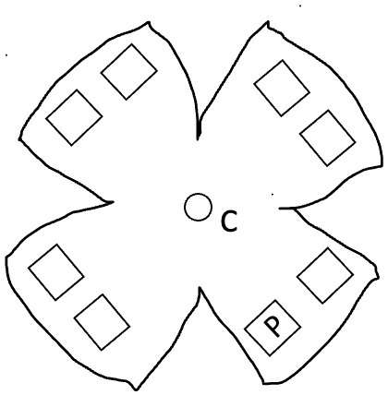
Suppl. Fig. 2: After immunostaining, whole retinal flat mounts with RBPMS, eight fields were sampled from each retina's peripheral (indicated with square boxes) areas to determine RGC counts. The circle in the center is the position at which the optic nerve exits the eye.

Supplementary Figure 3: Confirmation of RNA quality
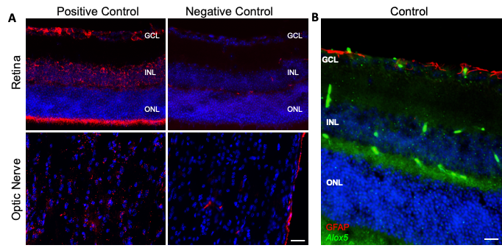
Suppl. Fig. 3: A. Using mRNA probes, representative images of positive and negative controls RNAscope ISH (red) of the retina and optic nerve. B. Representative images of RNAscope ISH (green), colocalized with GFAP protein (red) of the retina using mRNA probes for Alox5. Nuclei were labeled with DAPI to distinguish the nuclear layers of the retina. All images were obtained using a 40X objective. Scale bar = 50 µm. Labels: ganglion cell layer (GCL), inner nuclear layer (INL), outer nuclear layer (ONL).

