Additional file 5: Arm-level copy number alterations by chordoma outcome
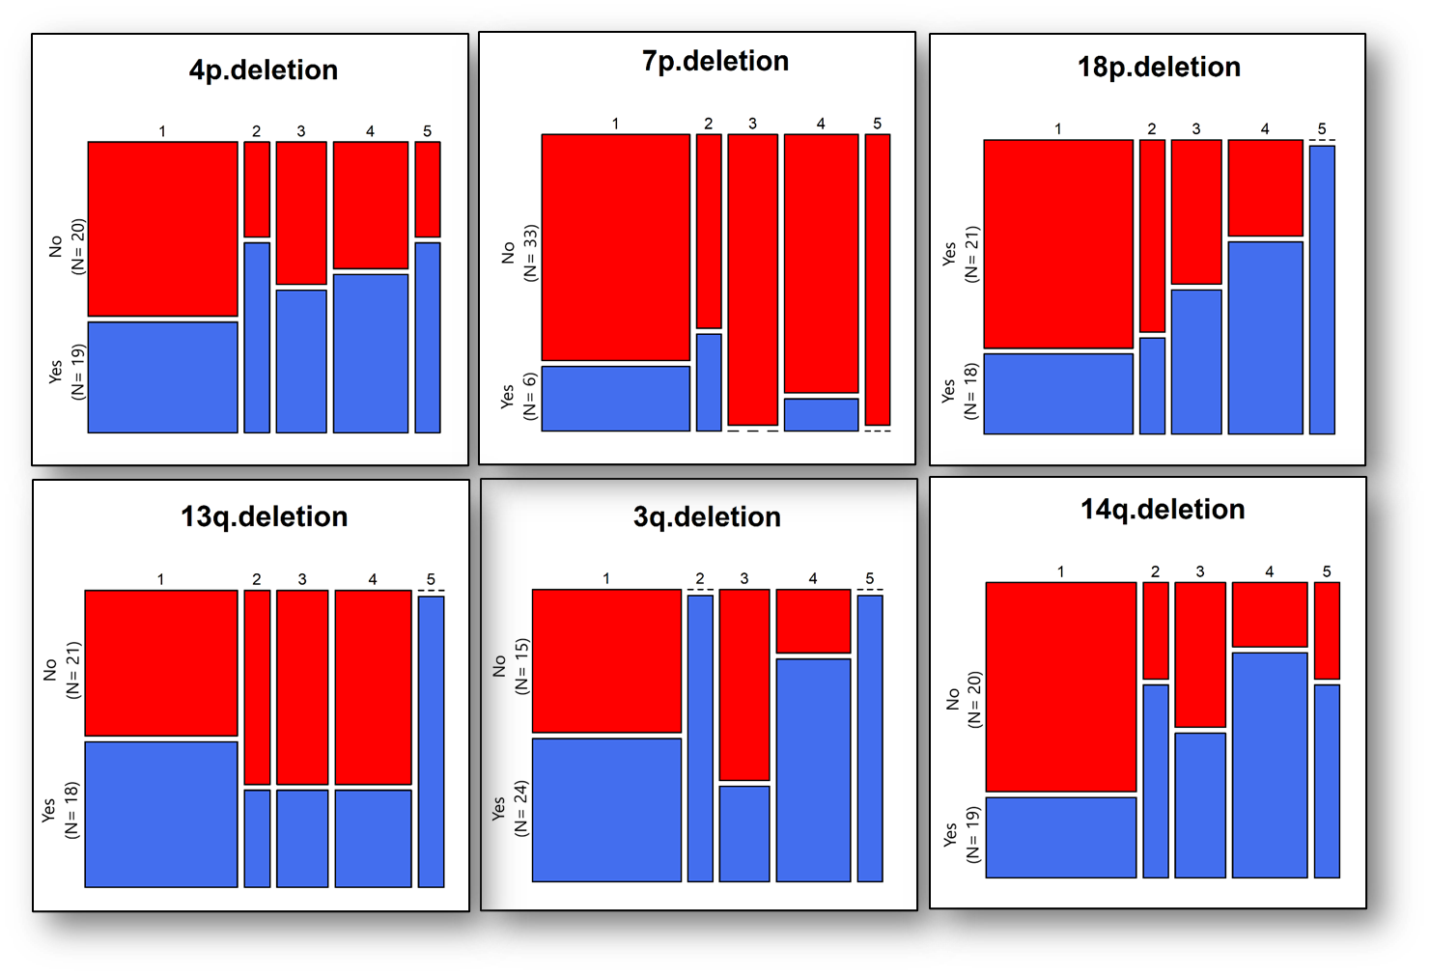

1= Having no chordoma anywhere (N=18).
2= Having chordoma at original site but tumor not growing (N= 3).
3= Having chordoma at the original site or elsewhere and the tumor was growing (N= 6).
4= Having chordoma spreading at other sites, including 12 deaths (N= 9).
5= Died (N= 3).

