Infrared spectral profiling of demyelinating activity in multiple sclerosis brain tissue (Supplemental Information)

Oleksandr Gakh^{1,†}, Jordan M. Wilkins^{1,†}, Yong Guo¹, Bogdan F. Popescu^{2,3}, Stephen D. Weigand⁴, Alicja Kalinowska-Lyszczarz⁵, Claudia F. Lucchinetti^{6,*}

¹Department of Neurology, Mayo Clinic, Rochester, MN 55905, United States
²Department of Anatomy, Physiology, and Pharmacology, University of Saskatchewan, Saskatoon, Saskatchewan S7K 0M7, Canada
³Cameco MS Neuroscience Research Center, University of Saskatchewan, Saskatoon, Saskatchewan S7K 0M7, Canada
⁴Department of Health Sciences Research, Mayo Clinic, Rochester, MN 55905, United States
⁵Department of Neurology, Division of Neurochemistry and Neuropathology, Poznan University of Medical Sciences, 49 Przybyszewskiego Street, 60-355 Poznan, Poland
⁶Department of Neurology, Frank and Charmaine Denius Dean’s Chair in Medical Leadership, Dean of Dell Medical School, Senior Vice President Medical Affairs, University of Texas at Austin, Austin, TX 78712, United States

† Authors contributed equally to this work.
* Correspondence:
Claudia F. Lucchinetti
claudia.lucchinetti@austin.utexas.edu

- Keywords: biomolecular profiling, cortex, demyelinating activity, human brain tissue, Fourier transform infrared spectroscopy, lesions, multiple sclerosis, sparse partial least squares-discriminant analysis, white matter.

Supplemental Figure 1
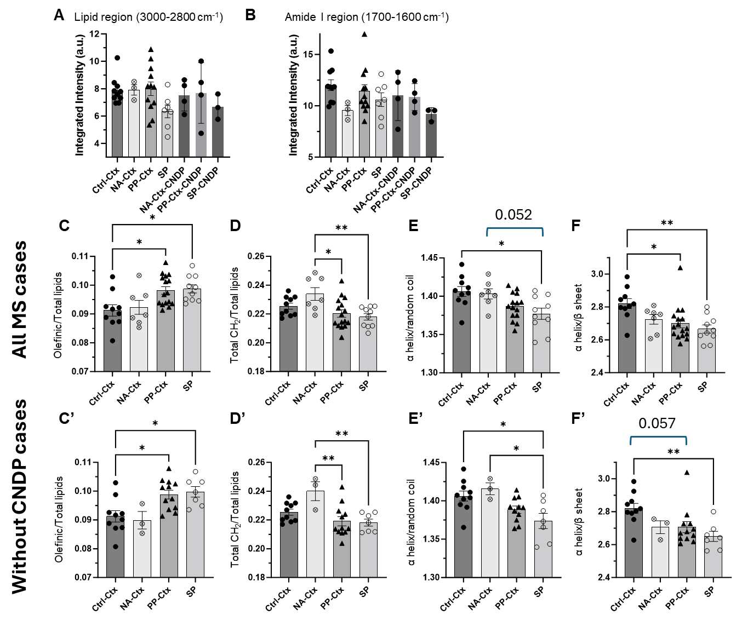

Supplemental Figure 1. Neurodegenerative pathology in the cortex does not significantly alter changes detected by FTIR spectroscopy in this study. Out of 24 MS cases, six cases had concurrent neurodegenerative pathology in the cortex. (A,B) Analysis of all samples (first four bars in graph) and only those with concurrent neurodegenerative pathology (indicated by CNDP) does not show significant differences in total lipids and amide I regions. (C-F) Original cortex data containing all MS cases. (C’-F’) Respective graphs seen in C-F without the six MS cases with concurrent neurodegenerative pathology. Differences between C-F and C’-F’ were minimal. Thus, we concluded that changes in MS cortex detected in this study are not significantly perturbed by concurrent neurodegenerative pathology. Significance was detected using one-way ANOVA post hoc Tukey test (* p < 0.05 and ** p < 0.01). Abbreviation: CNDP, concurrent neurodegenerative pathology.
Supplemental Figure 2

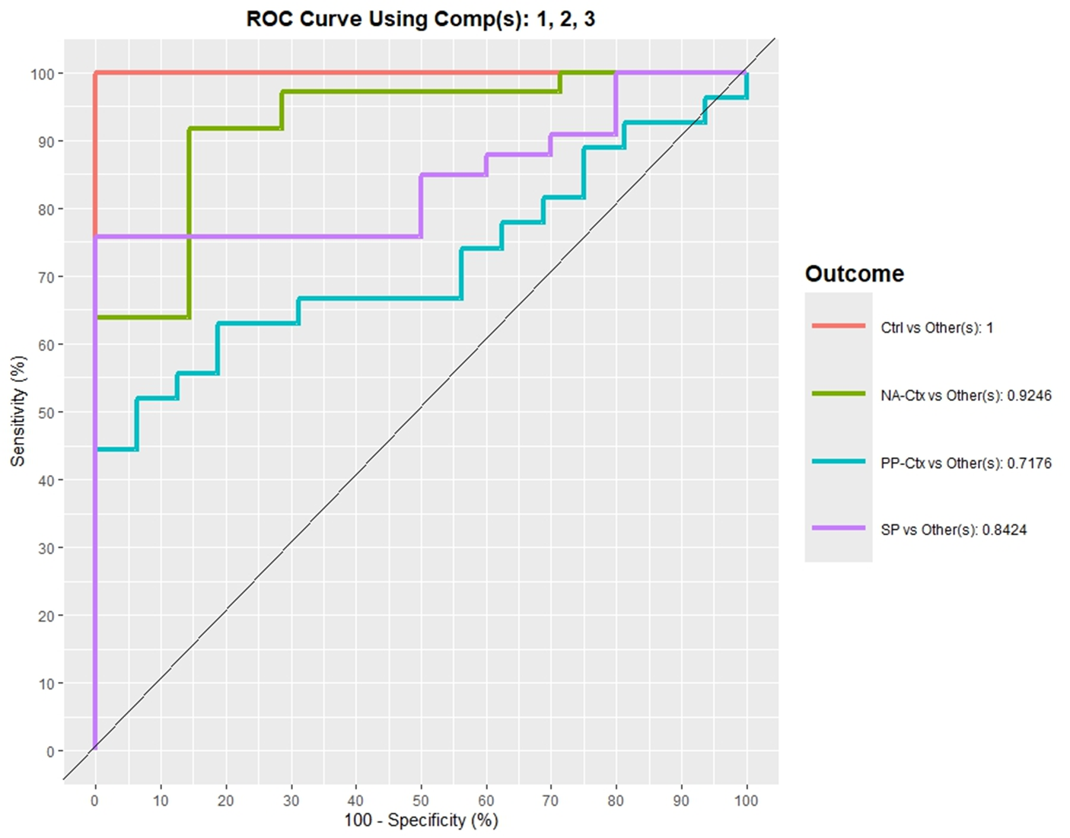
Supplemental Figure 2. The AUROC curve suggest that the spectral profiles of MS cortex and control cortex are unique. Multivariate analysis using sPLS-DA was performed on the second derivative spectra of MS and control cortex. The performance of the model is shown. Abbreviations: Ctrl, control; NA-Ctx, normal appearing cortex; PP-Ctx, periplaque cortex; SP, subpial lesion.

Supplemental Figure 3
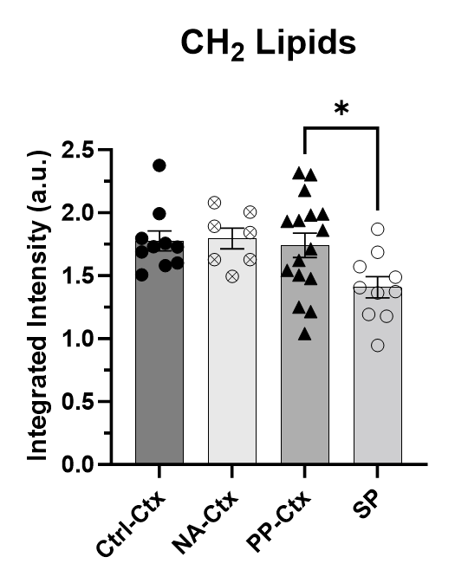
Supplemental Figure 3. The change of total CH₂ lipids in the MS and control cortex. The integrated area under the absorbance spectra for total CH₂ lipids for the respective regions in the cortex. Significance was detected using one-way ANOVA with post hoc Tukey test (* p < 0.05).
Supplemental Table 1

Summary of samples used in this study
 | Control | Chronic MS | Acute MS
Total number of individuals | 10 | 11 | 13
Age (years) | 55.2 ± 15.97 | 64.91 ± 9.22 | 41.85 ± 20.00
% Female | 10 | 64 | 54
Autopsy cases
Number of individuals | 10 | 11 | 7
Number of FFPE blocks analyzed | 20 | 20 | 8
Biopsy cases
Number of individuals | NA | NA | 6
Number of FFPE blocks analyzed | NA | NA | 8

Supplemental Table 2

Summary of clinical data for MS cases included in the study
Case no | Age (yrs) | Sex | Biopsy  (B) or  autopsy (A) | Disease duration at death /at biopsy | Disease duration at last follow-up (biopsy cases only) | Clinical diagnosis at death/biopsy | Disease course  at death  /biopsy | Diagnosis  at pathology | Coexisting  CNS pathology | Coexisting pathology outside  of CNS
Chronic cases
1. | 72 | M | A | 16.25 years | x | Clinically definite Multiple Sclerosis | SPMS | Chronic MS | 1. Nonspecific neurodegenerative changes in neocortex and entorhinal cortex (rare NFTs)  2. Cerebral atherosclerosis-grade I (minimal) | N/A
2. | 78 | F | A | N/A | x | Clinically silent Multiple Sclerosis | Silent MS | Chronic MS | Multiple hemorrhagic infarcts | 1. Hypertension  2. Cardiomyopathy  3. Chronic heart failure 4. Obesity  5. Aortic dissection with hemopericardium (immediate cause of death)
3. | 53 | F | A | 25 years | x | Clinically definite Multiple Sclerosis | RRMS | Chronic MS | None | 1. Hepatic failure post-transplant  2. Coronary artery disease
4. | 60 | M | A | 11 years | x | Clinically definite Multiple Sclerosis | RRMS | Chronic MS | 1. Nonspecific neurodegenerative changes (moderate, Braak & Braak III/VI)  2. Cranial atherosclerosis (marked) | 1. Coronary artery disease (post-CABG)  2. Myocardial infarction (immediate cause of death)
5. | 64 | F | A | N/A | x | N/A | N/A | Chronic MS | Subdural hematoma | N/A
6. | 66 | M | A | 12 years | x | Clinically definite Multiple Sclerosis | PPMS | Chronic MS | Nonspecific neurodegenerative changes (mild): rare neocortical and amygdaloid NFTs | Pneumonia (aspergillosis)
7. | 51 | M | A | 17 years | x | Clinically definite Multiple Sclerosis | RRMS | Chronic MS | 1. NFT-predominant type of AD, Braak & Braak IV/VI  2. Argyrophilic grain disease (tau positive argyrophilic grains predominantly in amygdaloid nucleus and CA4 sector of hippocampus)  3. Sparse tau-positive oligodendroglial inclusions and coiled bodies  4. Rare NF-positive ballooned neurons in the amygdaloid nucleus,  5. Multiple subarachnoid hemorrhages  (recent fall)  6. Cranial atherosclerosis - mild to focally marked | Esophagic adenocarcinoma
8. | 71 | F | A | 23 years | x | Clinically definite Multiple Sclerosis | SPMS | Chronic MS | None | Sepsis (post hardware removal from the right tibula fracture)
9. | 70 | F | A | 28 years | x | Clinically definite Multiple Sclerosis | SPMS | Chronic MS | 1. Non-specific neurodegenerative changes: moderate entorhinal and hippocampal NFTs  2. Cranial atherosclerosis -grade 1 | Bronchopneumonia
10. | 49 | F | A | 16 years | x | Clinically definite Multiple Sclerosis | SPMS | Chronic MS | 1. FTD with ubiquitin-positive inclusions and motor neuron disease  2. Cerebellar atrophy consistent with alcohol-induced cerebellar cortical degeneration  3. Posterior columns demyelination suggestive of subacute combined degeneration induced by vitamin B12 deficiency | 1. Lymphocytic mural endocarditis and epicarditis  2. Chronic gastritis  3. Retroperitoneal hematomas (fall)  4. Acute cor pulmonale 5. Pulmonary thromboemboli
11. | 57 | F | A | 22 years | x | Clinically definite Multiple Sclerosis | SPMS | Chronic MS | None | 1. Coronary atherosclerosis  2. Acute aspiration pneumonia  3. Pulmonary edema
Acute cases
1. | 9 | F | B | N/A | 4 years | N/A | N/A | Active MS (IP-2) | None | None
2. | 37 | F | B | 1 month | N/A | Clinically isolated demyelinating syndrome | Monophasic | Active MS (IP-2) | None | None
3. | 50 | F | A | 8 years | x | Clinically definite Multiple Sclerosis | RR-MS, fulminant | Active MS (IP-2) | Cerebral atrophy – generalized | Biopsy-confirmed myelodysplastic syndrome
4. | 68 | F | B | 1 month | 2 years | Clinically isolated demyelinating syndrome | Monophasic | Active MS (IP-2) | None | 1. Metastatic carcinoma of the pancreas  2. Coronary insufficiency  3. Cardiopulmonary arrest (immediate cause of death),  4. Malnutrition
5. | 69 | M | B | 10 weeks | 6 months | Clinically isolated demyelinating syndrome | Monophasic | Active MS (IP-2) | None | None
6. | 71 | M | A | 10 years | x | Clinically definite Multiple Sclerosis | SP-MS | Active MS (IP-2) | 1. Nonspecific neurodegenerative changes (minimal)  in neocortex  2. Cranial atherosclerosis (minimal) | None
7. | 28 | M | A | 3 weeks | x | Balo concentric sclerosis | Monophasic | Active MS (IP-3) | Tuberous sclerosis | None
8. | 28 | F | A | 8 weeks | x | Clinically definite multiple sclerosis | RRMS, fulminant | Active MS (IP-3) | 1. Late-subacute ischemic infarction  2. Cranial atherosclerosis (grade 1) | Acute myelogenous leukemia - M3 (post-chemotherapy, in remission)
9. | 34 | F | A | 13 months | x | Clinically definite multiple sclerosis | RR-MS, fulminant | Active MS (IP-3) | None | Hereditary spherocytosis status post splenectomy
10. | 37 | M | B | 1.8 months | 2 months | Balo concentric sclerosis | RR-MS | Active MS (IP-3) | None | None
11. | 38 | M | B | 10 days | N/A | uncertain | Monophasic | Active MS (IP-3) | None | None
12. | 17 | F | A | 3 weeks | x | Balo concentric sclerosis | Monophasic | Active MS (IP-3) | None | Pulmonary edema
13. | 58 | M | A | 3 months | x | Clinically definite multiple sclerosis | RR-MS, fulminant | Active MS (IP-2) | Cranial atherosclerosis (grade 2) | None

Abbreviations: CNS – Central Nervous System, MS – multiple sclerosis, RR- relapsing-remitting, SP-secondary progressive, PP-primary progressive, CABG – Coronary artery bypass graft, NFTs – neurofibrillary tangles, AD – Alzheimer’s disease, FTD – fronto-temporal dementia, NF – neurofilament, N/A – not available.

Supplemental Table 3

Quantification of MS and control tissue scanned by FTIR spectroscopy
 | Area analyzed (mm²) |  |  | Total number of ROIs |  |  | Number of individuals
ROI | Control | Chronic | Acute | Control | Chronic | Acute | Control | Chronic | Acute
NAWM | 1594 | 485 | NA | 25 | 14 | NA | 10 | 7 | NA
PPWM | NA | 846 | 997 | NA | 35 | 20 | NA | 10 | 7
Active | NA | NA | 1086 | NA | NA | 18 | NA | NA | 12
Inactive | NA | 340 | 116 | NA | 22 | 3 | NA | 7 | 2
RM | NA | 228 | NA | NA | 10 | NA | NA | 6 | NA
NA-Ctx | 2006 | 603 | 8 | 24 | 7 | 2 | 10 | 6 | 1
PP-Ctx | NA | 971 | 717 | NA | 47 | 10 | NA | 9 | 7
SP | NA | 2548 | 328 | NA | 52 | 5 | NA | 7 | 3

