Supplementary Method
Next-generation sequencing
- The detailed table for RNA quality control was provided, indicating that the RIN value from samples with grades A and B was RIN value ≥ 6.5，28S(25s)/18S ≥ 1.0.
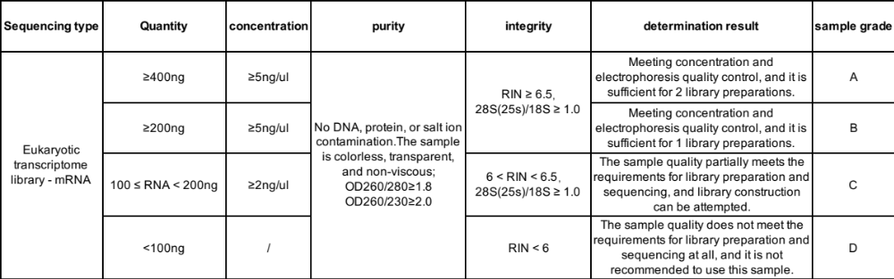
RNA quality requirements：

- The following are the details of the sequencing:
Sequencing machine: DNBSEQ-T7
Single-end or Paired-end: Paired-end
Read length: PE100
Read depth: Sequencing data volume > 100 million, Mapped rate > 90%
Was it mRNA poly-A enriched: yes.

- The quality control we conducted on the sequencing data：
The high-throughput sequencer generates raw image data files, which are then transformed into raw sequencing sequences through base calling and analysis. These raw sequences are referred to as raw data. To ensure the quality of information analysis, the software fastp is used to remove adapter sequences, filter out low-quality bases, and N bases (representing undetermined bases), resulting in high-quality clean data. The clean data is then subjected to statistical analysis, including the number of bases and sequences. The specific filtering criteria are as follows:
1) Removal of reads with a length less than 35bp after trimming adapter sequences and low-quality bases at both ends.
2) Removal of reads with an N (N represents undetermined base information) proportion greater than 10% of the total number of bases.
3) Removal of reads with a proportion of low-quality bases (quality value Q ≤ 5) accounting for more than 40% of the entire read length in single-end reads.

