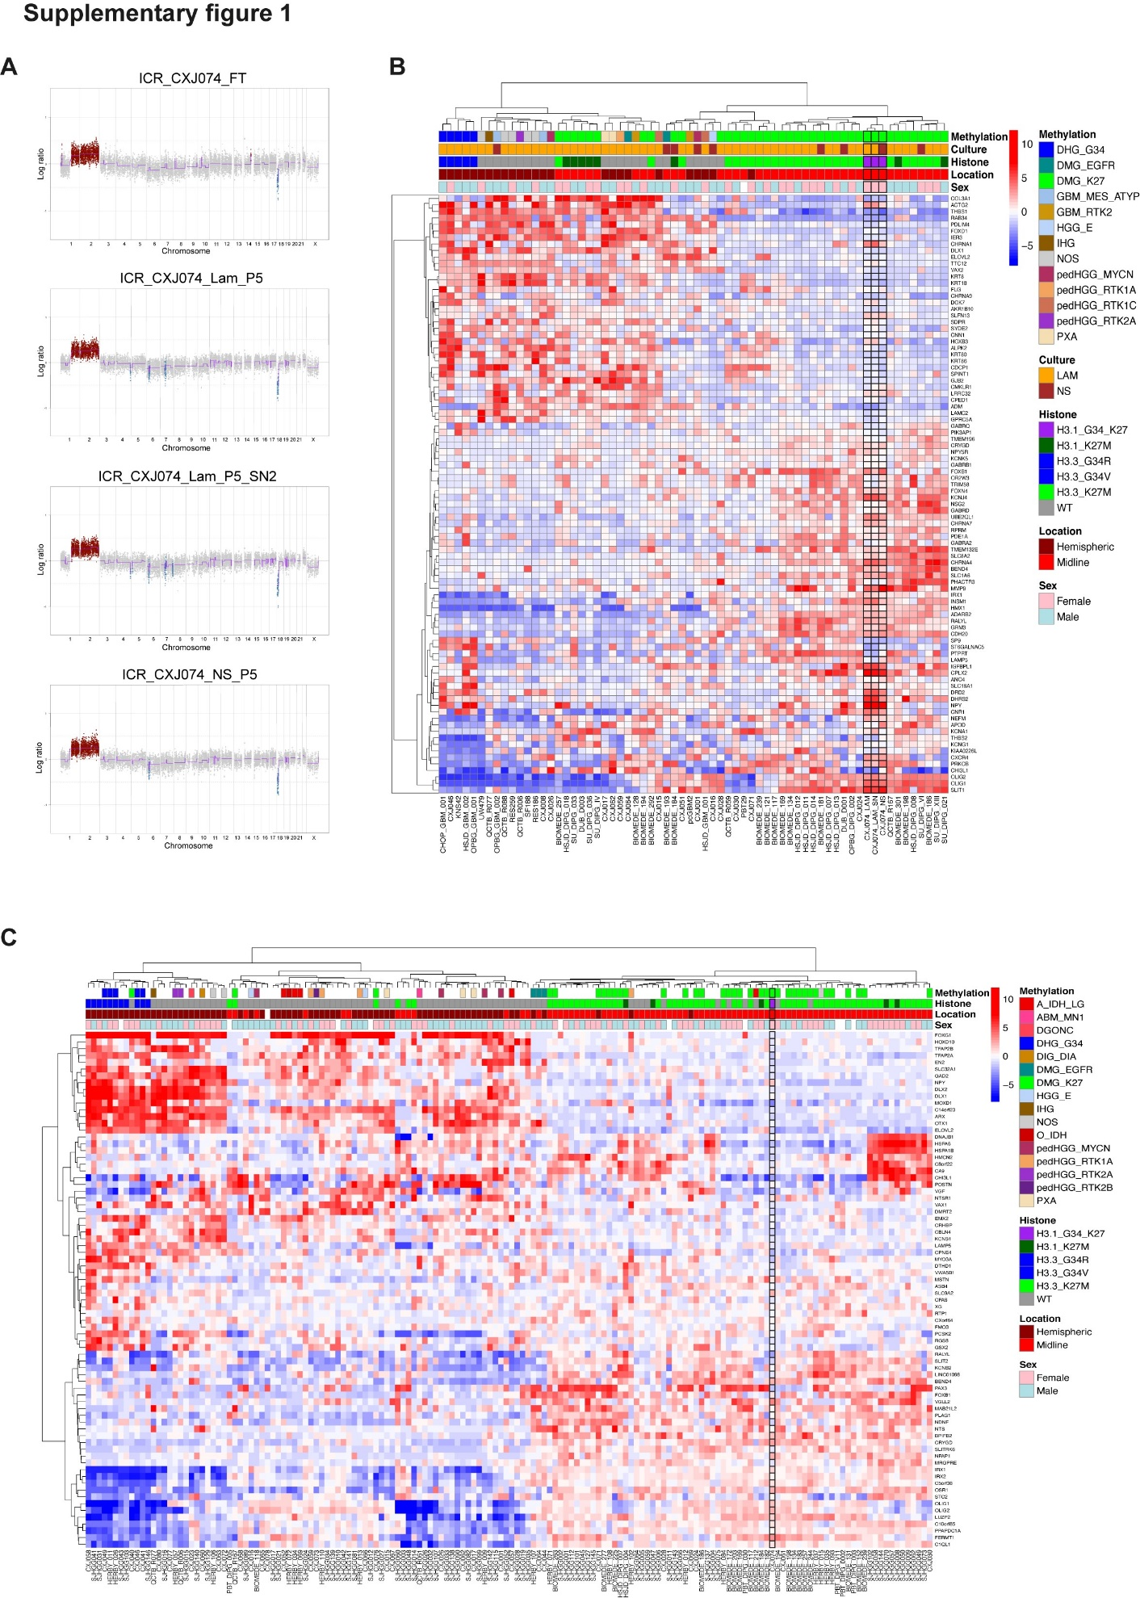
Supplementary Figure 1. Copy number and expression. A. Copy number plots derived from the Illumina array data showing the profiles of the patient-derived cell cultures and the primary tumour. Gains/amplifications highlighted in red, losses/deletions highlighted in blue. B. Heatmap showing the RNA expression profiles of the ICR-CXJ074 cultures (highlighted in black) compared to other histone-mutant and wildtype models. C. Heatmap showing RNA sequencing expression data for the primary tumour compared to other histone-mutant and wild-type tumours. ICR-CXJ074 is highlighted in black.

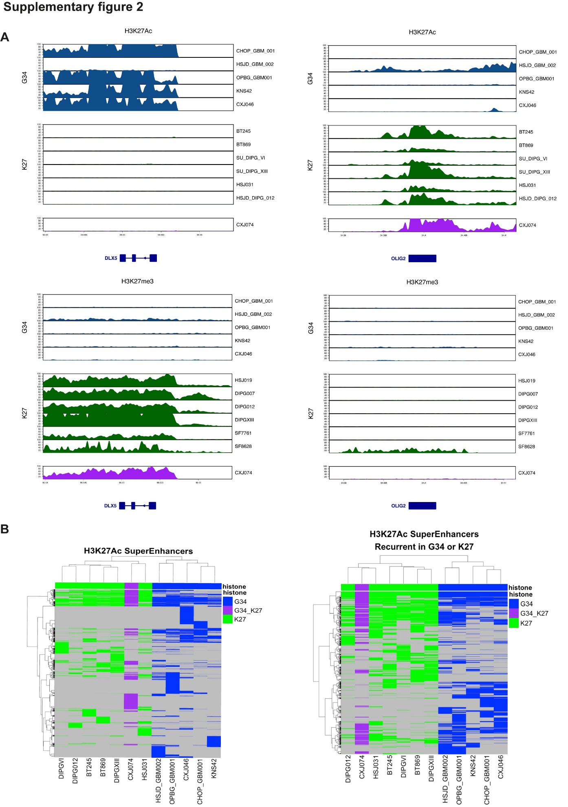
Supplementary Figure 2. ChIP-Seq results. A. Gene level H3K27ac and H3K27me3 loci highlighting profiles for genes DLX5 and OLIG2. B. Heatmaps showing the H3K27ac super-enhancer profiles of ICR-CXJ074 compared with other K27M-mutant and G34-mutant tumours. H3K27ac left, recurrent H3K27ac super enhancers right. ICR-CXJ074 is highlighted in purple.

