Supplementary Figures and Tables
Figure S1. NAMPT inhibitors inhibit NSCLC subcutaneous tumor growth. (A-C) C57BL/6J mice (n=5-8 mice per group) were injected subcutaneously with LLC cells. LLC-bearing mice were treated with vehicle, FK866, GMX1778 on tumor implation day 7. On day 14, the mice were pictured (A), then tumors were removed (B) and weighed (C). *P＜0.05, ** P<0.01.

Figure S2. NAMPT inhibitors inhibit NSCLC cell viability. (A-B) H460, A549 and LLC cells were treated with 0.1% DMSO, FK866 and GMX1778 for 72h, and then cell viability measured by CCK-8 assay.

Figure S3. NAMPT inhibitors inhibit DNA synthesis in NSCLC cells. (A) H460, A549 and LLC cells treated with different concentrations of FK866 and GMX1778 for 48h were tested for DNA synthesis by EdU assay. (B) The impact of supplementation with 1mmol/L NMN for 48h on DNA synthesis examined by EdU assay. ( H460: FK866 30nmol/L, GMX1778 30nmol/L; A549: FK866 3nmol/L, GMX1778 20nmol/L; LLC:FK866 3nmol/L, GMX1778 15 nmol/L) (Scale bar: 200 μm)

Figure S4. NAMPT inhibitors inhibit colony formation by NSCLC cells. (A) H460, A549 and LLC cells treated with different concentrations of FK866 and GMX1778 were assayed for colony formation. (B and C) Impact of supplementation with 1mmol/L NMN for 12 days on colony formation was measured. (H460: FK866 30nmol/L, GMX1778 30nmol/L; A549: FK866 3nmol/L, GMX1778 20nmol/L; LLC:FK866 3nmol/L, GMX1778 15 nmol/L) *P＜0.05, ** P<0.01, ***, P<0.001.

Figure S5. NAMPT inhibitors induce apoptosis and arrest cell cycle. (A) Flow cytometry analysis of H460, A549 and LLC cells apoptosis treated with different concentrations of FK866 and GMX1778 for 48h. Quantification of the total proportion of Annexin V-positive (early apoptotic) cells and 7ADD-stained double positive (late apoptotic) cells. (B) Western blot analysis of cell apoptosis proteins in H460, A549 and LLC cells treated with different concentrations of FK866 for 48h. (C) Western blot analysis of cell apoptosis proteins in H460 and LLC cells treated with different concentrations of GMX1778 for 48h. (D) Flow cytometry analysis of H460, A549 and LLC cells treated with different concentrations of FK866 for 48h. Quantification of the cell cycle profile. (E-F) Western blot analysis of cell cycle proteins in H460 and LLC cells treated with different concentrations of FK866 (E) and GMX1778 (F) for 48h. (G) Cell apoptosis proteins and cell cycle proteins were measured by western blot with and without supplementation with 1mmol NMN for 48h. (H460: FK866 30nmol/L, GMX1778 30nmol/L; A549: FK866 3nmol/L, GMX1778 20nmol/L; LLC:FK866 3nmol/L, GMX1778 15 nmol/L) β-actin was used as loading control for western blot. *P＜0.05, ** P<0.01, ***, P<0.001.

Figure S6. NAMPT inhibitors induce apoptosis in A549 cells. (A) NAMPT inhibitor-induced (3 nmol/L FK866, 20nmol/L GMX1778) apoptosis was measured by flow cytometry with and without supplementation with 1mmol NMN for 48h. (B) Quantification of the total proportion of cell apoptosis. ** P<0.01.

Figure S7. NAMPT inhibitors reduce migration of NSCLC cells. (A-B) H460, A549 and LLC cells were treated with different concentrations of FK866 for 48h. Cell migration was measured by wound-healing assays. (C-D) H460 and LLC cells were treated with different concentrations of GMX1778 for 48h. Cell migration was measured by wound-healing assays. *P＜0.05, ** P<0.01, ***, P<0.001.

Figure S8. NAMPT inhibitors reduce transwell migration of NSCLC cells. (A) H460, A549 and LLC cells were treated with different concentrations of FK866 and GMX1778 for 48h. Cell migration was measured by transwell assays. (B) Cell migration was measured by transwell assays with and without supplementation with 1mmol/L NMN for 48h.(H460: FK866 30nmol/L, GMX1778 30nmol/L; A549: FK866 3nmol/L, GMX1778 20nmol/L; LLC:FK866 3nmol/L, GMX1778 15 nmol/L) ** P<0.01, ***, P<0.001.

Figure S9. NAMPT inhibitors downregulate TGF-β1/Smads/RAB26 signaling axis proteins in NSCLC cells. Western blot analysis of TGF-β1/Smads/RAB26 axis key protein expression in H460 and A549 cells treated with different concentrations of GMX1778 for 48h. β-actin was used as loading control.

Figure S10. A patient who underwent surgical resection for primary NSCLC and NSCLC BM. Hematoxylin and eosin staining of tumor tissues (A, BM and B, primary) and the corresponding peri-tumor tissues. (Scale bar: 150μm)

Figure S11. NAMPT-TGF-β1-smads-RAB26 axis protein expression in 2 cases of primary NSCLC and NSCLC BM. Immunohistochemistry for the indicated proteins is presented. (Scale bar: 150 μm)
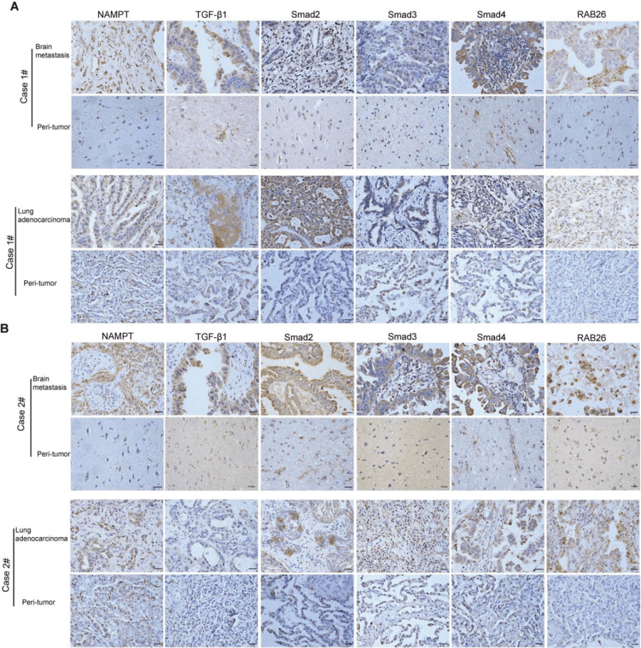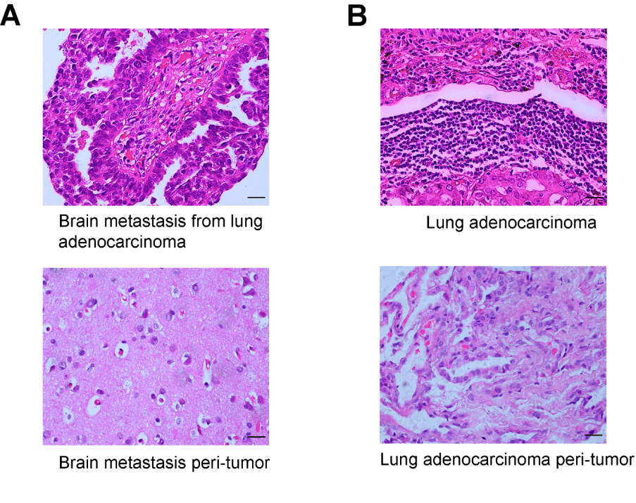
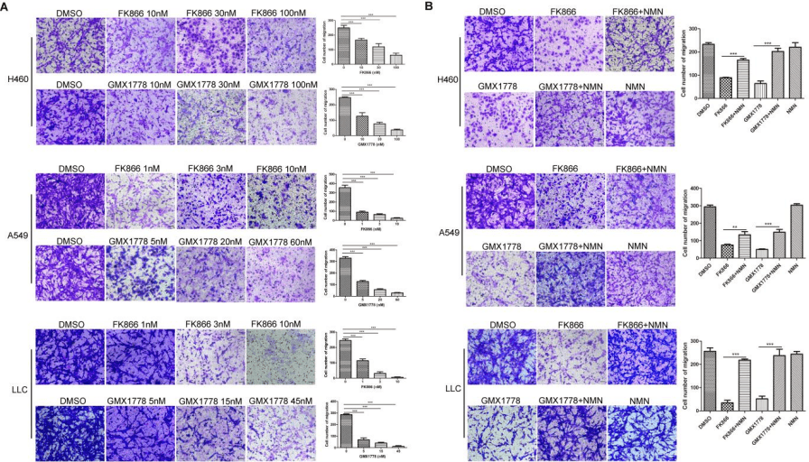
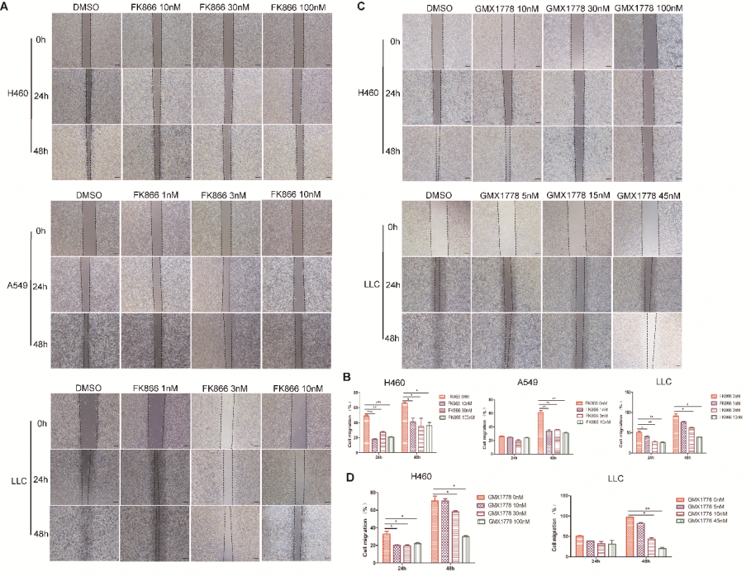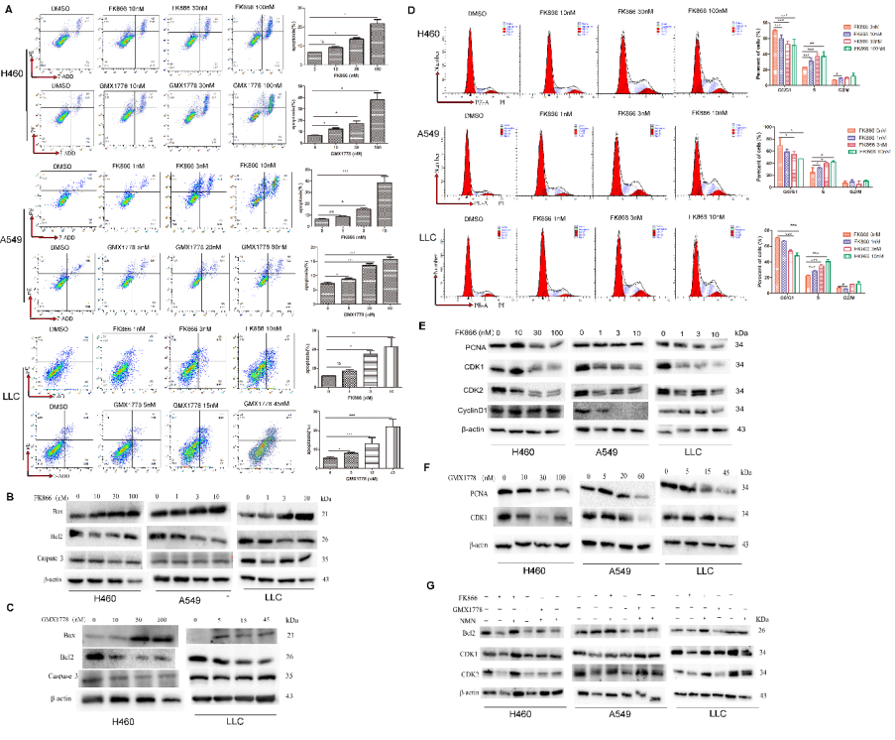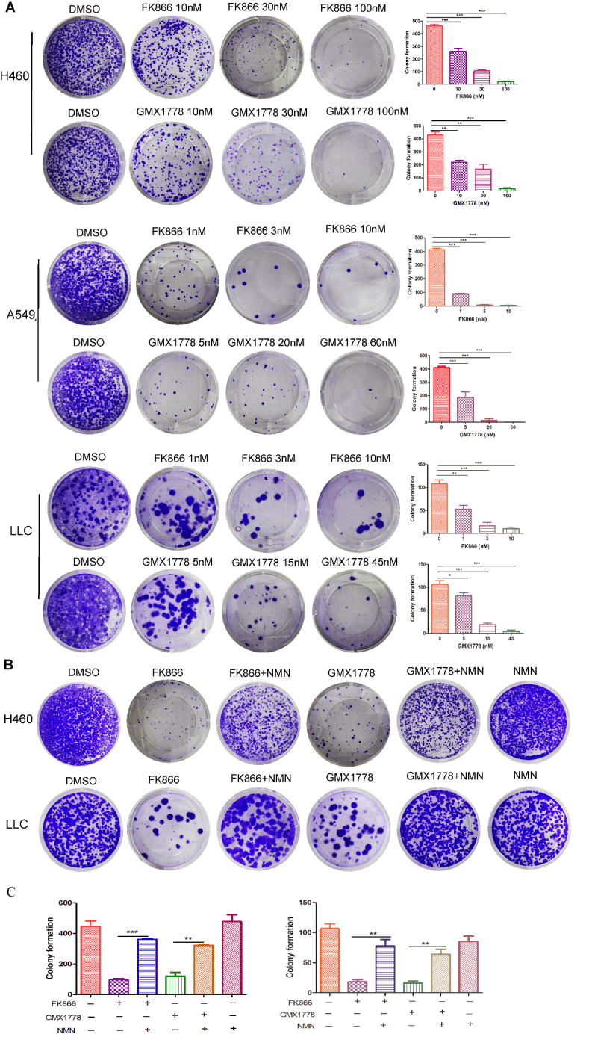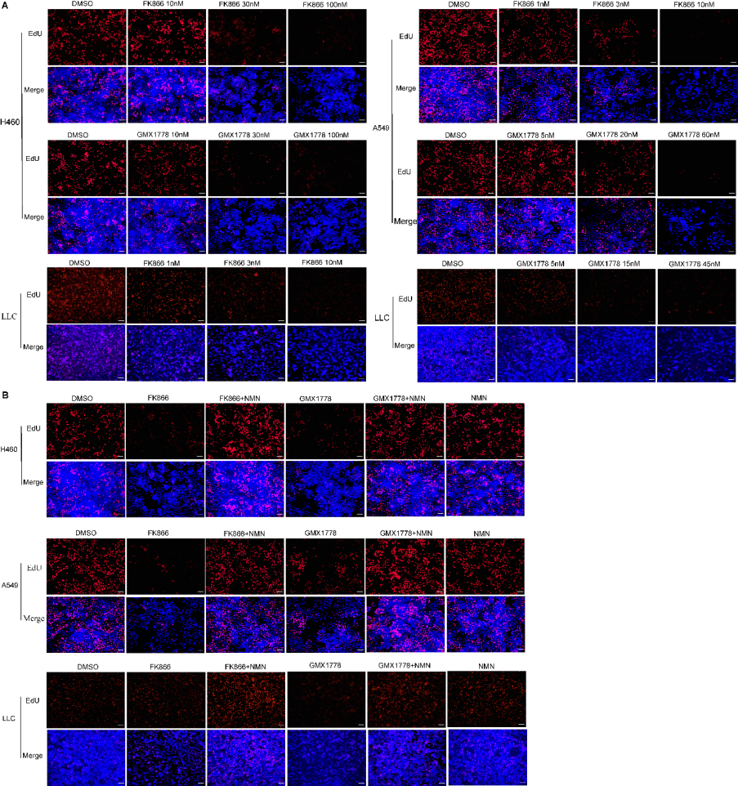
Table S1. Primary antibodies were used in the study

Antibody | Application | Cat.No | Manufacturer
Ki67 | IHC | 28074-1-AP | Proteintech
NAMPT | IHC, WB | 11776-1-AP | Proteintech
TGF-β1 | IHC, WB | 346599 | Zenbio
Smad2 | IHC, WB | 12570-1-AP | Proteintech
p-smad2 | WB | 18338S | CST
Smad3 | IHC, WB | 66516-1-Ig | Proteintech
p-smad3 | WB | 9520S | CST
Smad2/3 | WB | 5678S | CST
Smad4 | IHC, WB | 46535S | CST
RAB26 | IHC, WB | 251616 | Zenbio
Beta-actin | WB | 4967S | CST
BAX | WB | 50599-2-Ig | Proteintech
Bcl2 | WB | AF6139 | Affinity
Caspase 3 | WB | 19677-1-AP | Proteintech
PCNA | WB | Ab92552 | abcam
CDK1 | WB | 10762-1-AP | Proteintech
CDK2 | WB | Ab32147 | abcam
CyclinD1 | WB | 60186-1-Ig | Proteintech

Table S2. qRT-PCR primer information in the study
Gene name | Sequence (5’-3’)
HOMO RAB26 F | GTCTGCTGGTGCGATTCAAG
HOMO RAB26 R | GCATGGGTAACACTGCGGA
MUS RAB26 F | GAGATGCTCACGCACTGTTG
MUS RAB26 R | CAGTCTTGATTCATTCCCCCAC

Table S3. Target sequences of siRNAs in the study
Gene name | Target sequence (5’-3’)
HOMO siRAB26-1 F | GGCUGCAUGAUUACGUUAATT
HOMO siRAB26-1 R | UUAACGUAAUCAUGCAGCCTT
MUS siRAB26-2 F | GGAACAAAGUUCUGGACGUTT
MUS siRAB26-2 R | ACGUCCAGAACUUUGUUCCTT

Table S4. The intersection of genes in H460 cell and A549 cell genes with a fold change ≥ 2 and P value ≤ 0.005
down | up
  IL31RA
  VAV3
  CCDC148
  FGFR3
  VASH2
  YBX2
  VCAN
  RAB26
  MYB
  NOG
  STEAP1
  METTL7B
  PTGER2
  PEG10
  CNIH2
  EFHB
  NEXN
  MTUS1
  STEAP2
  USP51
  MYLK
  MCM4
  CAND2
  TMEM255A
  COLCA2
  PLCE1
  MCM5
  SH2D7
  GDF15
  BTG2
  CXCR4
  UNC79
  LHX3
  CNTF
  CDKN1A
  DRD4
  IL11
  CSF2
  S100A9
  SHC2
  ESPNL
  MFNG
  TCP11
  ASIC4
  C19orf38
  SLAMF9
  FBXW10

