Supplemental material SM3

Morphological descriptions

MEN-38
HE
Primær tumor
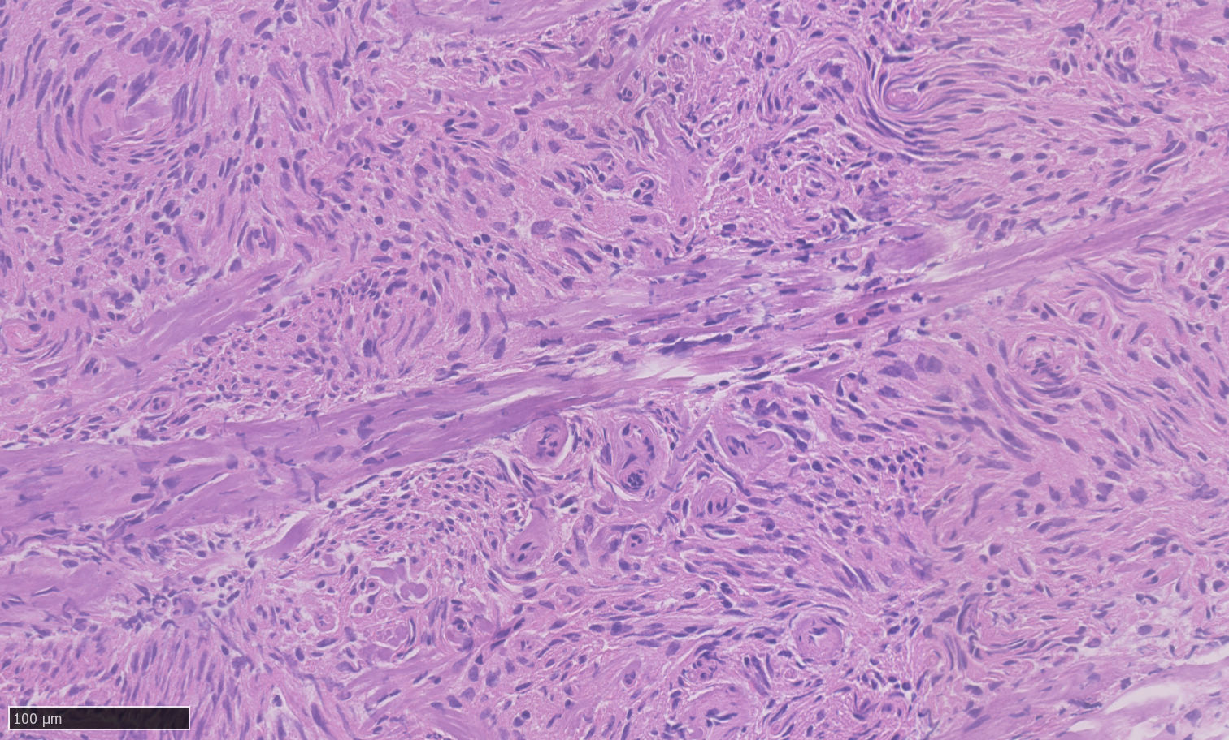

Resultat: Meningothelial Grade 1

Meningothelial meningioma grade 1 with a lobulated architecture and focally whorled growth pattern. Centrally there are collagen septa (insert) extending through the tumor. The tumor cells are spindle shaped with small oval to elongated nuclei without mitotic activity.

2D
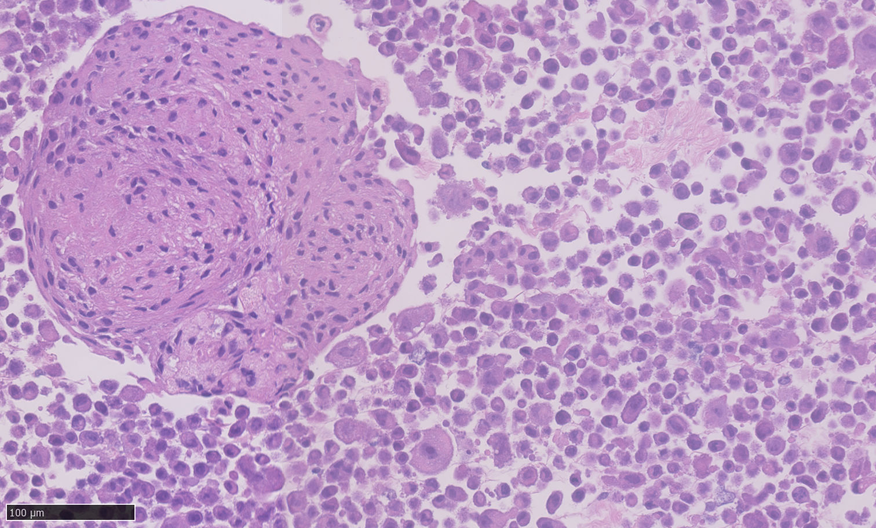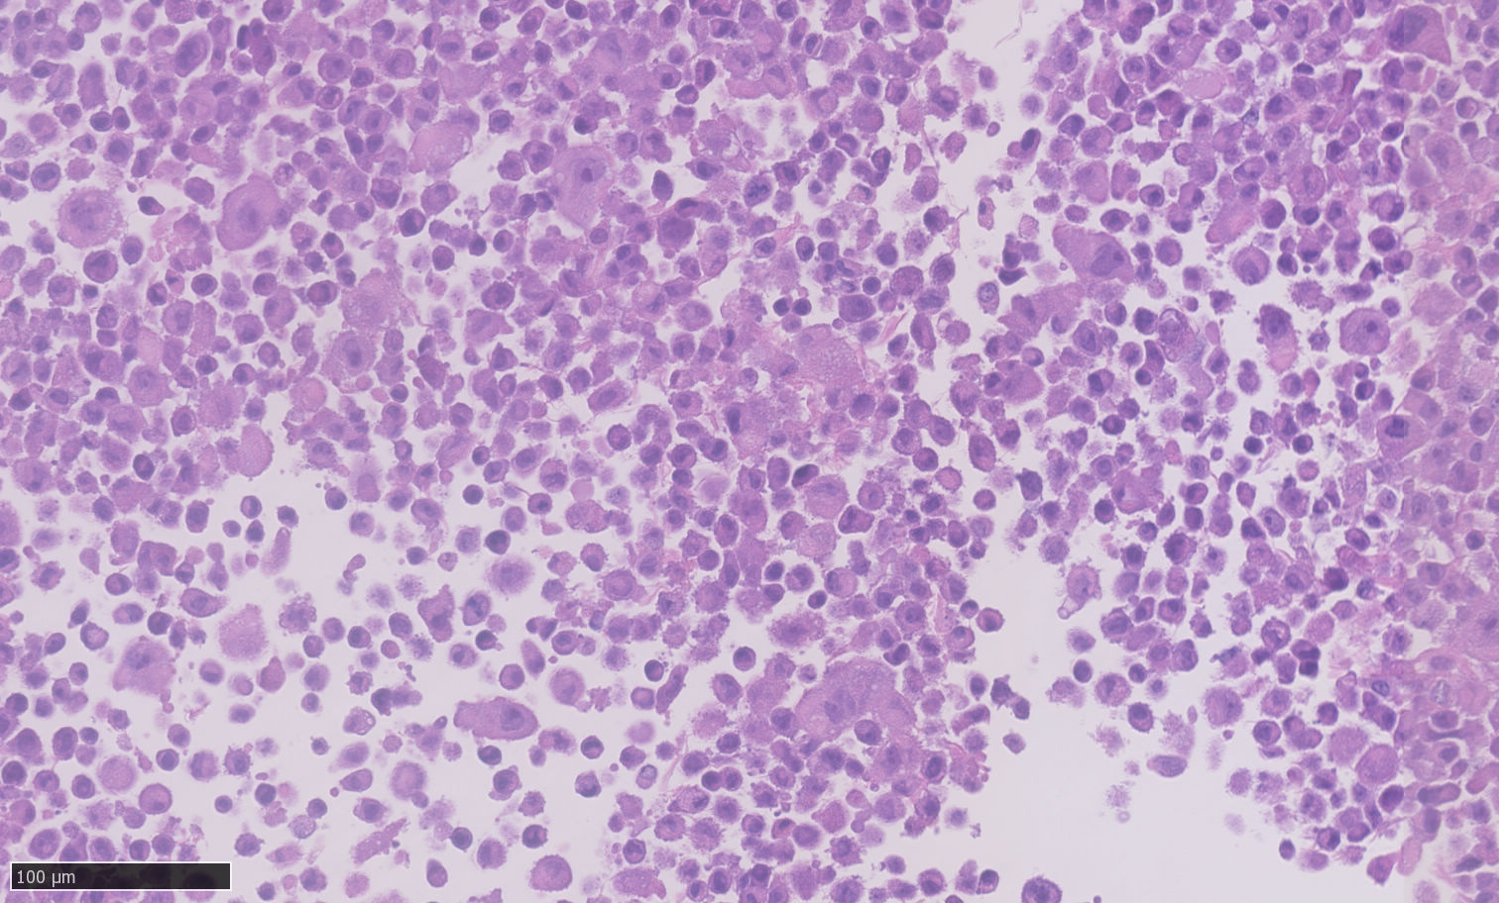

Meningeal tumor cells from monolayer culture coalesced in fibrin clots with single tumor cells exhibiting some variation in shape, size, and nuclear morphology (insert).

3D
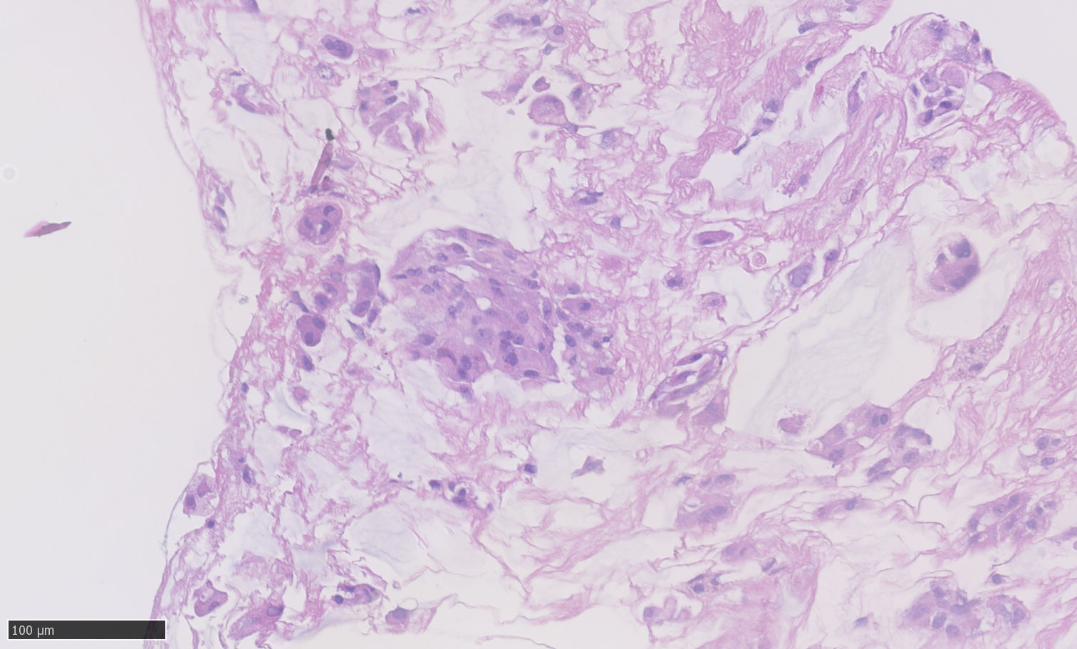

Meningeal tumor cells from 3D culture medium where organoids fragmented upon retrieval from the culture. Cells were coalesced in fibrin clots and individual tumor cells exhibit a rounded to slightly elongated morphology (insert).

MEN-39
HE
Primær tumor
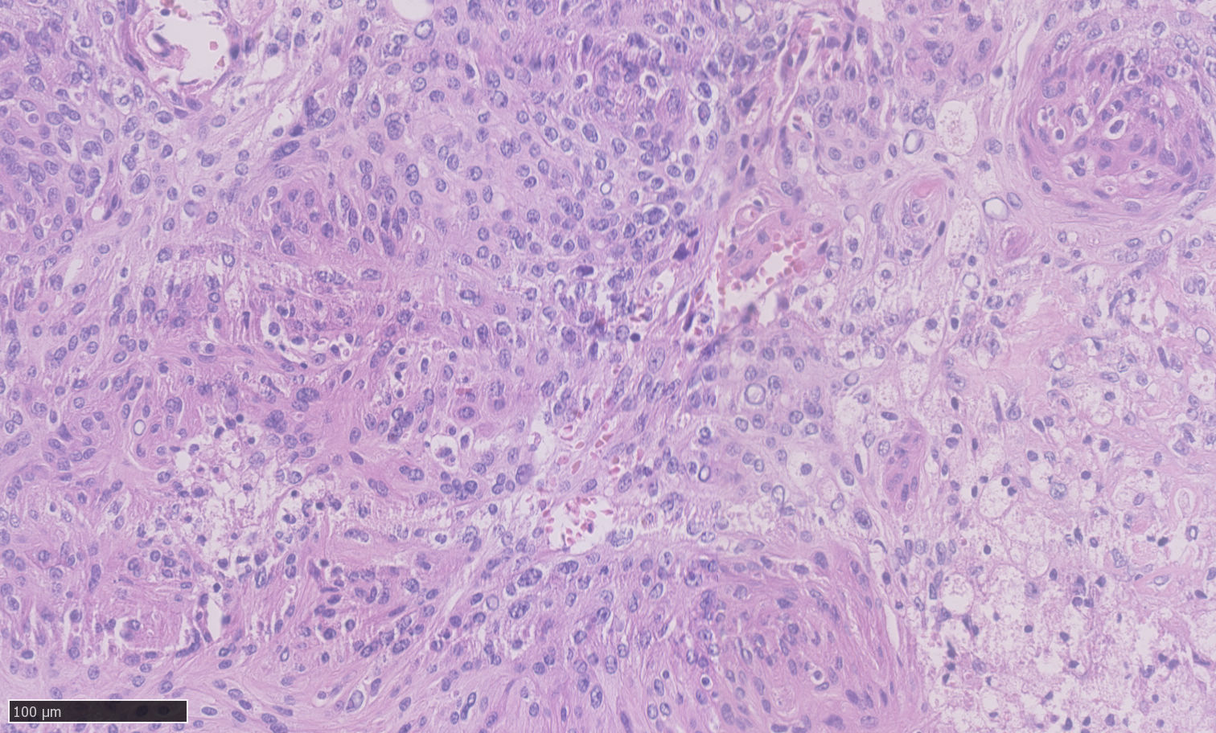

Meningothelial meningioma grade 1 with a whorled architecture, thin collagen septa, and focal clear cell appearing morphology. The tumor cells are blunt to spindle shaped with small oval nuclei some with nucleoli (insert). Some nuclei have pseudoinclusions.

2D
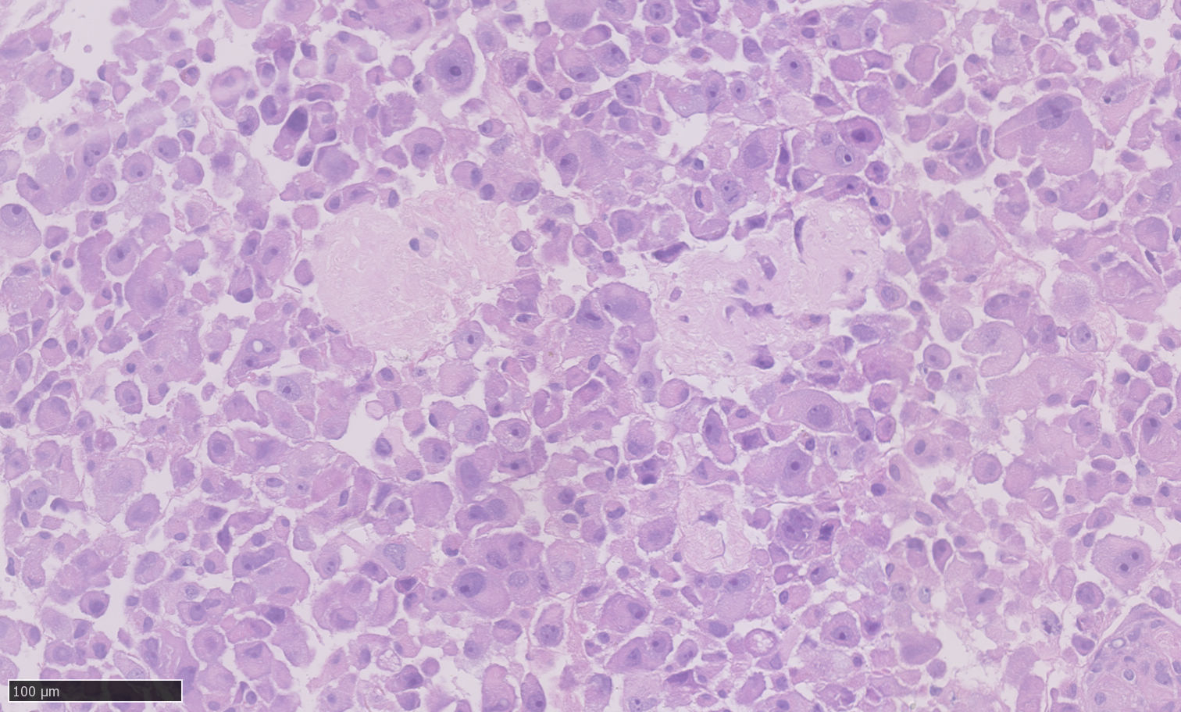

Meningeal tumor cells from monolayer culture coalesced in fibrin clots with single tumor cells exhibiting variation in shape, size, and nuclear morphology (insert), some nuclei have quite prominent nucleoli.

3D
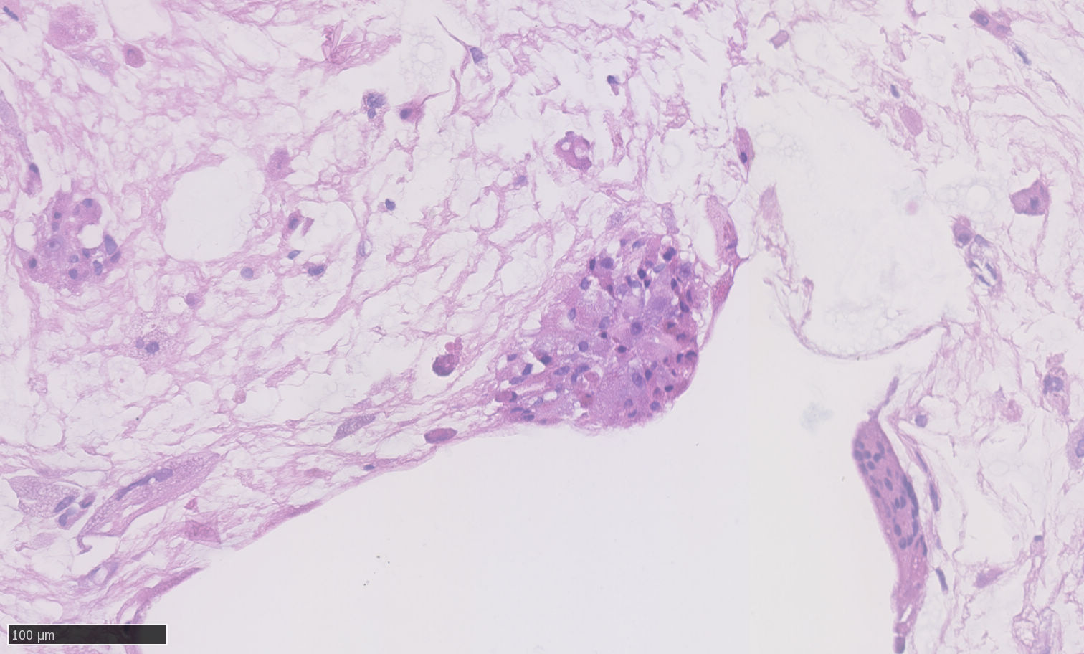

Meningeal tumor cells from 3D culture medium where organoids fragmented upon retrieval from the culture. Cells were coalesced in fibrin clots and individual tumor cells exhibit a rounded (insert) or slightly elongated morphology. The growth pattern somewhat resembles the primary tumor, however, there are no nuclear pseudoinclusions.

MEN-40
HE
Primær tumor
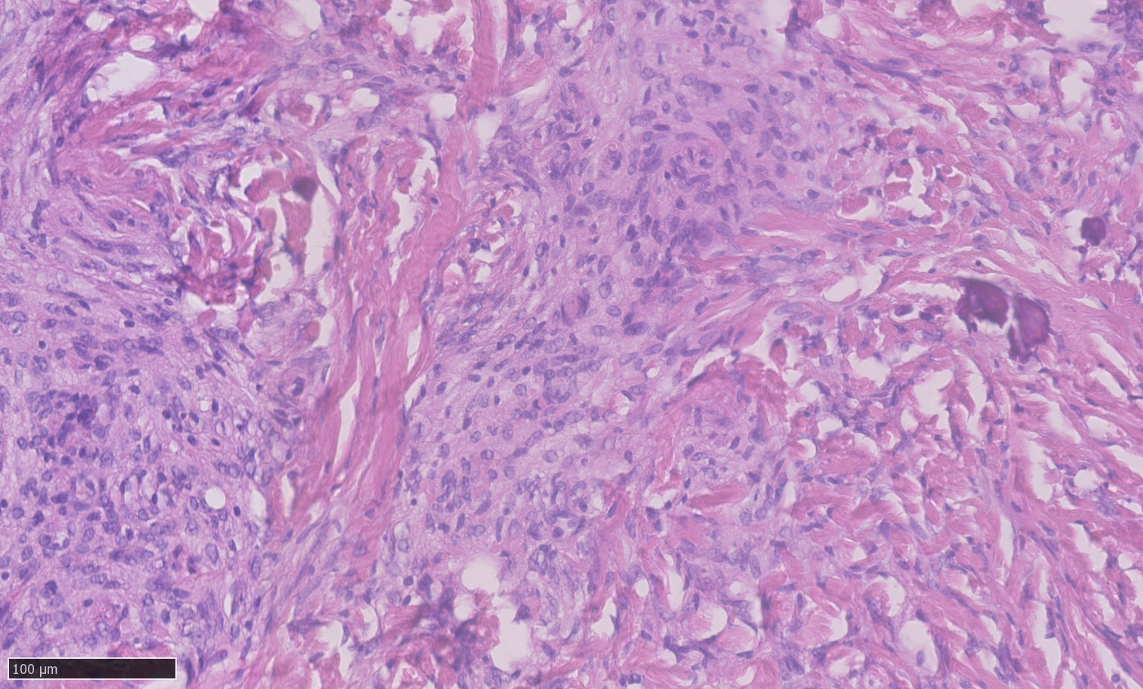
Resultat: Fibrous Grade 2

Fibrous meningioma grade 2 with a lobular to fascicular architecture where tumor cells are intermixed with collagen septa (insert). The tumor cells are blunt to spindle shaped with oval to irregular nuclei some with pseudoinclusions.

2D
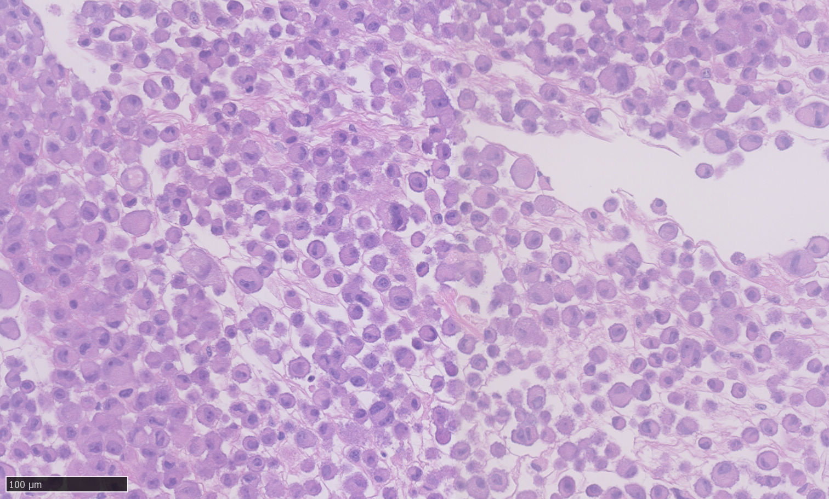
Meningeal tumor cells from monolayer culture coalesced in fibrin clots with single tumor cells exhibiting variation in shape, size, and nuclear morphology (insert), some nuclei have quite prominent nucleoli.

3D
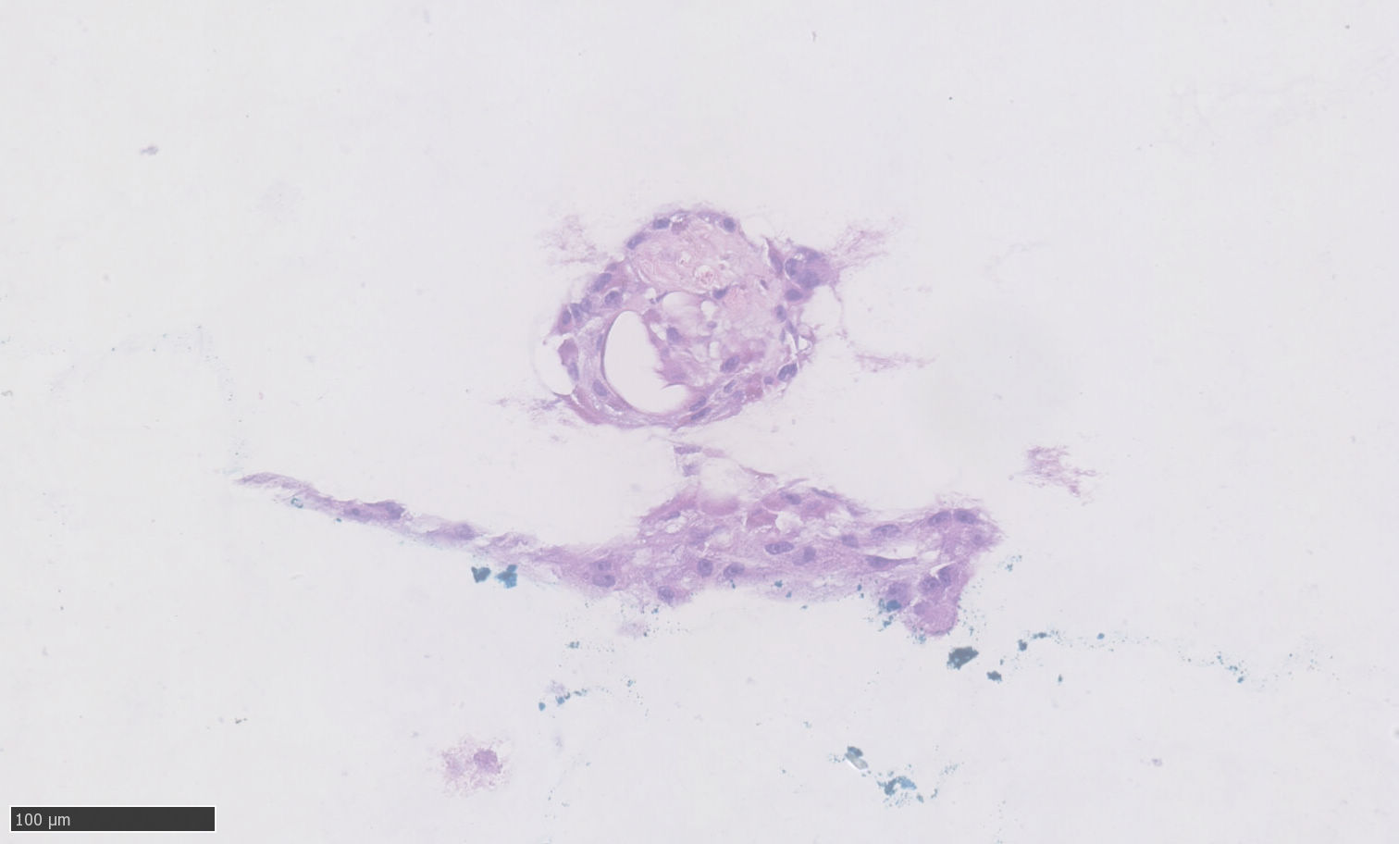
Meningeal tumor cells from 3D culture medium where organoids fragmented upon retrieval from the culture. Cells were coalesced in fibrin clots. Cells are few and individual tumor cells exhibit a rounded or irregular morphology (insert).

MEN-41
HE
Primær tumor
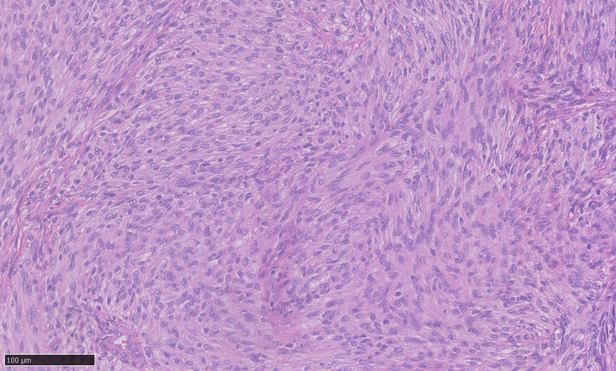
Resultat: Fibrous grade 1

Fibrous meningioma grade 1 with a fascicular growth pattern and tumor cells in a fibrous collagen matrix (insert). The tumor cells are spindle shaped with oval nuclei varying only little in size.

2D
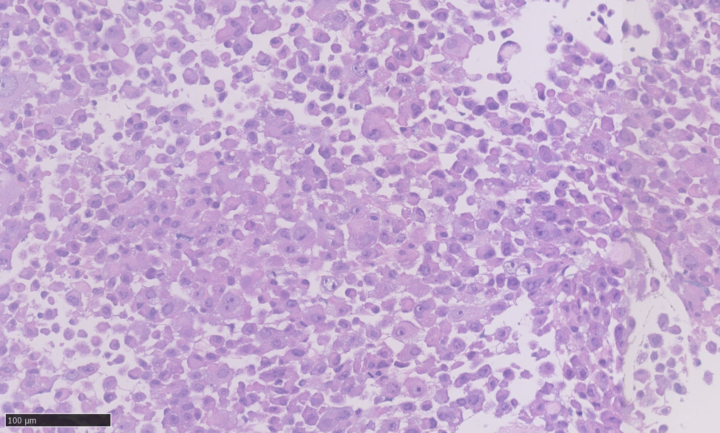
Meningeal tumor cells from monolayer culture coalesced in fibrin clots with single tumor cells exhibiting variation in shape, size, and nuclear morphology (insert), some nuclei have quite prominent nucleoli.

3D
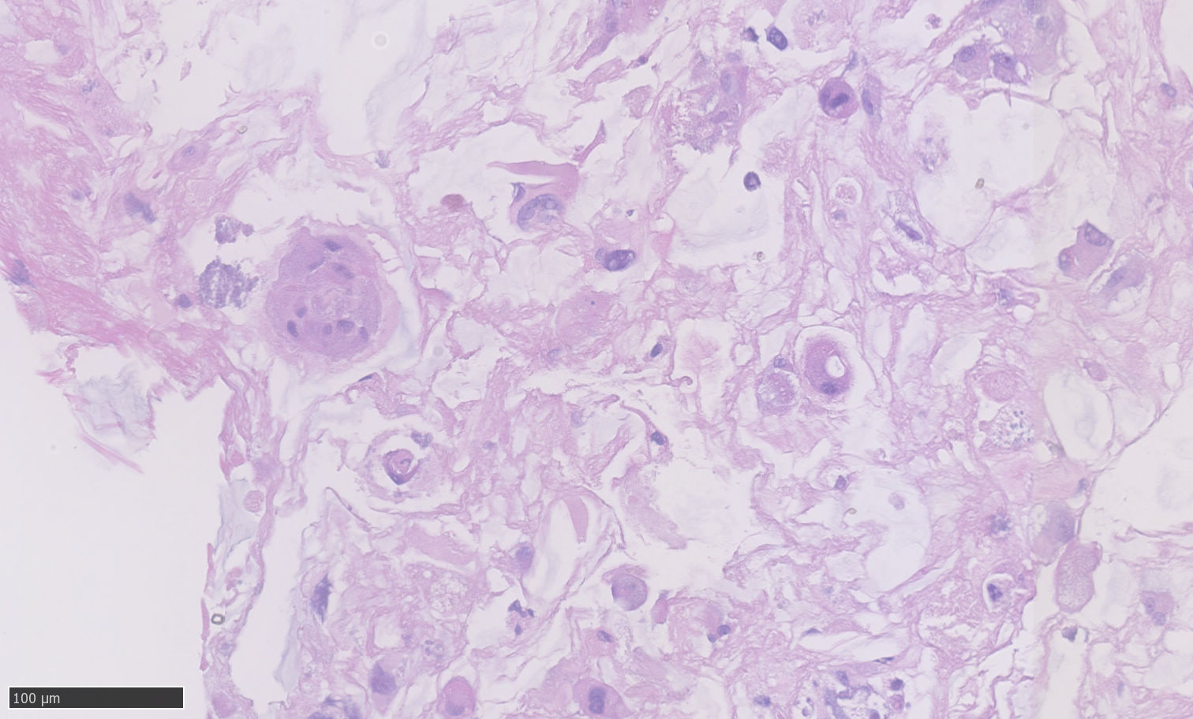

Meningeal tumor cells from 3D culture medium where organoids fragmented upon retrieval from the culture. Cells were coalesced in fibrin clots. The growth pattern is more whorled than in the primary tumor and the collagen matrix is absent. Individual tumor cells exhibit a rounded to irregular morphology (insert).

MEN-42
HE
Primær tumor
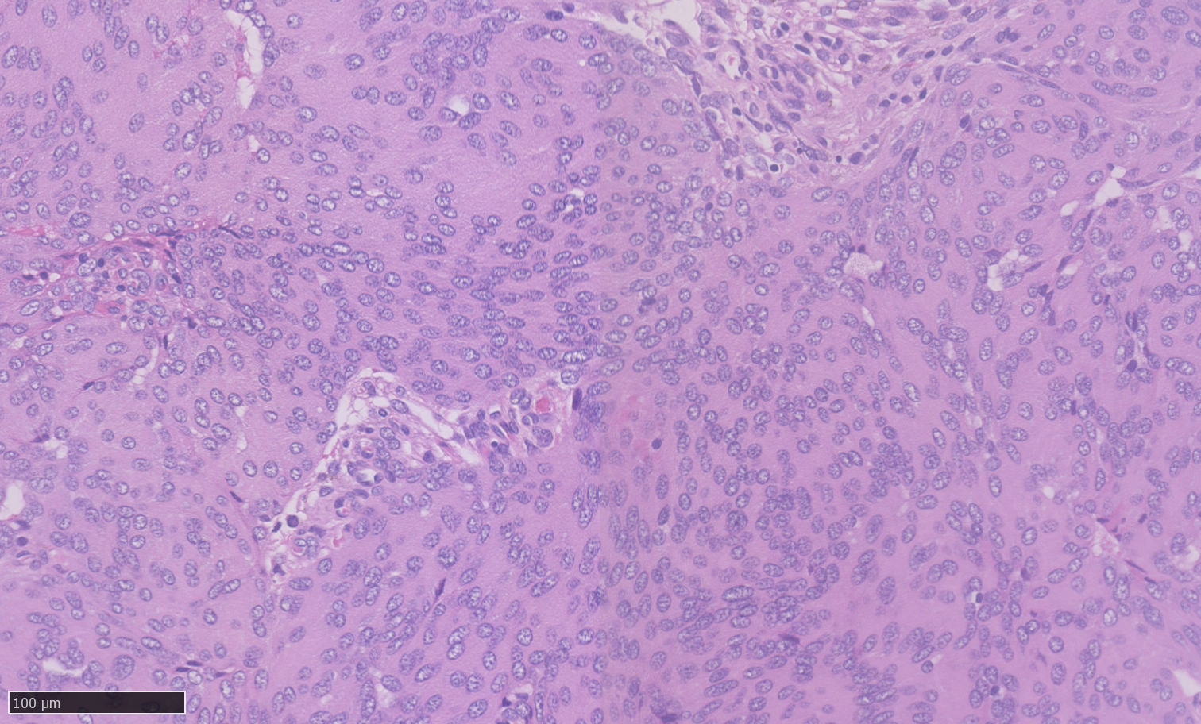
Resultat: Meningothelial Grade 1

Meningothelial meningioma grade 1 with a lobulated architecture. The tumor cells have abundant syncytia-like cytoplasm with small oval nuclei and indistinct nucleoli (insert).

2D
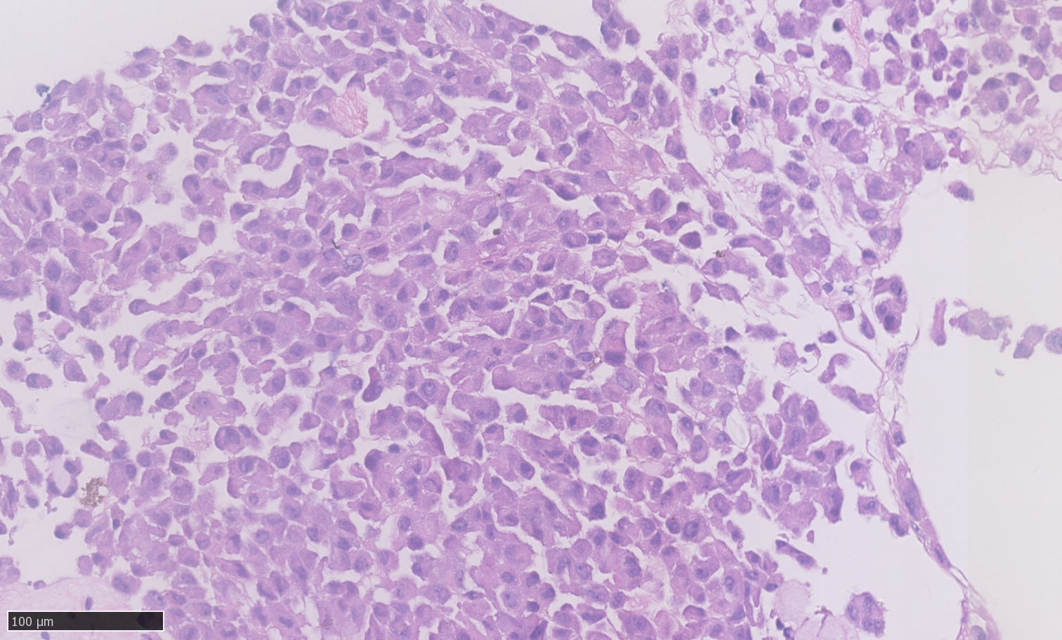

Meningeal tumor cells from monolayer culture coalesced in fibrin clots with single tumor cells exhibiting variation in shape, size, and nuclear morphology (insert), few nuclei have prominent nucleoli.

3D
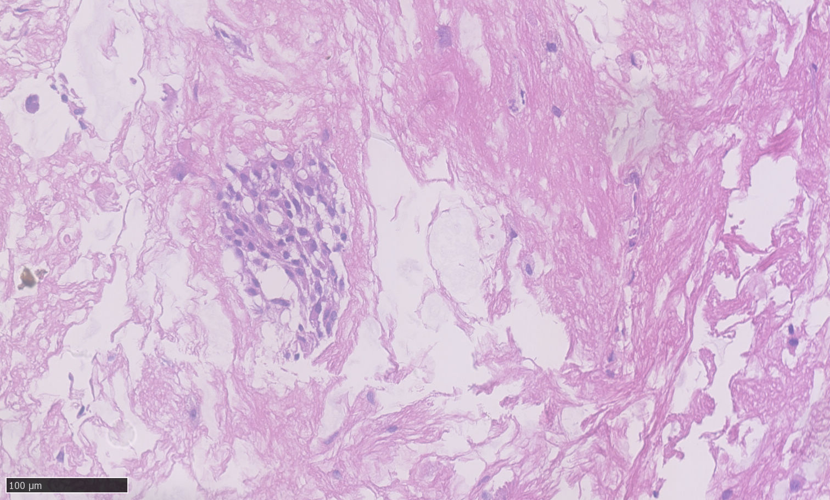

Meningeal tumor cells from 3D culture medium where organoids fragmented upon retrieval from the culture. Cells were coalesced in fibrin clots. Tumor cells form strands and exhibit an elongated morphology (insert). The nuclei are oval and quite uniform in shape and size.

