Supplementary Information
Therapeutic Potential of NGF-enriched Extracellular Vesicles in Modulating Neuroinflammation and Enhancing Peripheral Nerve Remyelination
Hancheol Yeo¹, Yoo Jung Kim¹, Jaekwon Seok¹, Yeonjoo Kwak¹, Soo Bin Jang¹, Na Hee Lim¹, Kwonwoo Song², Junghoon Lee³, Min Chul Cho³, and Ssang-Goo Cho^{1,}*

¹Department of Stem Cell and Regenerative Biotechnology, School of Advanced Biotechnology, Molecular & Cellular Reprogramming Center, Institute of Advanced Regenerative Science, and Institute of Health, Aging & Society, Konkuk University, Seoul 05029, Republic of Korea
²R&D Team, StemExOne Co., Ltd., Gwangjin-gu, Seoul 05029, Republic of Korea
³Department of Urology, Seoul National University Seoul Metropolitan Government Boramae Medical Center, Seoul National University College of Medicine, Seoul 07061, Republic of Korea

Hancheol Yeo, Yoo Jung Kim, and JaeKwon Seok have contributed equally to this work.
* Correspondence: ssangoo@konkuk.ac.kr; Tel.: +82-2-450-4207; Fax: +82-2-450-4207

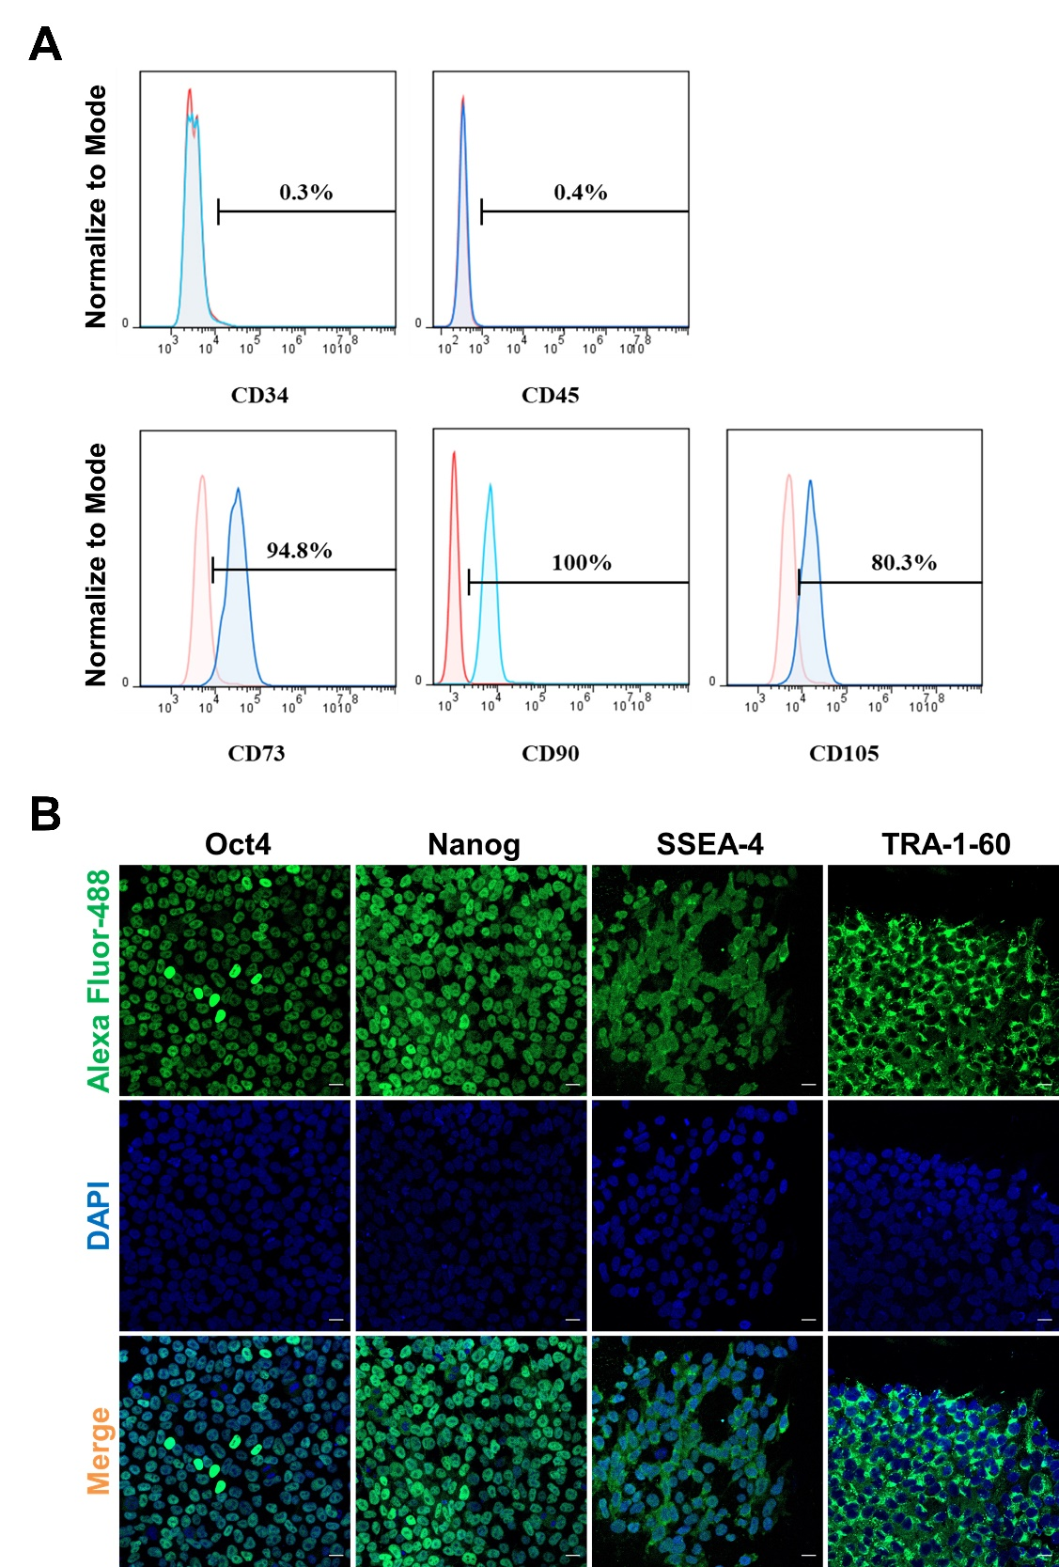
Supplementary Figure 1. USCs and UiPSCs characterization
(A) FACS analysis was performed to measure the expression of CD34, CD45, CD73, CD90, and CD105 in USCs. (B) Fluorescence microscopy images of UiPSCs immunostained for Oct4, Nanog, SSEA-4, and TRA-1-60. Scale bar = 20 μm.

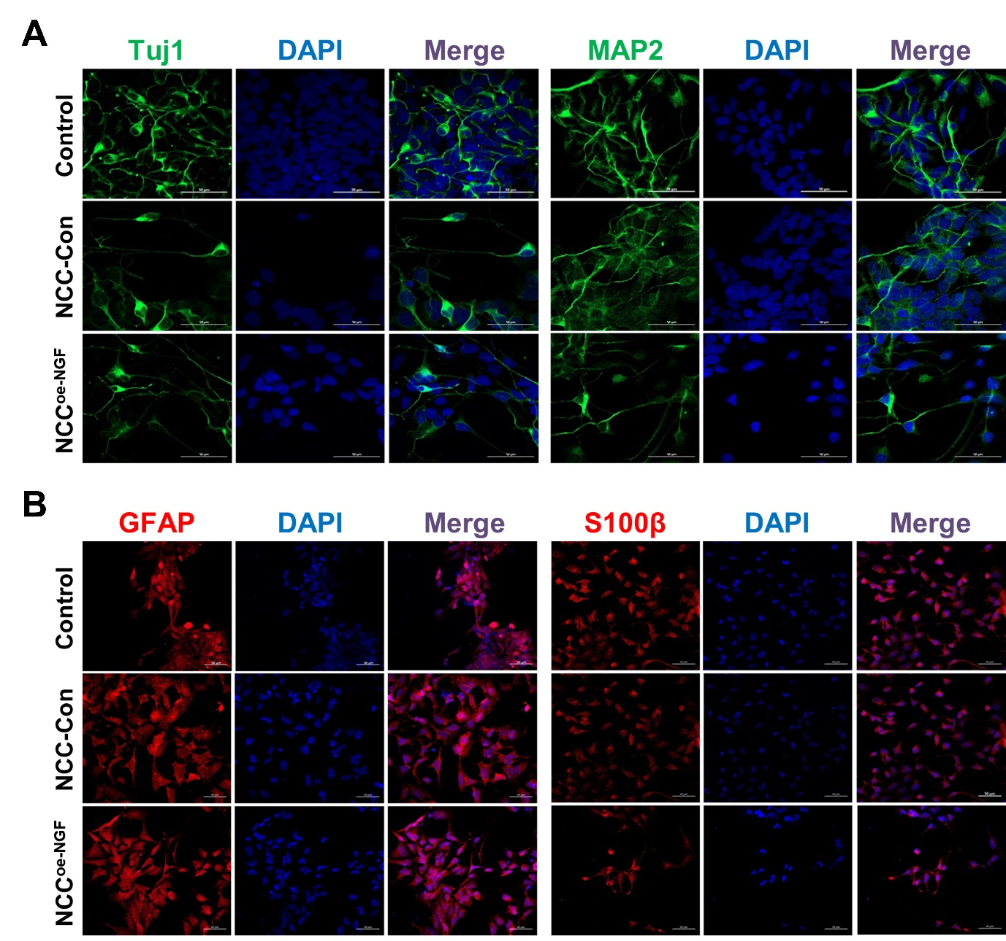
Supplementary Figure 2. Characterization of neural crest cells generated from NGF overexpressed UiPSC lines
(A) Fluorescence microscopy images of terminally differentiated NCCs in neurons immunostained for Tuj1 and MAP2. Scale bar = 50 μm. (B) Fluorescence microscopy images of terminally differentiated NCCs into Schwann cells immunofluorescence stained with GFAP and S100β. Scale bar = 50 μm. NCC, neural crest cell; UiPSC, urine-derived pluripotent stem cell

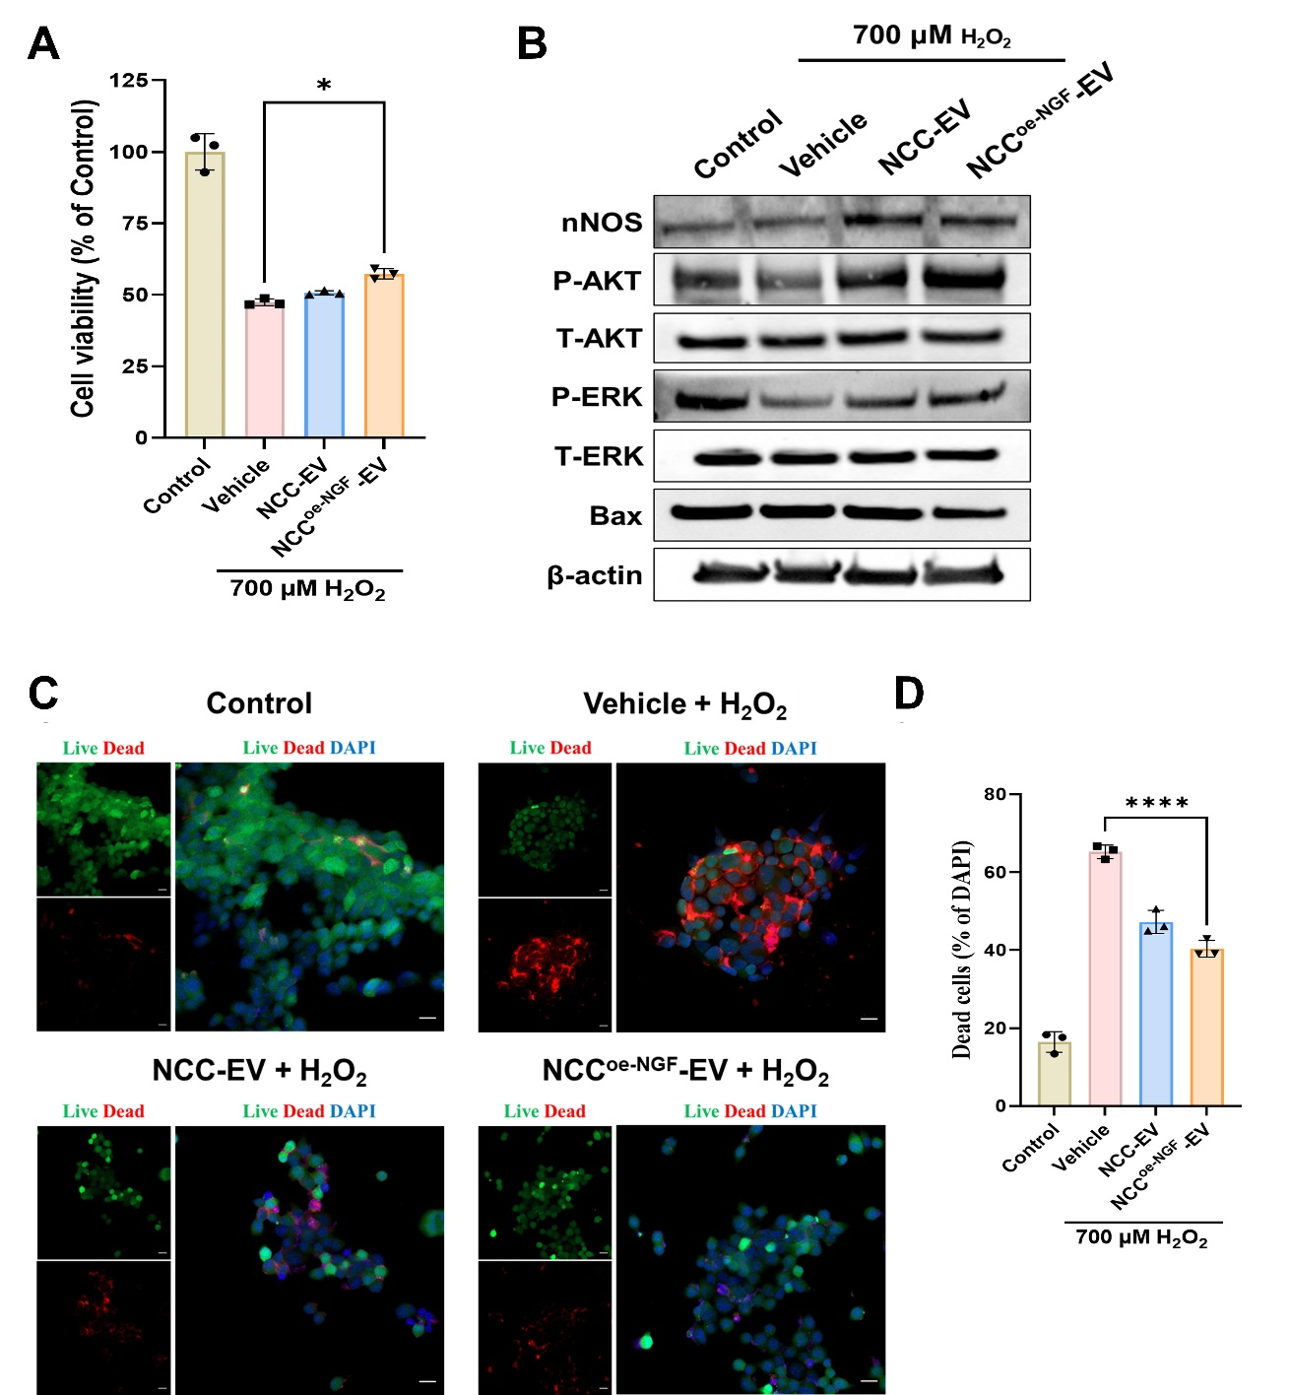
Supplementary Figure 3. NCC^{oe-NGF}-EVs protect H₂O₂-induced oxidative stress nerve cells apoptosis.
(A) The SH-SY5y cells were pretreated with NCC-EV and NCC^{oe-NGF}-EV for 6 h and 700 μM of H₂O₂ treatment for 6 h then the viability of cells was measured using CellRix. One‑way ANOVA followed by Tukey’s post‑hoc test. All values are shown as mean ± SD (n = 3). * P < 0.05 (B) Live/dead image using fluorescence microscopy which shows live cells with green and dead cells with red after 6 h EV pre-treatment and further 6 h H₂O₂ treatment. Scale bar = 10 μm (C) Graph showing dead cell percentage of each group in the live/dead image compared to control group. One‑way ANOVA followed by Tukey’s post‑hoc test. All values are shown as mean ± SD (n = 3). * P < 0.05, **** P < 0.0001 (D) The protein expression level of nNOS, P-AKT, T-AKT, P-ERK, T-ERK, Bax, and β-actin was measured by western blot in each group.
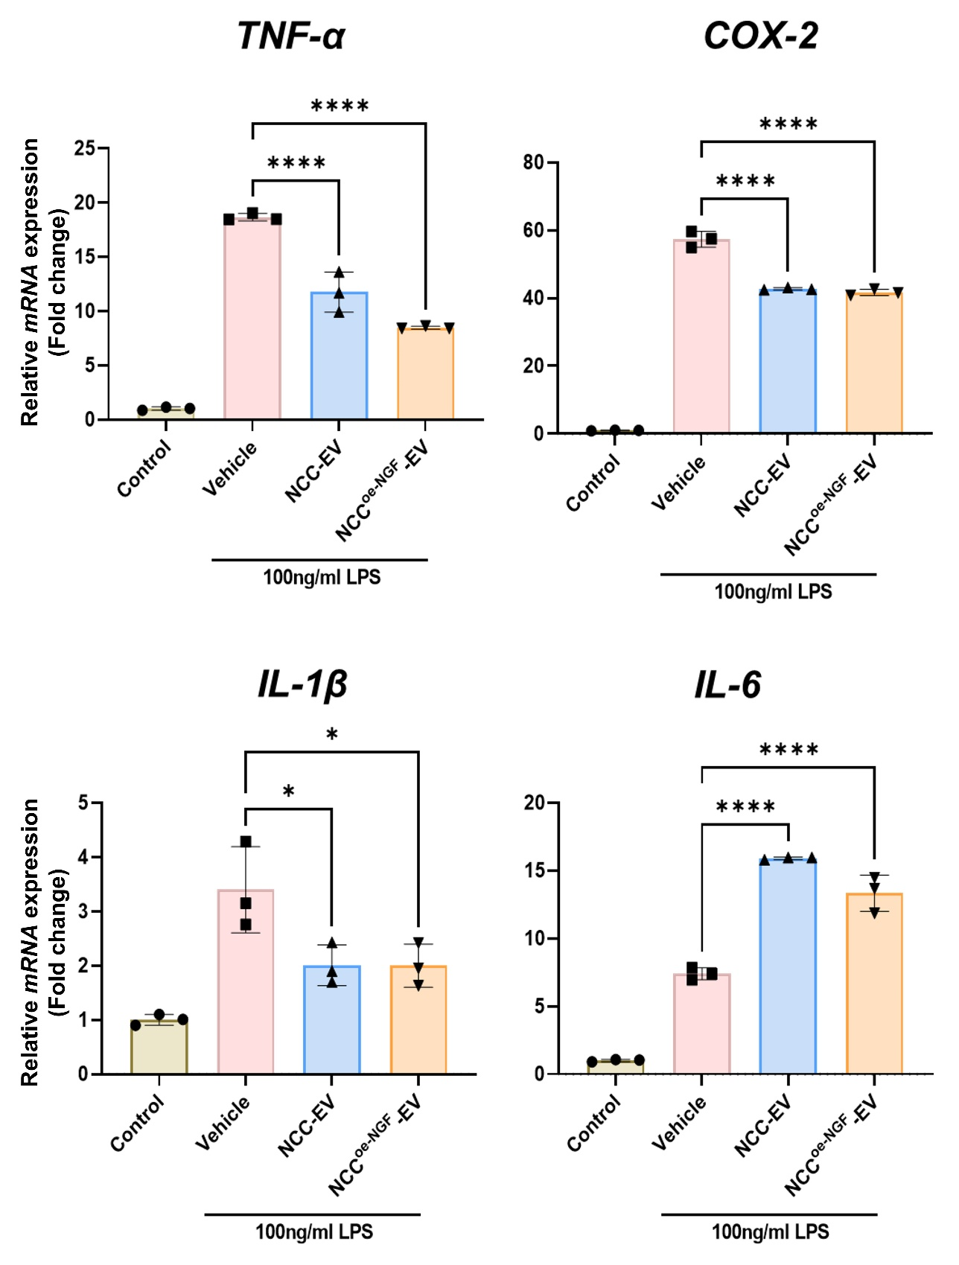
Supplementary Figure 4. NCC^{oe-NGF}-EVs attenuate LPS-induced neuronal inflammation gene expression
RT-qPCR was used to measure the expression of pro-inflammatory genes (TNF-α, COX-2, IL-1β, and IL-6). The relative gene expression levels were analyzed in triplicate and normalized to endogenous GAPDH. One‑way ANOVA followed by Tukey’s post‑hoc test. All values are shown as mean ± SD (n = 3). * P < 0.05, **** P < 0.0001
Supplementary Table 1. List of primer sequences used in RT-qPCR and RT-PCR
Method | Primer | Sequence (5ʹ → 3ʹ) | Accession No.
RT-PCR | hGAPDH forward | AAT CCC ATC ACC ATC TTC CAG | NM_001256799
RT-PCR | hGAPDH reverse | CAC GAT ACC AAA GTT GTC ATG | NM_001256799
RT-PCR | hNGF forward | TCA TCA TCC CAT CCC ATC TTC CAC | NM_002506
RT-PCR | hNGF reverse | ACA CAG GCC GTA TCT ATC CGG ATA | NM_002506
RT-qPCR | hGAPDH forward | GTC TCC TCT GAC TTC AAC AGC G | NM_002046
RT-qPCR | hGAPDH reverse | ACC ACC CTG TTG CTG TAG CCA A | NM_002046
RT-qPCR | hOct4 forward | CCT GAA GCA GAA GAG GAT CAC C | NM_002701
RT-qPCR | hOct4 reverse | AAA GCG GCA GAT GGT CGT TTG G | NM_002701
RT-qPCR | hSOX2 forward | GCT ACA GCA TGA TGC AGG ACC A | NM_003106
RT-qPCR | hSOX2 reverse | TCT GCG AGC TGG TCA TGG AGT T | NM_003106
RT-qPCR | hNGF forward | GGC AGA CCC GCA ACA TTA CT | NM_002506
RT-qPCR | hNGF reverse | CAC CAC CGA CCT CGA AGT C | NM_002506
RT-qPCR | hSOX10 forward | ATG AAC GCC TTC ATG GTG TGG G | NM_006941
RT-qPCR | hSOX10 reverse | CGC TTG TCA CTT TCG TTC AGC AG | NM_006941
RT-qPCR | hAP2α(TFAP2A) forward | GAC CTC TCG ATC CAC TCC TTA C | NM_003220
RT-qPCR | hAP2α(TFAP2A) reverse | GAG ACG GCA TTG CTG TTG GAC T | NM_003220
RT-qPCR | hp75^{NTR} forward | CCT CAT CCC TGT CTA TTG CTC C | NM_002507
RT-qPCR | hp75^{NTR} reverse | GTT GGC TCC TTG CTT GTT CTG C | NM_002507
RT-qPCR | hPAX3 forward | GGC TTT CAA CCA TCT CAT TCC CG | NM_181459
RT-qPCR | hPAX3 reverse | GTT GAG GTC TGT GAA CGG TGC T | NM_181459
RT-qPCR | mGAPDH forward | CAT CAC TGC CAC CCA GAA GAC TG | NM_008084
RT-qPCR | mGAPDH reverse | ATG CCA GTG AGC TTC CCG TTC AG | NM_008084
RT-qPCR | mTNF-α forward | GGT GCC TAT GTC TCA GCC TCT T | NM_013693
RT-qPCR | mTNF-α reverse | GCC ATA GAA CTG ATG AGA GGG AG | NM_013693
RT-qPCR | mCOX-2 forward | GCG ACA TAC TCA AGC AGG AGC A | NM_011198
RT-qPCR | mCOX-2 reverse | AGT GGT AAC CGC TCA GGT GTT G | NM_011198
RT-qPCR | mIL-1β forward | ACT GGA GAT TTG GCA ACA GG | NM_008361
RT-qPCR | mIL-1β reverse | GTG TAG GGG TGG AGA CCA GA | NM_008361
RT-qPCR | mIL-6 forward | AGT TGC CTT CTT GGG ACT GA | NM_031168
RT-qPCR | mIL-6 reverse | TCC ACG ATT TCC CAG AGA AC | NM_031168
RT-qPCR | mBDNF forward | GGC TGA CAC TTT TGA GCA CGT C | NM_007540
RT-qPCR | mBDNF reverse | CTC CAA AGG CAC TTG ACT GCT G | NM_007540
RT-qPCR | mNT-3 forward | CTA CTA CGG CAA CAG AGA CGC T | NM_001164034
RT-qPCR | mNT-3 reverse | GGT GAG GTT CTA TTG GCT ACC AC | NM_001164034

Supplementary Table 2. List of primary antibodies used in western blotting
Antibody List | Cat.No | Company | Dilution
Oct3/4 | SC-5279 | Santa Cruz Biotec. Biotec. | 1:1000
SOX2 | SC-20088 | Santa Cruz Biotec. Biotec. | 1:1000
NGF | A13922 | ABclonal | 1:1000
β-actin | SC-74403 | Santa Cruz Biotec. Biotec. | 1:1000
CD9 | ab263023 | Abcam | 1:1000
CD63 | ab109201 | Abcam | 1:1000
CD9 | ab263023 | Abcam | 1:1000
GM130 | 12480 | Santa Cruz Biotec. Biotec. | 1:1000
Calnexin | 2679 | Cell Signaling Technology | 1:1000
P-ERK | CSB-PA000749 | Cusabio | 1:1000
T-ERK | B7074 | Tebu-bio | 1:1000
P-AKT | #9271 | Cell Signaling Technology | 1:1000
T-AKT | #9272 | Cell Signaling Technology | 1:1000
βIII-tubulin (Tuj1) | #5666 | Cell Signaling Technology | 1:200
NF-H | A19084 | Cell Signaling Technology | 1:1000
nNOS | 4234 | Cell Signaling Technology | 1:1000
BAX | 2772 | Cell Signaling Technology | 1:1000
P-JNK | SC-6254 | Santa Cruz Biotec. Biotec. | 1:1000
P-NF-κB | #3033 | Cell Signaling Technology | 1:1000
T-NF-κB | #8242 | Cell Signaling Technology | 1:1000
p75^{NTR} | #8238 | Cell Signaling Technology | 1:1000
GAP43 | A19055 | ABclonal | 1:1000
TNF-a | SC-133192 | Santa Cruz Biotec. Biotec. | 1:1000
Iba-1 | PA5-27436 | Invitrogen | 1:1000
COX-2 | SC-7951 | Santa Cruz Biotec. Biotec. | 1:1000

Supplementary Table 3. List of primary antibodies used in immunocytochemistry and immunohistochemistry
Antibody List | Cat.No | Company | Dilution
Oct3/4 | SC-5279 | Santa Cruz | 1:500
Nanog | SC-33759 | Santa Cruz | 1:500
SSEA-4 | SC-21704 | Santa Cruz | 1:500
TRA-1-60 | SC-21705 | Santa Cruz | 1:500
Nestin | #656801 | Invitrogen | 1:500
SOX10 | PA5-40697 | Invitrogen | 1:500
PAX6 | SC-32766 | Santa Cruz | 1:500
Ap2a | C83E10 | Cell Signaling Technology | 1:500
βIII-tubulin (Tuj1) | #5666 | Cell Signaling Technology | 1:200
Iba-1 | PA5-27436 | Invitrogen | 1:500
F-actin | MA1-80729 | Cell Signaling Technology | 1:500
NF-H | A19084 | Cell Signaling Technology | 1:200
MBP | A1664 | ABclonal | 1:200
Cleaved caspase-3 | #9661 | Cell Signaling Technology | 1:200
MAP2 | #4542 | Cell Signaling Technology | 1:500
GFAP | A19058 | ABclonal | 1:500
S100β | A19108 | ABclonal | 1:500

