Relationship Between Cerebral Small Vessel Disease and Proteinopathies in the Medial Temporal Lobe: Supplementary Material

Supplementary Table 1. Number of excluded ROIs.

 | Number ROIs excluded (hippocampus) | Number ROIs excluded (parahippocampal cortex) | Number ROIs excluded (amygdala) | Number ROIs excluded (rhinal cortex)
Percentage area of Aβ-plaques | 37 | 30 | 23 | 24
Percentage area of cortical CAA | 33 | 29 | 24 | 26
Density of tau-tangles | 20 | 19 | 15 | 18
Density of pTDP-43 | 19 | 17 | 18 | 19

The table reports the total number of missing regions of interest (ROIs), summing the number of sections not available for analysis, (because missing or affected by artefacts), and those on which the deep-learning algorithm did not perform adequately (by far the minority).

Supplementary Table 2. Association between CAA and AD-related pathologies in single regions of interest.

 | Aβ-plaques area (%) |  |  |  | Tau-tangles  density (n/mm²) |  |  | pTDP-43 inclusions  density (n/mm²)
Cortical CAA (%) | Estimates | 95% CI | p |  | Estimates | 95% CI | p | Estimates | 95% CI | p
Hippocampal body | 0.18 | 0.56; 2.39 |  | 0.002 | 5.99 | -23.72;35.80 | 0.690 | 14.29 | -38.91; 67.49 | 0.596
AIC/BIC | 460.5/477.1 |  |  |  | 832.4/848.4 |  |  | 963.8/980.0
Observations/total R² | 121/40% |  |  |  | 108/25% |  |  | 111/3%
PHC | 3.28 | 2.40; 4.16 |  | <0.001 | 16.49 | 5.42; 27.65 | <0.001 | 16.21 | -6.37; 38.80 | 0.160
AIC/BIC | 109.0/125.0 |  |  |  | 934.5/950.4 |  |  | 1055.1/1071.3
Observations/total R² | 121/19% |  |  |  | 108/24% |  |  | 114/3%
Amygdala | 4.21 | 2.76; 5.66 |  | <0.001 | 23.10 | -9.82;56.07 | 0.170 | 37.66 | -15.56;90.88 | 0.160
AIC/BIC | 291.8/308.6 |  |  |  | 1017.3/1033.9 |  |  | 1100.3/1116.9
Observations/total R² | 125/38% |  |  |  | 119/46% |  |  | 118/5%
Rhinal Cortex | 4.00 | 2.53; 3.51 |  | <0.001 | 12.92 | 1.25;24.61 | 0.030 | 1.96 | -21.45;25.37 | 0.879
AIC/BIC | 429.9/446.7 |  |  |  | 977.1/993.5 |  |  | 1082.2/1098.5
Observations/total R² | 123/ 44 % |  |  |  | 116 / 33% |  |  | 112 / 2%

Results for cortical CAA % area of linear mixed effects models explaining proteinopathies (Aβ-plaques percentage area, tau-tangles density, pTDP-43 inclusions density). Subject and Braak-stage group were always set as random factors for the intercept, age at death and sex were further fixed-factors. Data represent standardized fixed-effects estimates (Est.) with confidence intervals (CI) and statistical significance. Models were compared using likelihood ratio tests; smaller AIC and BIC values indicate a better model fit. Significant effects are highlighted in bold. Key: AIC = Akaike Information Criterion; BIC = Bayesian Information Criterion; CAA = cerebral amyloid angiopathy.

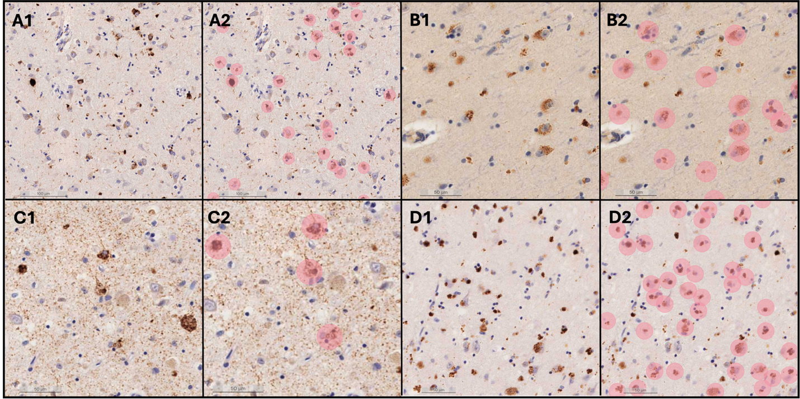

Supplementary Figure 1. Close-up images of histological sections from the MTL of four different ADNC cases on which immunohistochemistry against pTDP-43 was performed. Positive pTDP-43 inclusions visible in A1, B1, C1, and D1 are detected as objects by the AI-based algorithm used for quantification in this work (A2, B2, C2, D2 - in pink).

Supplementary Figure 2. Representation of the regions of interest included in this study. Schematic illustration of the area sampled from coronally cut hemisphere slabs, which included the amygdala and the rhinal cortex (A) and the hippocampal body and the posterior parahippocampal cortex (B). Example of a formalin-fixed coronal slab from the donor of a different autopsy-cohort from which the hippocampal body was sampled (C). Digitized whole-slide sections of the amygdala/rhinal cortex (RC) (D) and hippocampus/posterior parahippocampal gyrus (E) from the same case, on which immunohistochemistry against amyloid-β was performed. The regions of interest (ROIs) on which AI-measures of pathology were assessed are labelled in black. Arteriolosclerosis was assessed in the ROIs labelled in purple. Key: White matter (WM), posterior parahippocampal cortex (PHC), rhinal cortex (RC).

Supplementary Figure 3. Flow chart indicating the selection process of the cases included in this study.

Supplementary Figure 4. Heatmaps showing validation measures of AI-based models. The heatmaps display validation metrics for various deep learning models, showcasing precision, sensitivity, and F1-score for each convolutional neural network (CNN) created using the software Aiforia®. These metrics are averaged across all regions of interest and the three validators, reflecting the model's performance relative to ground truth. Key: False positives (FP), false negatives (FN), precision (TP/[TP+FP]), sensitivity (TP/ [TP +FN]) and F1-score (2 x Precision x Sensitivity/[Precision + Sensitivity]).

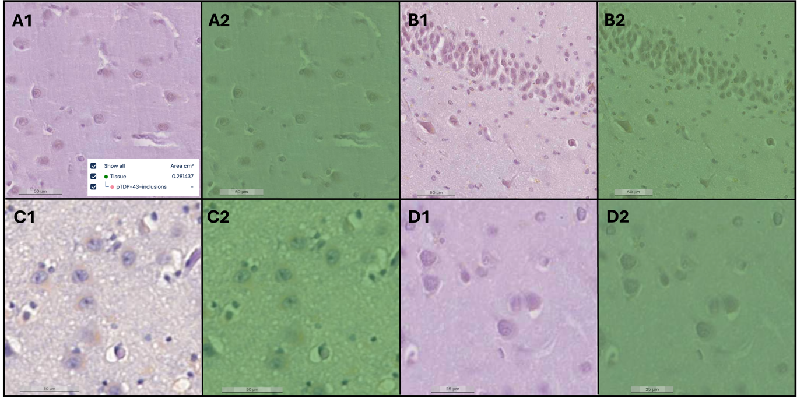
Supplementary Figure 5: Close-up images of histological sections with potential false positives from the MTL of four different ADNC cases on which immunohistochemistry against pTDP-43 was performed (A1, B1, C1, D1). The AI-based algorithm correctly did not identify any pTDP-43 inclusions in these areas (A2, B2, C2, D2). Accurately identified tissue is depicted in green.

Supplementary Figure 6. Validation of the relationship between burden of pathology and stages of disease. The box plots illustrate the Spearman-correlation between AI-based measures of pathology in the medial temporal lobe and stages, that traditionally represent the progression of AD-pathology. Both tau-tangles density and Braak-stage groups, as well as amyloid-β % area and Thal-phase groups were significantly correlated with each other in all regions of interest. Braak-stage groups were defined as follows: 0 = Braak-stage 0; 1 = Braak-stages I/II; 2 = Braak-stages III/IV; 3 = Braak-stages V/VI. Thal-phase groups were defined as follows: 0 = Thal-phase 0; 1 = Thal-phase I/II; 2 = Thal-phase III; 3 = Thal-phase IV/ V. Key: PHC = posterior parahippocampal cortex.

Supplementary Figure 7. Relationship between severity of arteriolosclerosis and AD-related pathologies in the medial temporal lobe. The Forest plots represent results of three linear mixed effects models in which AD-related pathologies were set respectively as dependent variable. The X-axis shows the confidence interval of the estimate of fixed-factors included in the models (arteriolosclerosis, age at death, and sex). Arteriolosclerosis was not significantly associated with any of the proteinopathies but had a tendency towards predicting amyloid-β plaques % area.

