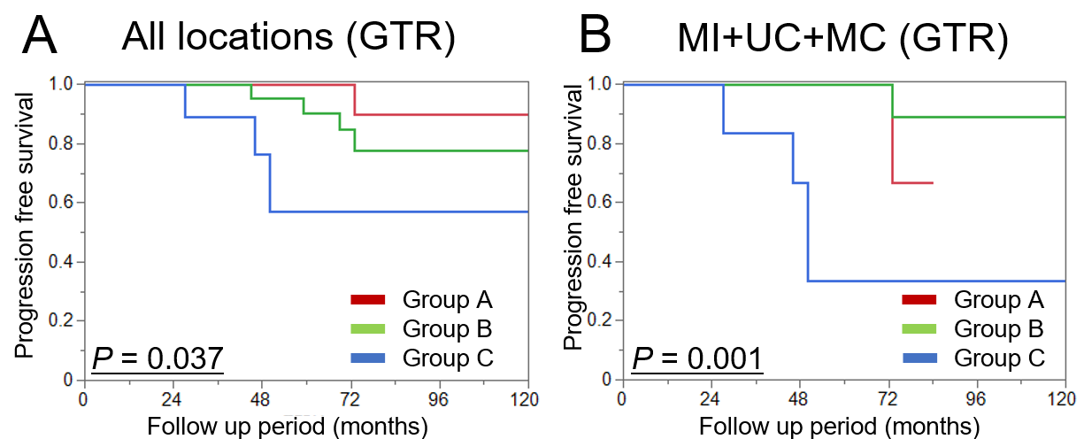
Extended Figure 1. Kaplan–Meier curves for tumor recurrence in posterior fossa meningiomas, stratified into the three molecular classification groups (A, B, and C). A: Patients who underwent gross total resection (GTR), across all anatomical locations. B: Subgroup analysis limited to tumors located in the upper clivus (UC), medial clivus (MC), or medial incisura (MI).

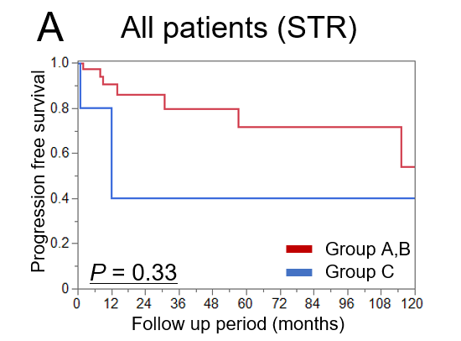
Extended Figure 2. Kaplan–Meier curves for tumor recurrence in posterior fossa meningiomas. A: Subgroup analysis of patients who underwent subtotal resection, stratified by molecular group. STR: subtotal resection.

Extended Table 1. Correlation between pathological subtypes and molecular classification groups
 | Group A (N = 71) | Group B (N = 45) | Group C (N = 16)
Meningothelial | 54 (76%) | 10 (22%) | 8 (50%)
Transitional | 12 (17%) | 14 (31%) | 3 (19%)
Fibrous | 0 | 20 (44%) | 2 (13%)
Psammomatous | 2 (3%) | 1 (2%) | 0
Angiomatous | 0 | 0 | 1 (6%)
Secretory | 1 (1%) | 0 | 0
Atypical | 2 (3%) | 0 | 1 (6%)
Clear cell | 0 | 0 | 1 (6%)

Extended Table 2. Associations between extent of resection, postoperative radiosurgery, and recurrence by molecular classification group
 | Group A (N = 71) | Group B (N = 45) | Group C (N = 16) | P-value
Subtotal resection | 26 (37%) | 14 (31%) | 6 (38%) | 0.809
Postop radiosurgery | 21 (30%) | 8 (18%) | 6 (38%) | 0.213
Recurrence | 9 (13%) | 5 (11%) | 6 (38%) | 0.028*

Extended Table 3. Distribution of driver mutations and CNAs across different anatomical locations.
 | NF2 w/o CNA | NF2 w/ CNA | KLF4/TRAF7 | TRAF7 | AKT1/TRAF7 | POLR2A | AKT1 | Others
Upper clivus | 1  (10%) | 2  (20%) | 1  (10%) | 0 | 3  (30%) | 2  (20%) | 0 | 1  (10%)
Middle clivus | 0 | 2  (18%) | 3  (27%) | 1  (9%) | 3  (27%) | 0 | 0 | 2  (18%)
Foramen magnum | 1  (8%) | 1  (8%) | 0 | 0 | 0 | 2  (17%) | 6  (50%) | 2  (17%)
Anterior petrous | 6  (35%) | 0 | 4  (24%) | 1  (6%) | 0 | 6  (35%) | 0 | 0
Posterior petrous | 18  (86%) | 2  (10%) | 0 | 0 | 0 | 1  (5%) | 0 | 0
Medial incisura | 10  (21%) | 5  (10%) | 4  (8%) | 3  (6%) | 4  (8%) | 9  (19%) | 0 | 13  (27%)
Falco tentorial | 1  (100%) | 0 | 0 | 0 | 0 | 0 | 0 | 0
Lateral tentorial | 2  (100%) | 0 | 0 | 0 | 0 | 0 | 0 | 0
Paramedian | 3  (50%) | 1  (17%) | 0 | 0 | 0 | 0 | 0 | 2  (33%)
Torcular | 4  (80%) | 0 | 0 | 0 | 0 | 0 | 0 | 1  (20%)

Extended Table 4. Distribution of tumor molecular groups across different anatomical locations.
 | Group A | Group B | Group C
Upper and middle clivus | 14  (67%) | 1  (5%) | 6  (29%)
Medial incisura | 31  (65%) | 10  (21%) | 7  (15%)

