Supplementary Information

Telomere-driven senescence accelerates tau pathology, neuroinflammation and neurodegeneration in a tauopathy mouse model.
Debora Palomares¹, Axelle Vanparys^{1,2}, Joana Jorgji¹, Esther Paître¹, Pascal Kienlen-Campard¹*, Nuria Suelves^{1*}
¹Aging and Dementia Group, Cellular and Molecular Division (CEMO), Institute of Neuroscience (IoNS), UCLouvain, Brussels, Belgium.
²Louvain Aging Brain Lab, Clinical Division (NEUR), Institute of Neuroscience (IoNS), UCLouvain, Brussels, Belgium.

*Correspondence to: Nuria Suelves (nuria.suelves@uclouvain.be) and Pascal Kienlen-Campard (pascal.kienlen-campard@uclouvain.be)

Supplementary Figures and Legends
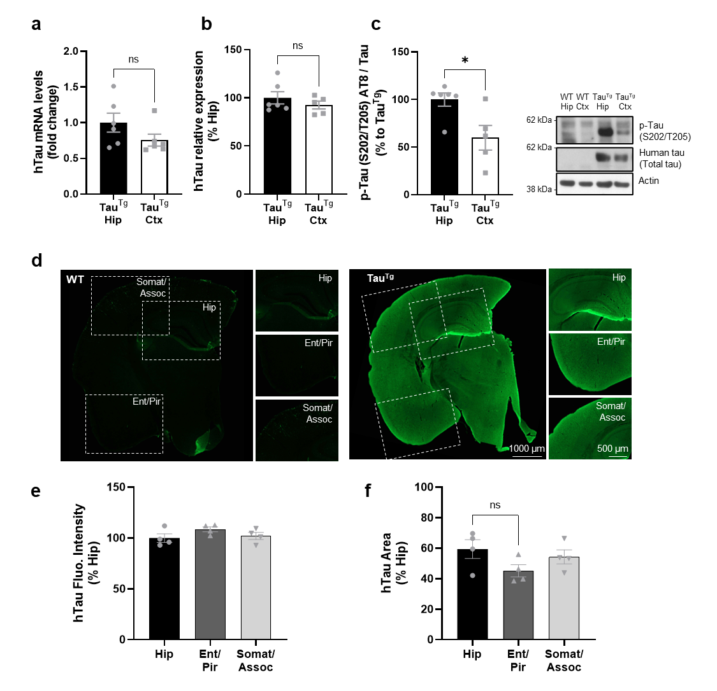
Fig. S1 The expression levels of the P301S human tau transgene remain consistent across different brain regions in 6-month-old Tau^{Tg} (PS19) mice. a mRNA levels of the human tau transgene were measured by RT-qPCR in hippocampal and cortical extracts from 6-month-old Tau^{Tg} mice (n=6 [3 m., 3 f.] per group, paired Student’s t-test). b-c Relative levels of the human tau protein were detected by WB in hippocampal and cortical protein extracts from 6-month-old WT and Tau^{Tg} mice using a total tau antibody (D1M9X clone) (b) and an antibody against pathologically phosphorylated tau (AT8) (c). n=5-6, *P < 0.05, paired Student’s t-test. d-f Immunofluorescence analysis of human tau (Tau13 clone) in the hippocampal, entorhinal/piriform and somatosensory/association cortical regions on brain sections from 6-month-old WT and Tau^{Tg} mice. The relative fluorescence intensity (e) and the percentage of area covered by Tau13 (f) were measured in the Tau^{Tg} brains. (Repeated-measures one-way ANOVA with Geisser-Greenhouse correction, n=4 [2 m., 2 f.] per group).

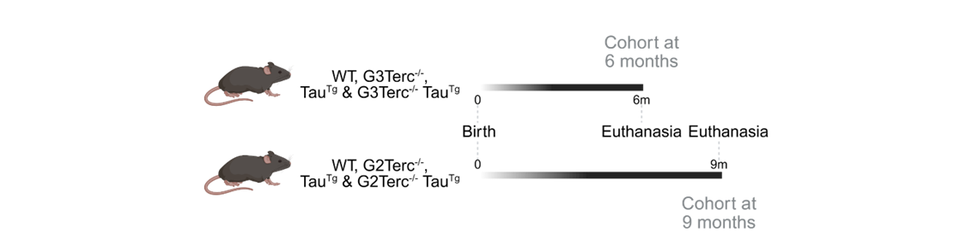
Fig. S2 Schematic representation of the two senescence models and experimental time points used for our study. WT, G3Terc^{-/-}, Tau^{Tg} and G3Terc^{-/-} Tau^{Tg} mice were sacrificed, and their brains collected at 6 months. WT, G2Terc^{-/-}, Tau^{Tg} and G2Terc^{-/-} Tau^{Tg} mice were sacrificed, and their brains collected at 9 months. Created in BioRender. Kienlen-Campard, P. (2025) https://BioRender.com/k4g060o

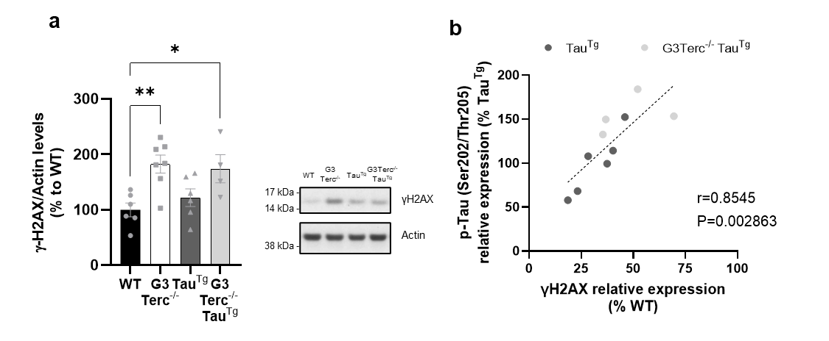
Fig. S3 Senescence-induced DNA damage correlates with pathological tau levels in tauopathy and senescence-tauopathy conditions at 6 months. a Relative levels of the DNA damage biomarker γH2AX detected by WB using hippocampal protein extracts from 6-month-old Tau^{Tg} and G3Terc^{-/-} Tau^{Tg} mice (*P < 0.05, **P < 0.01, One-way ANOVA with Tukey’s post-hoc analysis, n= 4-6 mice/group). b Correlation analysis of γH2AX and hyperphosphorylated tau in 6-month-old Tau^{Tg} and G3Terc-/- Tau^{Tg} mice (Fig. 3a and S3a, Spearman correlation, n=10)

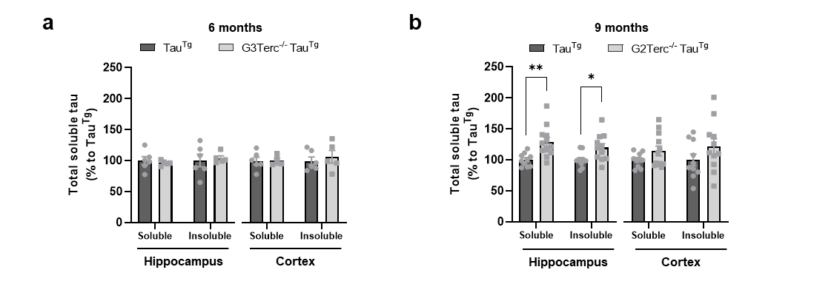
Fig. S4 Total tau levels are significantly increased in a senescent-tauopathy context in relatively aged mice. Quantification of total tau levels after normalization to actin (Fig. 3) in hippocampal and cortical protein extracts of 6-month-old Tau^{Tg} and G3Terc^{-/-} Tau^{Tg} (a) and 9-month-old Tau^{Tg} and G2Terc^{-/-} Tau^{Tg} mice (b). *P < 0.05, **P < 0.01 (Student’s t-test or Mann-Whitney’s test, n= 5-12 mice/group)

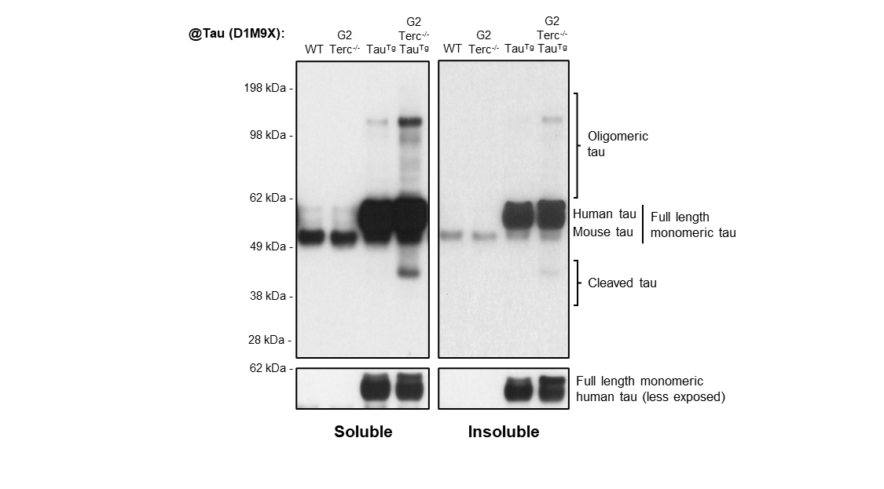

Fig. S5 Lack of truncated and oligomeric tau in non-tauopathy mice. WB analysis of truncated and oligomeric tau levels in soluble and insoluble protein extracts from 9-month-old WT, G2Terc^{-/-}, Tau^{Tg} and G2Terc^{-/-} Tau^{Tg} mouse hippocampi, using a total tau antibody (D1M9X clone). In the absence of mutated human tau (non-tauopathy conditions), there are no visible bands corresponding to truncated or oligomeric tau.

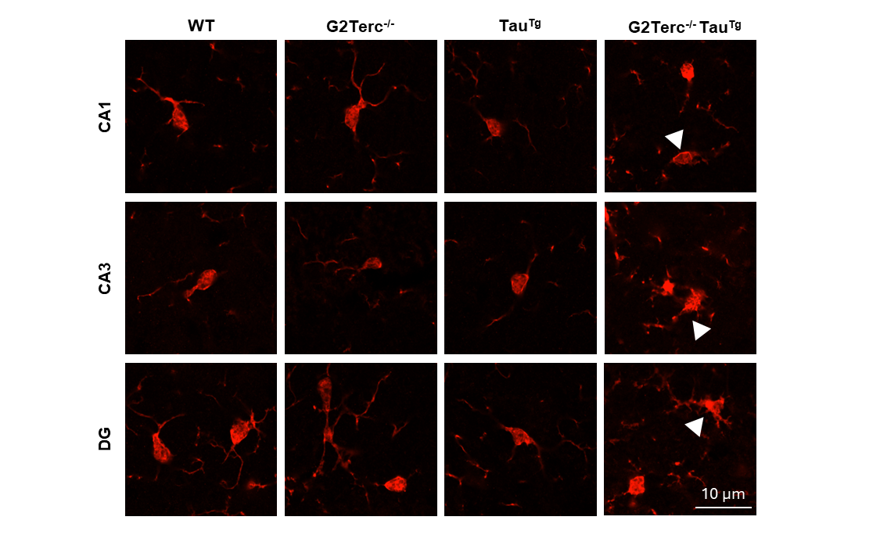
Fig. S6 Dystrophic microglia is observed in G2Terc^{-/-} Tau^{tg} brains. Iba1 (red) immunofluorescence representative images of 9-month-old WT, G2Terc^{-/-}, Tau^{Tg} and G2Terc^{-/-} Tau^{Tg} brains by confocal microscopy. Apparent beading and fragmentation of microglia projections, signs of dystrophic microglia (white arrow heads), were observed exclusively in the G2Terc^{-/-} Tau^{Tg} condition

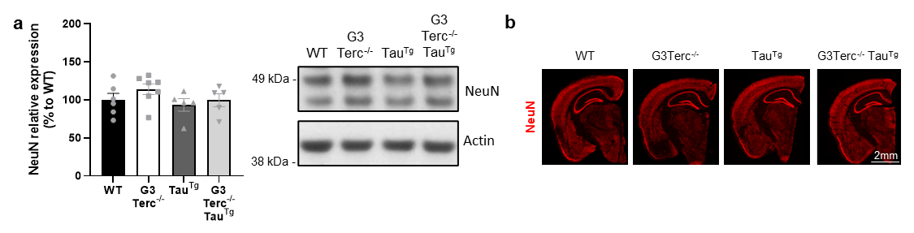
Fig. S7 Senescence does not affect neurodegeneration in G3Terc^{-/-} Tau^{Tg} brains at 6 months. a WB evaluation of NeuN expression in hippocampal extracts from 6-month-old WT, G3Terc^{-/-}, Tau^{Tg} and G3Terc^{-/-} Tau^{Tg} mice. One-way ANOVA with Tukey’s post-hoc analysis, n= 5-6 mice/group. b NeuN immunofluorescence representative images from WT, G3Terc^{-/-}, Tau^{Tg} and G3Terc^{-/-} Tau^{Tg} mice

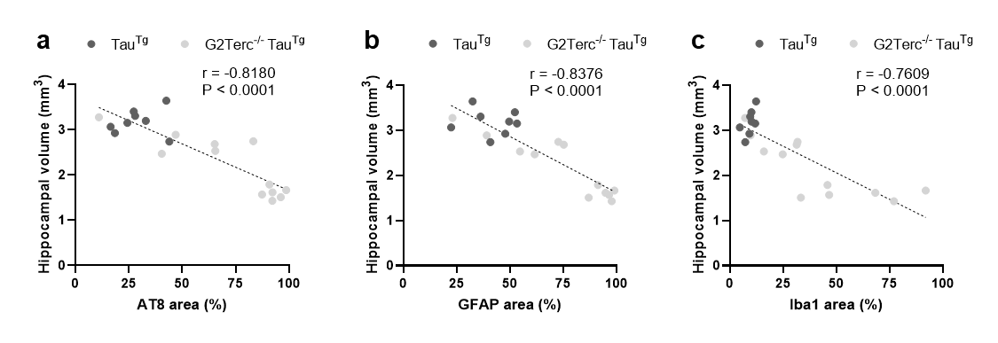
Fig. S8 Pathological tau immunostaining and neuroinflammation negatively correlate with hippocampal volume. a Correlation analysis of the relationship between hyperphosphorylated tau (AT8-positive area) and hippocampal volume (mm³) in 9-month-old Tau^{Tg} and G2Terc^{-/-} Tau^{Tg} mice (Fig. 2 and 8, Spearman correlation, n=20). b-c Correlation analysis of the relationship between hyperphosphorylated tau (AT8 area) and neuroinflammatory markers of astrogliosis (GFAP area) (b) and microgliosis (Iba1 area) (c) in 9-month-old Tau^{Tg} and G2Terc^{-/-} Tau^{Tg} mice (Fig. 2 and 6, Spearman correlation, n=20).

Supplementary Tables
Table S1 Sequences of primers used for quantitative RT-PCR
Target | Forward (5’- 3’) | Reverse (5’- 3’)
Il1b | GCAACTGTTCCTGAACTCAACT | ATCTTTTGGGGTCCGTCAACT
Cxcl1 | AACCGAAGTCATAGCCACAC | GACACCTTTTAGCATCTTTTGG
p19 | CGCAGGTTCTTGGTCACTGT | TGTTCACAGAAGCCAGAGCG
p21 | CCTGGTGATGTCCGACCTG | CCATGAGCGCATCGCAATC
Tbp | GATGTGCGTCAGGCGTTC | GGGTTATCTTCACACACCATGA
Gapdh | ACCCAGAAGACTGTGGATGG | ACACATTGGGGGTAGGAAC
Human Tau | GTCGAAGATTGGGTCCCT | GACACCACTGGCGACTTGTA

Table S2 Information on primary antibodies
Target | Clone | Source | Reference | Application (Dilution)
Actin | Polyclonal | Sigma-Aldrich | A2066 | WB (1:5,000)
AMPKα | Polyclonal | Cell Signaling | 2532 | WB (1:1,000)
CDK5 | J-3 | Santa Cruz Biotechnology | sc-6247 | WB (1:500)
Erk1/2 | 137F5 | Cell Signaling | 4695 | WB (1:1,000)
GFAP | ASTRO6 | Thermo Fisher Scientific | MA5-12023 | WB (1:1,000)
GFAP | Polyclonal | Abcam | ab4674 | IF (1:1,000)
GluR1 | C3T | Sigma-Aldrich | 04-855 | WB (1:5,000)
GSK3β | 27C10 | Cell Signaling | 9315 | WB (1:2,000)
Human Tau | Tau13 | BioLegend | 835201 | IF (1:1,000)
Iba1 | EPR16588 | Abcam | ab178846 | IF (1:500), WB (1:500)
NeuN | Polyclonal | Abcam | ab104225 | IF (1:1,000), WB (1:10,000)
NMDAR2B | 13/NMDAR2B | BD Biosciences | 610417 | WB (1:500)
pAMPKα Thr172 | 40H9 | Cell Signaling | 2535 | WB (1:1,000)
pErk1/2 Thr202/Tyr204 | (D13.14.4E) XP® | Cell Signaling | 4370 | WB (1:1,000)
pGSK3β Tyr216 + pGSK3α Tyr279 | Polyclonal | Abcam | ab75745 | WB (1:1,000)
PSD-95 | Polyclonal | Abcam | ab18258 | WB (1:2,000)
pTau Ser202 + Thr205 | AT8 | ThermoFisher | MN1020 | IF (1:500), WB (1:3,000)
pTau Ser396 + Ser404 | PHF-1 | Peter Davies | / | WB (1:1,000)
pTau Ser422 | Polyclonal | ThermoFisher | 44-764G | WB (1:1,000)
pTau Thr181 | AT270 | ThermoFisher | MN1050 | WB (1:3,000)
pTau Thr231 | AT180 | ThermoFisher | MN1040 | WB (1:1,000)
pTau Thr262 | Polyclonal | ThermoFisher | 44-750G | WB (1:1,000)
Synaptophysin | Polyclonal | Synaptic Systems | 101 002 | WB (1:50,000)
Total tau | D1M9X | Cell Signaling | 46687 | WB (1:3,000)
γH2AX | Polyclonal | Cell Signaling | 2577 | WB (1:1,000)

