Supplemental figures and legends
Supplementary Video 1. Normal mobility of WT mice. WT mice from 12 to 24 months of age have a normal spontaneous motility on a solid or grid support.

Supplementary Video 2. GAN^{A49E} mice with moderate gait abnormalities. KI mice exhibit alterations in their mobility on a solid support (limping or abnormal spacing of the legs) and on a grid support.

Supplementary Video 3. GAN^{A49E} mice with severe gait abnormalities. KI mice with paralysis of one or both hind limbs.
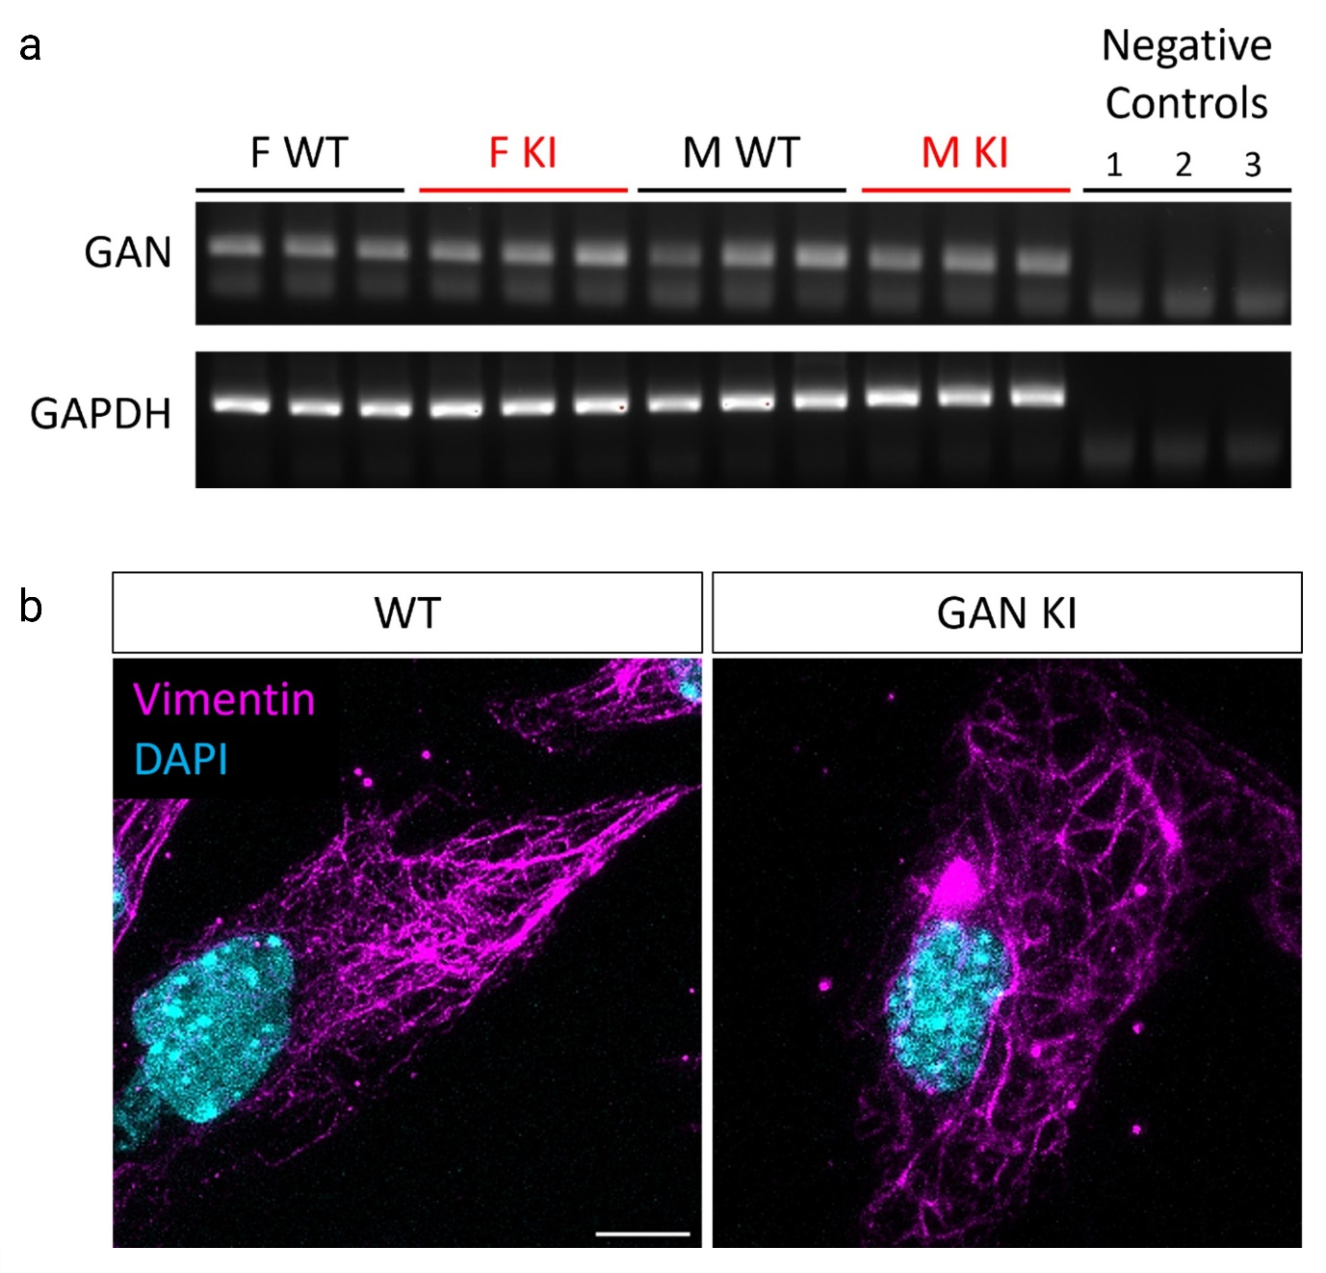
Supplementary Figure 1. GAN^{A49E} mice bear characteristics of the human mutation. (a) The levels of mutated GAN mRNA are similar to WT, in both males and females. Negative controls (1-3) correspond to experiments done without RNA template (1), without reverse transcriptase (2) and without PCR amplification (3). (b) Aggregation of vimentin in KI MEFs (Mouse Embryonic Fibroblasts), as revealed by immunofluorescence, scale bar 10 µm.
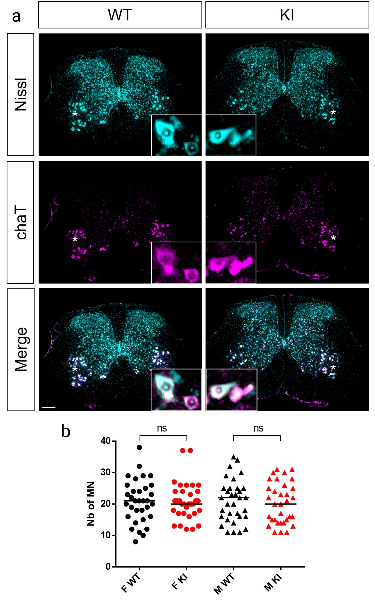Supplementary Figure 2. Lumbar motoneurons are preserved in GAN^{A49E} mice. (a) Cross sections of lumbar spinal cord from 24-month-old WT and KI mice, stained with Nissl (cyan) and ChaT (magenta). Scale bar 100µm. Inserts show higher magnification in regions marked by white stars, scale bar 5 µm. (b) Quantification of motoneuron number in the ventral horn of lumbar cross section shows no difference between WT and KI mice, regardless of the sex. Data are represented with the medians and each dot represents one section. Statistical analysis: non-parametric Mann-Whitney test, n=11-15 sections per animal, n=3 animals per group.
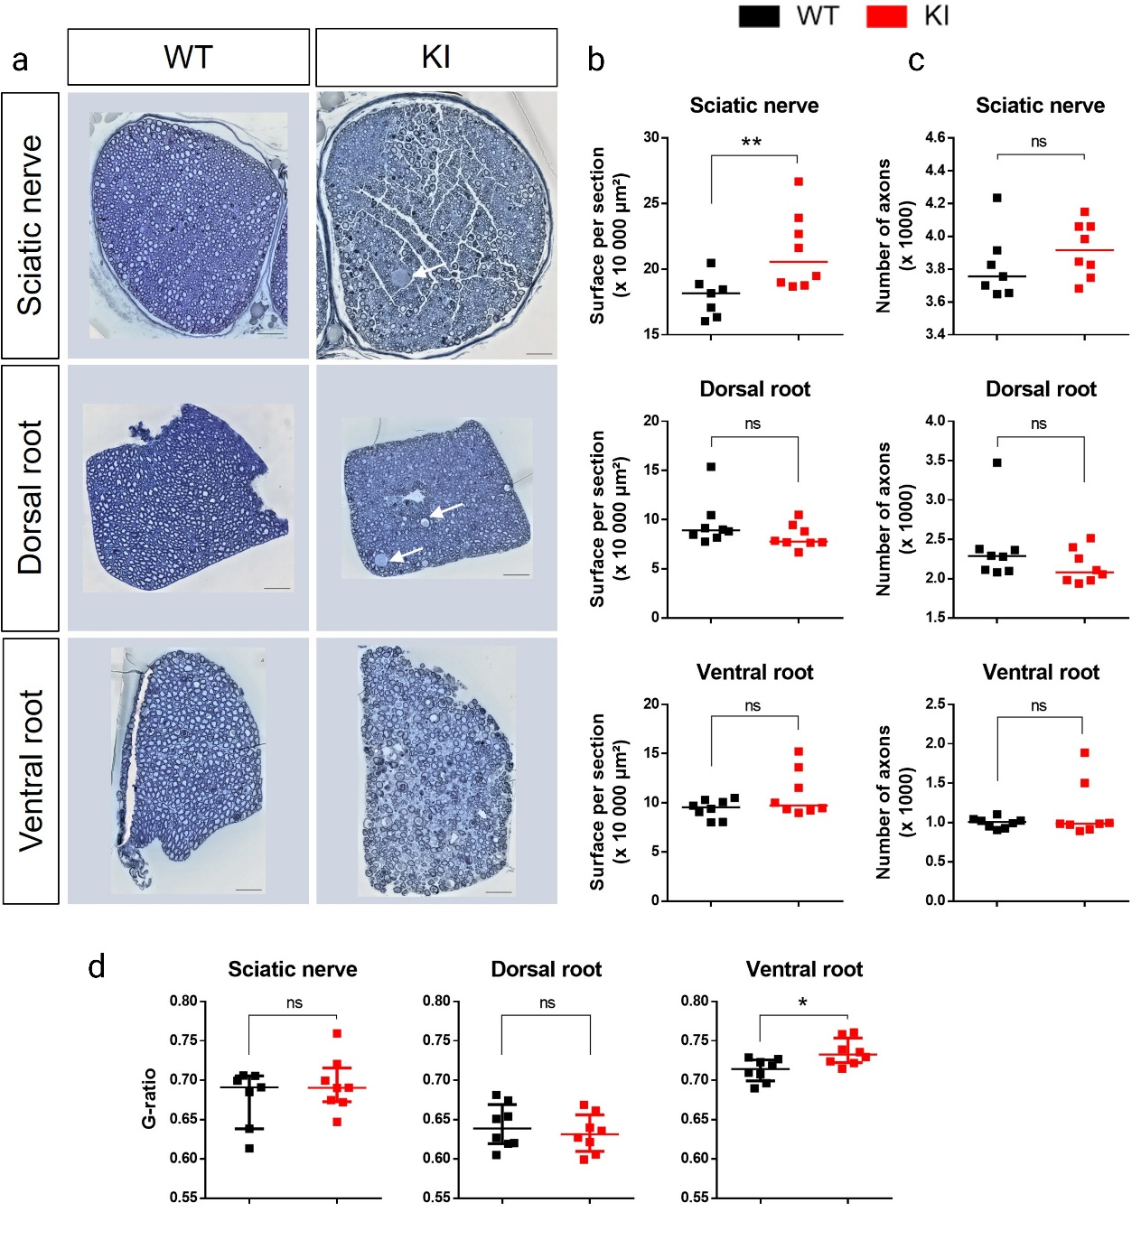Supplementary Figure 3. Peripheral axons are preserved but exhibit alteration of myelination in GAN^{A49E} mice. (a) Cross sections of peripheral nerves (sciatic nerve, dorsal and ventral roots) stained with toluidine blue. White arrows show giant axons. Scale bar 50µm. (b) Sciatic nerves from KI mice are larger compared to WT, while root sections show no difference. (c) The total number of axons per section is unaltered between KI and control mice in all regions. (d) The average g-ratio is increased in the ventral root of KI mice. Each graph is represented with the medians, and each dot represents the mean value per individual. Statistical analysis is performed using Mann-Whitney tests, N=7-8 animals per genotype, * p ≤ 0.05; ** p ≤ 0.01.
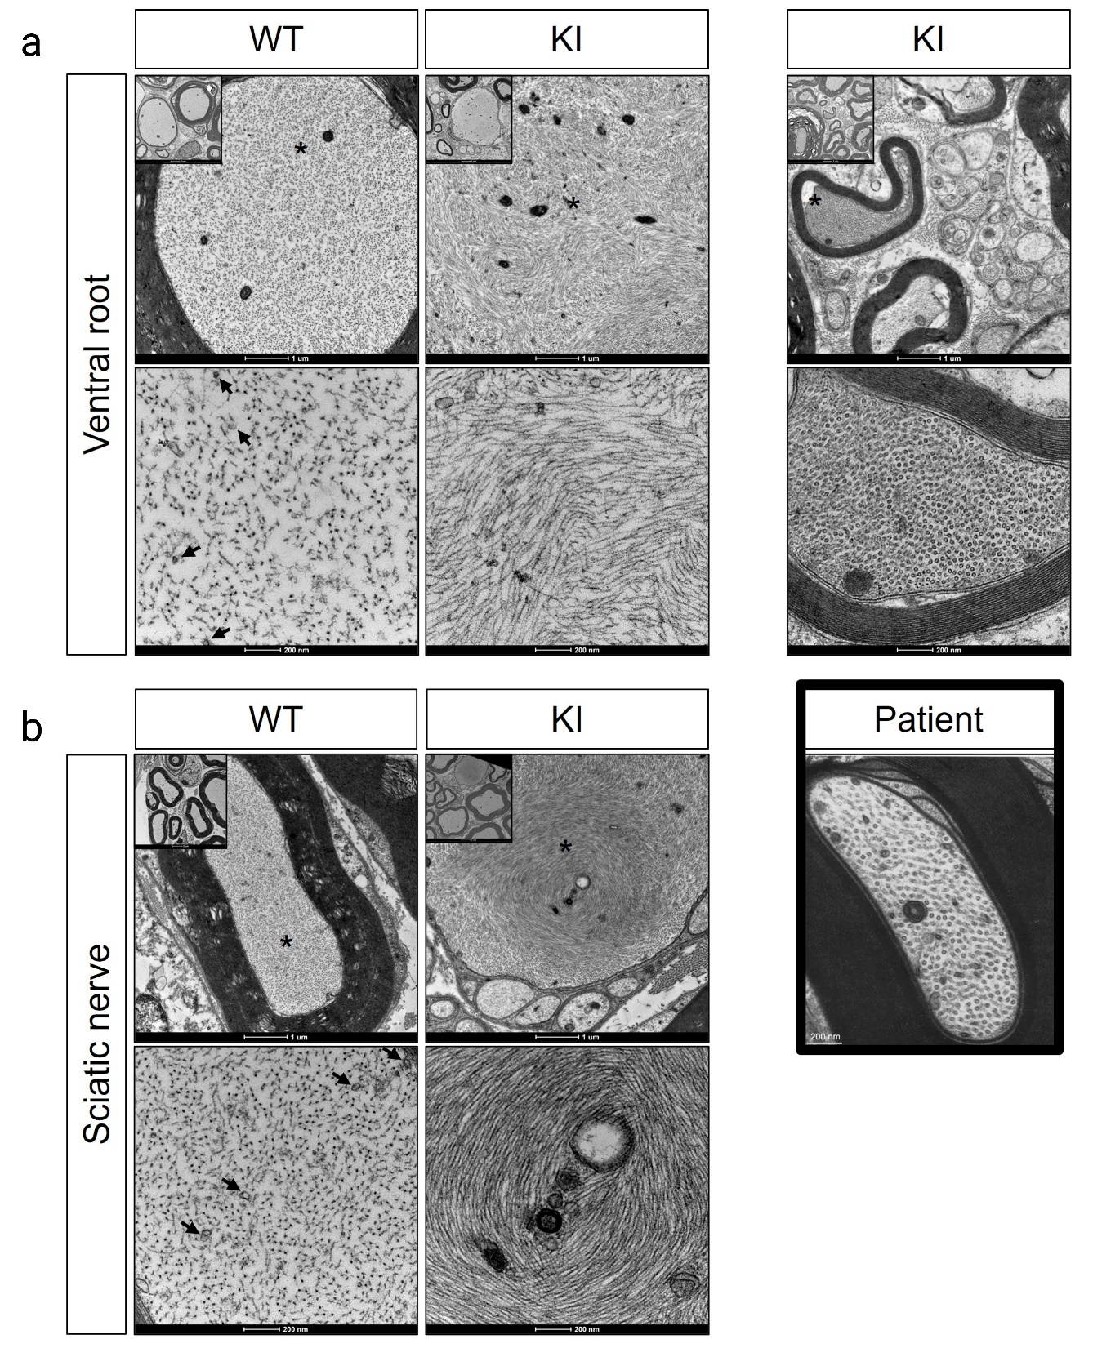
Supplementary Figure 4. Disorganization and compaction of NFs in the axoplasm in GAN^{A49E} mice. Electron micrographs of axons from ventral root (a) and sciatic nerve (b), showing the abnormal swirling and compaction of NFs and paucity of MTs (back arrows) in KI mice. (c) Dorsal root section of KI mice (top) and a patient biopsy (bottom, adapted from Asbury et al. [23] Copyright with permission from Springer Link), presenting axons with no NFs and filled with MTs.

