Supplementary Material

Methods

Statistical analysis
The linear mixed effects model for fitting the volumes is defined as a combination of intercepts, linear slopes, and a random effect term:

$$Volume=β_{0}+β_{1\left(Timepoint\right)}+β_{2\left(VCR;t>17\right)}+β_{3\left(SARM1\right)}+β_{4\left(VCR;SARM1;t>17\right)}$$
$${+β}_{5\left(VCR;t>17\right)}\left(t-t_{o}\right)+β_{6\left(SARM1\right)}\left(t-t_{o}\right)+β_{7\left(VCR;SARM1;t>17\right)}\left(t-t_{o}\right)+γ_{MouseID}$$

Random effects ($γ_{MouseID}$) were assigned by individual mouse ID and was common across all timepoints. The time $t_{o}$ is the reference timepoint in which the model is centered around to determine the effect at a particular timepoint (e.g., $t_{o}=23$ to obtain the vincristine (VCR) effect at P23). The term representing the volume at each timepoint, $β_{1\left(Timepoint\right)}$, consists of individual coefficients for P14, P23, P42, and P63. Coefficients with the VCR effect is set to zero for timepoints before treatment (P17). The symbol “:” indicates an interaction term. Statistical analysis was performed using a linear-mixed models from the lme4 package in R.¹

Reference
1. Bates D, Mächler M, Bolker B, Walker S. Fitting Linear Mixed-Effects Models Using lme4. J Stat Soft. 2015;67(1). doi:10.18637/jss.v067.i01

Supplementary Figures

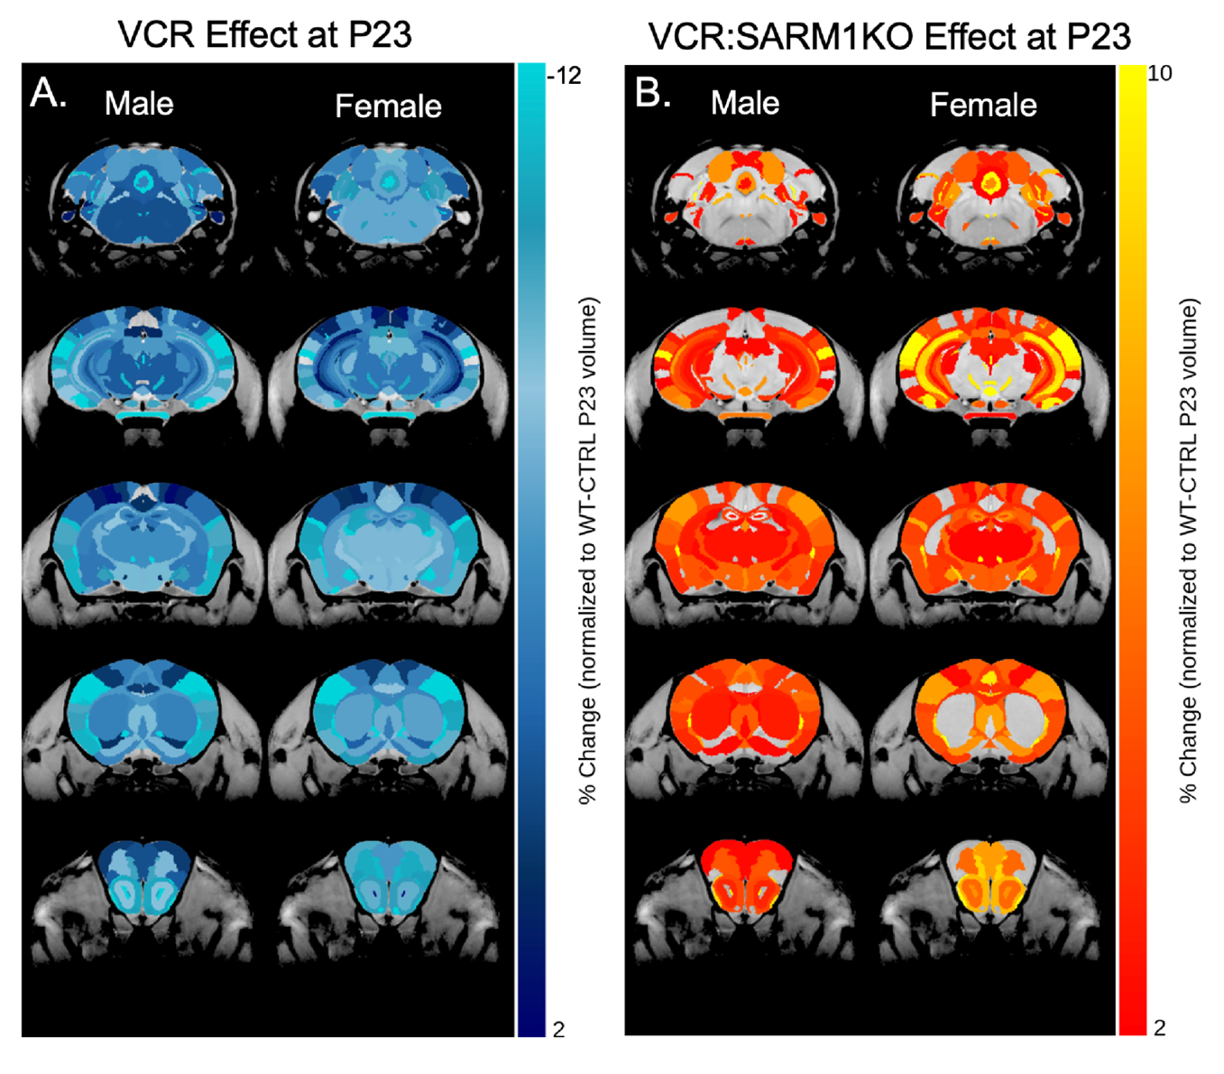
Supplementary Figure 1: The neuroanatomical plots of the VCR and VCR:SARM1KO effects with sex evaluated using a separate linear mixed-effect model. Highlighted structures represent regions that exhibit at least a 2% change, though none reached statistically significant after FDR correction (q>0.1). (A) The VCR effect at P23 on males and females separately shows similar regions affected. (B) Similar regions were also rescued from VCR at P23 due to SARM1KO.

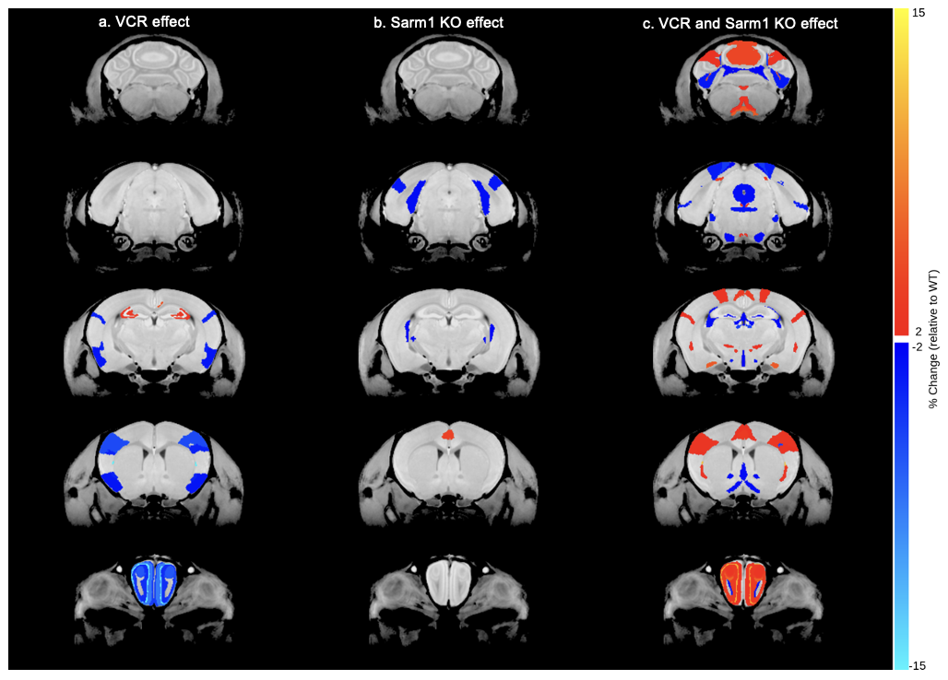
Supplementary Figure 2: The neuroanatomical plots of the VCR, Sarm1 KO, and VCR-Sarm1 KO effects on relative structural brain volumes at P23. A) The VCR effect on the brain (q<0.1) disproportionately reduces the olfactory bulb relative volumes while the hippocampal regions are increased. (B) Minimal effects on relative volumes of Sarm1 KO in saline-treated mice, with few structures affected (p<0.05, uncorrected). No structures were considered significant at q<0.1. (C) The effect of VCR-Sarm1 KO interaction on relative volumes qualitatively demonstrate a mitigation in VCR effect (p<0.05, uncorrected). No structures were considered significant at q<0.1.

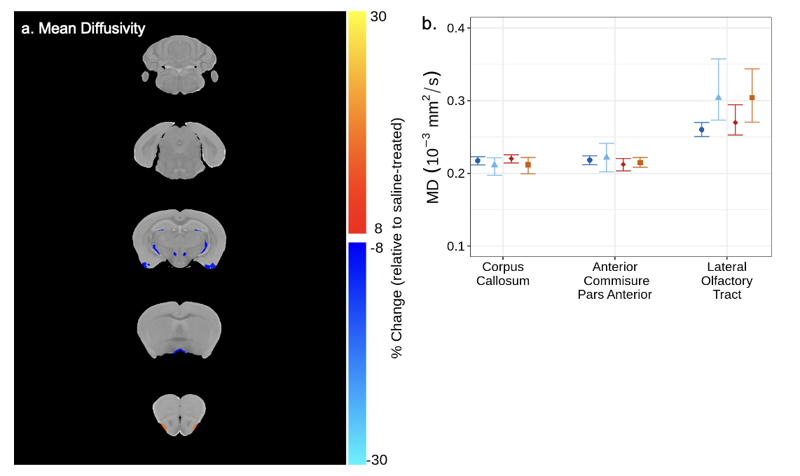
Supplementary Figure 3: The VCR effect on MD in wildtype and Sarm1 KO mice at P63. (A) Neuroanatomical maps highlighting regions that exhibited a minimum magnitude of 8% change in MD. No changes were considered statistically significant (q>0.1). (B) The MD between treatment and genotype groups in several white matter structures. Points and whiskers represent mean structure volume and bootstrapped 95% confidence intervals, respectively.

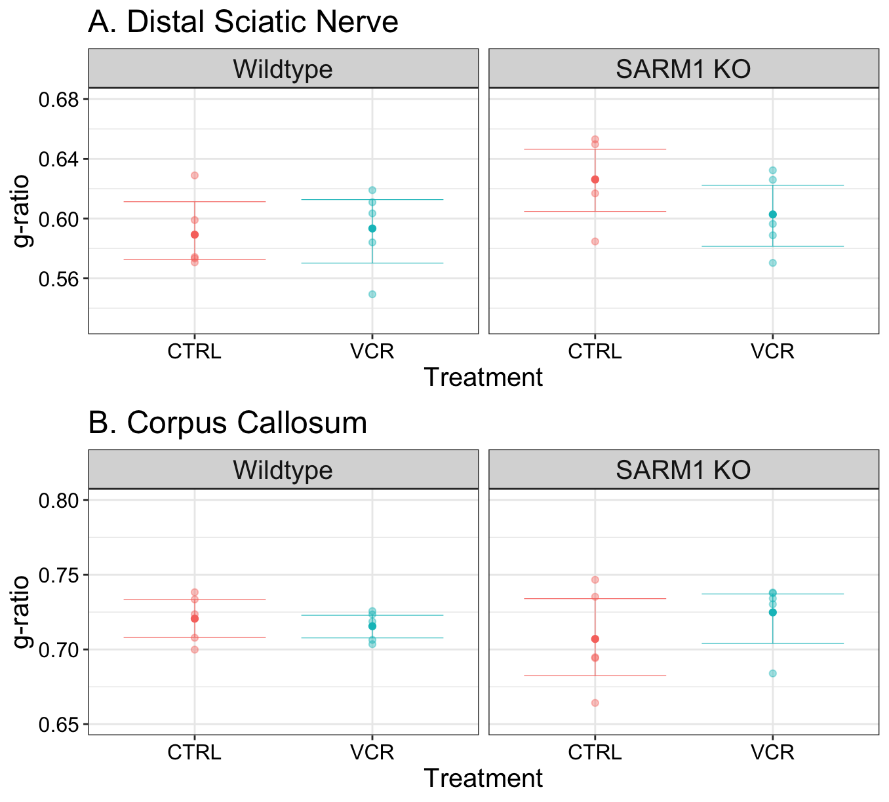

Supplementary Figure 4: The g-ratio for the distal sciatic nerve and corpus callosum between treatment groups for each genotype. No significant differences were found in g-ratio between treatment nor genotype.
Supplementary Tables

Timepoint  Group | 14 | 23 | 42 | 63
CTRL Wildtype | 14 (7) | 14 (7) | 12 (6) | 14 (7)
VCR Wildtype | 16 (7) | 15 (7) | 13 (5) | 13 (5)
CTRL SARM1 KO | 15 (6) | 14 (5) | 11 (5) | 15 (6)
VCR SARM1 KO | 16 (8) | 15 (7) | 13 (7) | 16 (8)

Supplementary Table 1: Mouse numbers for each group and imaging timepoint. The number of males is indicated in parantheses.

Structure | VCR |  | SARM1 KO |  |  |  | VCR and SARM1 KO
Structure | % volume  change | Uncorrected  p-value | % volume  change | Uncorrected  p-value | % volume  change | % rescue (vs. VCR wildtype) |  | Uncorrected  p-value
amygdala | -5.51 | 0.001† | -1.33 | 0.373 | 3.80 | 68.9 |  | 0.043
anterior_commissure_pars_anterior | -9.99 | <0.001† | 0.43 | 0.838 | 2.18 | 21.9 |  | 0.434
anterior_commissure_pars_posterior | -7.21 | 0.023† | -2.03 | 0.404 | 4.62 | 64.1 |  | 0.229
basal_forebrain | -7.74 | <0.001† | -0.64 | 0.685 | 4.20 | 54.3 |  | 0.011
bed_nucleus_of_stria_terminalis | -8.73 | <0.001† | -1.65 | 0.378 | 5.02 | 57.5 |  | 0.013
cerebellar_peduncle_inferior | -6.67 | 0.001† | -2.48 | 0.139 | 2.24 | 33.6 |  | 0.326
cerebellar_peduncle_middle | -7.33 | <0.001† | -0.04 | 0.981 | 1.08 | 14.7 |  | 0.642
cerebellar_peduncle_superior | -7.54 | 0.001† | -3.09 | 0.105 | 1.20 | 15.9 |  | 0.663
cerebral_aqueduct | -9.28 | 0.020† | 0.67 | 0.870 | 3.79 | 40.8 |  | 0.417
cerebral_peduncle | -7.16 | <0.001† | 0.84 | 0.579 | 2.33 | 32.5 |  | 0.168
colliculus_inferior | -6.02 | <0.001† | -0.40 | 0.802 | 4.48 | 74.4 |  | 0.007†
colliculus_superior | -6.79 | <0.001† | 1.62 | 0.293 | 2.23 | 32.8 |  | 0.154
corpus_callosum | -6.16 | <0.001† | 0.74 | 0.650 | 2.32 | 37.7 |  | 0.142
corticospinal_tract_pyramids | -6.40 | 0.009† | -1.80 | 0.350 | 3.30 | 51.7 |  | 0.262
cuneate_nucleus | -5.81 | 0.108 | 3.65 | 0.244 | 1.29 | 22.2 |  | 0.765
facial_nerve_cranial_nerve_7 | -7.05 | 0.065† | -3.02 | 0.275 | 5.69 | 80.8 |  | 0.228
fasciculus_retroflexus | -5.41 | 0.031† | -0.31 | 0.882 | -1.93 | 0.0 |  | 0.519
fimbria | -7.16 | <0.001† | 1.18 | 0.666 | 0.82 | 11.4 |  | 0.676
fornix | -6.98 | 0.004† | 0.34 | 0.867 | 1.59 | 22.8 |  | 0.576
fourth_ventricle | -9.68 | <0.001† | -2.99 | 0.132 | 6.69 | 69.1 |  | 0.026
fundus_of_striatum | -11.39 | 0.011† | 1.25 | 0.709 | 8.04 | 70.6 |  | 0.141
globus_pallidus | -6.59 | <0.001† | -1.59 | 0.389 | 3.57 | 54.2 |  | 0.089
habenular_commissure | -14.34 | 0.022† | 0.36 | 0.957 | 7.44 | 51.9 |  | 0.309
hypothalamus | -7.90 | <0.001† | -1.62 | 0.210 | 3.89 | 49.2 |  | 0.004†
inferior_olivary_complex | -14.14 | 0.002† | 2.79 | 0.407 | 8.51 | 60.2 |  | 0.123
internal_capsule | -7.10 | <0.001† | -3.16 | 0.084 | 4.11 | 57.9 |  | 0.044
interpedunclar_nucleus | -6.48 | 0.002† | -1.93 | 0.286 | 8.23 | 100.0 |  | 0.001†
lateral_olfactory_tract | -13.76 | <0.001† | -1.69 | 0.421 | 7.34 | 53.3 |  | 0.017
lateral_septum | -7.28 | <0.001† | 0.01 | 0.994 | 4.35 | 59.7 |  | 0.019
lateral_ventricle | -6.08 | 0.009† | 1.05 | 0.823 | 3.07 | 50.5 |  | 0.251
mammillary_bodies | -10.38 | <0.001† | -1.50 | 0.486 | 7.73 | 74.5 |  | 0.009
mammilothalamic_tract | -13.22 | <0.001† | 0.72 | 0.815 | 7.27 | 55.0 |  | 0.105
medial_lemniscus_medial_longitudinal_fasciculus | -9.89 | <0.001† | -2.41 | 0.161 | 6.77 | 68.5 |  | 0.012
medial_septum | -4.46 | 0.011† | 0.18 | 0.916 | -0.45 | 0.0 |  | 0.825
medulla | -6.72 | <0.001† | -1.15 | 0.366 | 1.70 | 25.3 |  | 0.195
midbrain | -4.84 | <0.001† | -0.38 | 0.766 | 0.58 | 11.9 |  | 0.619
nucleus_accumbens | -4.72 | 0.003† | 1.50 | 0.383 | 1.02 | 21.7 |  | 0.581
olfactory_peduncle | -9.40 | <0.001† | 0.38 | 0.831 | 4.76 | 50.6 |  | 0.012
olfactory_tubercle | -7.75 | <0.001† | 0.27 | 0.884 | 2.31 | 29.8 |  | 0.276
optic_tract | -8.84 | <0.001† | -0.82 | 0.622 | 5.46 | 61.8 |  | 0.006†
periaqueductal_grey | -5.36 | <0.001† | 1.18 | 0.449 | 0.72 | 13.4 |  | 0.652
pons | -5.28 | <0.001† | -1.01 | 0.457 | 1.89 | 35.8 |  | 0.136
pontine_nucleus | -8.69 | <0.001† | 0.91 | 0.647 | 1.67 | 19.3 |  | 0.471
posterior_commissure | -8.89 | <0.001† | 0.10 | 0.959 | 3.17 | 35.6 |  | 0.281
pre_para_subiculum | -3.10 | 0.035† | -2.28 | 0.197 | 1.79 | 57.8 |  | 0.296
stria_medullaris | -6.82 | <0.001† | -1.38 | 0.426 | 1.77 | 25.9 |  | 0.421
stria_terminalis | -9.30 | <0.001† | -3.11 | 0.106 | 3.59 | 38.6 |  | 0.121
striatum | -6.06 | <0.001† | -0.36 | 0.788 | 2.15 | 35.5 |  | 0.131
subependymale_zone_rhinocele | -5.77 | 0.147 | -1.22 | 0.697 | 4.96 | 86 |  | 0.304
superior_olivary_complex | -4.69 | 0.031† | 2.82 | 0.138 | 0.16 | 3.5 |  | 0.949
thalamus | -7.00 | <0.001† | -0.13 | 0.923 | 2.55 | 36.4 |  | 0.035
third_ventricle | -5.39 | 0.079† | 0.66 | 0.852 | 2.75 | 51 |  | 0.444
ventral_tegmental_decussation | -1.47 | 0.663 | -5.73 | 0.034 | 4.19 | 100 |  | 0.306
lobules_1_2_lingula_and_central_lobule_ventral | -4.59 | 0.010† | -2.03 | 0.397 | 2.61 | 56.9 |  | 0.206
lobule_3_central_lobule_dorsal | -5.53 | <0.001† | -0.26 | 0.884 | 5.81 | 100 |  | 0.001†
lobules_4_5_culmen_ventral_and_dorsal | -7.31 | <0.001† | -1.12 | 0.566 | 7.89 | 100 |  | 0.001†
lobule_6_declive | -5.94 | 0.004† | 0.78 | 0.731 | 1.60 | 26.9 |  | 0.506
lobule_7_tuber_or_folium | -9.77 | <0.001† | 1.04 | 0.718 | 3.65 | 37.3 |  | 0.107
lobule_8_pyramis | -4.39 | 0.033† | 2.05 | 0.371 | -2.78 | 0 |  | 0.248
lobule_9_uvula | -3.78 | 0.047† | 1.43 | 0.490 | 2.69 | 71.1 |  | 0.229
lobule_10_nodulus | -6.52 | 0.002† | 2.22 | 0.261 | 4.26 | 65.3 |  | 0.090
anterior_lobule_lobules_4_5 | -5.95 | <0.001† | -1.38 | 0.467 | 2.61 | 44 |  | 0.206
simple_lobule_lobule_6 | -7.27 | <0.001† | -1.50 | 0.402 | 3.86 | 53.1 |  | 0.066
crus_1_ansiform_lobule_lobule_6 | -8.08 | <0.001† | -2.38 | 0.148 | 5.12 | 63.4 |  | 0.010
crus_2_ansiform_lobule_lobule_7 | -5.40 | 0.003† | -1.45 | 0.495 | 3.56 | 65.9 |  | 0.087
paramedian_lobule_lobule_7 | -4.88 | 0.001† | 1.54 | 0.410 | -1.74 | 0 |  | 0.324
copula_pyramis_lobule_8 | -7.38 | 0.000† | 1.15 | 0.516 | 2.16 | 29.3 |  | 0.248
flocculus_FL | -5.91 | 0.006† | 0.21 | 0.936 | 1.94 | 32.8 |  | 0.436
paraflocculus_PFL | -3.25 | 0.103 | 5.39 | 0.096 | 3.87 | 100 |  | 0.095
trunk_of_arbor_vita | -5.66 | <0.001† | 0.11 | 0.940 | 0.53 | 9.5 |  | 0.778
lobule_1_2_white_matter | -21.55 | <0.001† | -1.74 | 0.721 | 11.00 | 51 |  | 0.112
lobule_3_white_matter | -10.62 | <0.001† | -6.86 | 0.006 | 9.60 | 90.4 |  | 0.008†
trunk_of_lobules_1_3_white_matter | -5.97 | 0.093 | -0.91 | 0.747 | 2.59 | 43.4 |  | 0.545
lobules_4_5_white_matter | -7.53 | 0.008† | -3.73 | 0.144 | 6.07 | 80.7 |  | 0.071
lobules_6_7_white_matter | -6.73 | 0.011† | -0.58 | 0.817 | 5.88 | 87.4 |  | 0.059
lobule_8_white_matter | -22.28 | <0.001† | -7.58 | 0.144 | 16.42 | 73.7 |  | 0.031
trunk_of_lobules_6_8_white_matter | -5.78 | 0.190 | -2.70 | 0.490 | 0.94 | 16.2 |  | 0.858
lobule_9_white_matter | -6.72 | 0.223 | -2.12 | 0.610 | 7.00 | 100 |  | 0.299
lobule_10_white_matter | -15.72 | 0.066† | -9.40 | 0.145 | 13.66 | 86.9 |  | 0.191
anterior_lobule_white_matter | -10.40 | 0.012† | -8.24 | 0.024 | 9.41 | 90.5 |  | 0.056
simple_lobule_white_matter | -14.34 | 0.002† | -4.67 | 0.240 | 10.06 | 70.1 |  | 0.063
crus_1_white_matter | -10.93 | 0.010† | -1.38 | 0.686 | 6.43 | 58.8 |  | 0.204
trunk_of_simple_and_crus_1_white_matter | -4.22 | 0.196 | -3.54 | 0.215 | 1.98 | 46.8 |  | 0.612
crus_2_white_matter | -13.53 | 0.012† | -1.30 | 0.771 | 8.92 | 65.9 |  | 0.165
paramedian_lobule | -13.11 | 0.021† | -4.59 | 0.351 | 10.29 | 78.5 |  | 0.131
trunk_of_crus_2_and_paramedian_white_matter | -7.29 | 0.011† | -1.40 | 0.596 | 4.09 | 56 |  | 0.229
copula_white_matter | -1.08 | 0.804 | -4.69 | 0.209 | 5.64 | 100 |  | 0.283
paraflocculus_white_matter | -7.71 | 0.014† | 0.18 | 0.950 | 7.80 | 100 |  | 0.037
flocculus_white_matter | -16.91 | 0.024† | -8.57 | 0.211 | 18.35 | 100 |  | 0.042
dentate_nucleus | -7.80 | <0.001† | -2.92 | 0.139 | 3.33 | 42.8 |  | 0.193
nucleus_interpositus | -8.54 | <0.001† | -1.23 | 0.505 | 3.01 | 35.3 |  | 0.231
fastigial_nucleus | -6.88 | 0.006† | -2.22 | 0.261 | 3.77 | 54.9 |  | 0.207
Cingulate_cortex_area_24a | -5.02 | 0.002† | 1.67 | 0.454 | 3.10 | 61.8 |  | 0.093
Cingulate_cortex_area_24a.1 | -5.37 | 0.019† | -0.46 | 0.838 | 3.01 | 56.2 |  | 0.263
Cingulate_cortex_area_24b | -6.56 | <0.001† | 2.52 | 0.147 | 4.33 | 65.9 |  | 0.050
Cingulate_cortex_area_24b.1 | -5.05 | 0.069† | -3.98 | 0.076 | 5.58 | 100 |  | 0.096
Cingulate_cortex_area_25 | -12.74 | <0.001† | -1.91 | 0.427 | 8.82 | 69.2 |  | 0.001†
Cingulate_cortex_area_29a | -5.83 | 0.007† | -1.59 | 0.443 | 6.04 | 100 |  | 0.018
Cingulate_cortex_area_29b | -6.51 | 0.004† | 1.59 | 0.367 | 1.94 | 29.8 |  | 0.473
Cingulate_cortex_area_29c | -2.22 | 0.220 | -0.11 | 0.952 | 1.61 | 72.3 |  | 0.453
Cingulate_cortex_area_30 | -3.44 | 0.024† | -0.63 | 0.666 | 2.86 | 83.4 |  | 0.111
Cingulate_cortex_area_32 | -6.13 | 0.002† | 2.54 | 0.226 | 6.85 | 100 |  | 0.003†
Amygdalopiriform_transition_area | -5.00 | 0.070† | -1.88 | 0.431 | 2.36 | 47.2 |  | 0.475
Primary_auditory_cortex | -9.20 | 0.002† | -2.44 | 0.259 | 5.66 | 61.5 |  | 0.113
Secondary_auditory_cortex_dorsal_area | -8.09 | 0.002† | -4.97 | 0.012 | 4.68 | 57.8 |  | 0.138
Secondary_auditory_cortex_ventral_area | -13.45 | <0.001† | 0.07 | 0.978 | 7.52 | 55.9 |  | 0.026
Caudomedial_entorhinal_cortex | -4.78 | 0.003† | -1.23 | 0.461 | -0.40 | 0 |  | 0.833
Cingulum | -5.89 | 0.002† | 1.49 | 0.441 | 2.96 | 50.3 |  | 0.180
Claustrum | -16.78 | <0.001† | -2.22 | 0.479 | 7.50 | 44.7 |  | 0.102
Cortex_amygdala_transition_zones | -5.17 | 0.040† | -1.31 | 0.530 | 2.69 | 51.9 |  | 0.373
Claustrum_dorsal_part | -26.12 | <0.001† | -3.51 | 0.470 | 16.09 | 61.6 |  | 0.037
Dorsal_nucleus_of_the_endopiriform | -11.51 | <0.001† | -2.57 | 0.152 | 6.83 | 59.3 |  | 0.007†
Dorsal_intermediate_entorhinal_cortex | -6.20 | 0.003† | -1.33 | 0.438 | 1.70 | 27.4 |  | 0.487
Dorsolateral_entorhinal_cortex | -7.86 | <0.001† | -0.14 | 0.948 | -0.23 | 0 |  | 0.927
Dorsolateral_orbital_cortex | -6.52 | 0.012† | -0.03 | 0.988 | 2.91 | 44.6 |  | 0.344
Dorsal_tenia_tecta | -8.31 | 0.001† | -0.54 | 0.821 | 5.24 | 63 |  | 0.086
Ectorhinal_cortex | -6.86 | 0.015† | -0.09 | 0.971 | 0.79 | 11.5 |  | 0.815
Frontal_cortex_area_3 | -12.46 | <0.001† | 1.69 | 0.541 | 1.92 | 15.4 |  | 0.655
Frontal_association_cortex | -5.88 | 0.010† | 0.58 | 0.765 | 3.94 | 67 |  | 0.146
Intermediate_nucleus_endopiriform_claustrum | -14.62 | <0.001† | -1.66 | 0.512 | 5.95 | 40.7 |  | 0.089
Insular_region_not_subdivided | -9.19 | <0.001† | -0.55 | 0.733 | 3.39 | 36.9 |  | 0.083
Lateral_orbital_cortex | -9.15 | <0.001† | -0.34 | 0.848 | 5.97 | 65.3 |  | 0.003†
Lateral_parietal_association_cortex | -7.51 | 0.205 | -2.28 | 0.608 | 1.12 | 14.9 |  | 0.878
Primary_motor_cortex | -5.31 | <0.001† | 0.25 | 0.867 | 4.27 | 80.4 |  | 0.013
Secondary_motor_cortex | -4.50 | 0.003† | 1.51 | 0.289 | 3.15 | 70.1 |  | 0.075
Medial_entorhinal_cortex | -9.55 | <0.001† | -0.53 | 0.800 | 1.73 | 18.1 |  | 0.553
Medial_orbital_cortex | -6.35 | 0.005† | -1.74 | 0.446 | 6.39 | 100 |  | 0.017
Medial_parietal_association_cortex | 1.22 | 0.764 | 1.44 | 0.648 | 2.12 | 0 |  | 0.667
Piriform_cortex | -10.23 | <0.001† | -0.13 | 0.925 | 3.17 | 31 |  | 0.065
Posterolateral_cortical_amygdaloid_area | -9.65 | 0.005† | -0.72 | 0.794 | 2.31 | 23.9 |  | 0.571
Posteromedial_cortical_amygdaloid_area | -8.21 | 0.003† | -1.16 | 0.638 | 6.92 | 84.2 |  | 0.032
Perirhinal_cortex | -7.81 | <0.001† | 0.37 | 0.849 | 1.22 | 15.6 |  | 0.652
Parietal_cortex_posterior_area_rostral_part | -8.55 | 0.514 | -10.69 | 0.268 | -1.46 | 0 |  | 0.928
Rostral_amygdalopiriform_area | -6.92 | 0.111 | 0.66 | 0.846 | 1.23 | 17.7 |  | 0.815
Primary_somatosensory_cortex | -12.36 | <0.001† | -0.35 | 0.846 | 6.19 | 50.1 |  | 0.010
Primary_somatosensory_cortex_barrel_field | -4.75 | 0.004† | 0.12 | 0.939 | 4.57 | 96.1 |  | 0.020
Primary_somatosensory_cortex_dysgranular_zone | -26.31 | <0.001† | -2.13 | 0.692 | 4.90 | 18.6 |  | 0.575
Primary_somatosensory_cortex_forelimb_region | -5.49 | 0.005† | -0.32 | 0.846 | 5.52 | 100 |  | 0.017
Primary_somatosensory_cortex_hindlimb_region | -6.47 | 0.010† | -0.42 | 0.841 | 5.84 | 90.3 |  | 0.051
Primary_somatosensory_cortex_jaw_region | -16.41 | <0.001† | 0.44 | 0.901 | 1.29 | 7.8 |  | 0.818
Primary_somatosensory_cortex_shoulder_region | -10.82 | 0.221 | 2.77 | 0.670 | 15.16 | 100 |  | 0.164
Primary_somatosensory_cortex_trunk_region | -0.32 | 0.937 | -0.41 | 0.898 | 1.78 | 100 |  | 0.721
Primary_somatosensory_cortex_upper_lip_region | -11.34 | <0.001† | -0.97 | 0.599 | 6.36 | 56.1 |  | 0.004†
Secondary_somatosensory_cortex | -8.74 | <0.001† | -1.29 | 0.489 | 3.47 | 39.7 |  | 0.118
Temporal_association_area | -4.50 | 0.060† | 0.21 | 0.918 | 0.72 | 16 |  | 0.801
Primary_visual_cortex | -4.09 | 0.082† | 0.18 | 0.930 | -2.01 | 0 |  | 0.475
Primary_visual_cortex_binocular_area | -5.69 | 0.040† | 0.40 | 0.850 | 1.18 | 20.7 |  | 0.726
Primary_visual_cortex_monocular_area | -6.93 | 0.013† | -1.36 | 0.534 | -0.97 | 0 |  | 0.774
Secondary_visual_cortex_lateral_area | -3.65 | 0.102 | -2.80 | 0.113 | 0.99 | 27.1 |  | 0.714
Secondary_visual_cortex_mediolateral_area | -8.06 | 0.003† | -1.81 | 0.413 | -2.77 | 0 |  | 0.384
Secondary_visual_cortex_mediomedial_area | -5.85 | 0.006† | -1.32 | 0.445 | 0.38 | 6.5 |  | 0.879
Claustrum_ventral_part | -13.23 | <0.001† | -3.66 | 0.155 | 8.22 | 62.1 |  | 0.035
Ventral_nucleus_of_the_endopiriform_claustrum | -11.45 | 0.004† | -0.15 | 0.960 | 3.91 | 34.1 |  | 0.409
Ventral_intermediate_entorhinal_cortex | -9.86 | <0.001† | -1.93 | 0.371 | 5.99 | 60.7 |  | 0.041
Ventral_orbital_cortex | -10.59 | <0.001† | -1.23 | 0.551 | 7.40 | 69.9 |  | 0.003†
Ventral_tenia_tecta | -10.79 | 0.001† | 3.32 | 0.336 | -3.19 | 0 |  | 0.415
CA10r | -4.42 | 0.009† | -0.93 | 0.575 | 3.48 | 78.7 |  | 0.081
LMol | -5.08 | 0.002† | -0.83 | 0.611 | 2.29 | 45.1 |  | 0.241
CA1Rad | -5.09 | 0.001† | -1.00 | 0.549 | 3.56 | 69.9 |  | 0.053
CA2Py | -4.81 | 0.023† | -2.12 | 0.258 | 3.54 | 73.6 |  | 0.161
CA20r | -7.68 | <0.001† | -0.86 | 0.637 | 4.59 | 59.8 |  | 0.041
CA2Rad | -6.27 | <0.001† | -1.13 | 0.543 | 4.05 | 64.6 |  | 0.069
CA3Py_Inner | -3.14 | 0.106 | -1.67 | 0.360 | 1.30 | 41.5 |  | 0.572
CA3Py_Outer | -5.01 | 0.003† | 0.14 | 0.949 | 2.85 | 56.7 |  | 0.146
CA30r | -4.84 | <0.001† | 0.45 | 0.829 | 2.86 | 59.2 |  | 0.088
CA3Rad | -4.49 | 0.003† | -0.59 | 0.707 | 3.20 | 71.3 |  | 0.069
SLu | -5.35 | 0.003† | -0.55 | 0.766 | 3.71 | 69.3 |  | 0.082
MoDG | -5.26 | <0.001† | 0.03 | 0.983 | 1.85 | 35.2 |  | 0.277
GrDG | -5.09 | 0.002† | -0.05 | 0.978 | 1.65 | 32.4 |  | 0.397
PoDG | -4.65 | 0.006† | -0.08 | 0.967 | 1.07 | 22.9 |  | 0.588
CA1Py | -6.67 | 0.008† | -0.79 | 0.727 | 4.84 | 72.5 |  | 0.106
Olfactory_bulb_glomerular_layer | -11.79 | <0.001† | -1.07 | 0.655 | 0.52 | 4.4 |  | 0.874
Olfactory_bulb_external_plexiform_layer | -15.11 | <0.001† | -2.75 | 0.161 | 4.07 | 26.9 |  | 0.110
Olfactory_bulb_mitral_cell_layer | -25.21 | <0.001† | -0.40 | 0.919 | 11.59 | 46 |  | 0.042
Olfactory_bulb_internal_plexiform_layer | -24.04 | <0.001† | 0.00 | 1.000 | 12.64 | 52.6 |  | 0.032
Olfactory_bulb_granule_cell_layer | -11.53 | <0.001† | -1.27 | 0.532 | 5.58 | 48.4 |  | 0.037
Accessory_olfactory_bulb_glomerular  external_plexiform_and_mitral_cell_layer | -14.12 | <0.001† | -2.48 | 0.237 | 6.20 | 43.9 |  | 0.017
Accessory_olfactory_bulb_granule_cell_layer | -10.55 | 0.003† | -1.48 | 0.637 | 10.16 | 96.3 |  | 0.015
Anterior_olfactory_nucleus | -8.72 | <0.001† | -0.18 | 0.927 | 4.20 | 48.2 |  | 0.031
subiculum | -5.22 | <0.001† | -1.77 | 0.202 | 2.60 | 49.8 |  | 0.087
Medial_amygdala | -10.16 | <0.001 | -2.67 | 0.222 | 5.45 | 53.6 |  | 0.049
Medial_preoptic_nucleus | -14.84 | 0.007 | -2.98 | 0.477 | 10.33 | 69.6 |  | 0.123
Pituitary_gland | -15.98 | <0.001 | -4.59 | 0.153 | 7.46 | 46.7 |  | 0.131

Supplementary Table 2: Segmented structures from the atlas with 183 labels. The percentage change of volumes at P23 are shown for the vincristine (VCR) effect, the SARM1 KO effect, and its interaction. The associated uncorrected p-values are shown. P-values that met the FDR of 10% are marked as †. The percent rescue was calculated for each structure by dividing the amount of volume recovered relative to the VCR effect at P63 from the linear-mixed effects model. Values that exceeded 100% were set to 100 and negative values were set to 0.

