Supplemental Material
Supplemental Figure 1
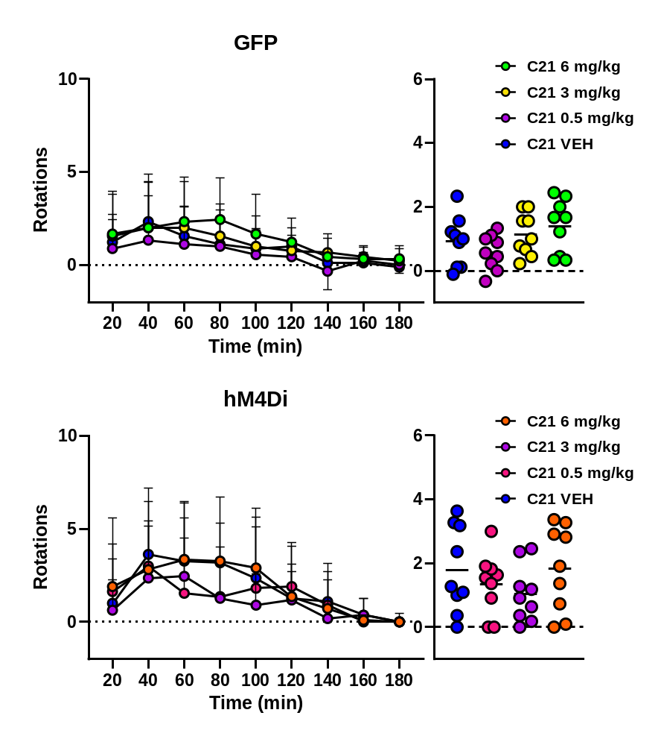
Supplemental Figure 1. No effect of DREADD activity on L-DOPA efficacy. Given that 5-HT receptor agonists can reduce efficacy of L-DOPA we assessed L-DOPA induced rotational behavior following vehicle or C21 treatment. There was no suppression of L-DOPA efficacy in GFP control animals (Top), but more importantly, the same was seen with either C21 dose of hM4Di expressing animals.

Supplemental Figure 2.
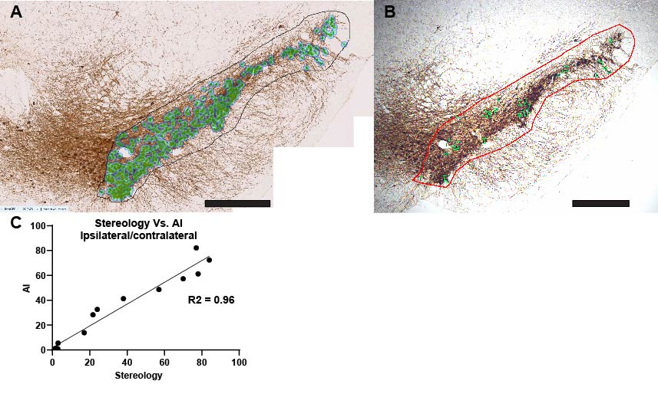
Supplemental Figure 2. Stereological validation of AI-based enumeration of nigral TH immunoreactive neurons. Screenshots from the same TH stained section from Aiforia with all the enumerated cells highlighted (A) and from StereoInvestigator showing the counting frames (B). C. A regression analysis from complete enumeration and stereological cell counting (presented as a ratio of the ipsilateral versus contralateral hemispheres) from 16 animals show a high degree of concordance (R² = 0.96, p < 0.0001)

