Supplementary Materials and Methods
Cell culture
ONS76 Med cells were cultured in RPMI-1640 medium supplemented with 10% fetal bovine serum (FBS) and 1% penicillin/streptomycin. DAOY Med cells were cultured in EMEM with 10% FBS and 1% penicillin/streptomycin. D425 Med cells were maintained in DMEM/F12 with 10% FBS and 1% penicillin/streptomycin. CAHL-01 and MED211 Med cells were cultured in a mixture of 30% Ham’s F12 and 70% DMEM, supplemented with 1% antibiotic-antimycotic, 20% B27 supplement, 5 μg/mL heparin, 20 ng/mL EGF, and 20 ng/mL FGF2. All cells were incubated at 37°C in a humidified atmosphere with 5% CO₂. For chemosensitivity assays, cells were treated with IACS-010759 (Selleckchem) at concentrations ranging from 0.1 to 30,000 nM. After 48 hours, cell proliferation was assessed using the CellTiter 96® AQueous Non-Radioactive Cell Proliferation Assay Kit (Promega, Madison, WI; G5430) according to the manufacturer's instructions. For α-KG supplementation, D425 Med cells were exposed to 2 mM dimethyl-2-oxoglutarate (α-KG; Sigma Aldrich, #349631) for 72 hours, and cell proliferation was measured by MTS assay.
Immunoblot analysis
Equal numbers of each cell line were pelleted and lysed using M-PER Protein Extraction Reagent (Pierce Biotechnology, Thermo Fisher Scientific, Waltham. MA) supplemented with protease inhibitor cocktail (Abcam, Cambridge, UK). Protein concentrations were determined with the BCA protein assay kit (Pierce Biotechnology). Equalized 7.5 µg aliquots of extracts were fractionated by SDS-polyacrylamide gel electrophoresis and transferred to polyvinylidene difluoride membranes for immunoblot analysis. Membranes were blocked with 5% bovine serum albumin (BSA; Fisher Scientific, Hampton, NH) in TBST buffer (10 mM Tris, pH 8.0; 150 mM NaCl; 0.5% Tween 20) for 60 min and then incubated with primary antibodies targeting H3K9me3 (cat. ab8898, 1:1000, Abcam), H3K4me3 (cat. Ab213224, 1:500, Abcam), H3K27me3 (cat. #9733, 1:500, Cell Signaling, Danvers, MA), H3K36me3 (cat. MA5-24687, 1:500, Invitrogen, Waltham, MA), and H3 (cat. Ab1791, 1:1000, Abcam), at 4°C overnight. Membranes were washed and incubated with a 1:10,000 dilution of horseradish peroxidase–conjugated anti-mouse or anti-rabbit antibodies for 1 h. Blots were washed and developed with the ECL system (Thermo Fisher Scientific) according to the manufacturer’s protocols.

SUPPLEMENTARY
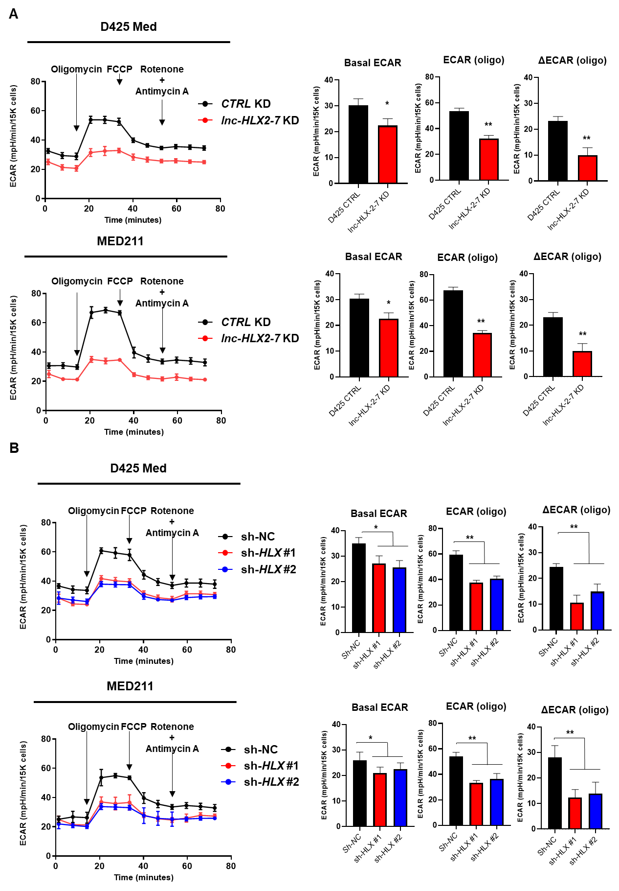
Supplementary Figure 1. Measurement of oligomycin-stimulated ECAR changes upon lnc-HLX-2-7 and HLX knockdown in vitro.
ECAR (A, B) was measured in untreated cells, followed by treatment with oligomycin and follow-up treatment with FCCP, rotenone, and antimycin A. Each phase (basal ECAR, oligomycin-stimulated ECAR; ECAR (oligo), and ΔECAR (oligo) = ECAR (oligo) − basal ECAR) was statistically analyzed. Each sample was measured in nine wells per treatment. Three independent experiments were performed, and data are presented as mean ± SD. *p<0.05, **p<0.01, Student’s t-test.
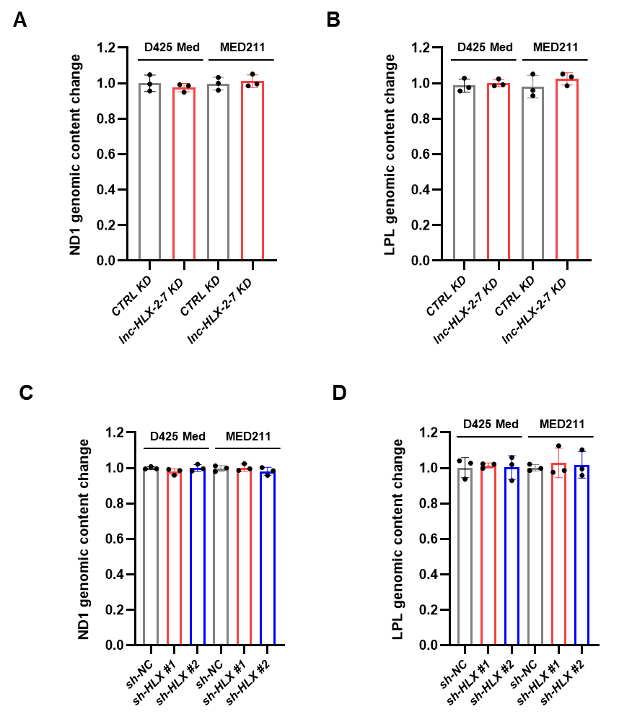
Supplementary Figure 2. Measurement of mitochondrial DNA levels upon lnc-HLX-2-7 or HLX Knockdown.
(A, C) Relative abundance of mitochondrial DNA (ND1) in D425 Med and MED211 cells following (A) lnc-HLX-2-7 KD or (C) HLX KD, normalized to nuclear ACTB levels. (B, D) Relative abundance of nuclear DNA (LPL) in the same cells, normalized to nuclear ACTB levels. Data represent three independent experiments and are presented as mean ± SD.

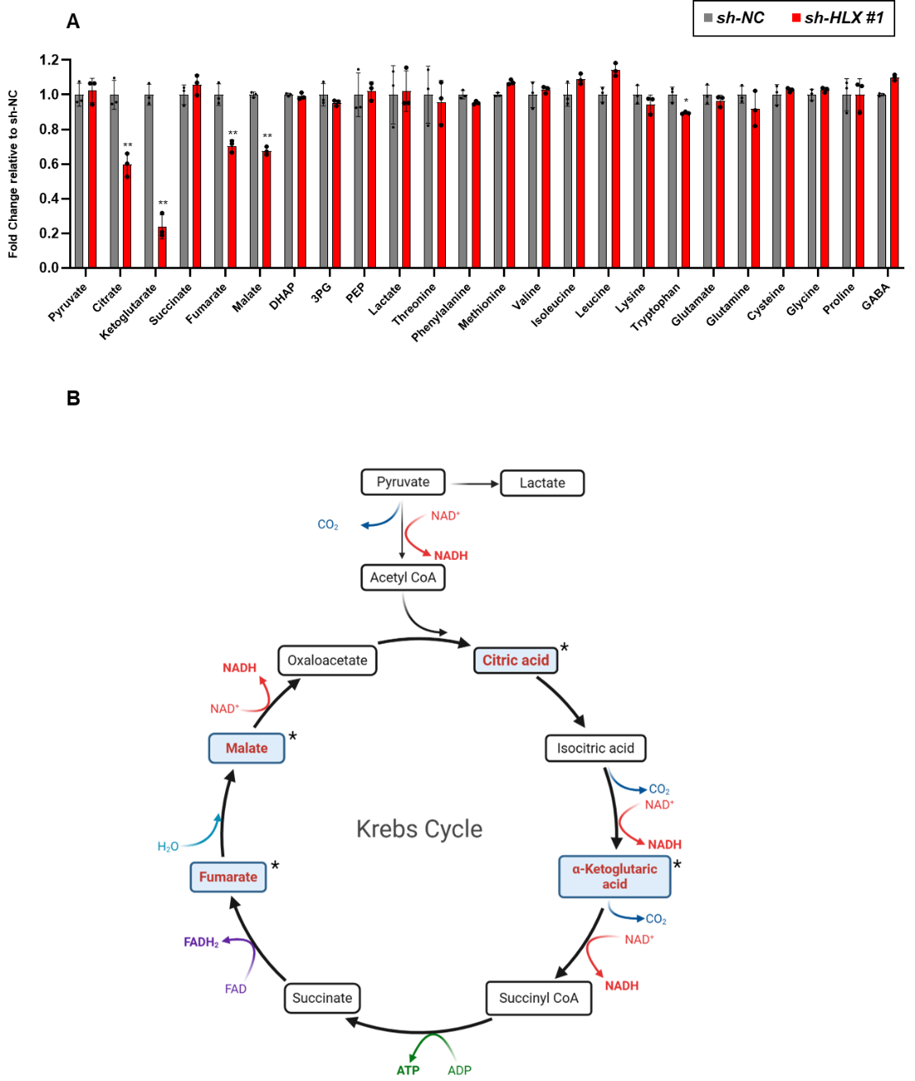
Supplementary Figure 3. Analysis of metabolomic changes upon HLX inhibition.
(A) Metabolic analysis of D425 Med-HLX KD and control cells. (B) Schematic of the Krebs cycle pathway in HLX KD cells. Highlighted* indicates metabolites that were significantly downregulated in HLX KD cells. 3PG: 3-phosphoglyceric acid; DHAP: dihydroxyacetone phosphate; PEP: phosphoenolpyruvic acid. Three independent experiments were performed, and data are presented as mean ± SD. *p<0.01, Student’s t-test.
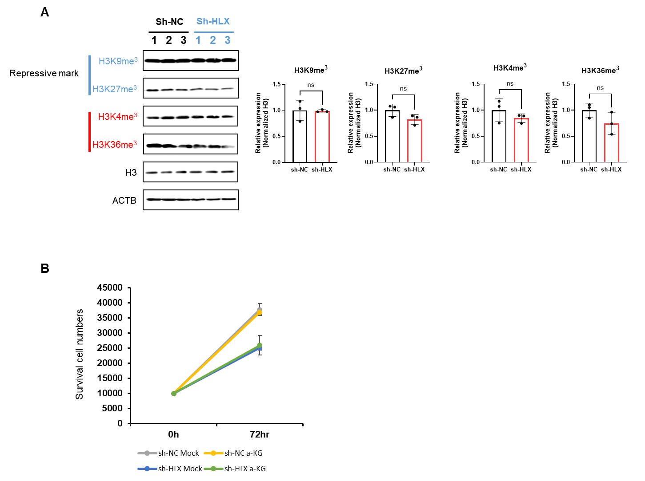
Supplementary Figure 4. α-KG supplementation in sh-HLX D425-Med cells.
(A) Representative immunoblot analysis depicting histone modification levels in D425 Med-HLX KD and control cells. (B) Survival cell numbers survival in D425 Med-HLX KD and control cells treated with or without cell-membrane-permeable α-ketoglutarate (α-KG) supplementation.

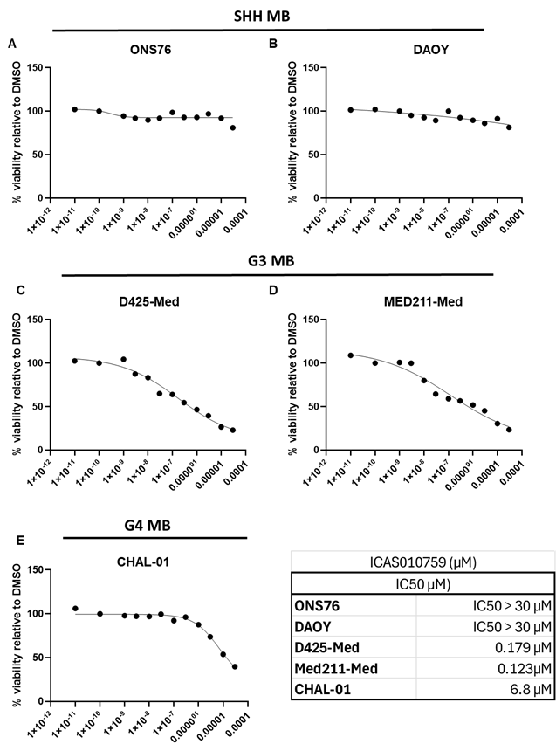
Supplementary Figure 5. Analysis of cell viability following IACS-010759 treatment in MB subtypes.
Cell viability assays demonstrate the effects of IACS-010759 across different MB subtypes: (A) ONS76, (B) DAOY, (C) D425-Med, (D) MED211-Med, and (E) CHAL-01 Med. The IC₅₀ value for each cell line is indicated.

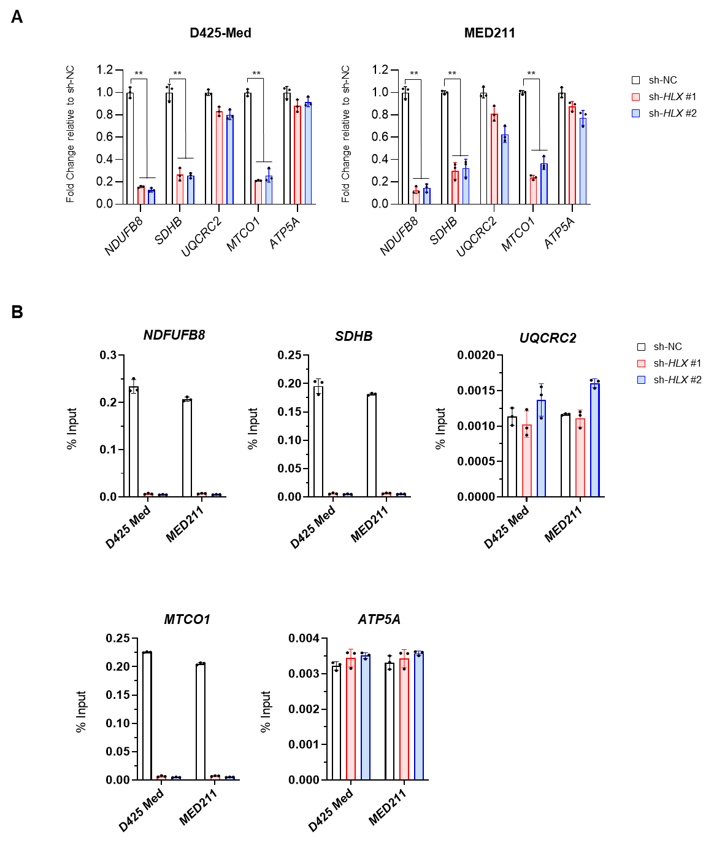
Supplementary Figure 6. Analysis of HLX binding at the OXPHOS gene promoters in HLX KD cells.
(A) Expression levels of NDUFB8, SDHB, UQCRC2, MTCO1, and ATP5A in D425 Med and MED211 cells after HLX knockdown. Relative expression levels to control (CTRL) are indicated in the y-axis. (B) HLX enrichment at the promoter regions of NDUFB8, SDHB, UQCRC2, MTCO1, and ATP5A in D425 Med and MED211 cells, determined by ChIP-qPCR. Enrichment is expressed as a percentage of input DNA. Error bars indicate s.e.m. n=3, *p<0.01, Student’s t-test.

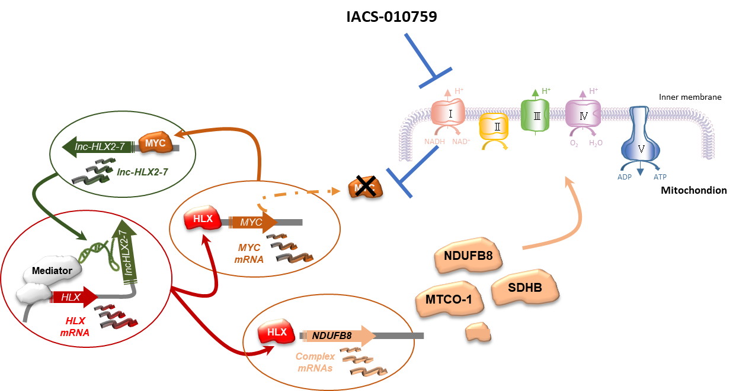

Supplementary Figure 7. Schematic of the lnc-HLX-2-7-HLX-MYC/OXPHOS pathway in G3 MB cells and impact of complex I inhibition.

Supplementary Table 1. RT-PCR (RT) and ChIP (CHIP) primers used in the study.
Target gene | Sequence
ACTB-RT-F | CACCATTGGCAATGAGCGGTTC
ACTB-RT-R | AGGTCTTTGCGGATGTCCACGT
NDUFB8-RT-F | CCACACCTGTTTCTTGGCATGTC
NDUFB8-RT-R | ATCACCGCCTCGTTCCAGGTAC
ATP5A-RT-F | GCTCCTTACTCTGGCTGTTCCA
ATP5A-RT-R | GCGGAGCAACAGAGACATCTGA
MT-CO-RT-F | GTAATACCCATCATAATCGGAGGCT
MT-CO-RT-R | GGAGGTAAGAGTCAGAAGCTTATGT
UQCRC2-RT-F | CCGTGGAATTGAAGCAGTTGGTG
UQCRC2-RT-R | CTGTGGTGACATTGAGCAGGAAC
PPAR alpha-RT-F | CTCAGGAAAGGCCAGTAACAA
PPAR alpha-RT-R | CGTCTTCTCAGCCATACACAG
PPAR delta-RT-F | CATCTACAATGCCTACCTGAAAAA
PPAR delta-RT-R | ACAATGTCTCGATGTCGTCGAT
PPAR gamma-RT-F | CTCAAACGAGAGTCAGCCTTTA
PPAR gamma-RT-R | GTGGGAGTGGTCTTCCATTAC
PGC-1 alpha-RT-F | CGTGTTCCCGATCACCATATT
PGC-1 alpha-RT-R | GCTGATATTCCTCGTAGCTGTC
PGC-1 beta-RT-F | CTTTCCAGAACTTGACCTCTCC
PGC-1 beta-RT-R | GCCTCATTCTCACTGTCAATCT
ATP5A-CHIP-F | caaatgaagaagcagagttcccaat
ATP5A-CHIP-R | agtcattgccaatcctactgagaat
UQCRC2-CHIP-F | gaaaaggggtgcatactggatattc
UQCRC2-CHIP-R | aattcctccaagactcagaataggg
MT-CO-CHIP-F | accgtacaaccctaacataaccatt
MT-CO-CHIP-R | tgtttcaggtgcgagatagtagtag
SDHB-CHIP-F | caggaataaagaggttgaaatcggg
SDHB-CHIP-R | ttctcagaaaggggaggagtct
NDUFB8-CHIP-F | attatgggccggtttgtaatttgtt
NDUFB8-CHIP-R | gtcacctcaacccaacaaatgtaaa

Supplementary Table 2. Summary of global metabolomics analysis.
 | D425 sh-CTRL (nmol per sample) |  |  |  | D425 sh-HLX(nmol per sample) |  |  | CTRL-KD (nmol per sample) |  |  | lnc-HLX-2-7-KD (nmol per sample)
 | rep.1 | rep.2 | rep.3 | rep.1 |  | rep.2 | rep.3 | rep.1 | rep.2 | rep.3 | rep.1 | rep.2 | rep.3
Pyruvate | 0.155373476 | 0.173337189 | 0.154163362 | 0.171480687 |  | 0.151813031 | 0.171408591 | 0.202320274 | 0.195609221 | 0.214187643 | 0.194611072 | 0.20385208 | 0.207337368
Citrate | 0.820083841 | 0.940080972 | 0.81149881 | 0.515665236 |  | 0.566005666 | 0.45044955 | 1.191327501 | 1.029418222 | 1.085354691 | 0.432340575 | 0.490909091 | 0.453403933
Ketoglutarate | 0.347789634 | 0.390399075 | 0.359714512 | 0.115879828 |  | 0.068838527 | 0.075524476 | 0.495017117 | 0.44259056 | 0.535469108 | 0.062438683 | 0.104006163 | 0.120499244
Succinate | 0.375571646 | 0.343551186 | 0.382196669 | 0.40751073 |  | 0.365864023 | 0.392457542 | 0.690148345 | 0.650054885 | 0.642562929 | 0.441800981 | 0.405624037 | 0.393154312
Fumarate | 0.239748476 | 0.262348178 | 0.233386201 | 0.175751073 |  | 0.163172805 | 0.179370629 | 0.419018638 | 0.375411636 | 0.402631579 | 0.163665032 | 0.150808937 | 0.190960666
Malate | 1.126714939 | 1.150115674 | 1.161042823 | 0.802467811 |  | 0.749575071 | 0.768731269 | 2.05195892 | 1.837541164 | 1.816475973 | 0.720882971 | 0.719202619 | 0.882299546
DHAP | 0.092606707 | 0.093695778 | 0.094234734 | 0.092103004 |  | 0.094730878 | 0.091378621 | 0.195131229 | 0.208430296 | 0.205949657 | 0.203524877 | 0.202403698 | 0.202753404
3PG | 0.228429878 | 0.2529786 | 0.22482157 | 0.220171674 |  | 0.227280453 | 0.226113886 | 0.206158235 | 0.203512623 | 0.199771167 | 0.194611072 | 0.198489985 | 0.187897126
PEP | 0.086432927 | 0.086668595 | 0.107057891 | 0.096909871 |  | 0.090113314 | 0.099455544 | 0.106511982 | 0.10298573 | 0.100400458 | 0.100480028 | 0.108763482 | 0.099054463
Lactate | 2.592987805 | 1.998843262 | 2.794210944 | 2.342274678 |  | 2.847025496 | 2.346153846 | 5.853936858 | 5.631174533 | 5.869565217 | 5.76033637 | 5.62211094 | 5.193645991
Threonine | 1.028963415 | 1.296124928 | 1.434575734 | 1.342274678 |  | 1.032577904 | 1.227272727 | 4.488018258 | 3.51701427 | 4.448512586 | 4.192011212 | 4.071263482 | 4.194780635
Phenylalanine | 0.465091463 | 0.470040486 | 0.487113402 | 0.456759657 |  | 0.448087819 | 0.451123876 | 0.781551921 | 0.71377607 | 0.751201373 | 0.732813595 | 0.727465331 | 0.756978064
Methionine | 0.246265244 | 0.245691151 | 0.250515464 | 0.269098712 |  | 0.264305949 | 0.262537463 | 0.388208444 | 0.35104281 | 0.374141876 | 0.375994394 | 0.370428351 | 0.402916793
Valine | 1.013719512 | 1.071370735 | 0.922839017 | 1.039055794 |  | 1.009631728 | 1.046553447 | 1.402890833 | 1.398902305 | 1.39221968 | 1.463108619 | 1.467734977 | 1.552847201
Isoleucine | 0.665243902 | 0.603875072 | 0.58667724 | 0.657939914 |  | 0.669688385 | 0.694105894 | 0.916089768 | 0.875960483 | 0.871853547 | 0.942710582 | 0.966508475 | 0.994057489
Leucine | 0.574161585 | 0.540312319 | 0.588818398 | 0.629613734 |  | 0.645042493 | 0.671628372 | 0.907873716 | 0.867398463 | 0.871167048 | 0.948159776 | 0.988474576 | 0.994057489
Lysine | 1.296227134 | 1.216657027 | 1.167168914 | 1.08444206 |  | 1.194475921 | 1.198951049 | 1.471814378 | 1.414379802 | 1.447139588 | 1.49989068 | 1.595038521 | 1.667546142
Tryptophan | 0.185213415 | 0.201445922 | 0.198057098 | 0.175751073 |  | 0.173371105 | 0.173976024 | 0.351236211 | 0.360592755 | 0.366590389 | 0.283358094 | 0.259100154 | 0.299981846
Glutamate | 26.07393293 | 29.05610179 | 27.0999207 | 25.42918455 |  | 26.90651558 | 27.00899101 | 34.27462914 | 34.97145993 | 33.64530892 | 35.39251577 | 34.33392912 | 34.61537065
Glutamine | 1.86242378 | 1.827067669 | 2.001982554 | 1.940987124 |  | 1.555240793 | 1.726273726 | 3.245340434 | 3.013172338 | 3.573226545 | 3.238514366 | 3.305978428 | 3.232223903
Cysteine | 0.606573933 | 0.680075188 | 0.657870738 | 0.673015021 |  | 0.666926346 | 0.657687313 | 1.599562571 | 1.585949506 | 1.610526316 | 1.573668535 | 1.526540832 | 1.493910741
Glycine | 3.215510671 | 3.084152689 | 3.28667724 | 3.235193133 |  | 3.321104816 | 3.298901099 | 5.099087105 | 4.959385291 | 6.245423341 | 4.559915907 | 4.56587057 | 5.003782148
Proline | 3.051219512 | 2.554771544 | 2.963362411 | 2.559656652 |  | 3.022096317 | 2.999400599 | 3.259033853 | 3.2298573 | 3.605491991 | 2.873440785 | 3.19229584 | 3.262329803
GABA | 0.34058689 | 0.3373048 | 0.34258525 | 0.368347639 |  | 0.379320113 | 0.374725275 | 0.446747813 | 0.446542261 | 0.451029748 | 0.455991591 | 0.454506934 | 0.478933434
2HG | 0.444512195 | 0.48097166 | 0.454996035 | 0.353433476 |  | 0.340368272 | 0.335814186 | 0.933548878 | 0.847639956 | 0.881464531 | 0.338682551 | 0.323459168 | 0.34822239
N-acetyl-Asp | 2.121722561 | 2.561017929 | 2.537272006 | 7.578540773 |  | 6.154674221 | 6.7999001 | 7.186991251 | 6.142919868 | 6.973455378 | 7.578540773 | 6.294453005 | 6.7602118
N-acetyl-Glu | 0.084375 | 0.106188548 | 0.134892942 | 0.080150215 |  | 0.076487252 | 0.082267732 | 0.200266261 | 0.109659715 | 0.073112128 | 0.077575333 | 0.110246533 | 0.092927383
Alanine | 1.30163872 | 1.233661076 | 1.279341792 | 1.134656652 |  | 1.102691218 | 1.132867133 | 2.120768353 | 1.990669594 | 2.049199085 | 1.135248774 | 1.128466872 | 1.210098336
Asparagine | 0.307660061 | 0.315442452 | 0.294944489 | 0.304184549 |  | 0.249220963 | 0.314235764 | 0.548421453 | 0.453457739 | 0.5097254 | 0.284285214 | 0.281336672 | 0.34056354
Aspartate | 4.093216463 | 4.506766917 | 4.38295004 | 6.251716738 |  | 6.618696884 | 6.732467532 | 5.213084823 | 4.576070252 | 5.091075515 | 6.137911703 | 6.2403698 | 6.717322239
Beta-alanine | 1.691615854 | 1.606882591 | 1.670103093 | 2.624678112 |  | 2.623512748 | 2.581318681 | 2.449410422 | 2.397694841 | 2.428146453 | 2.551471619 | 2.536710324 | 2.646898638
cis-aconitate | 0.0421875 | 0.035916715 | 0.050317209 | 0.02027897 |  | 0.020396601 | 0.031018981 | 0.061620388 | 0.054335895 | 0.050457666 | 0.028381219 | 0.015600924 | 0.01633888
Glycerol-3-phosphate | 2.370731707 | 2.71249277 | 2.412014274 | 1.871459227 |  | 1.881586402 | 1.938011988 | 3.185774059 | 2.750384193 | 2.854462243 | 1.447442186 | 1.569453005 | 1.608358548
Hydroxyproline | 0.114214939 | 0.107750145 | 0.150951626 | 0.135193133 |  | 0.126203966 | 0.142957043 | 0.13659186 | 0.164983535 | 0.157551487 | 0.147582341 | 0.167449923 | 0.169515885
Isocitrate | 0.022637195 | 0.031231926 | 0.024623315 | 0.014967811 |  | 0.014022663 | 0.012812188 | 0.046215291 | 0.04050494 | 0.037070938 | 0.018447793 | 0.018201079 | 0.01327534
Ornithine | 0.289653201 | 0.329496819 | 0.297085646 | 0.455793991 |  | 0.503541076 | 0.501023976 | 0.409262077 | 0.388254665 | 0.391304348 | 0.427137351 | 0.471667951 | 0.473827534
Putrescine | 0.627667683 | 0.524696356 | 0.56740682 | 0.36888412 |  | 0.499716714 | 0.474725275 | 0.466260936 | 0.501866081 | 0.490160183 | 0.452207428 | 0.245454545 | 0.255295008
Serine | 0.454030107 | 0.464574899 | 0.47908406 | 0.638546137 |  | 0.632613314 | 0.617007992 | 0.824172689 | 0.728594951 | 0.81478833 | 0.596005606 | 0.621436826 | 0.710996596
Tyrosine | 0.517911585 | 0.544476576 | 0.508168121 | 0.467381974 |  | 0.454674221 | 0.449100899 | 0.859946748 | 0.779802415 | 0.810755149 | 0.433917309 | 0.443066256 | 0.457488654
Urea | 0.440396341 | 0.440370156 | 0.406819984 | 0.506008584 |  | 0.476770538 | 0.474725275 | 0.702472423 | 0.561141603 | 1.023569794 | 0.48437281 | 0.794607088 | 0.833282905

