Supplementary information
Cell proliferation assay

Glioma patient-derived neurospheres, 30R cells, were established from surgical specimens by Dr Nakano and his colleagues. Cell proliferation was assessed using the CellTiter-Glo 3D Cell Viability Assay (Promega) in conjunction with an EnSight Multimode Plate Reader (PerkinElmer).

Immunolocalization

Detailed immunohistochemical methods have been described previously [Hayashi et al. 2016]. Briefly, autofluorescence was blocked using 0.1 M Tris-glycine. Nonspecific binding was blocked using 2% normal serum in PBS. The samples were then incubated overnight at 4 °C with primary antibodies against GRIA1 (1:100, HPA035202; Atlas Antibodies), GRIA2 (1:200, clone 7G6, sc-517265; Santa Cruz Biotechnology), GRIA3 (1:100, HPA058659; Atlas Antibodies), GRIA4 (1:100, clone F-9, sc-271894; Santa Cruz Biotechnology), and CD44 (1:200, LS-B16702; LS Bio) in an immunoreaction enhancer solution (Can Obtain Signal Immunostain; Toyobo). Secondary antibodies conjugated to Alexa Fluor Plus 488 or Alexa Fluor Plus 555 (1:400; Molecular Probes) were added for 1 h. Autofluorescence was further quenched using Vector TrueVIEW Autofluorescence Quenching Kit (Vector Laboratories). The nuclei were stained with 4’,6-diamidino-2-phenylindole (DAPI). Fluorescence signals were observed using a confocal laser-scanning microscope (LSM700; Carl Zeiss).

Image acquisition and data analysis

Multiplex immunofluorescence slides were digitized using a VS200 whole-slide scanner (Evident). Digital image analysis was performed using QuPath software (version 0.6.0) [21]. Within regions of interest (ROIs) identified as tumor areas by a pathologist, single cells were segmented and classified into four phenotypes based on the presence or absence of CD44 and GRIA1–4 expression. Statistical analyses were conducted using JMP software (version 19.0.5; JMP Statistical Discovery LLC, Cary, NC, USA). To evaluate the overall association between CD44 positivity and the expression of each GRIA subunit (GRIA1–4), cell counts were aggregated across all evaluated ROIs, and pooled odds ratios (ORs) with 95% confidence intervals (CIs) were calculated using standard contingency table analysis.

Statistics

All data are expressed as means ± SD. Statistical analyses were performed using Excel (Microsoft) or Igor Pro (WaveMetrics). A one-way analysis of variance (ANOVA) was applied, and probability values of P < 0.05 were considered significant.

Supplementary Figure Legends

Supplementary Fig. 1 Immunocytochemical staining for GRIA1 and GRIA3 in glioma sphere cells (GSCs).

a: GRIA1 (AMPA receptor) staining using an anti-GRIA1 antibody (1:100, HPA035202; Atlas Antibodies) in glioma sphere cells (GSCs). b: Nuclei staining with 4’,6-diamidino-2-phenylindole (DAPI). c: Merged images of a and b. d: GRIA3 staining (1:100, HPA058659; Atlas Antibodies). e: Nuclei staining. f: Merged image of d and e.

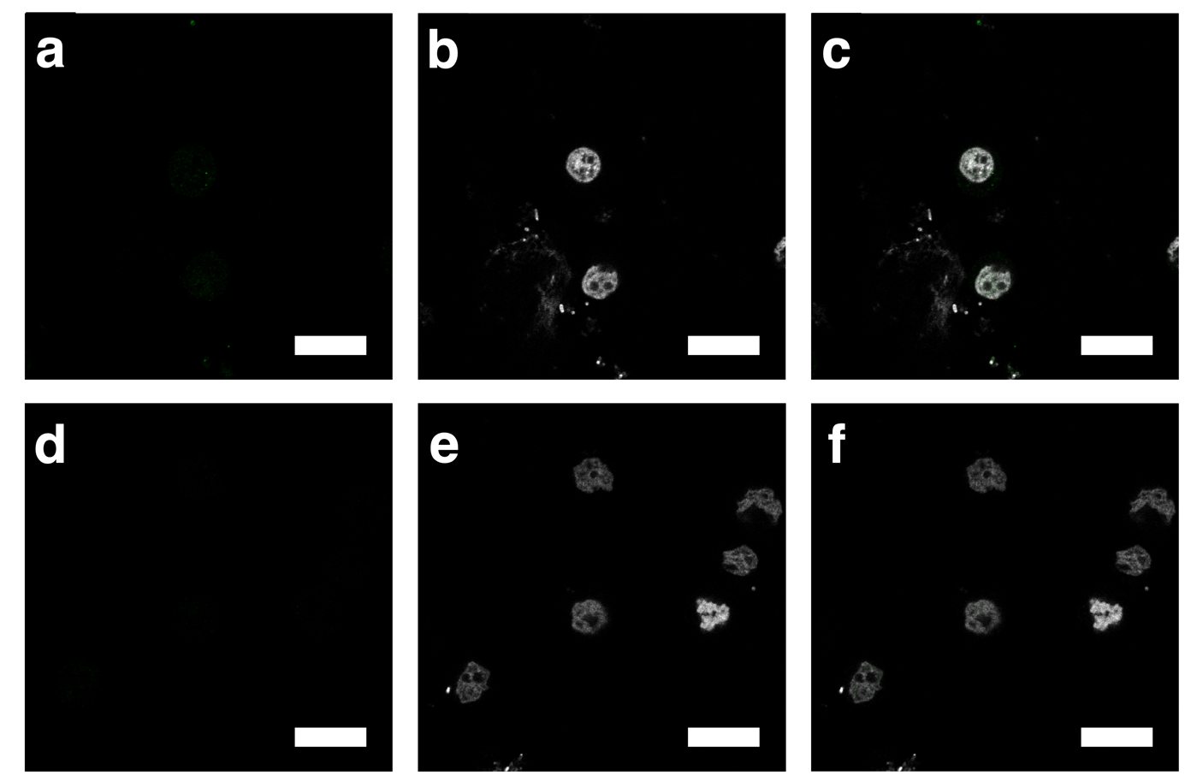

Supplementary Fig. 2 Immunofluorescence staining for ABAT and SV2A in the tumor specimen resected at 14 years of age.

a: ABAT staining (molecular target of valproic acid: 1:200, HPA041528; Atlas Antibodies). b: Nuclei staining. c: Merged image of a and b. d: SV2A staining (molecular target of levetiracetam; 1:100, clone E-8, sc-376234; Santa Cruz Biotechnology). e: Nuclei staining. f: Merged image of d and e. Bars = 20 μm.

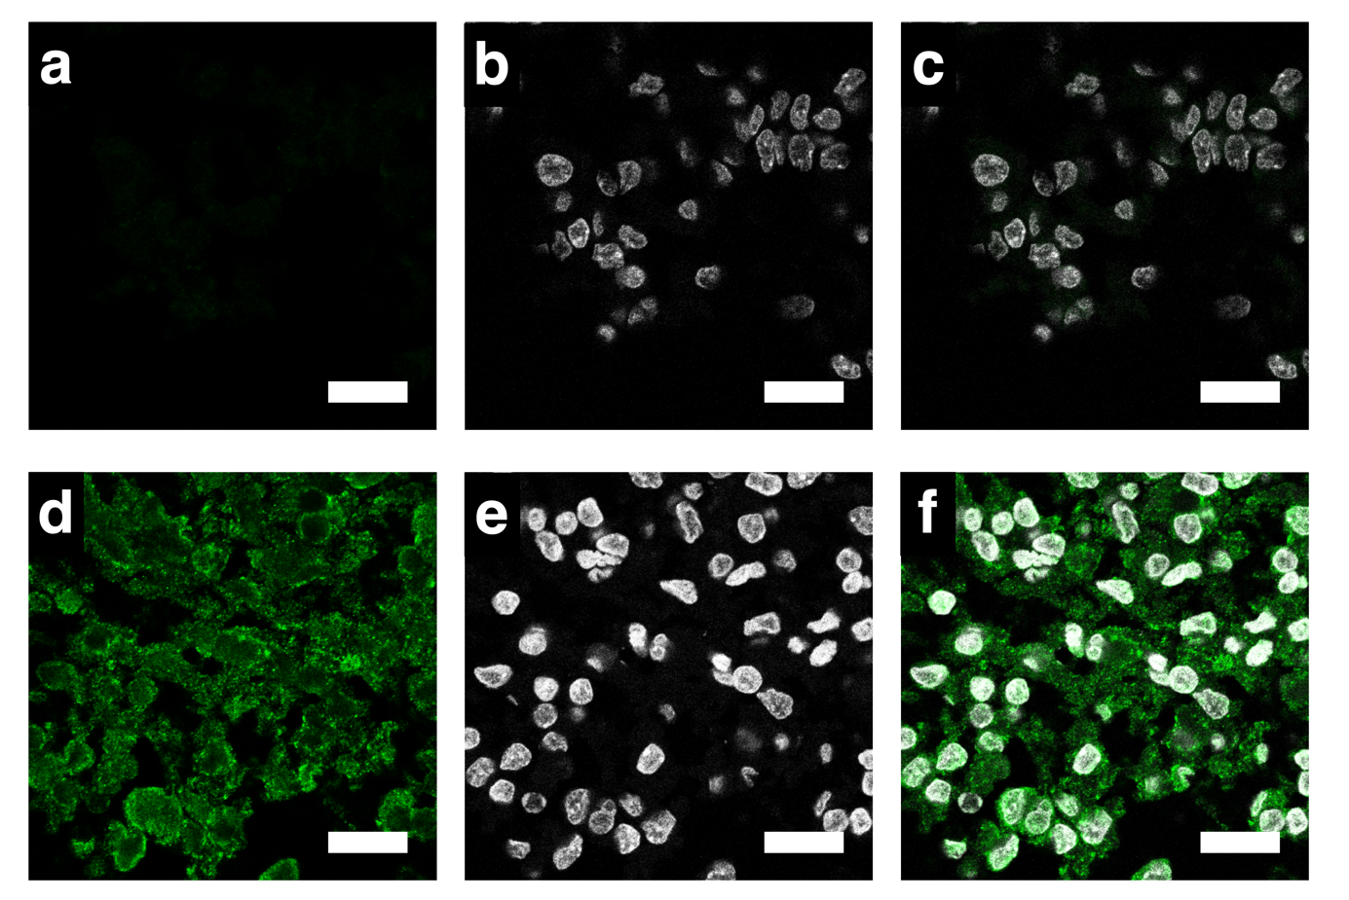

Supplementary Fig. 3 Survival analysis of adult gliomas stratified by receptor-associated gene expression.

a–f: Kaplan–Meier overall survival curves for adult low-grade glioma (LGG) stratified by high versus low gene expression. Among the analyzed genes, high expression of GRIA3 (c) and ABAT (e) (red lines) were significantly associated with overall survival, whereas GRIA1 (a), GRIA2 (b), GRIA4 (d), and SV2A (f) showed no significant association.

g–l: Kaplan–Meier overall survival curves for adult high-grade glioma (HGG) stratified by high versus low gene expression. High expression of GRIA3 (i) and GRIA4 (j) (red lines) was significantly associated with overall survival, while GRIA1 (g), GRIA2 (h), ABAT (k), and SV2A (l) were not significantly associated with prognosis. P values were calculated using the log-rank test.

