Fig4a
Fig4b
Fig4c
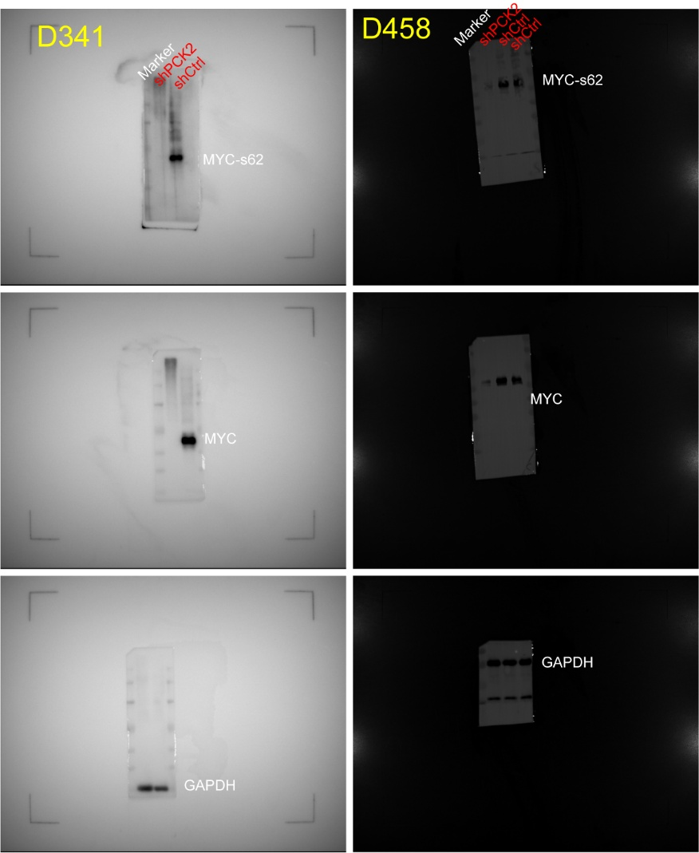
Fig5b
Fig5h
Sup Fig4c

Sup Fig5g
Sup Fig5i

