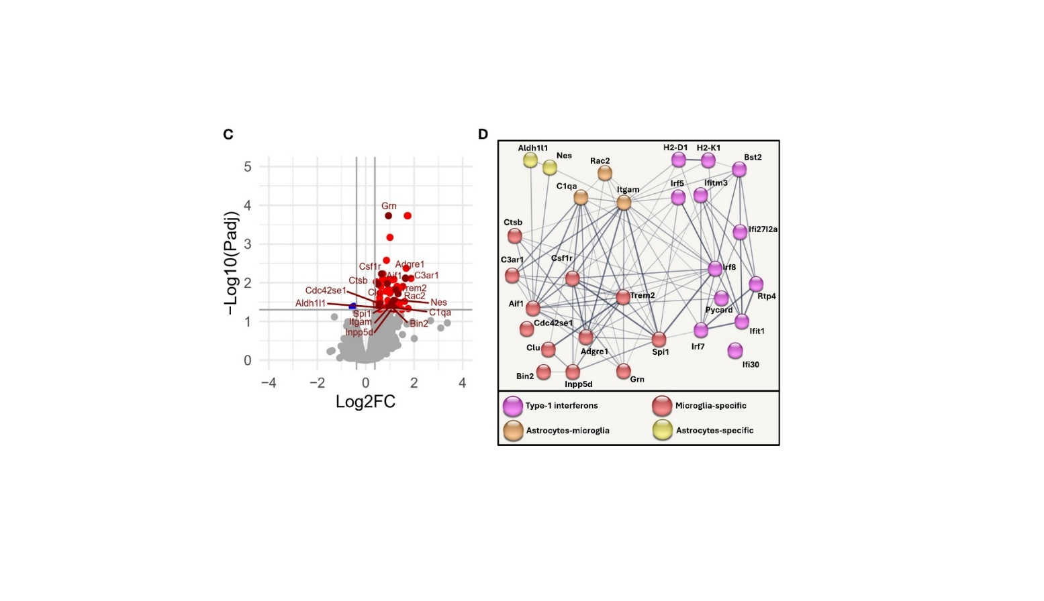
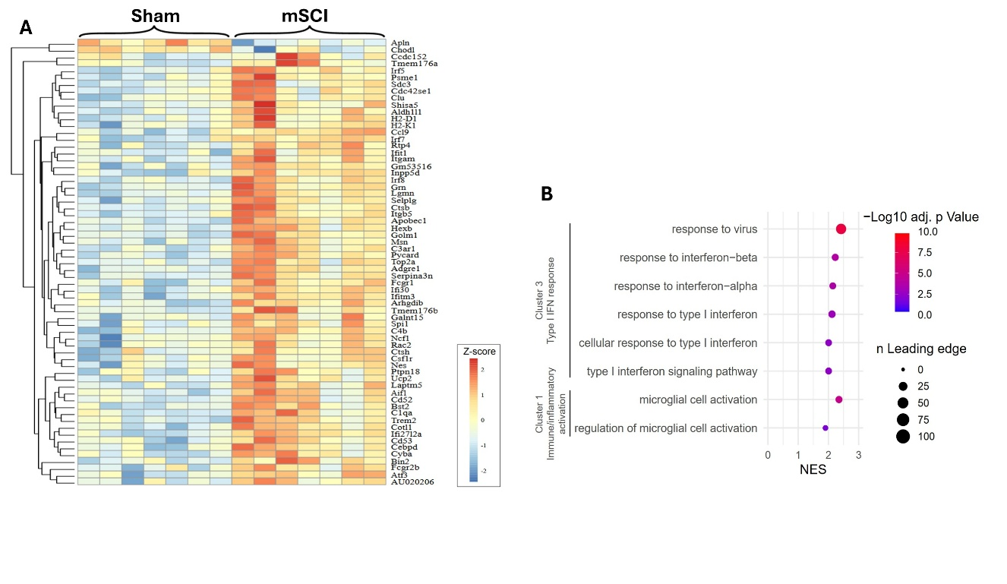
Supplementary Figure S1. Glial activation and Type 1 IFNs are the key pathways early induced following mild spinal cord injury. (A) According to RNAseq analysis with thresholds set at p<0.05 for adj. p-value and ±1.3 for Log2FC, 65 genes are differentially expressed two days following mSCI, compared to sham condition. Each column of the heatmap represents one independent PS19 mouse, each row indicates the relative expression of one gene. Colour scale represents Z-score value (expression – mean expression)/SD). n=7 spinal cords / group. (B) GSEA dot plot showing representative significantly enriched gene sets from gene set cluster 1 and 3 when ranking the differentially expressed genes of 2-day post mSCI vs sham condition. (C) Volcano plot of all detected genes when comparing 2-day post mSCI vs sham condition. Differentially expressed genes (adj. p-value <0.05 and FC > 1.3 or <0.7) are coloured, either in blue for downregulation or red for upregulation. Dots in dark red colour are astrocyte- or microglia-related genes. (D) Gene ontology analysis shows major pathways activated following mSCI: microglia activation (15 genes out of 65) and Type I IFNs (12 out of 65). Network image is generated through STRING online program V12.0. NES: normalized enrichment score.
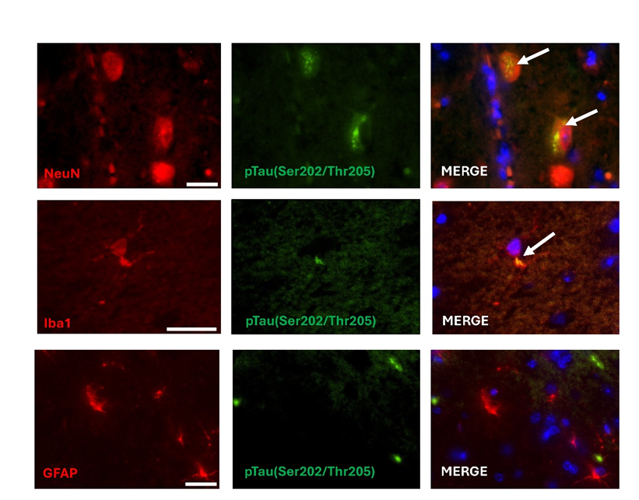
Supplementary Figure S2. pTau immunoreactivity in PS19 spinal cords. Spinal cord tissue sampled at day 126 are immunolabelled using antibodies against NeuN (neurons), Iba1 (microglia), GFAP (astrocytes), pTau(Ser202/Thr205) and Hoechst dye for nucleus staining. As shown by colocalizations (white arrows), pTau accumulation is found in neurons and microglia but not in astrocytes. Scale bar represents 20µm.

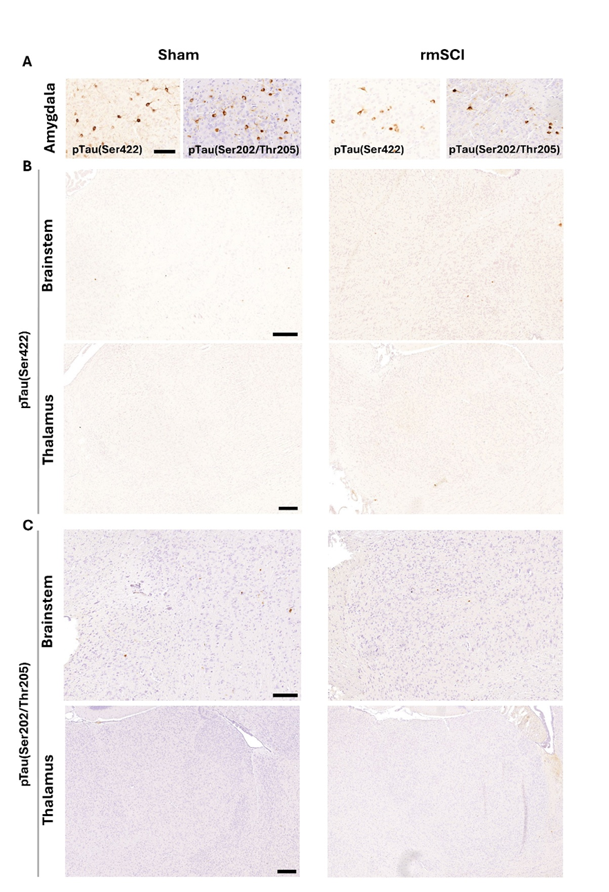
Supplementary Figure S3. Tauopathy signature at day 126 in selected brain regions of PS19 mice. Brain tissues are respectively immunolabelled using antibodies against pTau(Ser422) or pTau(Ser202/Thr205). (A) Obvious phosphorylation of tau is already detected in the amygdala. (B-C) Very few to no immunoreactivity is observed in the brainstem and the thalamus for both epitopes. Scale bars represent 100µm (A) and 200µm (B and C).
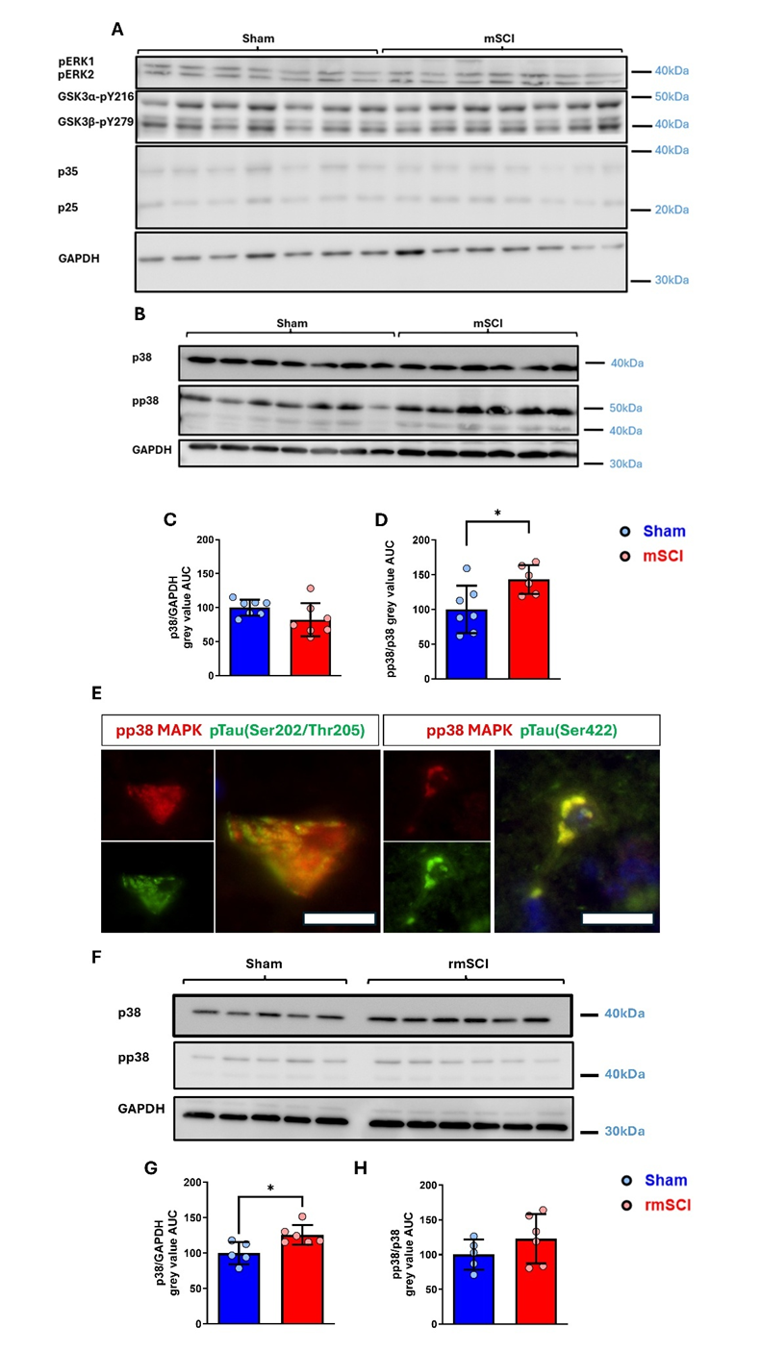Supplementary Figure S4. Tau kinases activation following SCI at day 2 and 126 (A) Activated form of pERK1/2, GSK3α-p216 and GSK3β-p279 and CDK5 cofactors investigated by immunobloting. No difference was observed between sham and mSCI. n=7 spinal cords / group. (B-D) Immunobloting of p38MAPK and pp38MAPK. Significant increase of p38MAPK activation was detected in mSCI group. AUC, area under the curve, n=6-7 spinal cords / group. (E) Representative image of pp38 – pTau(Ser202/Thr205) and pp38 – pTau(Ser422) colocalization observed in spinal cord tissue at day 126. Colocalization was not observed at day 2 since pathological pTau signature cannot be detected in two-month-old PS19 mice. (F) Immunoblotting analysis of p38/pp38 at day 126. Although no difference was detected regarding pp38, a significant increase of total p38 was detected in rmSCI spinal cords. AUC, area under the curve, n=5-6 spinal cords / group. Scale bars represent 20µm. Data are presented as mean ± SD. *p<0.05, two-tailed Mann-Whitney test.

Supplementary Table S1 GSEA results. Table of significantly enriched gene sets identified by GSEA. Gene sets are ranked by decreasing NES value. Clusters of similarity for each positively enriched gene set is indicated.

