Pathway / programme | Associated genes
Mitochondrial gene expression | TFAM, POLRMT, TFB1M, TFB2M, LRPPRC, PNPT1, SUPV3L1, FASTKD2, FASTKD5, GRSF1, MRPL12, MRPL11, MRPL18, MRPS22, MRPS27, DAP3, TUFM, TSFM, GFM1, GFM2, MTERF1, MTERF3, NRF1, GABPA, GABPB1, PPARGC1A, SIRT3, HSPD1, HSPE1, LONP1
Mitochondrion organisation | TOMM20, TOMM40, TOMM22, TIMM23, TIMM44, TIMM8B, TIMM17A, TIMM50, SAMM50, CHCHD3, CHCHD6, OPA1, MFN1, MFN2, DNM1L, FIS1, MFF, MID49, MID51, YME1L1, OMA1, IMMT, ATG32, PINK1, PRKN, BNIP3, BNIP3L, PHB1, PHB2, SLC25A4, SLC25A5
Cellular redox homeostasis | PRDX1, PRDX3, PRDX5, SOD1, SOD2, CAT, TXN, TXN2, TXNRD1, TXNRD2, GPX1, GPX4, GLRX, GLRX2, GSR, NQO1, HMOX1
Pro-apoptotic signaling | TP53, BBC3, PMAIP1, BAX, BAK1, BID, BCL2L11, APAF1, CASP9, CASP3, CYCS, DIABLO, AIFM1, ENDOG, JUN, FOS, DDIT3, ATF4, EGR1, GADD45A, GADD45B
Muscle structure development | ACTC1, ATF3, FOS, IGF2, MEF2C, MYH9, NOS1, PAX6, PTK2, SNAI2, SOX2, VCL
Vasculature development | ANXA2, CCN2, EPHB1, CCN1, MEF2C, MYH9, PAX6, PTK2, RGMA, ROBO4, SOX2, THY1, VCL
Extracellular matrix (ECM), core set | BGN, COL15A1, COL4A1, COL4A2, COL6A1, COL6A2, COL6A3, DCN, FN1, HSPG2, LAMA2, LAMB1, LAMB2, LAMC1, LUM, NID1, NID2, SDC4, SPARC
ECM - basement membrane | LAMC1, DAG1, COL4A3, LAMB2, COL4A5, LAMA4, HSPG2, COL4A1, COL4A2, LAMA2
ECM - fibrillar collagens | COL1A2, COL14A1, COL3A1, COL1A1, COL5A1, COL12A1, COL15A1
ECM - collagen VI / myomatrix | COL6A2, COL6A1, COL6A3
ECM - proteoglycans | GPC1, BGN, SDC3, HSPG2, SDC4, DCN
ECM - glycoproteins / matrisome | VWF, EMILIN1, FBLN1, SPARC, POSTN, FN1, TNC, FBLN2, FBLN5
ECM - fibronectin matrix / wound healing | CCN2, POSTN, FN1, TIMP1, TNC, SERPINH1, MMP2
ECM -remodelling enzymes | ADAMTS1, P4HA1, PLOD1, TIMP1, TIMP2, SERPINH1, MMP2, TIMP3
ECM – cell-matrix adhesion receptors | ITGA6, ITGAV, DAG1, ITGA7, ITGA5, CD44, ITGB1, SDC4
Neuromuscular junction development | ACHE, CHRNA1, CHRNB1, CHRND, CHRNG, COLQ, DOK7, LRP4, MUSK, RAPSN, AGRN
Regulation of MAPK cascade | MAPK1, MAPK3, MAPK8, MAPK9, MAPK14, MAP2K1, MAP2K2, MAP2K3, MAP2K4, MAP2K6, MAP2K7, RAF1, BRAF, KRAS, HRAS, NRAS, FGFR1, EGFR, PDGFRA, PDGFRB, GRB2, SOS1, DUSP1, DUSP5, DUSP6, SPRY2, SPRY4, EGR1, EGR2, EGR3, FOS, JUN, MYC
ERK core/upstream | FGFR1, PDGFRA, PDGFRB, GRB2, RAF1, BRAF, MAP2K1, MAP2K2, MAPK1, EGR1, EGR3, FOS, JUN, JUNB, MYC, DUSP6
p38 stress/inflammatory | MAP3K7, MAP2K3, MAPK14, MAPK12, MAPKAPK2, MAPKAPK3, ATF3, DDIT3, GADD45A, GADD45B, GADD45G, HSPB1, MEF2C, MEF2D, DUSP1
JNK/AP-1 | MAP2K7, JUN, JUNB, JUND, FOS, ATF3, EGR1, DDIT3, GADD45B, GADD45G
Cytokine production | CCL3, IL6R, IL6ST, TNFRSF1A, IFNGR1, IFNGR2, TICAM1, TLR2, TLR4, MYD88, IRAK1, TRAF6, NFKB1, RELA, STAT1, STAT3, IRF1, IRF7, CXCL8, IL1B, TNF, CEBPB, CEBPD, PTGS2
Tissue injury / inflammatory remodelling signalling | ATF3, FOS, JUN, HSPB1, STAT3, CEBPB, CEBPD, DDIT3, GADD45B, GADD45G, IL6ST, TNFRSF1A, NFKB1, RELA, PTGS2
Supplementary Material 1: Curated pathway gene sets used for AOI-level pathway scoring. Curated gene sets used to calculate AOI-level pathway scores in the spatial transcriptomic analysis. Pathways were selected from Gene Ontology (GO) Biological Process terms or from closely related biologically curated programmes relevant to LOPD pathology. AOI-level pathway scores were calculated as the mean log2 expression of the genes included in each set. The full list of pathways and associated genes is provided below. Definitions of GO-derived pathways should be referred to the Gene Ontology (GO) Biological Process resource.

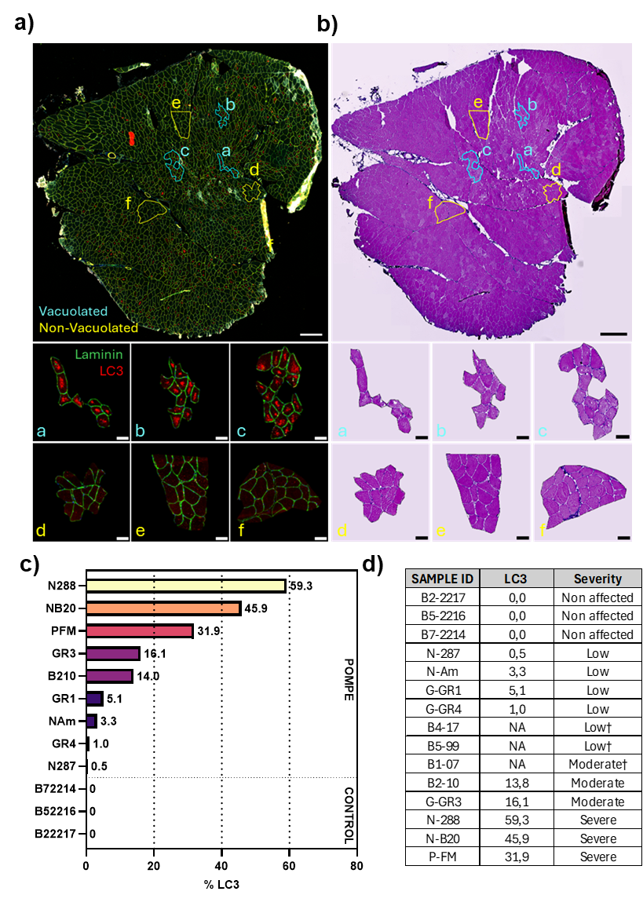
Supplemental Figure S1: Selection of region of interest (ROI) vacuolated or not in Pompe skeletal muscle tissue. (a) Representative image of Pompe muscle tissue and ROIs selected with GeoMx DSP. Cross-section were stained with laminin (green) and LC3 (red) antibodies to visualize fibre contours and autophagic vacuoles respectively. Muscle scale : 500μm. ROI scale: 50μm. (b) Haematoxylin and eosin (H&E) image of cross section used with GeoMx DSP. (c) Percentage of LC3B staining in Pompe biopsies. 3 muscles B107, B599, B417 were not analysed because of varying quality staining across the section. (d) Samples classification ≤10% ; Moderate between 10%-30% ; Severe ≥30%, † evaluated by eyes with Haematoxylin and Eosin staining.

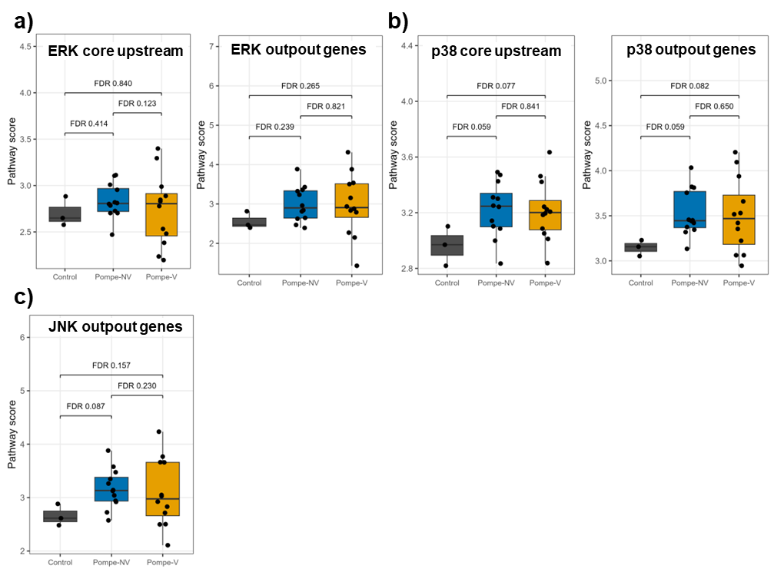
Supplemental Figure S2: Branch-specific MAPK pathway scores in control and Pompe muscle. Pathway scores for (a) ERK-related programmes, including ERK core upstream and ERK output genes (left and right panels), (b) p38-related programmes, including p38 core upstream and p38 output genes, and (c) JNK output genes across Control, Pompe-NV and Pompe-V samples across Control, Pompe non-vacuolated (Pompe-NV) and Pompe vacuolated (Pompe-V) samples. Each dot represents one sample; boxplots show median and interquartile range. FDR-adjusted P values for pairwise group comparisons are shown above brackets. A JNK core upstream score is not shown because only one corresponding gene was detected in the dataset.

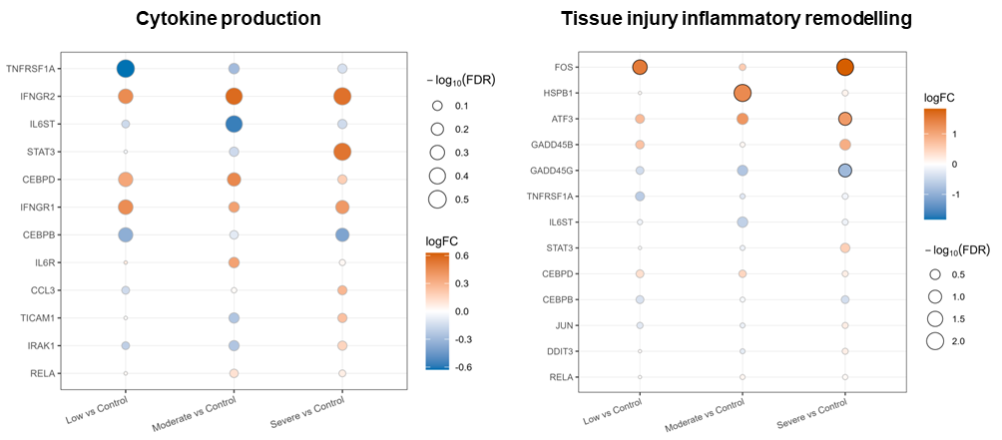
Supplemental Figure S3: Gene-level changes in cytokine production and tissue injury / inflammatory remodelling programmes across LC3-defined severity groups. Dot heatmaps showing differential expression of genes associated with cytokine production and tissue injury / inflammatory remodelling signalling in low, moderate, and severe samples, each compared with Control. Dot colour indicates logFC, dot size indicates −log10(FDR), and black outlines mark genes with FDR < 0.10.

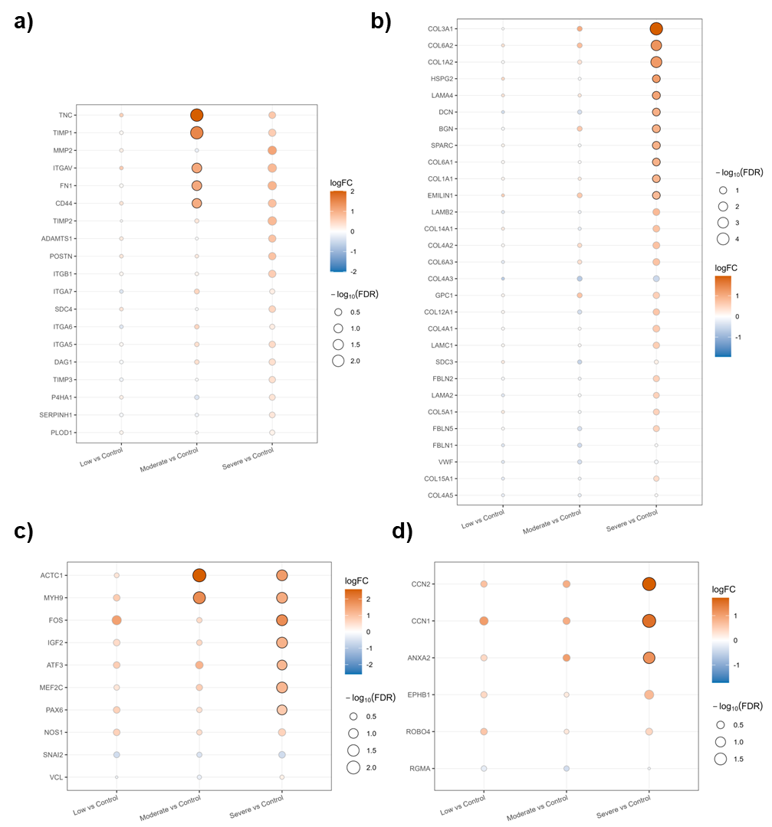
Supplementary Fig. S4: Gene-level changes in structural, vascular, and extracellular matrix programmes across LC3-defined severity groups. Dot heatmaps showing differential expression of genes associated with muscle structure development, vasculature development, ECM structural scaffold, and ECM remodelling in low, moderate, and severe samples, each compared with Control. Analyses were performed on GeoMx Whole Transcriptome Atlas AOIs using limma with duplicateCorrelation to account for multiple AOIs from the same patient. Dot colour indicates logFC, dot size indicates −log10(FDR), and black outlines mark genes with FDR < 0.10.

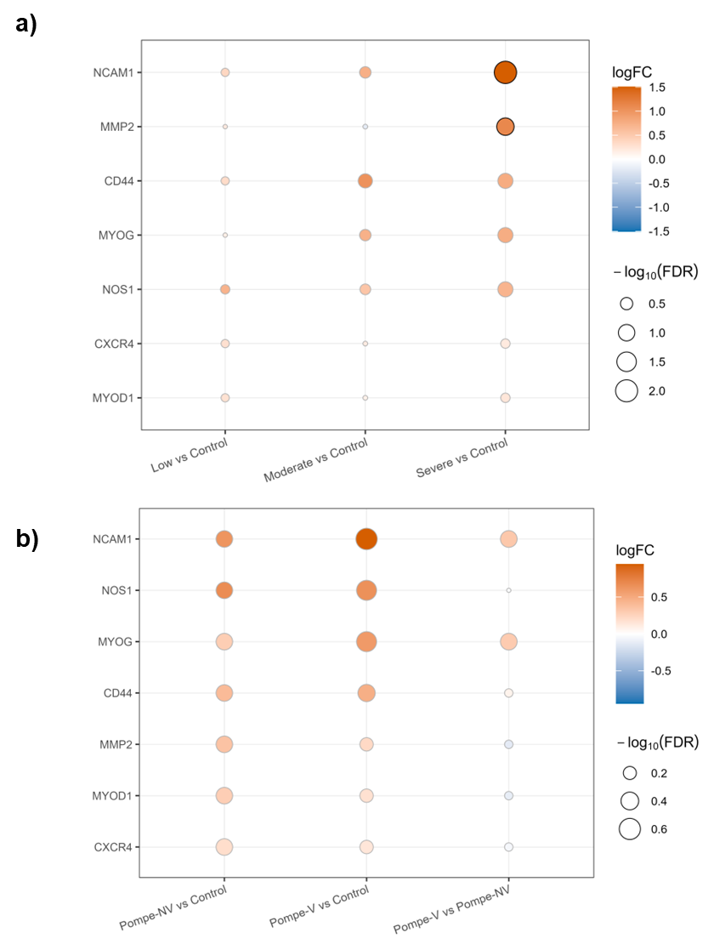
Supplementary Fig. S5: Gene-level changes in nitric oxide, matrix remodelling, and satellite cell-associated markers across disease progression. Dot heatmaps showing differential expression of satellite cell activation-associated markers, across (a) LC3-defined severity groups (low, moderate, and severe, each compared with Control) and (b) across histological groups (Control, Pompe-NV and Pompe-V). Dot colour indicates logFC, dot size indicates −log10(FDR), and black outlines mark genes with FDR < 0.10.

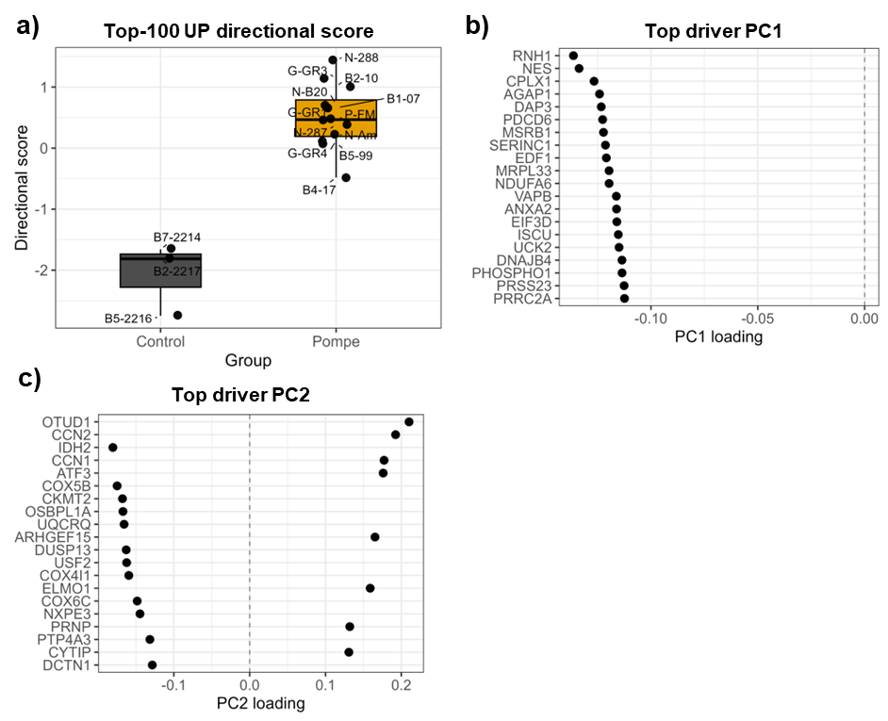
Supplemental Figure S6: Directional score based on the TOP-100 Pompe-upregulated genes and principal component driver genes. (a) Directional score computed per patient from the TOP-100 genes upregulated in Pompe versus Control. Each point represents one patient (mean expression across AOIs) and the boxplot summarises group distributions (Control vs Pompe); higher scores indicate stronger concordance with the Pompe-upregulated signature. Patient identifiers are shown. (b) Top driver genes for PC1 from the patient-level PCA performed on the TOP-100 Pompe-upregulated genes. Genes are ranked by loading magnitude and plotted as PC1 loadings (subset shown; loadings computed on all TOP-100 genes). The dashed vertical line indicates zero loading. (c) Top driver genes for PC2 shown as PC2 loadings using the same PCA and ranking approach as in (b). Positive and negative loadings indicate opposing contributions to PC2; the dashed vertical line indicates zero loading.

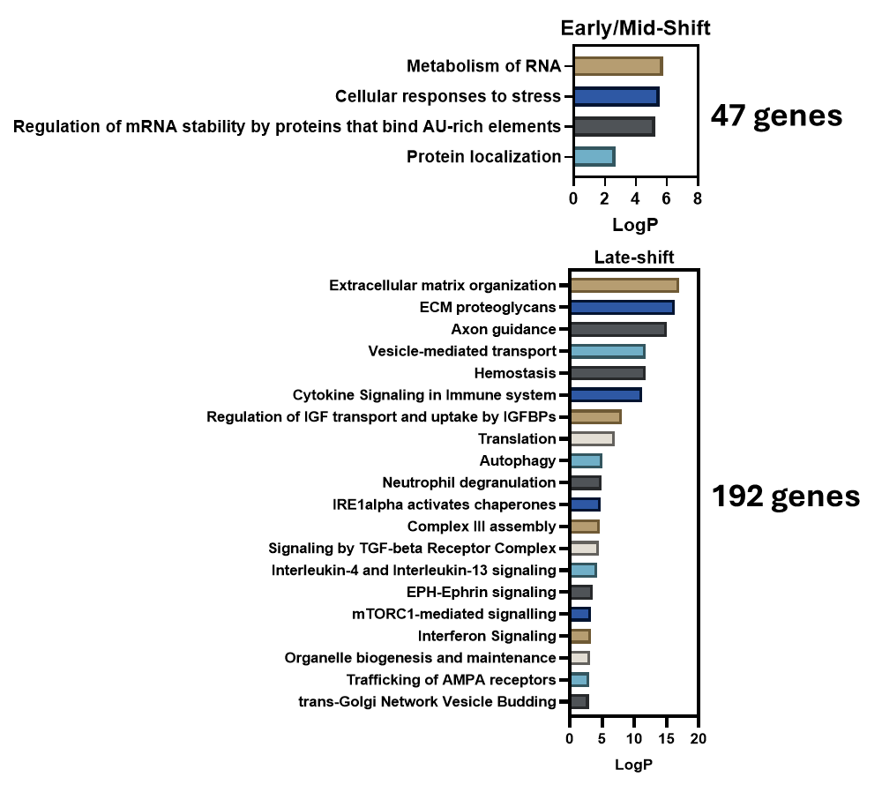
Supplementary Figure S7: Functional enrichment of dynamic gene programmes along the PC1-based pseudotime trajectory. Gene expression was modelled along the patient-level pseudotime trajectory using a generalized additive mixed model, and dynamic genes were assigned to Early/Mid-shift or Late-shift groups according to the pseudotime position of their maximal rate of change.

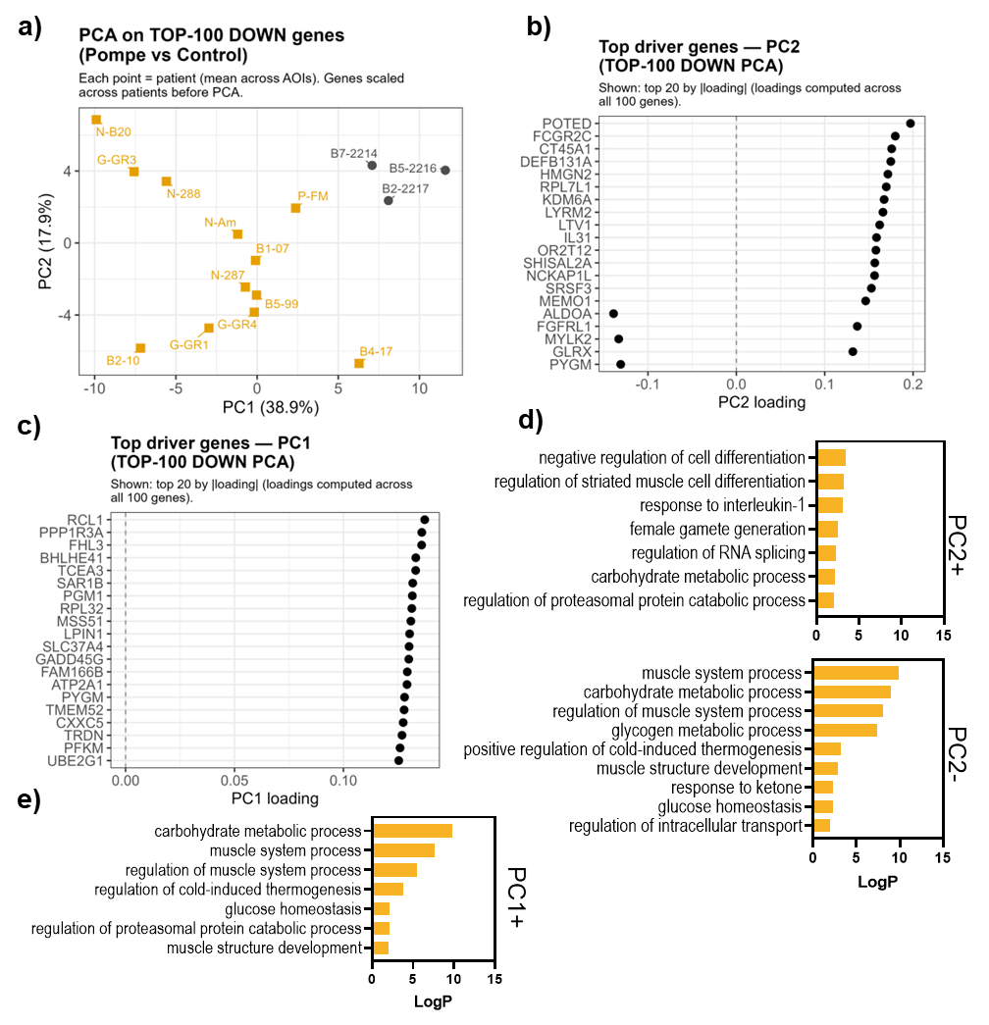
Supplemental Figure S8: PCA of Pompe-downregulated genes highlights metabolic and muscle-identity programs contributing to patient separation. (a) Patient-level PCA performed on the TOP-100 genes downregulated in Pompe versus Control. Each point represents one patient (mean expression across AOIs); gene expression was z-scored across patients before PCA. Patient identifiers are shown, and axes indicate the percentage variance explained by PC1 and PC2. (b) Top driver genes for PC2 from the TOP-100 DOWN PCA. Genes are ranked by loading magnitude and plotted as PC2 loadings (top 20 shown; loadings computed using all 100 genes). The dashed vertical line indicates zero loading. (c) Top driver genes for PC1 shown as PC1 loadings using the same approach as in (b). (d) Gene Ontology biological process enrichment of PC2-directional gene sets derived from PCA loading signs (PC2+ and PC2−). Bars represent enriched terms ranked by significance. (e) Gene Ontology biological process enrichment of PC1-directional gene sets derived from PCA loading signs (PC1+ shown). Bars represent enriched terms ranked by significance.

