Supplementary Information

Study cohorts

We assembled and analyzed a post-mortem tissue cohort of 53 individuals, balanced for gender (c²=3.189, df=1, p=0.074; Chi-squared test) with 33 males and 20 females. Amongst the 53 individuals, 33 were people who died of non-neurological diseases aged between 40 and 73 years old at death, and whose brains were collected as part of the sudden death brain bank. Ten of the 53 individuals were diagnosed with ALS, which was confirmed at post-mortem, with a further 10 individuals diagnosed with AD during life and confirmed at postmortem. To compare aspects of TDP-43 pathology across aging and neurodegenerative diseases we established 4 study cohorts (see Table 1): (i) a young “<60s cohort” consisting of 19 individuals aged 40-59 years (median=50; IQR=47.5-57) at autopsy; (ii) an older “≥60s cohort” consisting of 14 individuals aged 60-74 years (median=69; IQR=63.5-71.8) at autopsy; (iii) an “ALS cohort” consisting of 10 individuals aged 61-80 years (median=70.5; IQR=65.5-74.5) at autopsy; and (iv) an “AD cohort” consisting of 10 individuals aged 69-84 years (median=74; IQR=72-77.2) at autopsy; see figure 1A for an illustration of the study design (with cohorts and histological investigation information) and Table 1 for a detailed demographic summary. Our a priori rationale for dividing our aging cohorts into <60s and ≥60s was as follows; 1) the median age of at death for control aging brains was 58 (IQR: 50.0-67.0), so a sixth-decade cut-off facilitated the most statistical power to perform inferential analyses (in addition to investigations of the relationship between normal aging and TDP-43 pathology) investigating differences in aspects of TDP-43 brain pathology between “younger” and “older” control brains, and 2) There is extensive evidence of significant aging-related changes in brain health and biology begin to occur in the sixth decade¹⁻⁵.

To understand aspects of TDP-43 pathology across aging and neurodegenerative diseases, it is necessary to consider the potential confounding factors of sex, and age at death, differences between study groups. The four study cohorts (<60s, ≥60s, ALS and AD) were balanced for gender (c²=2.695, df=3, p=0.441; Chi-squared test; see Table 1). Data exploration of age at death indicated homogeneity of variances for both mean (F=0.424, df=3,49, p=0.752; Levene’s test; see Table 1), and median (F=0.285, df=3,49, p=0.836; Levene’s test; see Table 1), across all four study cohorts. Amongst the four study groups however, age at death was not normally distributed for AD (W=0.815, n=10, p=0.022; Shapiro test; see Table 1). Therefore, medians with interquartile ranges are reported for summaries of age at death for study cohorts, and (conservatively, and for consistency) non-parametric statistics were employed throughout when comparing age distributions between study cohorts.

As expected, median age at death differed between study groups (c²=39.272, df=3, p<0.001; Kruskal-Wallis rank sum test; see Table 2; Suppl. Fig. 1A). Pairwise Dunn’s post hoc statistics comparing median age at death between cohorts are presented in Table 2 - there were no significant differences in age at death between ALS and AD (z=1.051, p=0.880; Dunn’s test), but also between ≥60s and ALS (z=0.678, p=1; Dunn’s test), and ≥60s and AD (z=1.813, p=0.210; Dunn’s test). Age at death was significantly lower for the <60s cohort compared with ≥60s (z=4.017, p<0.001; Dunn’s test), but also for both ALS (z=4.340, p<0.001; Dunn’s test) and AD (z=5.543, p<0.001; Dunn’s test) (see Table 2; Suppl. Fig. 1A).
Ferritin level differences are brain region-specific in aging and disease

Because brain ferritin accumulated iron can be measured by MRI, we need to understand brain region differences in aging and disease. In addition to the analyses comparing ferritin levels across all four cohorts (<60s, ≥60s, AD, ALS) together, we analysed aging- and disease-comparable groups separately here, but without significant differences in results.

To do these analyses we tested brain-region specific aging-related differences in ferritin levels between <60s and ≥60s (“Aging Comparison), and disease-related differences in ferritin levels between AD, ALS and the age-matched ≥60s cohort (Disease Comparison).

No evidence for non-normality in ferritin level data was uncovered for <60s, ≥60s, AD or ALS cohort by Shapiro-Wilk tests, however inequality of variances amongst groups in the “Aging comparison” between <60s and ≥60s (F=8.547, df=1,30, p=0.007; Levene’s test), and in the “Disease Comparison” between AD, ALS and ≥60s (F=5.1855, df=2,29, p=0.012; Levene’s test), informed our non-parametric approach here.

Hippocampus ferritin is an AD-specific marker of disease

Amygdala ferritin levels similar across aging and disease
Amygdala median ferritin levels were higher in ≥60s than in <60s but this difference was not significant (W=86, p=0.091; Wilcoxon rank sum test) (Suppl. Fig. 2). No significant difference in amygdala ferritin levels between AD, ALS or age-matched ≥60s (c²= 2.059, df=2, p= 0.357; Kruskal-Wallis rank sum test) was revealed (Suppl. Fig. 2).

Higher hippocampus ferritin levels is a disease-specific signature of AD
Hippocampus median ferritin levels were higher in ≥60s than in <60s but this difference was not significant (W=151, p=0.305; Wilcoxon rank sum test) (Suppl. Fig. 2). However, hippocampus ferritin levels were significantly different in the disease comparison between AD, ALS, and age-matched ≥60s (c²= 9.502, df=2, p= 0.009; Kruskal-Wallis rank sum test) (Suppl. Fig. 2). Here, for AD significantly higher hippocampus ferritin levels were increased compared to age-matched (i.e. ≥60s) controls (z= 3.08, p= 0.006; Dunn’s test).

Hippocampus ferritin levels in ALS were lower but not significantly different to AD (z= 1.54, p= 0.372; Dunn’s test), or significantly different compared to age-matched ≥60s (z=1.45 =, p= 0.455; Dunn’s test) (Suppl. Fig. 2).

Higher frontal cortex ferritin levels in disease are likely a function of aging
Frontal cortex median ferritin levels were higher in ≥60s than in <60s (W=180, p=0.030; Wilcoxon rank sum test) (Suppl. Fig. 2), however but not significantly different in the disease comparison between AD, ALS or age-matched ≥60s cohorts (c²=4.094, df=2, p= 0.129; Kruskal-Wallis rank sum test).
Brain region ferritin is a viable biomarker for concurrent TDP-43 pathology

Model selection and interrogation
To investigate the relationship between ferritin immunoreactivity (predictor) and TDP-43 pathology burden (outcome) across brain regions in neurodegenerative disease and aging, we used multivariable interaction linear regression modelling. An initial maximal model was fitted including ferritin intensity, cohort, brain region, and their interactions (TDP-43 ~ Ferritin × Cohort x Brain region). Ferritin intensity (F1,146=236.84, p< 0.001) and cohort (F3,146=127.28, p< 0.001) were both highly significant predictors of TDP-43 pathology burden, whereas brain region was not a significant independent predictor (F2,146=0.99, p=0.375). A significant Ferritin × Cohort interaction was observed (F3,146=16.14, p< 0.001), indicating that the relationship between ferritin and TDP-43 pathology differed between cohorts.

Because brain region did not significantly contribute additional explanatory power after accounting for ferritin intensity and cohort effects, and there was no evidence that brain region substantially modified the association, the final model was simplified to include ferritin, cohort, and their interaction (TDP-43 ~ Ferritin * Cohort). The final model was highly significant (F7,148=96.84, p<0.001) explaining 81.2% of the variance in TDP-43 pathology burden (R2Adj.=0.812). In this model, both ferritin intensity (F1,148=239.97, p< 0.001) and cohort (F3,148=128.97, p< 0.001) remained highly significant predictors of TDP-43 pathology burden, and the Ferritin × Cohort interaction also remained highly significant (F3,148=17.00, p< 0.001). To characterise these effects, cohort-specific simple slope estimates (β), 95% confidence intervals, and associated p-values were extracted from the fitted interaction model. We then carried out brain region-specific Ferritin × Cohort linear regression analyses to determine whether the strength and significance of these cohort-specific ferritin–TDP-43 relationships differed between the amygdala, frontal cortex, and hippocampus.

Supplementary Tables

Supplementary Table 1. Unadjusted linear regression statistics quantifying within-cohort associations between ferritin intensity and TDP-43 pathology burden. Separate simple linear regression models were performed for each brain region and cohort combination (TDP-43 ~ Ferritin) to characterise the unadjusted relationship between ferritin intensity (predictor) and TDP-43 pathology burden (outcome). The table presents overall regression statistics, including F-statistic, degrees of freedom, exact model p-value, and adjusted R² together with regression slope estimates (β), standard errors (SE), and associated p-values. Positive β values indicate that increased ferritin intensity was associated with increased TDP-43 pathology burden within the corresponding cohort and brain region. These analyses represent descriptive within-group associations and do not account for cohort effects or ferritin × cohort interactions. Scatterplots with regression lines, adjusted R² values, and p-values are presented in Supplementary Figure 3A, and forest plots of regression slope estimates with 95% confidence intervals are presented in Supplementary Figure 3B.

Supplementary Table 1. Regression statistics quantifying how variation in ferritin contributes to TDP-43 pathology burden (TDP-43 ~ Ferritin)
 |  | Linear regression model (Ferritin ~ TDP-43) statistics |  |  |  | Regression slope coefficients & p-values
Cohort | Region | F | df | p-value  (exact) | R² adjusted | Estimate | SE | p-value  (significant)
<60s | Amygdala | 3.07 | 1,17 | 0.0976 | 0.103 | -0.791 | 0.45102 | 0.098
≥60s | Amygdala | 0.65 | 1,12 | 0.4345 | -0.027 | 0.168 | 0.2083 | 0.435
AD | Amygdala | 18.82 | 1,8 | 0.00248 | 0.664 | 1.764 | 0.4066 | < 0.01**
ALS | Amygdala | 59.62 | 1,8 | 0.00006 | 0.867 | 0.875 | 0.11331 | < 0.001***
<60s | Hippocampus | 1.07 | 1,17 | 0.316 | 0.004 | -0.359 | 0.34739 | 0.316
≥60s | Hippocampus | 2.28 | 1,11 | 0.15909 | 0.097 | 0.312 | 0.20688 | 0.159
AD | Hippocampus | 7.64 | 1,8 | 0.0245 | 0.425 | 0.932 | 0.33724 | < 0.05*
ALS | Hippocampus | 3.98 | 1,8 | 0.0811 | 0.249 | 0.870 | 0.43587 | 0.081
<60s | Frontal cortex | 0.04 | 1,17 | 0.847 | -0.056 | -0.072 | 0.36726 | 0.847
≥60s | Frontal cortex | 21.38 | 1,11 | 0.00073 | 0.629 | 0.447 | 0.09657 | < 0.001***
AD | Frontal cortex | 0.14 | 1,7 | 0.723 | -0.121 | 0.670 | 1.8133 | 0.723
ALS | Frontal cortex | 41.39 | 1,8 | 0.00020 | 0.818 | 1.084 | 0.16853 | < 0.001***
Scatterplots with R2 and p-values are presented in Figure 5A.
Forest plots of regression slope estimates with SE are presented in Figure 5B

Supplementary Figure 1

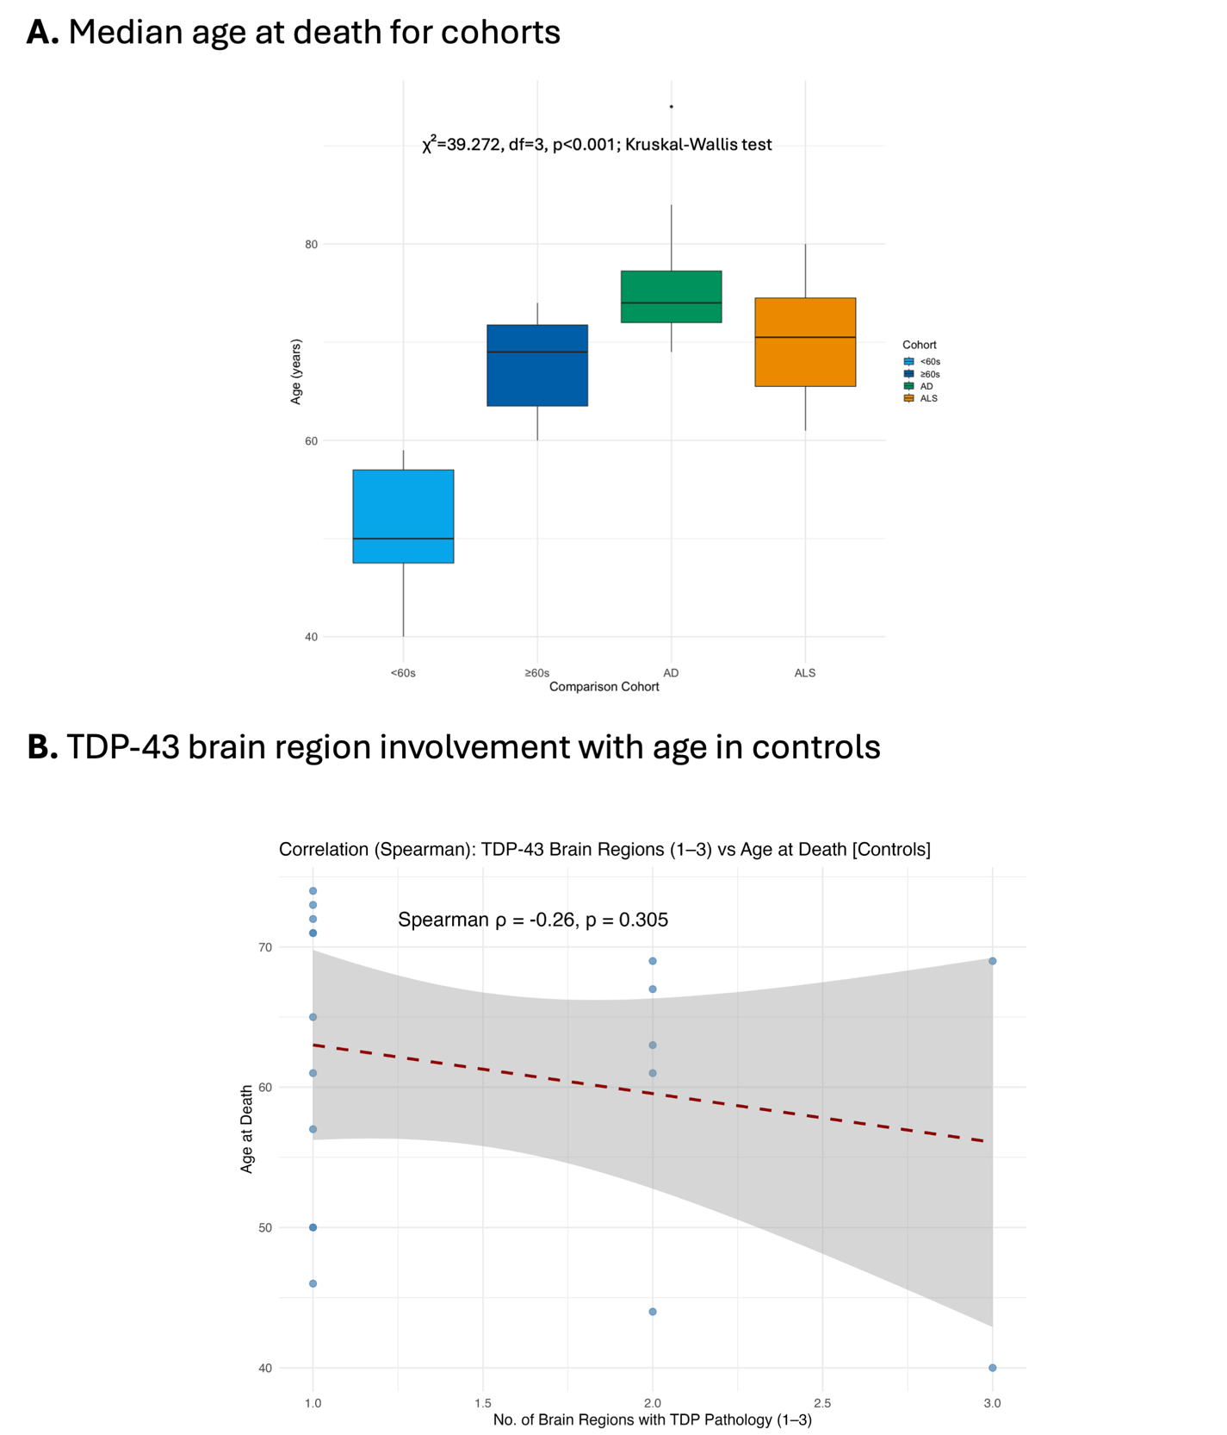

Supplementary Figure 1. A, Median age at death boxplots for each of the four study cohorts (<60s, ≥60s, ALS and AD) (see also table 2). B, TDP-43 brain region involvement with age in aging controls.
Supplementary Figure 2

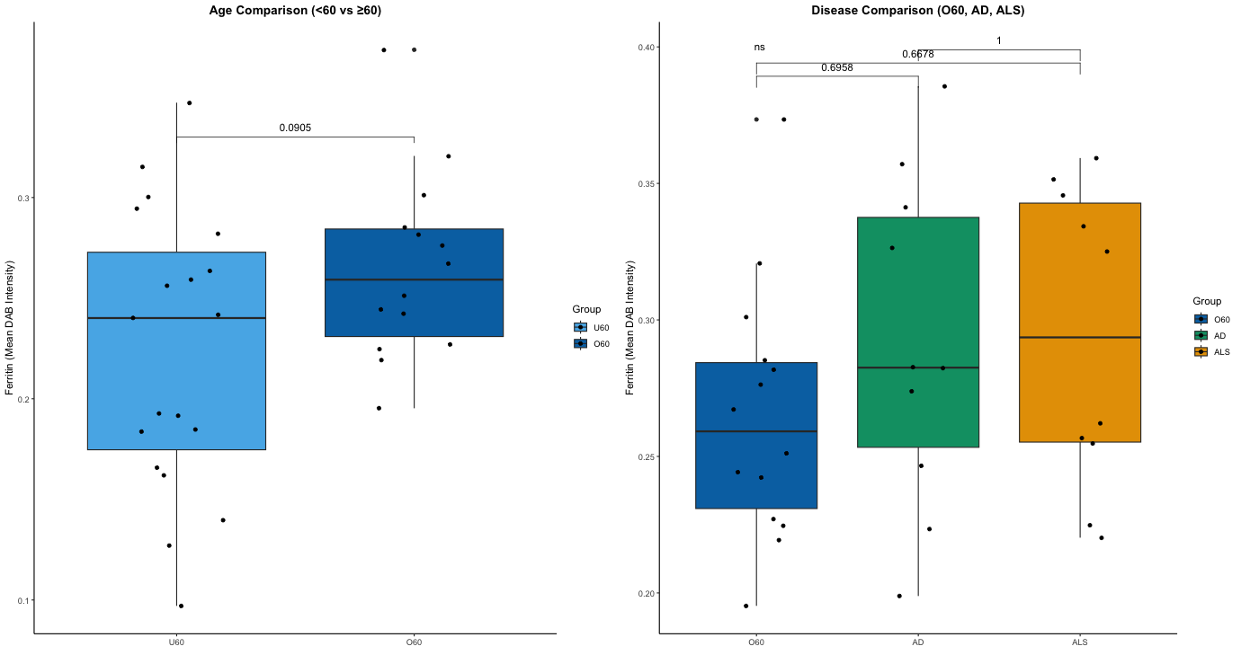
Amygdala
B
A

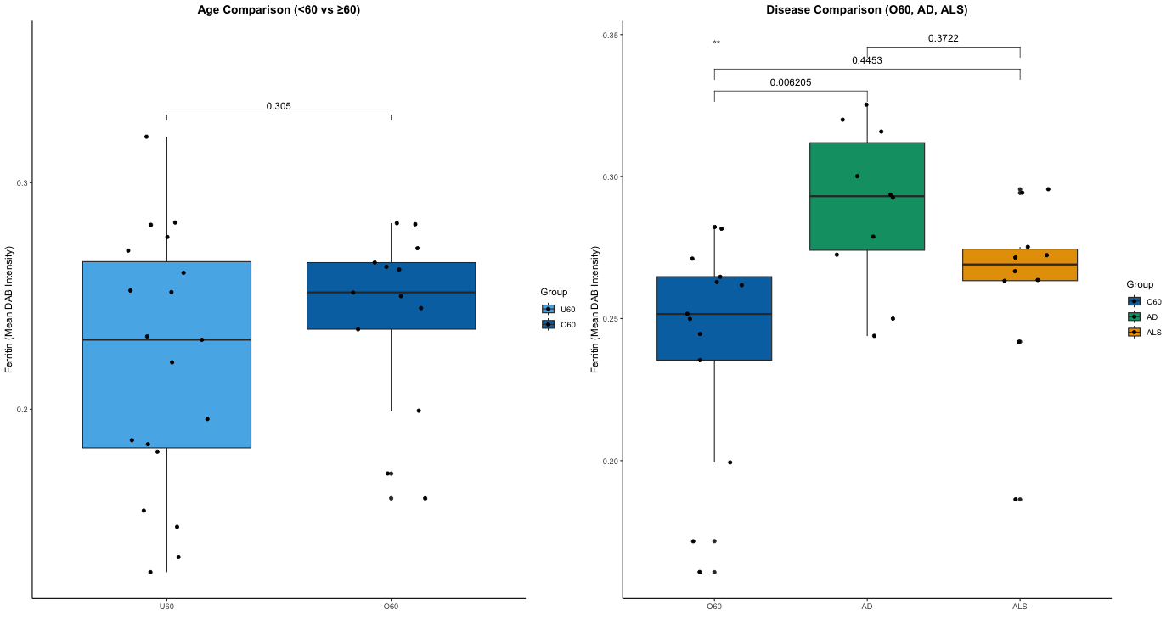
Hippocampus
C

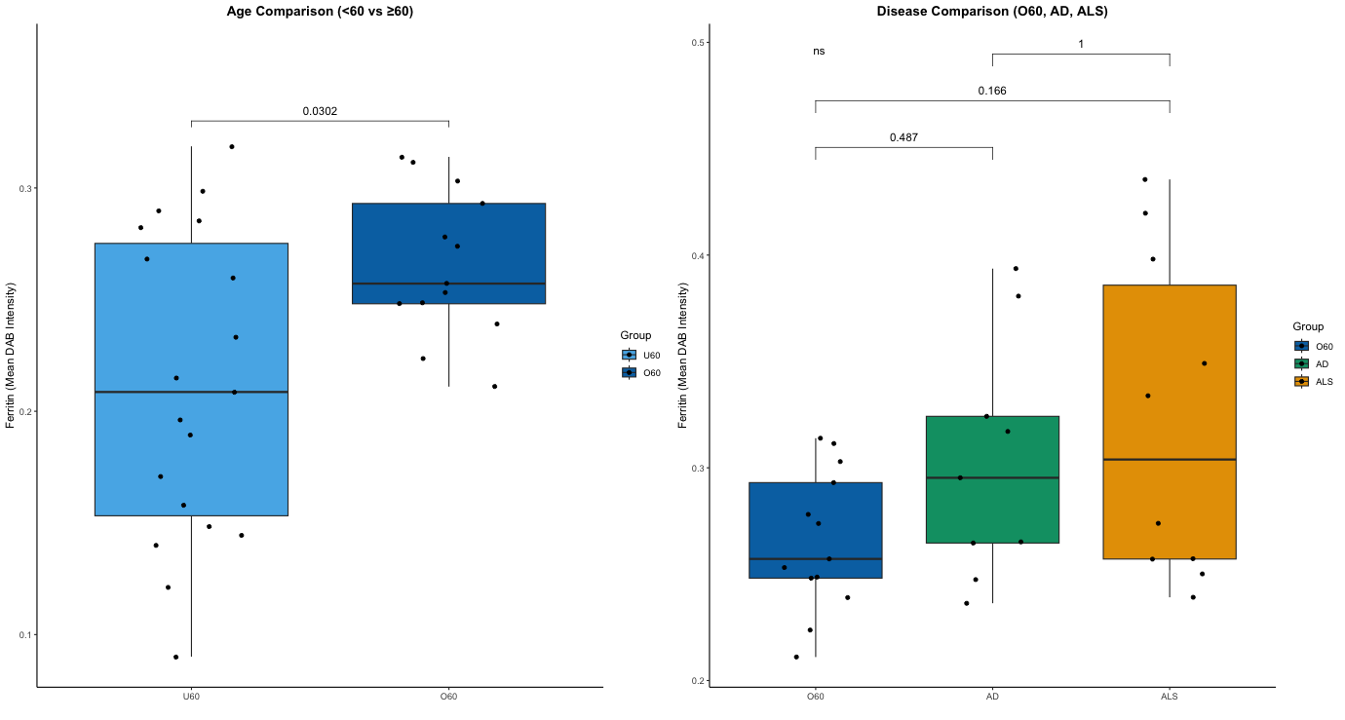
Frontal cortex

Supplementary Figure 2: Increased hippocampus ferritin levels are a disease-specific signature of AD. For amygdala (A), hippocampus (B) and frontal cortex (C), median ferritin levels were statistically compared between <60s and ≥60s (“Aging Comparison), and AD, ALS and the age-matched ≥60s cohort (Disease Comparison) using Wilcoxon rank sum tests and Kruskal-Wallis rank sum tests, respectively with p-values for group comparison presented with significance bars.
Supplementary Figure 3

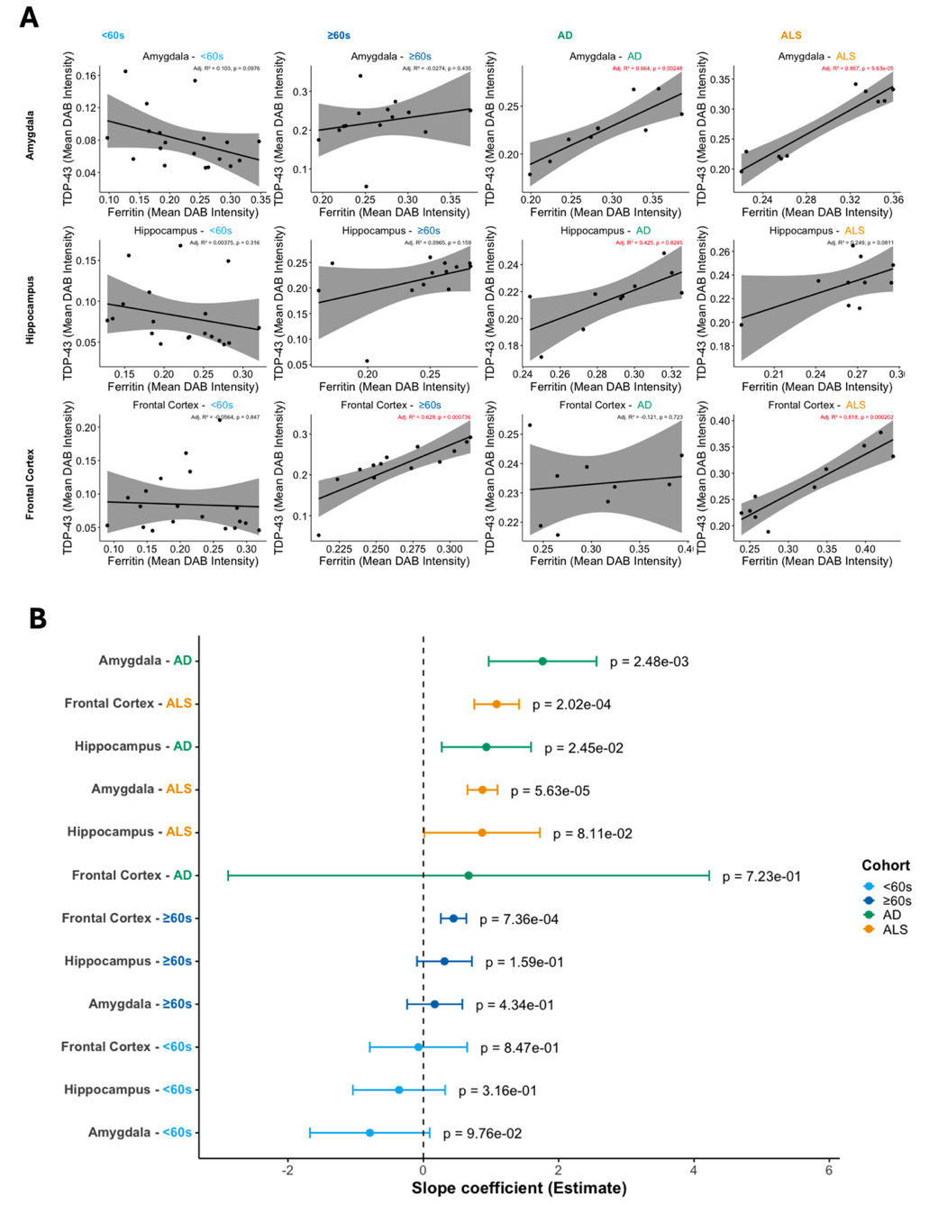

Supplementary Figure 3. Unadjusted regression analyses showing within-cohort associations between ferritin intensity and TDP-43 pathology burden across specific brain regions in neurodegenerative disease and aging. (A), Scatterplots showing the relationship between ferritin intensity and TDP-43 pathology burden across the amygdala, hippocampus, and frontal cortex in aging (<60s and ≥60s), Alzheimer’s disease (AD), and amyotrophic lateral sclerosis (ALS) cohorts. Regression lines represent fitted simple linear regression models performed separately for each brain region and cohort combination (TDP-43 ~ Ferritin). Each point represents an individual case, with colours indicating cohort. Regression lines with 95% confidence intervals depict the unadjusted within-group relationship between ferritin intensity (predictor) and TDP-43 pathology burden (outcome). Adjusted R² values and p-values for each individual regression model are displayed. (B), Forest plot showing regression coefficients (β ± standard error) and associated p-values from the unadjusted linear regression models for each cohort (<60s, ≥60s, AD, and ALS) across the amygdala, hippocampus, and frontal cortex. These analyses provide descriptive estimates of the direction and strength of within-cohort ferritin–TDP-43 associations but do not account for differences in cohort effects or formally test whether ferritin–TDP-43 relationships differ between biological groups.

Supplementary Referenes
- Bethlehem RAI, Seidlitz J, White SR, et al. Brain charts for the human lifespan. Nature 2022; 604(7906): 525-33.
- Cedres N, Machado A, Molina Y, et al. Subjective Cognitive Decline Below and Above the Age of 60: A Multivariate Study on Neuroimaging, Cognitive, Clinical, and Demographic Measures. Journal of Alzheimer’s Disease 2019; 68(1): 295-309.
- Fjell AM, Westlye LT, Grydeland H, et al. Critical ages in the life course of the adult brain: nonlinear subcortical aging. Neurobiology of Aging 2013; 34(10): 2239-47.
- Liu RSN, Lemieux L, Bell GS, et al. A longitudinal study of brain morphometrics using quantitative magnetic resonance imaging and difference image analysis. NeuroImage 2003; 20(1): 22-33.
- Statsenko Y, Habuza T, Charykova I, et al. Predicting Age From Behavioral Test Performance for Screening Early Onset of Cognitive Decline. Frontiers in Aging Neuroscience 2021; 13.

