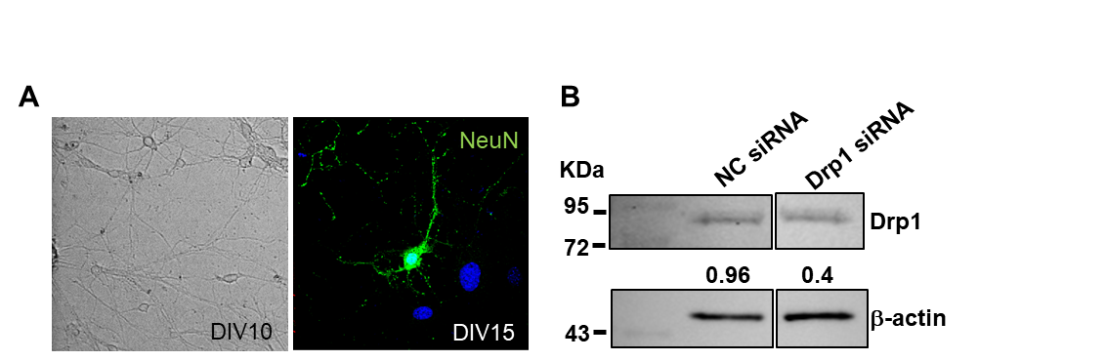
Supplementary Figure 1. Validation of primary hippocampal neurons and siRNA-mediated Drp1 knockdown. (A) Representative phase-contrast image of cultured primary hippocampal neurons at days in vitro (DIV)10 and immunofluorescence image showing NeuN-positive neurons at DIV15. NeuN immunostaining was used to confirm the neuronal identity of the primary hippocampal cultures. NeuN is shown in green and nuclei are counterstained with DAPI (blue). (B) Representative Western blot showing Drp1 protein expression in primary hippocampal neurons transfected with negative control siRNA (NC siRNA) or Drp1-targeting siRNA (Drp1 siRNA). Drp1 siRNA markedly reduced DRP1 protein expression compared with NC siRNA. β-actin was used as a loading control. Numbers indicate the relative Drp1/β-actin band intensity.

Supplementary Table 1. List of primary antibodies
Antibody | Company | Catalog No. | Dilution(s) | Applications | Source
Drp1 | Abcam | Ab18424 | WB | WB | Rabbit
p-Drp1 (Ser616) | Cell signaling | #3455 | WB | WB | Rabbit
Opa1 | BD | 612606 | 1:1,000 | WB | Mouse
Mff | Santa Cruz | Sc-168593 | 1:1,000 | WB | Goat
Mfn2 | Abcam | Ab56889 | 1:1,000 | WB | Mouse
Synapsin1 | Synaptic Sys. | 106104 | 1:3,000 | WB, IF | Guinea pig
Hormer1 | Synaptic Sys | 160002 | 1:3,000, 1:500 | WB, IF | Rabbit
Glutaminase1 | Synaptic Sys | 456-0P | 1:3,000 | WB | Rat
TASK-1 | Alomone | APC-024 | 1:1,000, 1:200 | WB, IF | Rabbit
p-Tau (Ser396) | Santa Cruz | Sc-32275 | 1:1,000 | WB | Mouse
Tau | Santa Cruz | Sc-32274 | 1:1,000 | WB | Mouse
HO-1 | Enzo | ADI-SPA-895 | 1:3,000 | WB | Rabbit
NQO-1 | Abcam | ab34173 | 1:1,000 | WB | Rabbit
NeuN | Millipore | MAB377 | 1:500 | IF | Mouse
GFAP | Sigma-Aldrich | G3893 | 1:1,000 | WB | Mouse
Iba-1 | Wako | 016-20001 | 1:1,000 | WB | Rabbit
Iba-1 | Wako | 019-19741 | 1:200, 1:500 | IF, IHC | Rabbit
TREM2 | Santa Cruz | Sc-373828 | 1:1,000 | WB | Mouse
Galectin-3 | Santa Cruz | Sc-23938 | 1:1,000, 1:200 | WB, IF | Rat
LAMP1 | Abcam | Ab24170 | 1:1,000, 1:100 | WB, IF | Rat
LC3B | Cell signaling | #83506 | 1:200 | IF | Mouse
Beclin-1 | Santa Cruz | Sc-48341 | 1:1,000 | WB | Mouse
p62 | Sigma-Aldrich | P0067 | 1:1,000 | WB | Rabbit
MTCO2 | Abcam | Ab3298 | 1:500 | IF | Mouse
VDAC1 | Abcam | Ab15895 | 1:500 | IF | Rabbit
β-actin | Sigma | A5441 | 1:50,000 | WB | Mouse
WB, western blot; IF, immunofluorescence; IHC, immunohistochemistry

