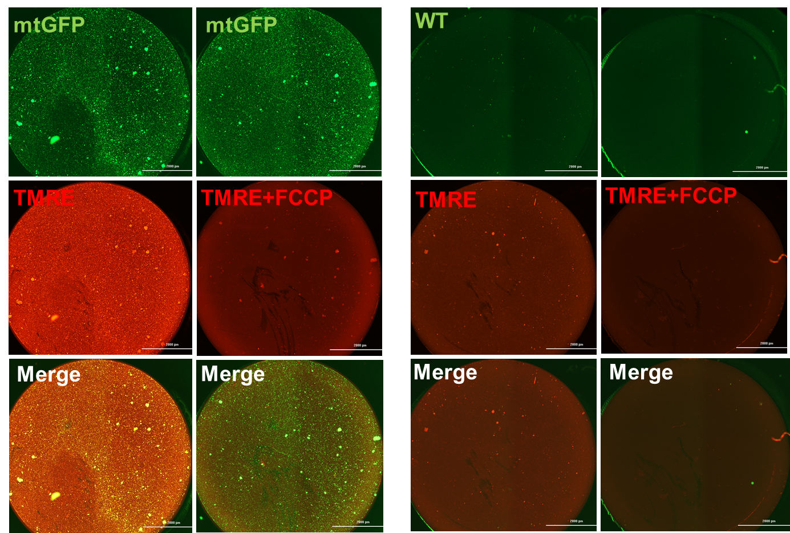
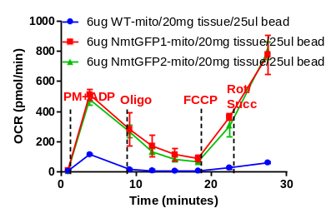
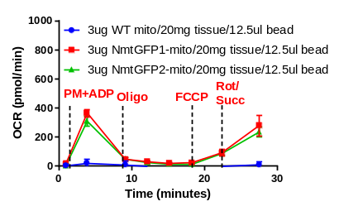
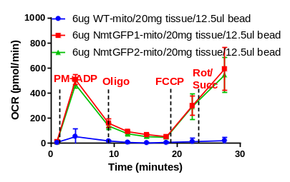
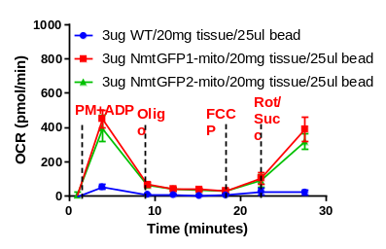
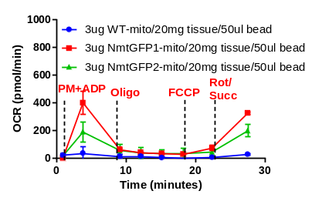
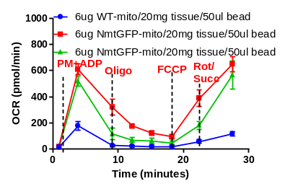
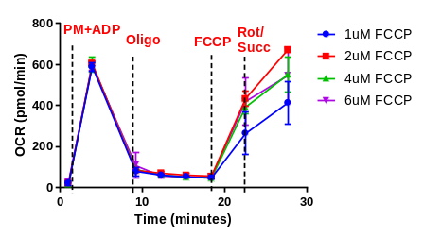
Supplementary figures:
Isolated mitochondria
A.
Anti-GFP bead and tissue optimization
FCCP optimization
B.
C.
Optimization of isolated mitochondria
Fig. S1: Optimization of anti-GFP bead-based mitochondrial isolation

Figure S1: Optimization of anti-GFP bead-based mitochondrial isolation
(A) Representative images of anti-GFP bead isolated mitochondria (green) from NmtGFP mice. WT mice (no mitoGFP tag). Isolated mitochondria were stained with TMRE (red) to test whether isolated mitochondria maintain intact membrane potential. Some wells were pretreated with FCCP to disrupt membrane potential before staining with TMRE. No TMRE (red) stain after FCCP treatment further demonstrates the intactness of mitochondria.
(B) OCR traces from the neuronal fraction of mitochondria. The tissue amount (grams) was narrowed down based on our published work and pilot experiments. Approximately 1 µl of anti-GFP antibody for 1mg or 0.5mg of tissue was used in both WT and NmtGFP brain homogenates to verify the specificity of binding. Two different concentrations of mitochondria (3 µg and 6 µg) were loaded into each SeahorseXFe96 well plate to check the saturation point.
(C) OCR traces from neuronal fraction of mitochondria optimized for FCCP with 1, 2, 4, and 6 µM concentration.

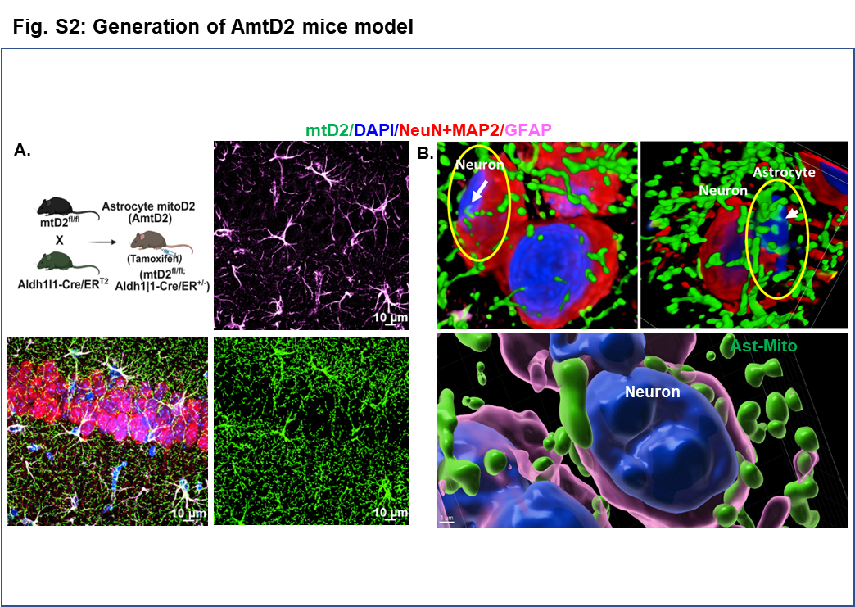

Figure S2: Generation of AmtD2 mice model

(A) Schematic illustrating the generation of astrocyte-specific mitochondrial-reporter mice (AmtD2) and representative micrograph of a brain section from AmtD2 mice.
(B) Confocal Z-stage image 3D constructed in Imaris, showing astrocytic mitochondria in proximity to neuronal nuclei (White arrow). This observation eliminates ambiguity about whether they are just juxtaposed on top of the neurons, not getting inside. (AmtGFP-green; GFAP-pink; NeuN+MAP2-red and DAPI-blue).

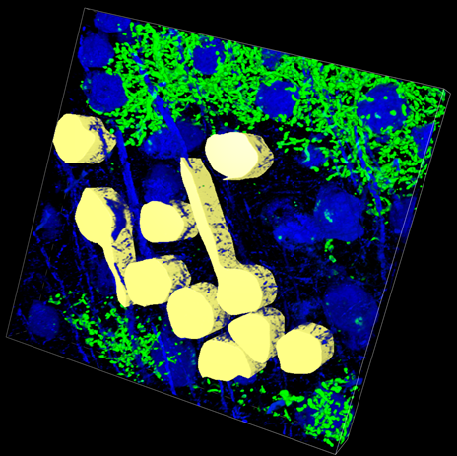
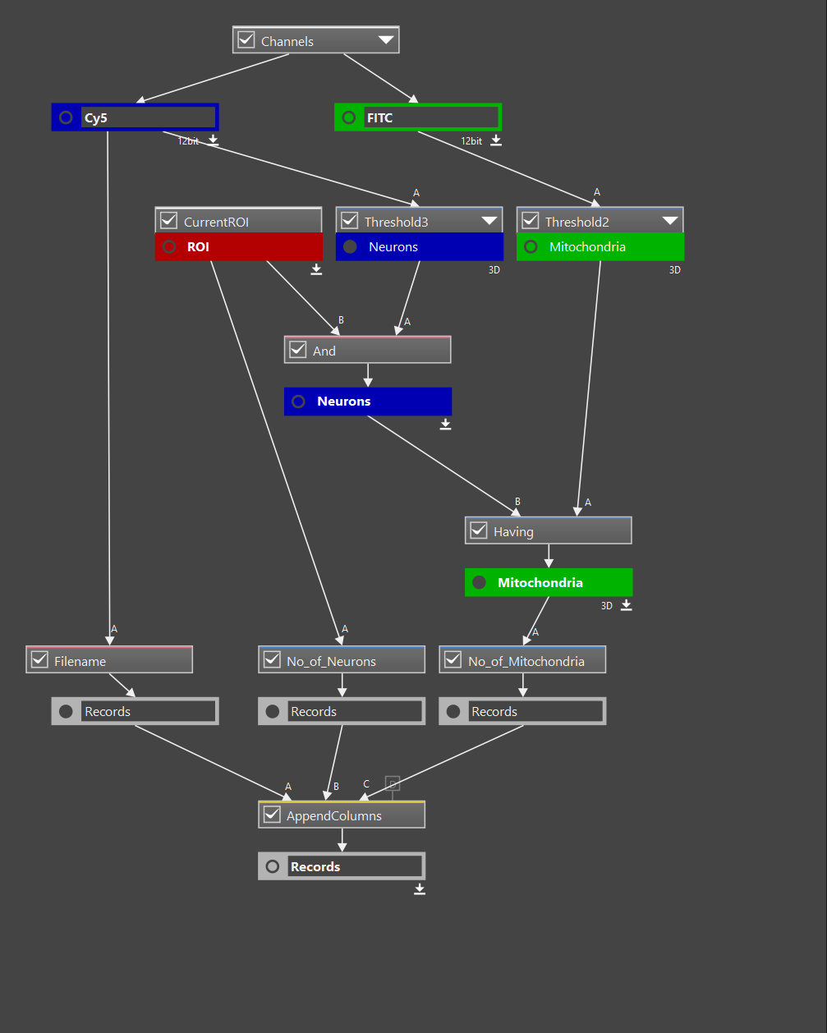
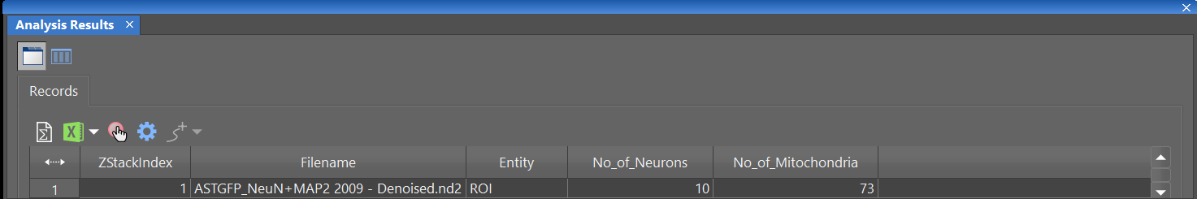
A.
B.
C.
Fig S3: Unbiased astrocyte-derived mitochondrial count in neurons using Nikon NIS-Elements general analysis software
Figure S3: Unbiased astrocyte-derived mitochondrial count in neuron using Nikon NIS-elements general analysis software
(A) Representative confocal z-stack and 3D images with selected region of interest (ROI) traces for the quantification of astrocytic mitochondrial transfer to neurons. (B, C) The workflow in NIS-Elements general analysis quantifies the number of neurons and mitochondria within the ROI in a 3D image.

Video 1. Z-stack confocal images were reconstructed into a 3D volume using Imaris to visualize astrocytic mitochondria localized within neurons.

