Supplementary Figure 1. Bootstrapping Non-parametric Difference Test (Edge)

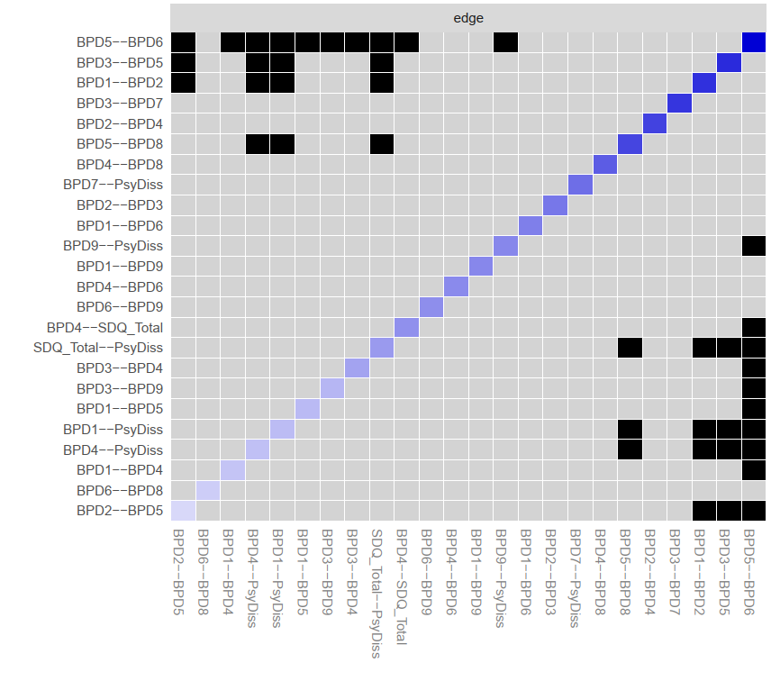

Supplementary Figure 2. Bootstrap Non-parametric Difference Test (Strength)

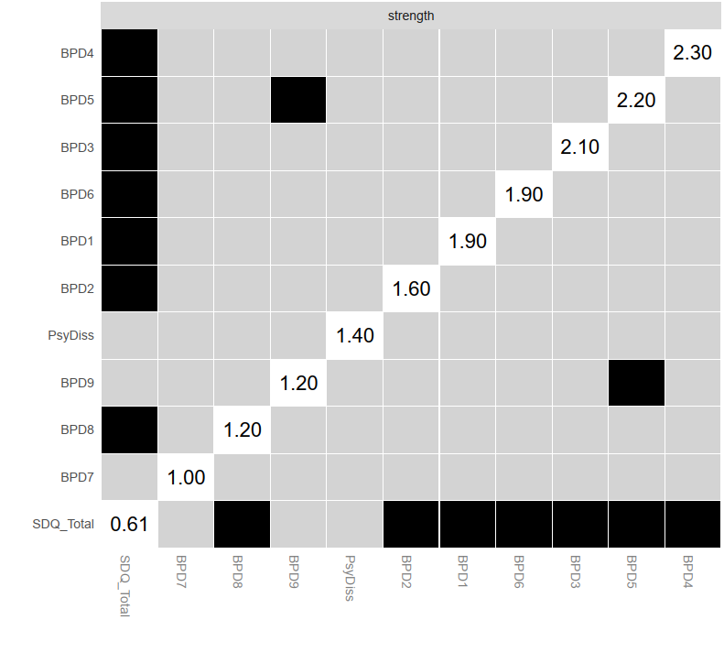

Appendix 1. The R Studio Syntax for the Non-parametric MGM network analysis

Step 1: Fitting the MGM to the data
mynetwork <- mgm(data= as.matrix(BPD_and_dissociation), type = “gaussian” ,level =”interval” ,lambdaSel = "EBIC",lambdaGam = 0.25, k = 2, pbar = FALSE, scale = TRUE, ruleReg = "AND", saveData = TRUE, saveModels = TRUE)

Step 2: Visualizing the Network
myplot<-qgraph(mynetwork$pairwise$wadj, vsize=6, layout="spring", color="lightblue", edge.colour= mynetwork$pairwise$edgecolor, border.width=1.5,border.color="black",nodeNames = mynames, legend = TRUE)

Step 3: Estimate the network structure using Bootnet
mynetwork2<- bootnet_mgm(BPD_and_dissociation, type, level, tuning = 0.25, missing = c("listwise"), verbose = TRUE, criterion = c("EBIC"), nFolds = 10, order = 2, rule = c("AND"), unlock = TRUE, transform = c("none"))

Step 4: Obtaining the Centrality Table, Centrality Plot, Network Plot and the Edge Weighting Table
- CentralityTable<- centralityTable(mynetwork2)
write.csv(CentralityTable, "MyCentralityTable.csv")
- pdf("MyCentrality.pdf", width=4)
c1<- centralityPlot(myplot)
dev.off()
- pdf("MyExpectedInfluence.pdf", width=4)
c2<- centralityPlot(myplot, include = "ExpectedInfluence")
dev.off()
- int24<- showInteraction(object=mynetwork, int=c(2,3))
int24$parameters
round(mynetwork$pairwise$wadj, 2)
showInteraction(object = mynetwork,
int = c(8,9))

Step 5: Bootstrapping the network structure
b1<- bootnet(mynetwork2, boots=1000,nCores=8, statistics = c("strength","expectedInfluence","edge"))
b2<- bootnet(mynetwork2,noots=1000,nCores=4,type="case", statistics = c("strength","expectedInfluence","edge"))

Step 6: Obtaining the Correlation Stability Coefficient
corStability(b2)
pdf("EdgeStability.pdf")
plot(b1,labels = FALSE, order="sample")
dev.off()
pdf("CentrStability.pdf")
plot(b2)
dev.off()

Step 7: Obtaining the Edge Weight Stability Plot
plot(b1, labels = FALSE, order = "sample")

Step 8: Obtaining the nodewise accuracy and the intercept/marginal model accuracy coefficient
pred_obj <- predict(object = mynetwork,
data = BPD_and_dissociation,
errorCon = 'R2')
pred_obj$error
res_obj<- resample(object = mynetwork, data=as.matrix(BPD_and_dissociation), nB=50)
plotRes(object = res_obj,
quantiles = c(0.05, .95))

Step 9. Obtaining the non-parametric difference test
differenceTest(b1, "x", "y", "strength", alpha=0.05, verbose = TRUE)
plot(b1, "edge", plot = "difference", onlyNonZero = TRUE, order = "sample")
plot(b1, "strength", plot = "difference", onlyNonZero = FALSE, order = "sample")

