Supplementary Material for
“Clinical profiles of adolescent personality pathology: A latent structure examination of the Semi-Structured Interview for Personality Functioning DSM-5 (STiP-5.1) in a help-seeking sample.”

Madelyn Thomson, Marialuisa Cavelti, Stefan Lerch, Julian Koenig, Corinna Reichl, Ines Mürner-Lavanchy, Andrea Wyssen, Michael Kaess

Contents: 3 eTexts, 1 eFigure, 7 eTables
- eText 1: Brief overview of research elucidating subgroups in (B)PD.
- eText 2: Conceptual considerations included in the study
- eText 3: Homogeneity in the classes by self- and interpersonal functioning
- eFigure 1: Inhomogeneities of each class across self and interpersonal functioning, depicted by individual data points
- eTable 1. Specification and graphic illustration of FMM variants. Adapted from Clark et al. (1)
- eTable 2: Additional fit indices for each tested model (N=502)
- eTable 3: Composition and item thresholds for the best Factor Mixture Model (FMM-3; 2 classes, four factors) (N=502)
- eTable 4: Composition and item thresholds for best factor analysis (FA; 4 factors) (N=502)
- eTable 5: Composition of best latent class analysis (LCA; 8 classes) (N=502)
- eTable 6: Description of core domains, elements and individual facets (items) with their respective abbreviations
- eTable 7: Correlation coefficients between self- and interpersonal-functioning for each class (N=502)

eText 1: Brief overview of research elucidating subgroups in (B)PD.
Several studies have incorporated variations of cluster-analytic, factor analytic, latent class/trait approaches, and even finite mixture modelling, in an attempt to elucidate meaningful subgroups in categorical BPD. For the most part, only one approach is employed at a time, and many have found a three-cluster solution to best represent subgroups of BPD, often reflecting groups of externalising, externalising, or mixed (“core” BPD) compositions, or combinations of paranoid/schizotypal, and interpersonally unstable (antisocial, aggressive) groups (2–5). Severity dimensions have also been found to help differentiate subgroups (2), and many conclude that discrete classes exist along a severity continuum (6–11). In contrast to the various three-cluster solutions yielded in some studies, others, using FA for example, have found that BPD criteria (including in youth) corresponds mostly to a unidimensional structure (12). When considering BPD in light of the newer conceptualisations of PD (i.e., AMPD and ICD-11), Wolf and colleagues (2) assigned BPD variables to ICD-11 trait and personality functioning domains, and found that a dimensional model with 3 clusters differentiating subtypes by personality traits – roughly corresponding to the model of ICD-11 – was the best fit. However, this was not based on empirical evidence, rather, on case vignettes, limiting its validity in the context of the newer dimensional conceptualisations. When considering personality types more broadly, Rossi and colleagues (13) corroborated a 3-cluster solution of resilient, overcontrolled, and undercontrolled personality types based on DSM-5 Criterion B traits, with differences between groups then based on severity of personality functioning impairment (via self-report). Direct comparison of FA, LCA, and FMM to determine the best structure of PD has also been limited to BPD. One found that a unitary latent trait model was the best fit, and another found a single-factor two-class FMM to be the best fit (14,15).
eText 2: Conceptual considerations included in the study
Conceptual considerations employed in the study are outlined as follows:
- In the determination of the number of factors to test. That is, variations of FAs tested were limited to three, following the concept of the STiP-5.1. These variations were based on previous literature, and the logical/conceptual constitution of the instrument and included a one-factor solution (unidimensional) with all facets (items), a two-factor solution capturing self- and interpersonal- functioning, and a 4-factor solution pertaining to each of the four elements. Testing alternatives of 3 or 5 factors, for example, does not reflect the theoretical construction of the instrument and therefore was not included.
- The composition of each factor (i.e., self- and interpersonal functioning) was determined by the theoretical construction of the instrument. For example, we allowed only for facets associated with self-functioning to comprise self-functioning, and not interpersonal functioning.
- Although various iterations of FMMs can be constructed with varying degrees of measurement invariance (see below for details), an FMM-4 is considered to be very complex, where factor loadings are allowed to vary between classes, and therefore, have different meaning across each class. This ultimately renders interpretation of the models significantly challenging (if not impossible), thus, limiting its conceptual understanding and clinical applicability. Therefore, we did not iterate FMMs past FMM-3.
- Numbers of classes or profiles (e.g. for LCA or FMM) should be considered conceptually meaningful and have clinical utility. Therefore, if the best solution determined by statistical procedures contains excessive numbers of classes (i.e., beyond 5 or 6), then alternative options should be considered, as an increase in the number of classes may mean more classes with smaller sizes, and may not make conceptual sense (16).
eText 3: Homogeneity in the classes by self- and interpersonal functioning
We allowed for inhomogeneity to be present in the clusters, enabling the viewing of individual data point distribution across each profile, as well as the overall means for each profile. For clinical application purposes, each profile cluster was measured against the clinically relevant threshold for impairment in personality functioning (moderate or higher severity) across self- and interpersonal-functioning of the STiP-5.1. This allows for the examination of the cluster profiles based on overall personality pathology and cut across self- and interpersonal functioning. The three-sigma ellipse included in eFigure 1 demonstrates the overlap between classes two and three, but also some of the differences – scores are higher for self-functioning in class 2, but not as high for class 3.
eFigure 1. Inhomogeneities of each class across self and interpersonal functioning, depicted by individual data points
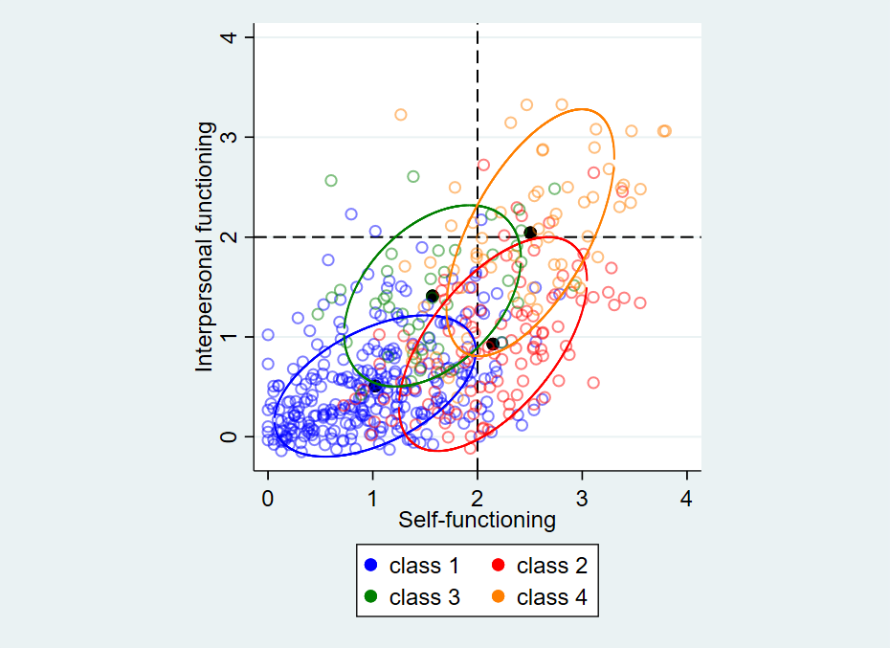
Notes: The four black dots reflect the mean of each class across self and interpersonal functioning (i.e., no homogeneity). Larger coloured circles represent the spread of each class. Three sigma ellipses (i.e., inclusion of 99% of the data points are captured in the ellipse) are depicted in the figure.

eTable 1. Specification and graphic illustration of FMM variants. Adapted from Clark et al. (1)
FMM Variation | Parameters
 | Factor means | Factor variances and covariances | Item thresholds | Factor loadings | Illustration | Interpretation
FMM-1 (latent class factor analytic model) | Class-variant | Fixed to zero | Class-invariant | Class-invariant | 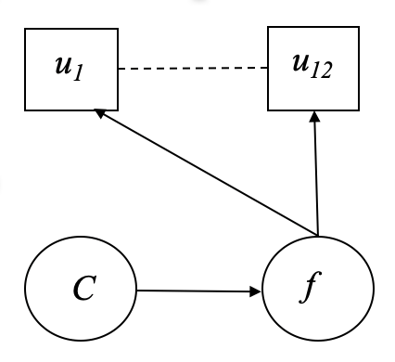 | Most restrictive model. There is no within-class heterogeneity. Class membership is based on each indivdiual’s location on the factor. The factor is measured the same way across classes.
FMM-2 (mixture factor analysis) | Class-variant | Class-variant | Class-invariant | Class-invariant | 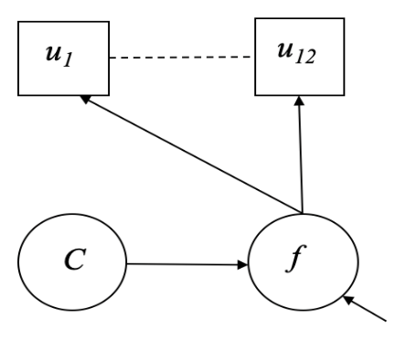 | There is within-class heterogeneity. Class membership is based on each indivdiual’s location on the factor. The factor is measured the same way across classes.
FMM-3 | Fixed to zero | Class-variant | Class-variant | Class-invariant | 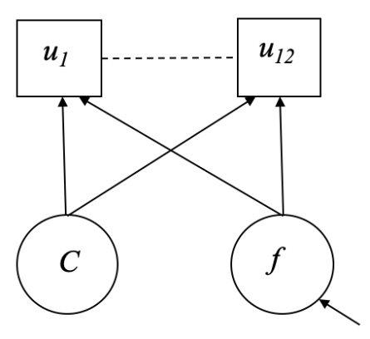 | There are different amounts of heterogeneity within each class. Classes are based on the responses to the items rather than the factor means and variances.
FMM-4 | Fixed to zero | Class-variant | Class-variant | Class-variant | 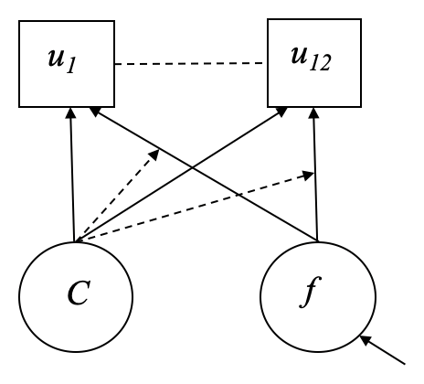 | Least restrictive model. There are different amounts of heterogeneity within each class. Classes are based on the responses to the items rather than the factor means and variances. The factor is not measured the same way across classes, indicating that there is potentially a different factor within each class.
Notes. u = individual STiP-5.1 facets (observed variables), C = latent class variable, f = latent factor. Boxes indicate observed variables. Circles indicate latent variables. The arrow pointing into the latent factor indicates a residual.

eTable 2: Additional fit indices for each tested model (N=502)

Model | BIC | AIC | saBIC | Entropy | Ek | CLC | ICLBIC
fa_4f | 16483.77 | 16306.59 | 16350.46 | - | - | - | -
fa_1f | 16695.74 | 16543.87 | 16581.48 | - | - | - | -
fa_2f | 16530.62 | 16374.53 | 16413.18 | - | - | - | -
lca_9c | 16404.63 | 15864.65 | 15998.35 | 0.91 | 100.37 | 15809.40 | 16605.38
lca_10c | 16415.66 | 15820.83 | 15968.11 | 0.92 | 98.25 | 15735.34 | 16612.16
lca_8c | 16402.64 | 15917.50 | 16037.62 | 0.90 | 106.48 | 15900.45 | 16615.59
lca_7c | 16414.44 | 15984.14 | 16090.68 | 0.89 | 104.52 | 15989.18 | 16623.48
lca_6c | 16430.33 | 16054.87 | 16147.84 | 0.89 | 98.04 | 16072.96 | 16626.41
lca_5c | 16503.81 | 16183.20 | 16262.58 | 0.87 | 106.65 | 16244.49 | 16717.11
lca_4c | 16579.73 | 16313.96 | 16379.76 | 0.89 | 76.55 | 16341.06 | 16732.83
lca_3c | 16679.33 | 16468.40 | 16520.62 | 0.85 | 83.83 | 16536.05 | 16846.99
lca_2c | 17004.65 | 16848.56 | 16887.21 | 0.90 | 35.14 | 16844.85 | 17074.94
lca_1c | 18384.08 | 18282.84 | 18307.91
fmm3_4c_2f | 16176.50 | 15817.92 | 15906.71 | 0.96 | 27.84 | 15703.60 | 16232.18
fmm3_2c_2f | 16284.33 | 16060.74 | 16116.10 | 0.96 | 12.18 | 15979.10 | 16308.69
fmm3_2c_4f | 16222.05 | 15947.84 | 16015.74 | 0.85 | 52.89 | 15923.62 | 16327.83
fmm2_2c_4f | 16220.86 | 16005.71 | 16058.98 | 0.83 | 57.41 | 16018.54 | 16335.69
fmm3_3c_2f | 16265.62 | 15974.54 | 16046.61 | 0.92 | 43.57 | 15923.68 | 16352.76
fmm3_5c_2f | 16184.15 | 15758.07 | 15863.57 | 0.89 | 91.30 | 15738.67 | 16366.75
fmm3_4c_1f | 16300.85 | 15971.80 | 16053.27 | 0.94 | 40.36 | 15896.53 | 16381.58
fmm3_6c_1f | 16243.71 | 15796.53 | 15907.25 | 0.90 | 89.05 | 15762.63 | 16421.80
fmm3_5c_1f | 16275.43 | 15887.32 | 15983.42 | 0.89 | 87.26 | 15877.83 | 16449.94
fmm4_2c_1f | 16432.87 | 16175.54 | 16239.25 | 0.96 | 13.22 | 16079.99 | 16459.32
fmm3_2c_1f | 16465.48 | 16254.55 | 16306.78 | 0.97 | 10.79 | 16176.12 | 16487.05
fmm3_3c_1f | 16386.16 | 16116.17 | 16183.02 | 0.84 | 86.03 | 16160.24 | 16558.23
fmm2_2c_2f | 16418.07 | 16245.11 | 16287.94 | 0.58 | 145.45 | 16454.00 | 16708.97
fmm2_4c_2f | 16441.68 | 16209.66 | 16267.11 | 0.80 | 139.18 | 16378.03 | 16720.05
fmm2_3c_2f | 16442.95 | 16253.11 | 16300.11 | 0.74 | 145.60 | 16454.30 | 16734.14
fmm1_4c_2f | 16546.03 | 16364.63 | 16409.54 | 0.83 | 117.61 | 16513.85 | 16781.25
fmm1_4c_4f | 16560.03 | 16361.75 | 16410.84 | 0.83 | 114.83 | 16497.41 | 16789.68
fmm1_5c_2f | 16564.68 | 16370.62 | 16418.67 | 0.86 | 117.15 | 16512.93 | 16798.98
fmm1_5c_4f | 16591.12 | 16371.75 | 16426.06 | 0.86 | 114.73 | 16497.20 | 16820.57
fmm1_3c_2f | 16662.28 | 16493.54 | 16535.32 | 0.83 | 91.00 | 16595.54 | 16844.28
fmm1_3c_4f | 16666.47 | 16489.29 | 16533.16 | 0.84 | 89.90 | 16585.08 | 16846.26
fmm1_3c_1f | 16713.23 | 16548.71 | 16589.44 | 0.83 | 92.65 | 16656.01 | 16898.54
fmm1_4c_1f | 16664.62 | 16491.65 | 16534.48 | 0.79 | 143.36 | 16696.38 | 16951.34
fmm2_2c_1f | 16654.61 | 16490.08 | 16530.82 | 0.45 | 191.73 | 16795.54 | 17038.06
fmm1_2c_1f | 17004.65 | 16848.56 | 16887.21 | 0.90 | 35.14 | 16844.85 | 17074.94
fmm1_2c_2f | 17004.65 | 16848.56 | 16887.21 | 0.90 | 35.14 | 16844.85 | 17074.94
fmm1_2c_4f | 17004.65 | 16848.56 | 16887.21 | 0.90 | 35.14 | 16844.85 | 17074.94
fmm1_5c_1f | 16657.17 | 16475.77 | 16520.69 | 0.72 | 224.61 | 16838.98 | 17106.38
fmm1_6c_1f | 16669.61 | 16479.77 | 16526.78 | 0.75 | 224.87 | 16839.51 | 17119.34
fmm2_3c_1f | 16652.90 | 16475.72 | 16519.59 | 0.57 | 234.94 | 16861.60 | 17122.79
fmm2_4c_1f | 16662.92 | 16473.09 | 16520.09 | 0.62 | 261.67 | 16906.42 | 17186.26
Notes: BIC=Baysian Information Criterion; ACI=Akaike Information Criterion; saBIC=sample adjustic Baysian Information Criterion; Ek=unscaled entropy; CLC=Classification Likelihood Criterion; ICLBIC= Integrated classification likelihood BIC approximation; fa=factor analysis; lca=latent class analysis; fmm=factor mixture model; f=factor; c=class. Items in bold indicate the best model of each type (e.g., the best FA, the best LCA, and the best FMM).

eTable 3: Composition and item thresholds for the best Factor Mixture Model (FMM-3; 2 classes, four factors) (N=502)
Two-tailed
Estimate S.E. Est./S.E. P-Value
Latent class 1
F1 by
STIP_1_1 1.000 0.000 999.000 999.000
STIP_1_2 1.162 0.092 12.685 0.000
STIP_1_3 1.011 0.104 9.722 0.000
STIP_2_1 0.247 0.048 5.116 0.000
STIP_2_2 0.648 0.102 6.370 0.000
STIP_2_3 0.810 0.110 7.350 0.000
F2 by
STIP_3_1 1.000 0.000 999.000 999.000
STIP_3_2 2.665 0.747 3.567 0.000
STIP_3_3 3.026 0.757 3.995 0.000
STIP_4_1 5.480 1.592 3.441 0.001
STIP_4_2 5.525 1.583 3.491 0.000
STIP_4_3 2.830 0.819 3.453 0.001
F2 with
F1 0.039 0.012 3.215 0.001
Means
F1 0.000 0.000 999.000 999.000
F2 0.000 0.000 999.000 999.000
Intercepts
STIP_1_1 0.939 0.058 16.223 0.000
STIP_1_2 1.481 0.066 22.498 0.000
STIP_1_3 1.508 0.068 22.165 0.000
STIP_2_1 0.347 0.032 10.702 0.000
STIP_2_2 0.633 0.059 10.780 0.000
STIP_2_3 1.229 0.059 20.787 0.000
STIP_3_1 0.257 0.030 8.605 0.000
STIP_3_2 0.465 0.042 10.968 0.000
STIP_3_3 0.780 0.048 16.303 0.000
STIP_4_1 0.587 0.051 11.450 0.000
STIP_4_2 0.590 0.054 10.882 0.000
STIP_4_3 0.373 0.041 9.095 0.000
Latent class 2
F1 by
STIP_1_1 1.000 0.000 999.000 999.000
STIP_1_2 1.162 0.092 12.685 0.000
STIP_1_3 1.011 0.104 9.722 0.000
STIP_2_1 0.247 0.048 5.116 0.000
STIP_2_2 0.648 0.102 6.370 0.000
STIP_2_3 0.810 0.110 7.350 0.000
F2 by
STIP_3_1 1.000 0.000 999.000 999.000
STIP_3_2 2.665 0.747 3.567 0.000
STIP_3_3 3.026 0.757 3.995 0.000
STIP_4_1 5.480 1.592 3.441 0.001
STIP_4_2 5.525 1.583 3.491 0.000
STIP_4_3 2.830 0.819 3.453 0.001
F2 with
F1 0.064 0.023 2.828 0.005
Means
F1 0.000 0.000 999.000 999.000
F2 0.000 0.000 999.000 999.000
Intercepts
STIP_1_1 1.816 0.110 16.483 0.000
STIP_1_2 2.262 0.105 21.464 0.000
STIP_1_3 2.270 0.105 21.616 0.000
STIP_2_1 2.788 0.058 48.283 0.000
STIP_2_2 1.744 0.139 12.566 0.000
STIP_2_3 2.004 0.106 18.850 0.000
STIP_3_1 0.347 0.053 6.495 0.000
STIP_3_2 0.710 0.093 7.653 0.000
STIP_3_3 1.175 0.102 11.495 0.000
STIP_4_1 1.337 0.115 11.660 0.000
STIP_4_2 1.238 0.112 11.097 0.000
STIP_4_3 0.765 0.100 7.675 0.000
Class 3
F1 by
STIP_1_1 1.000 0.000 999.000 999.000
STIP_1_2 1.162 0.092 12.685 0.000
STIP_1_3 1.011 0.104 9.722 0.000
STIP_2_1 0.247 0.048 5.116 0.000
STIP_2_2 0.648 0.102 6.370 0.000
STIP_2_3 0.810 0.110 7.350 0.000
F2 by
STIP_3_1 1.000 0.000 999.000 999.000
STIP_3_2 2.665 0.747 3.567 0.000
STIP_3_3 3.026 0.757 3.995 0.000
STIP_4_1 5.480 1.592 3.441 0.001
STIP_4_2 5.525 1.583 3.491 0.000
STIP_4_3 2.830 0.819 3.453 0.001
F2 with
F1 0.035 0.020 1.729 0.084
Means
F1 0.000 0.000 999.000 999.000
F2 0.000 0.000 999.000 999.000
Intercepts
STIP_1_1 1.448 0.171 8.466 0.000
STIP_1_2 1.813 0.173 10.457 0.000
STIP_1_3 2.335 0.182 12.837 0.000
STIP_2_1 0.528 0.103 5.133 0.000
STIP_2_2 1.083 0.174 6.219 0.000
STIP_2_3 2.215 0.183 12.133 0.000
STIP_3_1 2.507 0.109 22.986 0.000
STIP_3_2 1.182 0.175 6.745 0.000
STIP_3_3 1.500 0.184 8.166 0.000
STIP_4_1 1.132 0.169 6.707 0.000
STIP_4_2 1.401 0.173 8.121 0.000
STIP_4_3 0.745 0.124 6.013 0.000
Class 4
F1 by
STIP_1_1 1.000 0.000 999.000 999.000
STIP_1_2 1.162 0.092 12.685 0.000
STIP_1_3 1.011 0.104 9.722 0.000
STIP_2_1 0.247 0.048 5.116 0.000
STIP_2_2 0.648 0.102 6.370 0.000
STIP_2_3 0.810 0.110 7.350 0.000
F2 by
STIP_3_1 1.000 0.000 999.000 999.000
STIP_3_2 2.665 0.747 3.567 0.000
STIP_3_3 3.026 0.757 3.995 0.000
STIP_4_1 5.480 1.592 3.441 0.001
STIP_4_2 5.525 1.583 3.491 0.000
STIP_4_3 2.830 0.819 3.453 0.001
F2 with
F1 0.066 0.027 2.428 0.015
Means
F1 0.000 0.000 999.000 999.000
F2 0.000 0.000 999.000 999.000
Intercepts
STIP_1_1 2.368 0.147 16.081 0.000
STIP_1_2 2.697 0.127 21.319 0.000
STIP_1_3 2.596 0.119 21.810 0.000
STIP_2_1 2.732 0.087 31.307 0.000
STIP_2_2 2.340 0.173 13.514 0.000
STIP_2_3 2.295 0.171 13.439 0.000
STIP_3_1 2.506 0.124 20.137 0.000
STIP_3_2 1.695 0.196 8.662 0.000
STIP_3_3 2.123 0.156 13.604 0.000
STIP_4_1 2.148 0.173 12.441 0.000
STIP_4_2 2.015 0.164 12.253 0.000
STIP_4_3 1.775 0.175 10.140 0.000
Notes: S.E.=standard error; Est.= estimate. For a full description of each variable, please refer to eTable 6.

eTable 4: Composition and item thresholds for best factor analysis (FA; 4 factors) (N=502)
Two-Tailed
Estimate S.E. Est./S.E. P-Value
F1 by
STIP_1_1 1.000 0.000 999.000 999.000
STIP_1_2 1.021 0.064 15.838 0.000
STIP_1_3 0.885 0.067 13.154 0.000
F2 by
STIP_2_1 1.000 0.000 999.000 999.000
STIP_2_2 1.012 0.083 12.148 0.000
STIP_2_3 0.862 0.079 10.913 0.000
F3 by
STIP_3_1 1.000 0.000 999.000 999.000
STIP_3_2 0.881 0.081 10.936 0.000
STIP_3_3 1.020 0.088 11.579 0.000
F4 by
STIP_4_1 1.000 0.000 999.000 999.000
STIP_4_2 0.992 0.057 17.441 0.000
STIP_4_3 0.611 0.051 11.970 0.000
F1 with
F2 0.606 0.063 9.656 0.000
F3 0.345 0.044 7.894 0.000
F4 0.520 0.055 9.396 0.000
F2 with
F3 0.398 0.048 8.315 0.000
F4 0.503 0.058 8.631 0.000
F3 with
F4 0.469 0.050 9.475 0.000
Intercepts
STIP_1_1 1.339 0.050 26.544 0.000
STIP_1_2 1.821 0.051 35.474 0.000
STIP_1_3 1.871 0.053 35.629 0.000
STIP_2_1 1.169 0.056 21.037 0.000
STIP_2_2 1.112 0.057 19.513 0.000
STIP_2_3 1.606 0.051 31.714 0.000
STIP_3_1 0.731 0.046 15.931 0.000
STIP_3_2 0.723 0.042 17.295 0.000
STIP_3_3 1.084 0.045 23.983 0.000
STIP_4_1 0.978 0.050 19.644 0.000
STIP_4_2 0.966 0.050 19.471 0.000
STIP_4_3 0.653 0.042 15.642 0.000
Notes: S.E.=standard error; Est.= estimate. For a full description of each item, please refer to eTable 6.

eTable 5: Composition of best latent class analysis (LCA; 8 classes) (N=502)
Two-Tailed
Estimate S.E. Est./S.E. P-Value
Latent Class 1
Means
STIP_1_1 1.189 0.193 6.149 0.000
STIP_1_2 1.552 0.222 6.980 0.000
STIP_1_3 2.232 0.240 9.286 0.000
STIP_2_1 0.590 0.169 3.487 0.000
STIP_2_2 1.044 0.211 4.942 0.000
STIP_2_3 2.159 0.257 8.396 0.000
STIP_3_1 2.555 0.210 12.193 0.000
STIP_3_2 1.160 0.283 4.098 0.000
STIP_3_3 1.482 0.275 5.379 0.000
STIP_4_1 0.879 0.181 4.862 0.000
STIP_4_2 1.069 0.226 4.720 0.000
STIP_4_3 0.685 0.166 4.113 0.000
Latent Class 2
Means
STIP_1_1 1.512 0.259 5.834 0.000
STIP_1_2 2.373 0.218 10.887 0.000
STIP_1_3 2.330 0.299 7.806 0.000
STIP_2_1 0.583 0.132 4.427 0.000
STIP_2_2 0.925 0.248 3.730 0.000
STIP_2_3 1.857 0.286 6.493 0.000
STIP_3_1 0.293 0.079 3.704 0.000
STIP_3_2 0.547 0.232 2.355 0.019
STIP_3_3 0.925 0.198 4.676 0.000
STIP_4_1 0.617 0.184 3.355 0.001
STIP_4_2 0.579 0.155 3.727 0.000
STIP_4_3 0.471 0.132 3.567 0.000
Latent Class 3
Means
STIP_1_1 0.511 0.111 4.627 0.000
STIP_1_2 0.837 0.152 5.513 0.000
STIP_1_3 0.890 0.129 6.918 0.000
STIP_2_1 0.194 0.050 3.911 0.000
STIP_2_2 0.411 0.071 5.826 0.000
STIP_2_3 0.780 0.080 9.755 0.000
STIP_3_1 0.221 0.041 5.450 0.000
STIP_3_2 0.269 0.048 5.561 0.000
STIP_3_3 0.518 0.050 10.450 0.000
STIP_4_1 0.305 0.053 5.730 0.000
STIP_4_2 0.286 0.053 5.448 0.000
STIP_4_3 0.246 0.055 4.467 0.000
Latent Class 4
Means
STIP_1_1 1.279 0.193 6.628 0.000
STIP_1_2 1.817 0.156 11.610 0.000
STIP_1_3 1.929 0.184 10.479 0.000
STIP_2_1 2.800 0.086 32.419 0.000
STIP_2_2 1.463 0.182 8.020 0.000
STIP_2_3 1.711 0.159 10.762 0.000
STIP_3_1 0.418 0.108 3.859 0.000
STIP_3_2 0.524 0.095 5.499 0.000
STIP_3_3 0.887 0.121 7.341 0.000
STIP_4_1 0.685 0.124 5.502 0.000
STIP_4_2 0.640 0.131 4.892 0.000
STIP_4_3 0.368 0.122 3.001 0.003
Latent Class 5
Means
STIP_1_1 2.818 0.238 11.815 0.000
STIP_1_2 3.313 0.346 9.588 0.000
STIP_1_3 3.049 0.154 19.774 0.000
STIP_2_1 2.724 0.530 5.137 0.000
STIP_2_2 2.227 0.601 3.703 0.000
STIP_2_3 2.163 0.344 6.293 0.000
STIP_3_1 0.142 0.185 0.770 0.442
STIP_3_2 0.872 0.218 3.993 0.000
STIP_3_3 1.338 0.245 5.452 0.000
STIP_4_1 2.208 0.719 3.072 0.002
STIP_4_2 1.881 0.317 5.932 0.000
STIP_4_3 1.147 0.228 5.020 0.000
Latent Class 6
Means
STIP_1_1 1.524 0.562 2.709 0.007
STIP_1_2 2.218 0.308 7.208 0.000
STIP_1_3 2.358 0.348 6.771 0.000
STIP_2_1 0.378 0.376 1.004 0.315
STIP_2_2 0.806 0.695 1.159 0.247
STIP_2_3 1.761 0.379 4.646 0.000
STIP_3_1 0.652 0.272 2.401 0.016
STIP_3_2 1.264 0.631 2.002 0.045
STIP_3_3 1.721 0.338 5.089 0.000
STIP_4_1 2.110 0.668 3.160 0.002
STIP_4_2 2.518 0.856 2.941 0.003
STIP_4_3 0.786 0.371 2.117 0.034
Latent Class 7
Means
STIP_1_1 2.940 0.200 14.693 0.000
STIP_1_2 3.279 0.174 18.846 0.000
STIP_1_3 2.989 0.155 19.333 0.000
STIP_2_1 2.897 0.145 19.965 0.000
STIP_2_2 3.048 0.204 14.978 0.000
STIP_2_3 2.678 0.237 1.296 0.000
STIP_3_1 2.732 0.184 14.812 0.000
STIP_3_2 2.475 0.228 10.848 0.000
STIP_3_3 2.415 0.221 10.949 0.000
STIP_4_1 2.890 0.172 16.823 0.000
STIP_4_2 2.843 0.181 15.677 0.000
STIP_4_3 2.571 0.184 13.950 0.000
Latent Class 8
Means
STIP_1_1 2.144 0.181 11.850 0.000
STIP_1_2 2.318 0.220 10.559 0.000
STIP_1_3 2.341 0.250 9.359 0.000
STIP_2_1 2.435 0.333 7.302 0.000
STIP_2_2 1.903 0.254 7.497 0.000
STIP_2_3 2.426 0.180 13.504 0.000
STIP_3_1 1.940 0.355 5.466 0.000
STIP_3_2 1.265 0.243 5.215 0.000
STIP_3_3 2.151 0.190 11.320 0.000
STIP_4_1 2.038 0.363 5.611 0.000
STIP_4_2 1.972 0.308 6.394 0.000
STIP_4_3 1.408 0.251 5.612 0.000
Notes: S.E.=standard error; Est.= estimate. For a full description of each variable, please refer to eTable 6.

eTable 6: Description of core domains, elements and individual facets (items) with their respective abbreviations
Core domains | Elements | Facets
Self-functioning | Identity | STIP_1_1: Experience of oneself as unique, with clear boundaries between self and others
Self-functioning | Identity | STIP_1_2: Stability of self-esteem and accuracy of self-appraisal
Self-functioning | Identity | STIP_1_3: Capacity for, and ability to regulate, a range of emotional experience
Self-functioning | Self-direction | STIP_2_1: Pursuit of coherent and meaningful short-term and life goals
Self-functioning | Self-direction | STIP_2_2: Utilization of constructive and prosocial internal standards of behaviour
Self-functioning | Self-direction | STIP_2_3: Ability to self-direct productively
Interpersonal functioning | Empathy | STIP_3_1: Comprehension and appreciation of others’ experiences and motivations
Interpersonal functioning | Empathy | STIP_3_2: Tolerance of differing perspectives
Interpersonal functioning | Empathy | STIP_3_3: Understanding the effects of one’s own behaviour on others
Interpersonal functioning | Intimacy | STIP_4_1: Depth and duration of connection with others
Interpersonal functioning | Intimacy | STIP_4_2: Desire and capacity for closeness
Interpersonal functioning | Intimacy | STIP_4_3: Mutuality of regard as reflected in interpersonal behaviour
Note: Abbreviated items correspond to items in eTables 3 - 5.

eTable 7: Correlation coefficients between self- and interpersonal-functioning for each class (N=502)
Class | Coefficient | Standard error | z | P>|z| | [95% conf. interval]
1 | .5429775 | .083123 | 6.53 | 0.000 | .3800594 | .7058956
2 | .6542887 | .1048907 | 6.24 | 0.000 | .4487067 | .8598707
3 | .410771 | .1972057 | 2.08 | 0.037 | .0242549 | .797287
4 | .646686 | .1408482 | 4.59 | 0.000 | .3706287 | .9227433

References for Supplementary Materials
1. Clark SL, Muthén B, Kaprio J, D’Onofrio BM, Viken R, Rose RJ. Models and Strategies for Factor Mixture Analysis: An Example Concerning the Structure Underlying Psychological Disorders. Struct Equ Model Multidiscip J. 2013 Oct 1;20(4).
2. Wolf K, Scharoba J, Noack R, Keller A, Weidner K. Subtypes of borderline personality disorder in a day-clinic setting-Clinical and therapeutic differences. Personal Disord. 2023 Sep;14(5):555–66.
3. Smits ML, Feenstra DJ, Bales DL, de Vos J, Lucas Z, Verheul R, et al. Subtypes of borderline personality disorder patients: a cluster-analytic approach. Borderline Personal Disord Emot Dysregulation. 2017 Jul 3;4(1):16.
4. Antoine SM, Fredborg BK, Streiner D, Guimond T, Dixon-Gordon KL, Chapman AL, et al. Subgroups of borderline personality disorder: A latent class analysis. Psychiatry Res. 2023 May 1;323:115131.
5. Lenzenweger MF, Clarkin JF, Yeomans FE, Kernberg OF, Levy KN. Refining the borderline personality disorder phenotype through finite mixture modeling: implications for classification. J Personal Disord. 2008 Aug;22(4):313–31.
6. Bornovalova MA, Levy R, Gratz KL, Lejuez CW. Understanding the Heterogeneity of BPD Symptoms through Latent Class Analysis: Initial Results and Clinical Correlates among Inner-city Substance Users. Psychol Assess. 2010 Jun;22(2):233–45.
7. Clifton A, Pilkonis PA. Evidence for a single latent class of Diagnostic and Statistical Manual of Mental Disorders borderline personality pathology. Compr Psychiatry. 2007 Feb;48(1):70–8.
8. Fossati A, Maffei C, Bagnato M, Donati D, Namia C, Novella L. Latent structure analysis of DSM-IV borderline personality disorder criteria. Compr Psychiatry. 1999 Feb;40(1):72–9.
9. Shevlin M, Dorahy M, Adamson G, Murphy J. Subtypes of borderline personality disorder, associated clinical disorders and stressful life-events: a latent class analysis based on the British Psychiatric Morbidity Survey. Br J Clin Psychol. 2007 Sep;46(Pt 3):273–81.
10. Slavin-Stewart C, Boylan K, Burke JD. Subgroups of Adolescent Girls With Borderline Personality Disorder Symptoms. J Personal Disord. 2018 Oct;32(5):636–53.
11. Oladottir K, Wolf-Arehult M, Ramklint M, Isaksson M. Cluster analysis of personality traits in psychiatric patients with borderline personality disorder. Borderline Personal Disord Emot Dysregulation. 2022 Feb 8;9(1):7.
12. Michonski JD. The Underlying Factor Structure of DSM criteria in Youth BPD. In: Sharp C, Tackett JL, editors. Handbook of Borderline Personality Disorder in Children and Adolescents [Internet]. New York, NY: Springer; 2014 [cited 2021 Jan 4]. p. 35–48. Available from: https://doi.org/10.1007/978-1-4939-0591-1_4
13. Rossi G, Weekers LC, Hutsebaut J. Resilient, undercontrolled, and overcontrolled personality types based upon DSM-5 maladaptive personality traits. Heliyon. 2021 May 1;7(5):e06938.
14. Conway C, Hammen C, Brennan P. A Comparison of Latent Class, Latent Trait, and Factor Mixture Models of DSM-IV Borderline Personality Disorder Criteria in a Community Setting: Implications for DSM-5. J Personal Disord. 2012 Oct 1;26(5):793–803.
15. Hallquist MN, Pilkonis PA. Refining the phenotype of borderline personality disorder: Diagnostic criteria and beyond. Personal Disord. 2012 Jul;3(3):228–46.
16. Weller BE, Bowen NK, Faubert SJ. Latent Class Analysis: A Guide to Best Practice. J Black Psychol. 2020 May 1;46(4):287–311.

