Supplements

We here present tables with data on the sexo-relational profile of participants and the results of a MANOVA, replicating the results of Frías et al. (2017), who also presented their findings in a table as well as the bivariate associations of the variables in the regression models.
Moreover, we visualized the interactions of the moderation analyses in the figures 1-3.

Supplementary table 1.
Descriptive data on the sexo-relational profile of the participants.
 | BPD |  |  | HC
 | N | M | SD | N | M | SD
Age at initial sexual contact | 98 | 15.67 | 3.11 | 115 | 15.98 | 4.73
Number of sexual partners lifetime | 114 | 9.91 | 4.68 | 115 | 8.24 | 4.08
 | N | n | % | N | n | %
Sex, female | 50 | 50 | 100 | 55 | 55 | 100
Gender identity, female | 50 | 43 | 86.0 | 55 | 55 | 100

Supplementary table 2.
Childhood trauma in women with BPD with masochistic fantasies with and without suffering from these.
 | BPD with  masochistic fantasies (n=84) |  | Difference |  | Effect size
Variables | Suffering (n=47) | Not suffering (n=42) | Statistic | p | η²
CTQ
Emotional abuse | 3.34 (1.05) | 3.44 (0.87) ª | F=0.37 | .547 | .004
Physical abuse | 2.17 (1.17) | 1.81 (1.15) | F=2.22 | .140 | .026
Sexual abuse | 3.13 (1.06) ^{b} | 2.24 (1.24) ª | F=12.40 | .001 | .131
Emotional neglect | 2.94 (1.17) | 3.00 (1.15) | F=0.12 | .735 | .001
Physical neglect | 2.63 (1.22) ª | 2.33 (1.20) | F=1.84 | .179 | .022
Note. BPD = Borderline personality disorder, CTQ = Child trauma questionnaire. Values range between 5 and 35. a: missing patient data n = 1. b: missing patient data n = 2.

Supplementary table 3.
Bivariate associations of the independent variables in the binary logistic regression model predicting BDSM 12 months prevalence (see Table 3).
 | CSA | BSL | BSL-S | SRS | age
CSA | 1 | .420** | .230* | .017 | .154
BSL |  | 1 | .436** | -.021 | .082
BSL-S |  |  | 1 | .183 | -.056
SRS |  |  |  | 1 | -.151
age |  |  |  |  | 1
Note. N=103. *p<.05 **p<.001.

Supplementary table 4.
Bivariate associations of the independent variables in the multiple linear regression models predicting distress from MF in sexual fantasies, masochistic fantasies, and sexual behavior (see Table 6).
 | CSA | BSL | BSL-S | SRS | SM-Introj | age
CSA | 1 | .554** | .327* | .017 | .114 | .165
BSL |  | 1 | .437** | -.079 | .125 | .099
BSL-S |  |  | 1 | .158 | -.056 | -.024
SRS |  |  |  | 1 | -.151 | -.119
SM-Introj |  |  |  |  | 1 | .116
age |  |  |  |  |  | 1
Note. N=79. *p<.05 **p<.001.

Supplementary table 5.
Bivariate associations of the independent variables in the moderation analyses to predict distress from MF in sexual fantasies, masochistic fantasies, and sexual behavior in women with BPD (see Table 7).
 | CSA | SM-Introj | age
CSA | 1 | .115 | .146
SM-Introj |  | 1 | .098
age |  |  | 1
Note. N=83.

Supplementary figure 1.
Visualization of the interaction in the moderation analysis to predict distress from MF in sexual fantasies in women with BPD (see table 7).

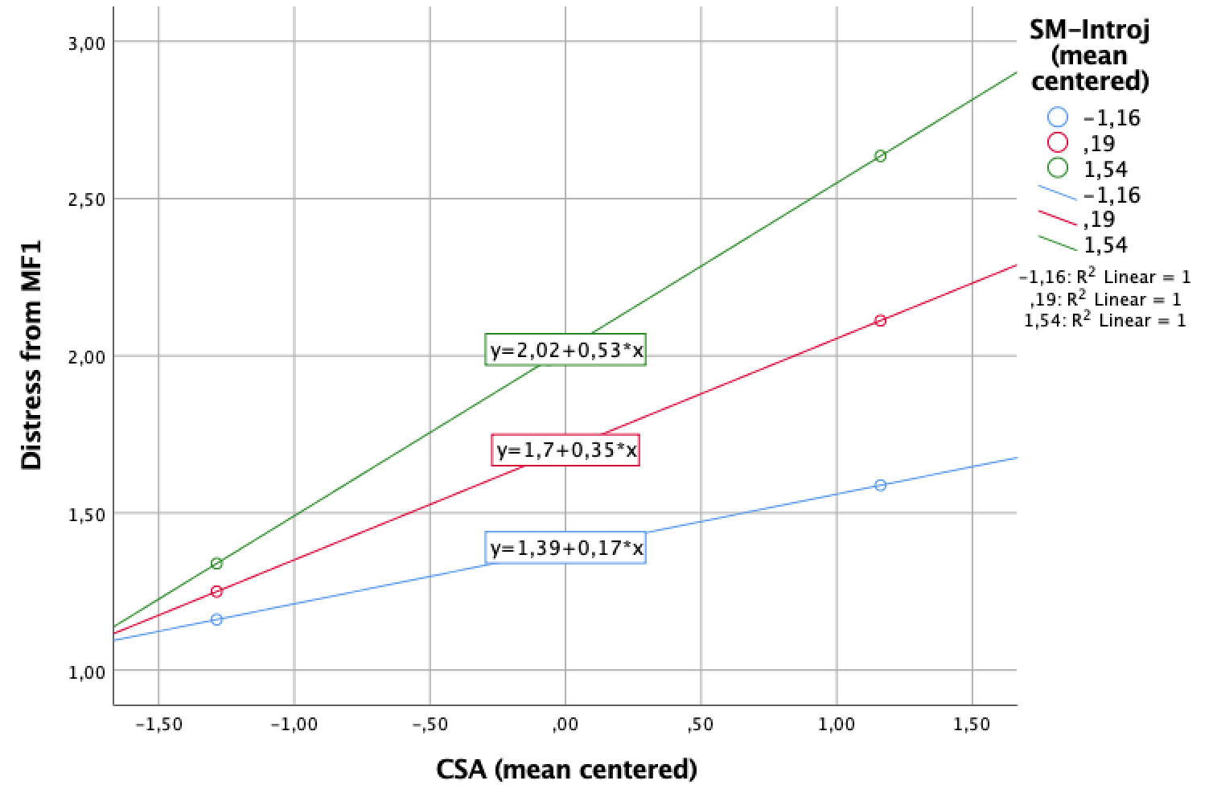
Supplementary figure 2.
Visualization of the interaction in the moderation analysis to predict distress from MF in masturbation fantasies in women with BPD (see table 7).
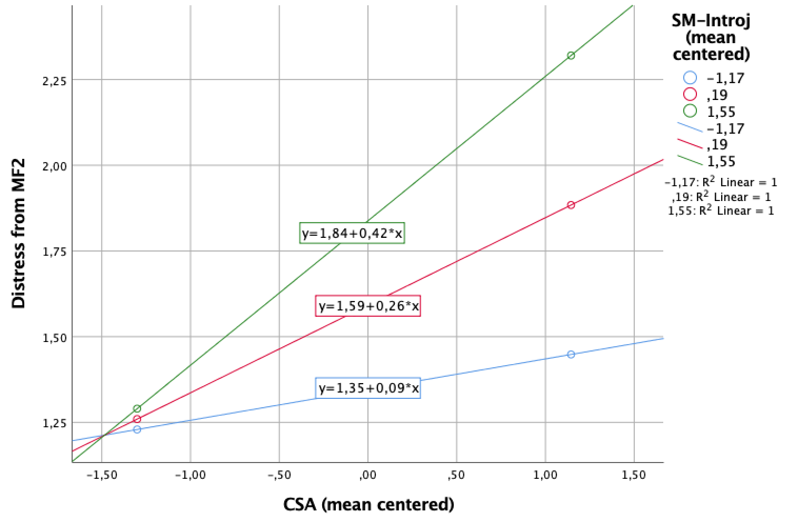

Supplementary figure 3.
Visualization of the interaction in the moderation analysis to predict distress from MF in sexual fantasies in women with BPD (see table 7).
