Portable Surface Acoustic Wave Sensor Systems for Microplastic Detection in Beverages
Jeong Hyeon Kim^{a,b}, Min Jae Hwang^{c}, Ha Yoon Jo^{d}, So Yeon Choi ^{d}, Seong Hyeon Park ^{d}, and Haneol Lee ^{a,b,d*}

ª Division of Advanced Materials Engineering, Jeonbuk National University, 567 Baekje-daero, Deokjin-gu, Jeonju-si, Jeollabuk-do, 54896, Republic of Korea
^{b} Department of JBNU-KIST Industry-Academia Convergence Research, Jeonbuk National University, 567 Baekje-daero, Deokjin-gu, Jeonju-si, Jeollabuk-do, 54896, Republic of Korea
^{c} Department of Semiconductor Science & Technology, Jeonbuk National University, 567 Baekje-daero, Deokjin-gu, Jeonju-si, Jeollabuk-do, 54896, Republic of Korea
^{d} Department of Electronics Engineering, Jeonbuk National University, 567 Baekje-daero, Deokjin-gu, Jeonju-si, Jeollabuk-do, 54896, Republic of Korea

⁎ E-mail addresses: haneol@jbnu.ac.kr (H. Lee)
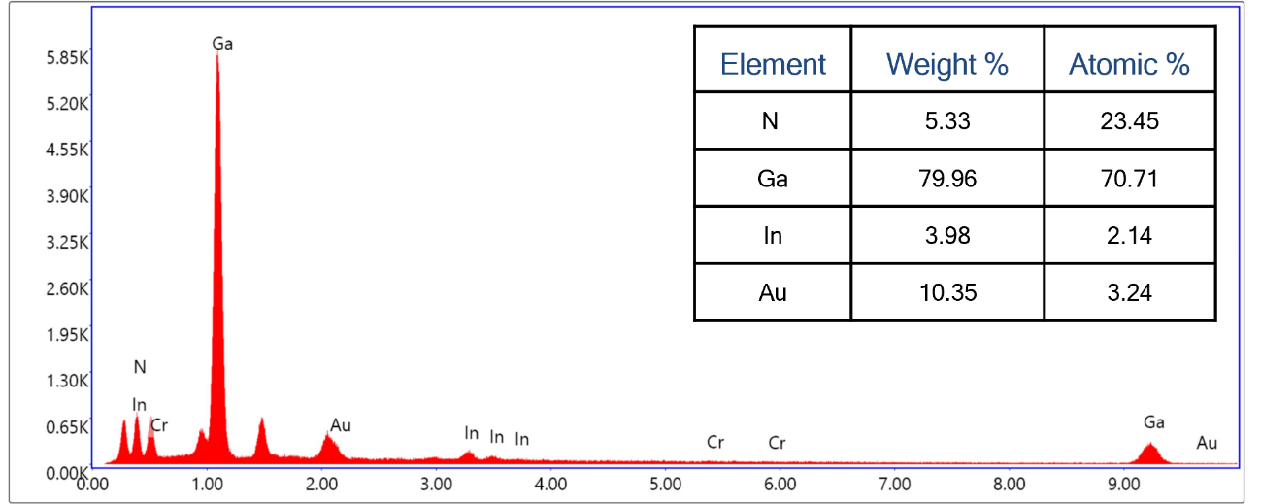
Figure S1 EDS spectrum of InGaN.

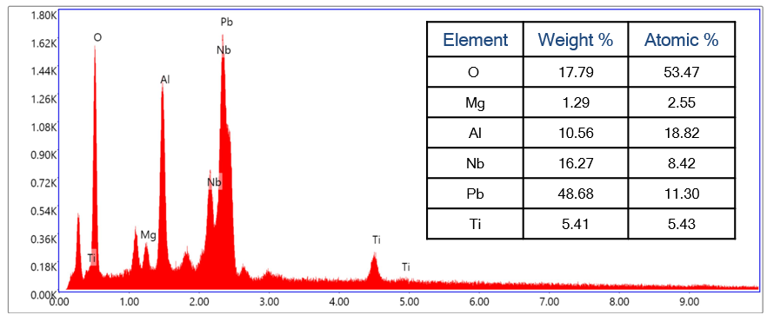
Figure S2 EDS spectrum of PMN-PT.

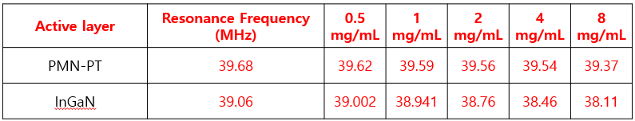
Table S1 Summary of resonance frequency shifts under active layer and concentrations.

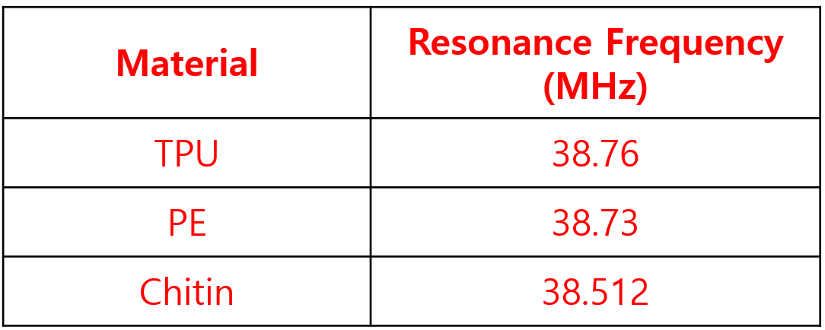
Table S2 Summary of resonance frequency shifts with microparticle types.

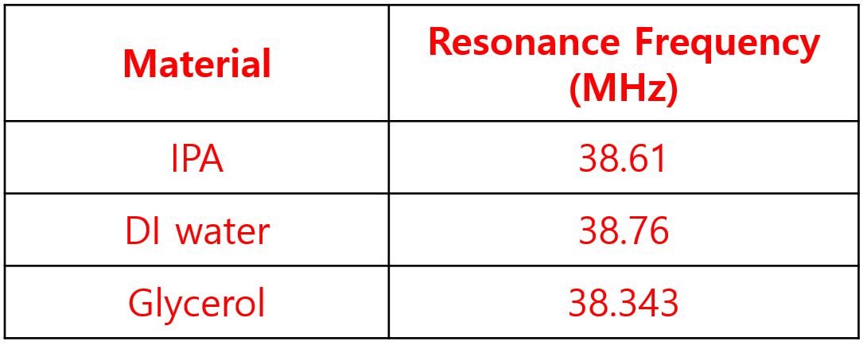
Table S3 Summary of resonance frequency shifts with dispersion media.

