Supplementary Material
‘Van Gogh’s Irises and Roses: The Contribution of Chemical Analyses and Imaging to the Assessment of Color Changes in the Red Lake Pigments’

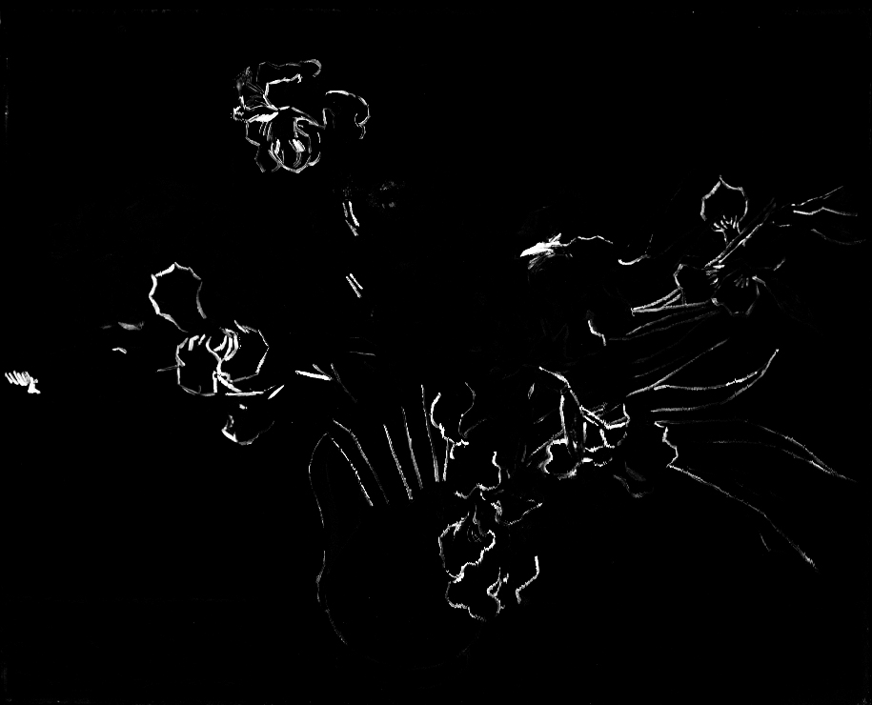
Figure S1. Irises. Fe distribution map acquired by XRF imaging showing the location of Prussian blue in the outlines of the irises.

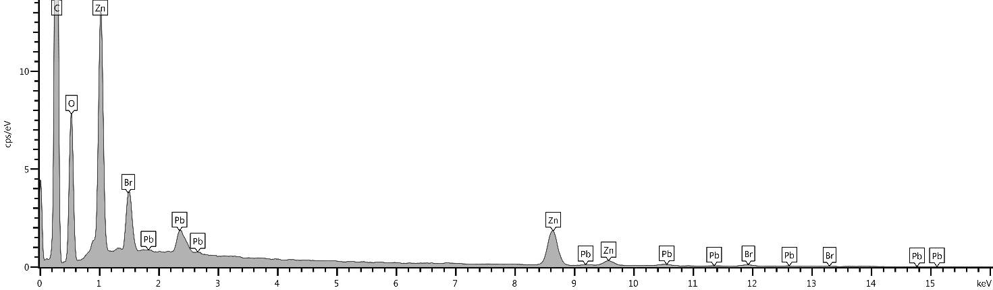
Figure S2. Irises. SEM-EDS spectrum acquired in the particles that fluoresce yellow when illuminated with ultraviolet light in the sample shown in Figure 2b.
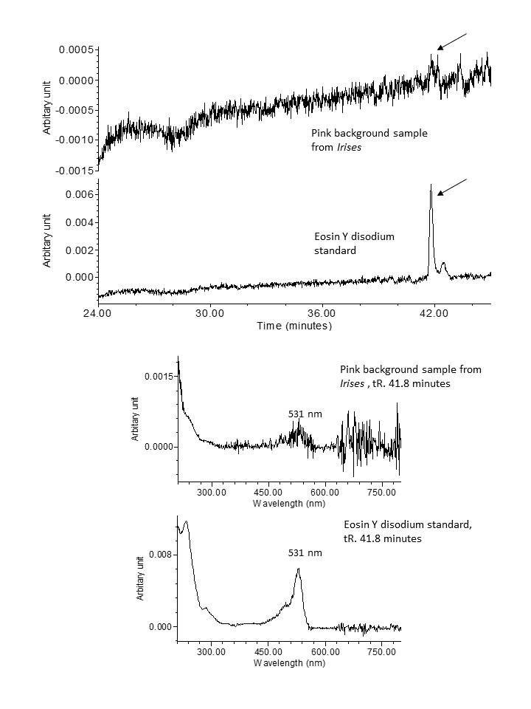

Figure S3. Chromatograms at 530 nm of the sample removed from the pink background of Irises and of an eosin Y disodium standard (top graphs); UV spectra of the peaks at 41.8 minutes, indicated by arrows in the chromatograms in the top graph, showing the presence of eosin in the sample from Irises (bottom graphs).

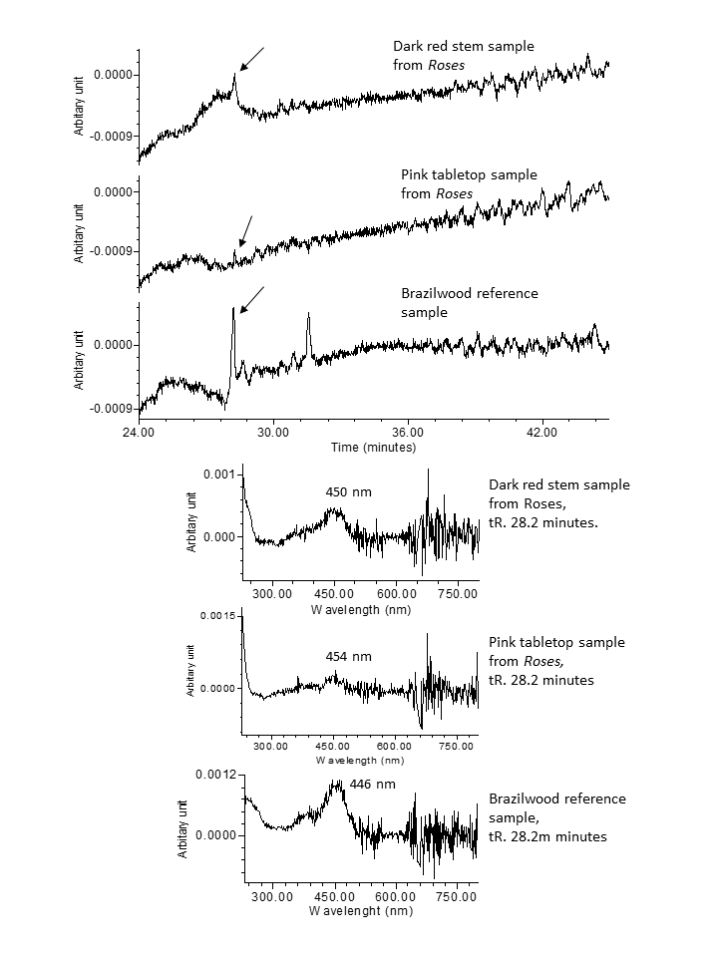

Figure S4a. Chromatograms at 450 nm of the samples removed from a dark red stem and from the pink tabletop in Roses, and of a brazilwood reference sample (top graphs); UV spectra of the peaks at 28.2 minutes, indicated by arrows in the chromatograms, showing that a brazilein derivative, a main colorant of soluble redwood dye, is likely present in the samples from Roses (bottom graphs) [1].

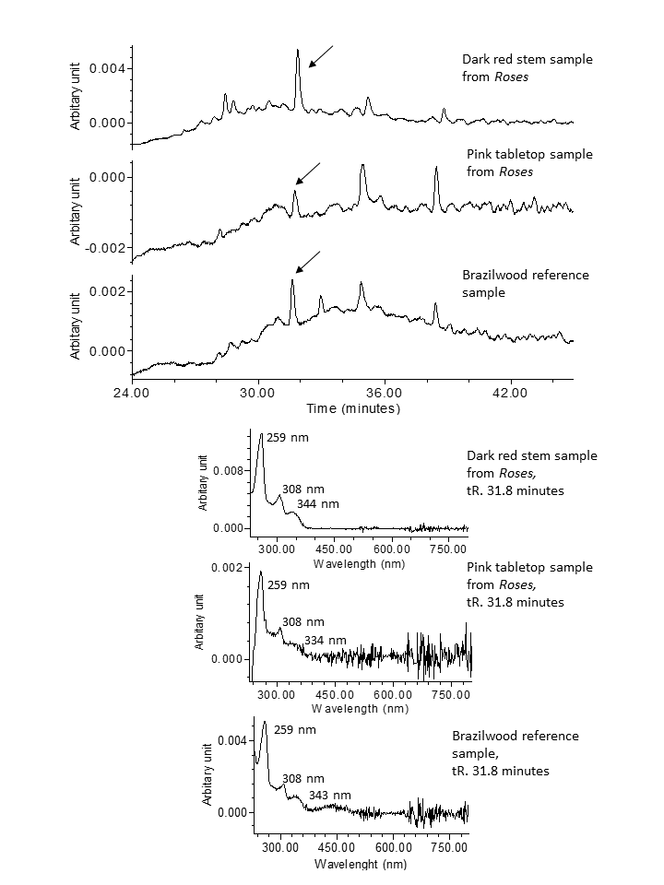
Figure S4b. Chromatograms at 307 nm of the samples removed from a dark red stem and the pink tabletop in Roses, and of a brazilwood reference sample (top graphs); UV spectra of the peaks at 31.8 minutes, indicated by arrows in the chromatograms, showing the presence of a ‘type C compound,’ that is a characteristic of a soluble redwood dye, in the samples from Roses [1].

References
[1]. Nowik W. The possibility of differentiation and identification of red and blue “soluble” dyewoods: determination of species used in dyeing and chemistry of their dyestuffs. In: Kirby J, editor. Dyes in history and archaeology 16/17. London: Archetype; 2001. p. 129–44.

