Additional file

Figure S1: Preparation of FIB lamella and lift-out procedure (a) cutting the thin lamella with ion beam (b) perpendicular view of the lamella showing uniform thickness (c) lift out (d) Omniprobe FIB holder (e) thin lamella attached to FIB holder (arrow) and (f) low resolution TEM image of the lamella

(a) (b) (c)
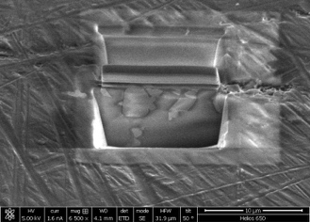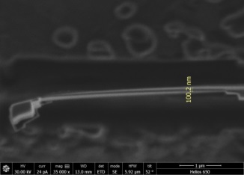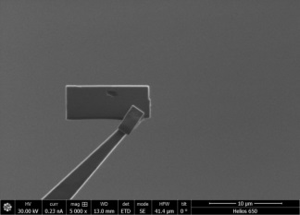

(d) (e) (f)
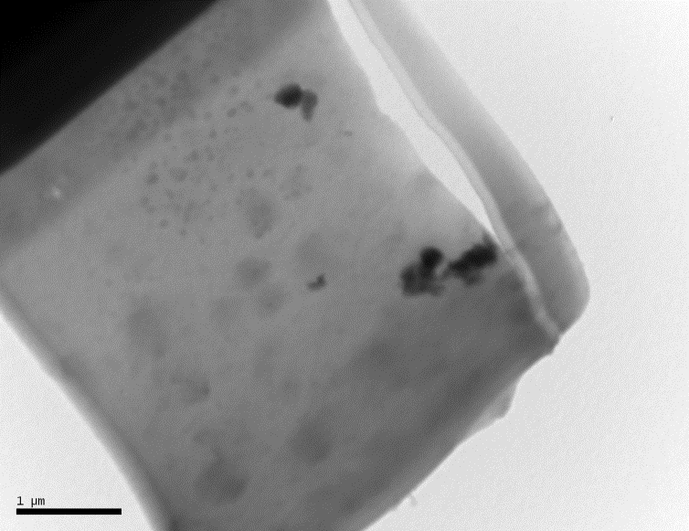

Fig. S2 (green sample)

(a) SEM image of the green tesserae showing glass matrix with 200-400 nm precipitates (opacifiers/pigments) (b) EDS analysis on a matrix area (c) EDS analysis on precipitate area

(b) (c)
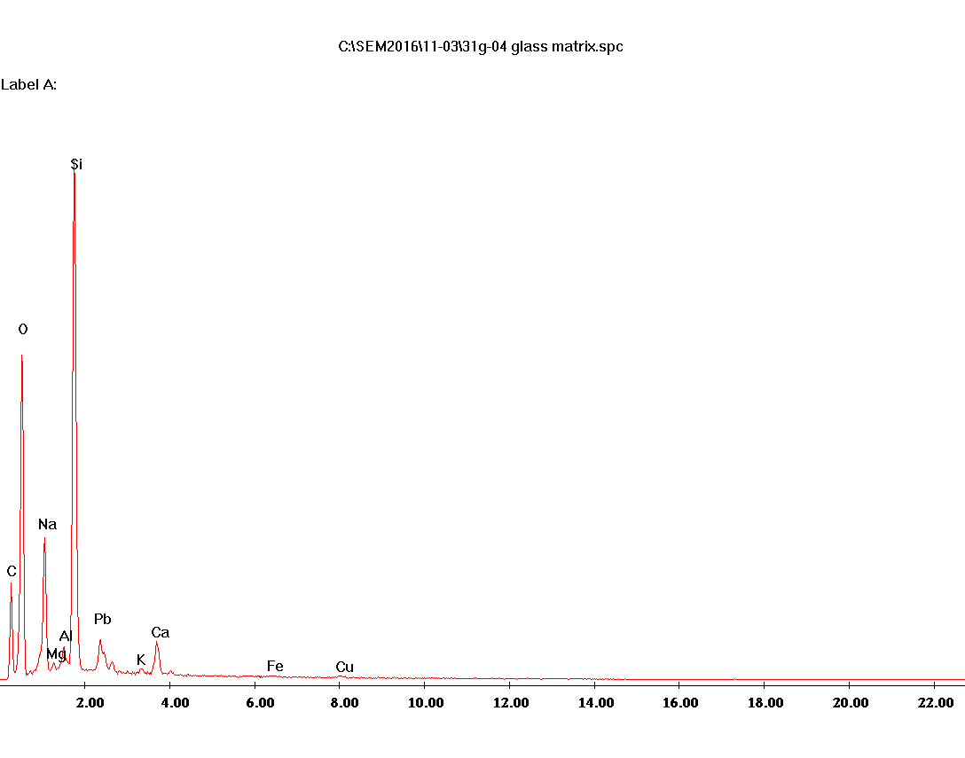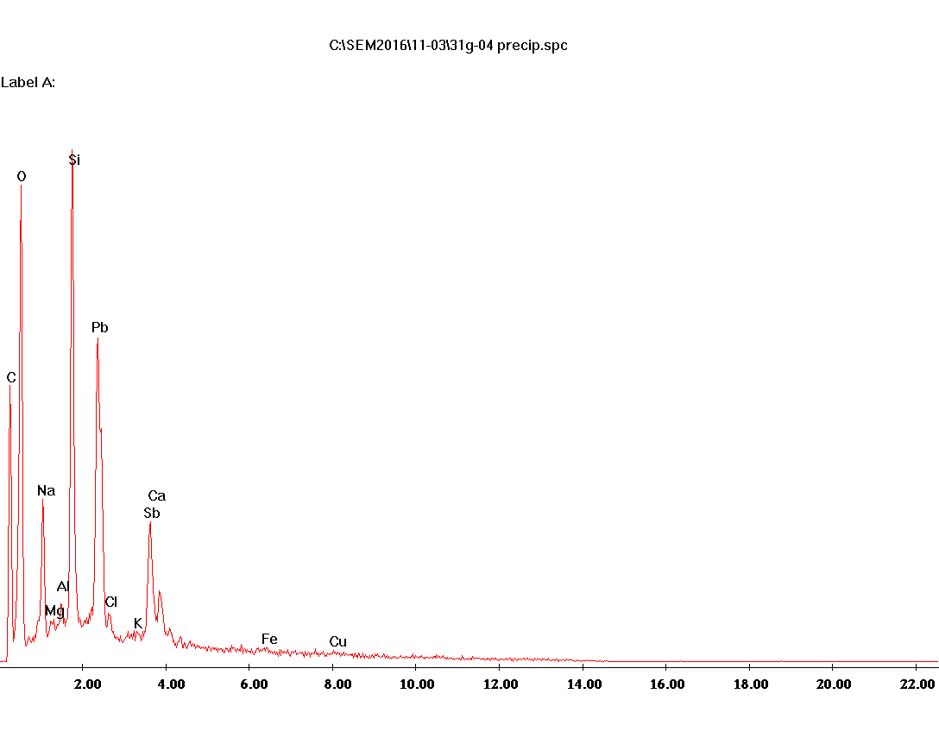

Table S1 EDS analysis on the matrix of green sample (Fig. S2 - b)

kV:15.00, Tilt: 0.00, Take-off:35.22, Tc:35.0
Detector Type :SUTW-Sapphire, Resolution :130.83, Lsec :121
EDAX ZAF Quantification, Standardless,
Element Normalized
SEC Table : Default
Element, Wt %, At %, K-Ratio, Z, A, F
C K, 15.76, 27.08, 0.0296, 1.0657, 0.1761, 1.0003
O K, 31.28, 40.35, 0.1007, 1.0454, 0.3079, 1.0004
CuL, 3.27, 1.06, 0.0169, 0.8587, 0.6014, 1.0022
NaK, 7.07, 6.35, 0.0359, 0.9753, 0.5187, 1.0025
MgK, 0.66, 0.56, 0.0040, 0.9989, 0.6055, 1.0049
AlK, 1.35, 1.03, 0.0096, 0.9695, 0.7269, 1.0090
SiK, 27.02, 19.85, 0.2192, 0.9965, 0.8138, 1.0006
PbM, 7.09, 0.71, 0.0497, 0.6820, 1.0264, 1.0002
ClK, 0.79, 0.46, 0.0063, 0.9403, 0.8346, 1.0020
K K, 0.56, 0.29, 0.0048, 0.9431, 0.9133, 1.0051
SbL, 0.91, 0.15, 0.0068, 0.7459, 1.0041, 1.0002
CaK, 3.59, 1.85, 0.0325, 0.9636, 0.9371, 1.0005
FeK, 0.65, 0.24, 0.0057, 0.8714, 0.9937, 1.0073
Total, 100.000, 100.000

Table S2 EDS analysis on the precipitate of green sample (Fig. S2 - c)
Acquisition Time:10:49:47, Date:11-Mar-2016
kV:15.00, Tilt: 0.00, Take-off:35.22, Tc:35.0
Detector Type :SUTW-Sapphire, Resolution :130.83, Lsec :66
EDAX ZAF Quantification, Standardless,
Element Normalized
SEC Table : Default
Element, Wt %, At %, K-Ratio, Z, A, F
C K, 13.36, 28.48, 0.0297, 1.1207, 0.1986, 1.0002
O K, 24.07, 38.51, 0.0787, 1.0990, 0.2974, 1.0003
CuL, 3.14, 1.26, 0.0146, 0.9022, 0.5155, 1.0014
NaK, 6.03, 6.71, 0.0275, 1.0246, 0.4452, 1.0015
MgK, 0.77, 0.81, 0.0043, 1.0490, 0.5392, 1.0028
AlK, 1.19, 1.13, 0.0081, 1.0245, 0.6592, 1.0050
SiK, 17.55, 15.99, 0.1407, 1.0617, 0.7546, 1.0007
PbM, 21.66, 2.68, 0.1616, 0.7218, 1.0333, 1.0002
ClK, 0.73, 0.52, 0.0056, 0.9931, 0.7752, 1.0028
SbL, 7.56, 1.59, 0.0571, 0.7890, 0.9568, 1.0002
CaK, 2.80, 1.79, 0.0255, 1.0186, 0.8952, 1.0005
FeK, 1.16, 0.53, 0.0106, 0.9314, 0.9767, 1.0049

Fig. S3 ( white sample)

(a) SEM image of the green tesserae showing glass matrix with 200-400 nm precipitates (opacifiers/pigments) (b) EDS analysis on a matrix area (c) EDS analysis on precipitate area

(b) (c)

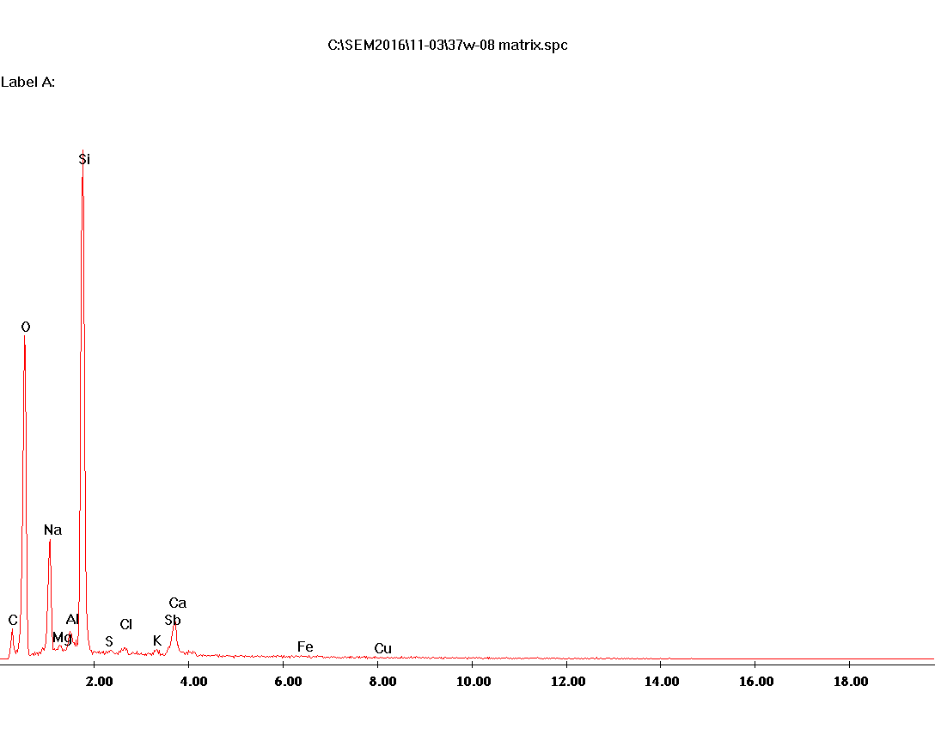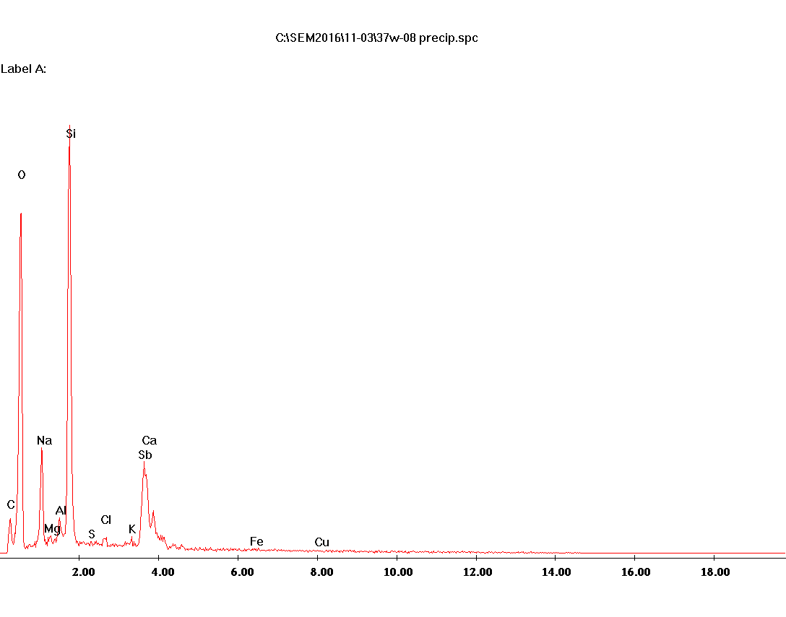

Table S3 EDS analysis on the matrix of white sample (Fig. S3 - b)

kV:15.00, Tilt: 0.00, Take-off:35.43, Tc:35.0
Detector Type :SUTW-Sapphire, Resolution :130.83, Lsec :32
EDAX ZAF Quantification, Standardless,
Element Normalized
SEC Table : Default
Element, Wt %, At %, K-Ratio, Z, A, F
C K, 13.06, 21.41, 0.0232, 1.0506, 0.1693, 1.0004
O K, 36.21, 44.56, 0.1234, 1.0306, 0.3305, 1.0004
NaK, 7.70, 6.60, 0.0410, 0.9617, 0.5511, 1.0032
MgK, 0.71, 0.58, 0.0045, 0.9850, 0.6357, 1.0062
AlK, 1.51, 1.10, 0.0110, 0.9542, 0.7555, 1.0115
SiK, 31.35, 21.97, 0.2569, 0.9781, 0.8372, 1.0009
S K, 0.22, 0.14, 0.0017, 0.9678, 0.8030, 1.0023
ClK, 0.59, 0.33, 0.0048, 0.9256, 0.8635, 1.0035
K K, 0.64, 0.32, 0.0056, 0.9284, 0.9378, 1.0088
SbL, 2.35, 0.38, 0.0177, 0.7338, 1.0277, 1.0002
CaK, 4.62, 2.27, 0.0420, 0.9482, 0.9583, 1.0003
FeK, 0.62, 0.22, 0.0053, 0.8542, 0.9972, 1.0010
CuK, 0.41, 0.13, 0.0034, 0.8188, 1.0017, 1.0000
Total, 100.000, 100.000

Table S4 EDS analysis on the precipitate of white sample (Fig. 3S - c)

kV:15.00, Tilt: 0.00, Take-off:35.43, Tc:35.0
Detector Type :SUTW-Sapphire, Resolution :130.83, Lsec :34
EDAX ZAF Quantification, Standardless,
Element Normalized
SEC Table : Default
Element, Wt %, At %, K-Ratio, Z, A, F
C K, 11.14, 21.69, 0.0250, 1.0932, 0.2049, 1.0003
O K, 29.37, 42.94, 0.1091, 1.0722, 0.3462, 1.0003
NaK, 6.33, 6.44, 0.0282, 1.0000, 0.4440, 1.0020
MgK, 0.59, 0.57, 0.0033, 1.0240, 0.5436, 1.0039
AlK, 1.40, 1.21, 0.0094, 0.9957, 0.6685, 1.0072
SiK, 21.84, 18.19, 0.1717, 1.0260, 0.7644, 1.0022
S K, 0.19, 0.14, 0.0015, 1.0114, 0.8055, 1.0064
ClK, 0.61, 0.40, 0.0052, 0.9659, 0.8649, 1.0108
K K, 0.68, 0.41, 0.0063, 0.9687, 0.9377, 1.0293
SbL, 20.23, 3.89, 0.1593, 0.7665, 1.0272, 1.0002
CaK, 5.96, 3.48, 0.0565, 0.9900, 0.9578, 1.0003
FeK, 0.75, 0.31, 0.0066, 0.8973, 0.9797, 1.0012
CuK, 0.92, 0.34, 0.0079, 0.8638, 0.9933, 1.0000
Total, 100.000, 100.000

Fig. S4 Green tesserae highlighting some of the crystals with various sizes analyzed by means of EPMA

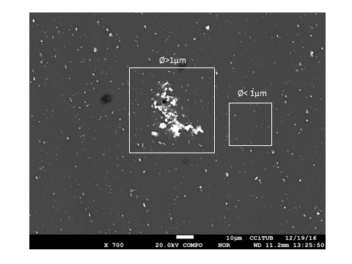

Fig. S5 White tessereae highlighting some of the crystals with various sizes analyzed by means of EPMA

