Additional information
Micro Raman analysis - Results
Pre-resonance micro-Raman analysis of palygorskite-based and sepiolite-based Maya blue replicas was aimed at confirming and investigating dye-clay interactions as function of differences in weight ratio (indigo-clay), temperature and heating time.
Some of the Maya blue samples are shown in Fig. S1 and Fig. S2 and compared with reference spectra of synthetic indigo (Aldrich) and commercial Maya blue (proper palygorskite-based Maya blue, Kremer).

Fig. S1 Raman spectra (λ = 785 nm) of reference materials and palygorskite-based Maya blue replicas. Dash-dot vertical lines indicate the signals involved in the dye-clay interactions. The spectra are baselined and shifted vertically for clarity.
The Raman spectrum of Maya blue reference (Fig. S1, dark blue bottom line) shows some spectral differences compared to the spectrum of indigo (Fig. S1, blue top line): the bands at 95, 132 and 172-182 (doublet) cm⁻¹ disappear after the thermal treatment, the complex envelope in the 200-300 cm⁻¹ range merges in a single broad band, the signal at 546 cm⁻¹ shifts to higher wavenumber (558 cm⁻¹), the band at 599 cm⁻¹ losses its intensity and slightly changes its position (603 cm⁻¹), the broad band at 636 cm⁻¹ disappears completely, that at 676 cm⁻¹ doubles its width while the one at 1227 cm⁻¹ decreases in intensity, the bands at 1251 and 1313 cm⁻¹ shift respectively at 1259 and 1322 cm⁻¹, the signal at 1367 cm⁻¹ vanishes as the other mentioned above, finally the strong peaks at 1574 and 1584 cm⁻¹ coalesce in a unique band at ca. 1578 cm⁻¹. The assignments of the signals involved in the dye-clay interactions have been deeply discussed by del Río et al. (1). Similar changes to the spectral features have been recently reported and interpreted by Bernardino et al. but, due to the resonance conditions used (λ = 632.8 nm), differences can be seen in comparison to the data reported in the present paper where instead pre-resonance conditions (λ = 785 nm) have been employed (2).
Differences in weight ratio (indigo-clay), temperature and time, influence the Raman spectral features and quality of the replicas. The unheated simple mixture of indigo and palygorskite (1%, black line) shows Raman signals compatible with those of the pure dye. Spectral changes ascribable to the dye-clay interaction (as discussed above) are visible only upon heating, independently of the initial concentration of the dye and the time. An interesting fact is worth to be discussed, that is the presence of indigo not bound or partially bound to the clay in some of the replicas. This occurrence can be seen in two groups: i) replicas heated at 130°, 160° and 180° C for 1 hour (respectively red line, violet line, dark green line), ii) replicas with initial high concentration of indigo (5%, dark pink line). On the one hand, this is an indication that a short thermal treatment is not totally efficient for a complete loss of the clay water molecules and the interaction with the dye, on the other hand, a high concentration of indigo lead to a hybrid pigment with free molecules of the dye because the clay can host only a certain amount of the organic component. This outcome is not in accordance with Tsiantos et al. who, on the basis of NIR spectra, claim that up to 10% of indigo the dye can be completely hosted by the clay (3). Raman analysis is not a bulk technique, therefore several areas have been probed in our research to obtain reproducible results. Free molecules of indigo have been undoubtedly detected in all the samples containing 5% of indigo. One plausible explanation could be that the NIR analysis is not so sensitive for tiny amounts of free molecule of indigo.
The scenario is different when sepiolite substitutes palygorskite. Because of the bigger size of the channels in the sepiolite structure, the interaction between the clay and the dye occurs already after grinding even prior the thermal treatment (Fig. S2, black line) as already noted and reported by Giustetto et al. (4). This can be possibly due to the larger section of the sepiolite channels and also by the higher mobility of the zeolitic water in sepiolite than in palygorskite. The spectral features indicating indigo interacting with the inorganic matrix can be observed independently from the initial concentration similarly to what has been observed in palygorskite-based Maya blue replicas. However, the behaviour of the dye-clay adduct is intermediate between the pure dye and palygorskite-based Maya blue. In some cases, for example, the bands between 200 and 300 cm⁻¹ are not completely merged in a single broad band (Fig. S2, red line, green line and dark green line), the same can be noticed for the two bands at 1574 and 1584 cm⁻¹. These spectral features can be attributed to the different interaction of the indigo molecule in the larger channels of the sepiolite where it is anchored only on one side. In this case, the temperature seems to influence more the quality of the Raman results. In fact, no Raman signals have been recorded for the replica heated at 180° C. The spectra collected on this replica are all characterized by a high background hiding the bands of the dye/dye-clay adduct. Finally, the presence of free molecules of indigo can be seen also in the sepiolite-based adduct when using an initial high concentration (5%, dark pink line) of the dye.

Fig. S2 Raman spectra of reference materials and sepiolite-based Maya blue replicas recorded using a laser diode at 785 nm. Dash-dot vertical lines indicate the signals involved in the dye-clay interactions. The spectra are baselined and shifted vertically for clarity.

Colorimetric analysis
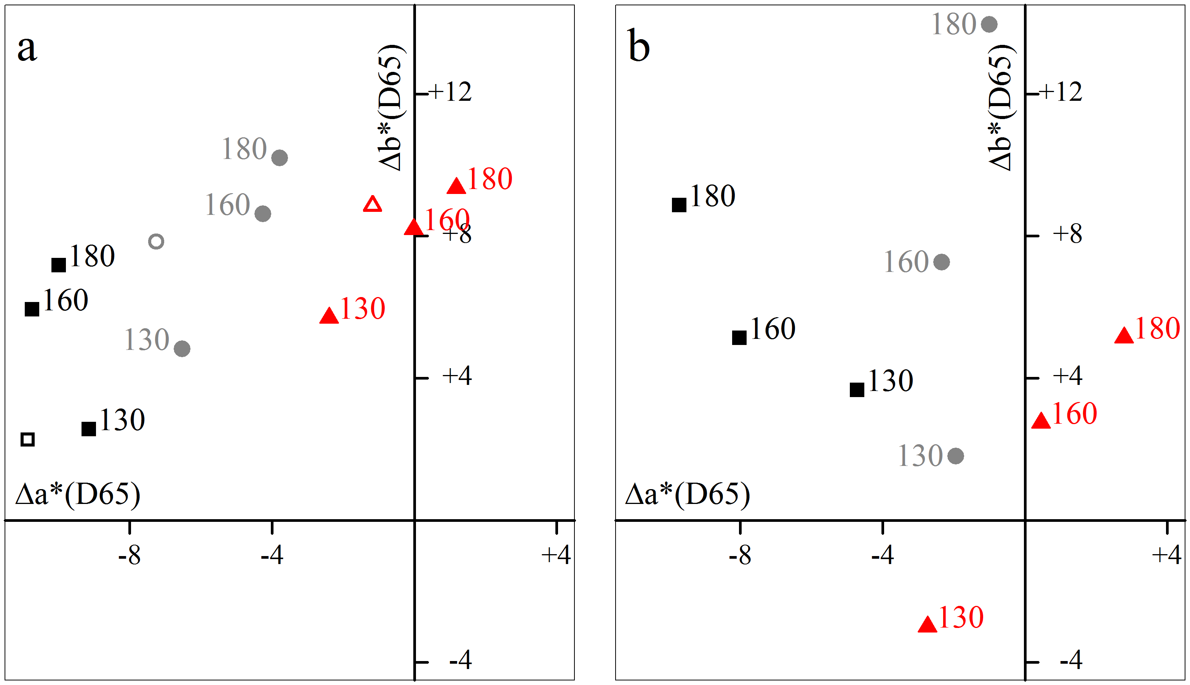
Fig. S3 Projection in the Δa*Δb* space of the colorimetric measurements of the palygorskite-containing (a) and sepiolite-containing (b) samples after heating.

References
1. Sánchez del Río M, Boccaleri E, Milanesio M, Croce G, van Beek W, Tsiantos C, et al. A combined synchrotron powder diffraction and vibrational study of the thermal treatment of palygorskite–indigo to produce Maya blue. Journal of Materials Science. 2009;44(20):5524-36.
2. Bernardino N, Constantino VRL, De Faria D. Probing the indigo molecule in Maya blue simulants with resonance Raman spectroscopy. The Journal of Physical Chemistry C. 2018;122(21):11505-15.
3. Tsiantos C, Tsampodimou M, Kacandes GH, Sánchez del Río M, Gionis V, Chryssikos GD. Vibrational investigation of indigo–palygorskite association(s) in synthetic Maya blue. Journal of Materials Science. 2011;47(7):3415-28.
4. Giustetto R, Seenivasan K, Bordiga S. Spectroscopic characterization of a sepiolite-based Maya Blue pigment. Periodico di Mineralogia. 2010;79:21-37.

