Supplementary Information for “Oxidative degradation of archaeological wood and the effect of alum, iron and calcium salts”
Caitlin M. A. McQueen, Martin N. Mortensen, Francesco Caruso, Sara Mantellato, Susan Braovac

SEM-EDS of salt-impregnated wood pieces
SEM-EDS analyses were performed using an FEI Quanta 450 Scanning Electron Microscope coupled with an Oxford X-Max^{N} 50 mm² detector, using low vacuum mode to avoid charging and a voltage of 20 kV. The other parameters (spot size, pressure, and working distance) were modified depending on the sample.

3 × 1 × 1 cm³ birch pieces that had undergone treatment with each of the salt combinations used in the study were cut through the middle of the long edge, and the presence of the corresponding inorganic ions confirmed throughout the inner face using linescans and spectra from 2D maps, as shown for representative samples in Figures S1 and S2. In the samples that had not been treated with iron, calcium and alum salts, the corresponding elements (Fe, Ca, Cl and K, Al, S, respectively) were not detected.

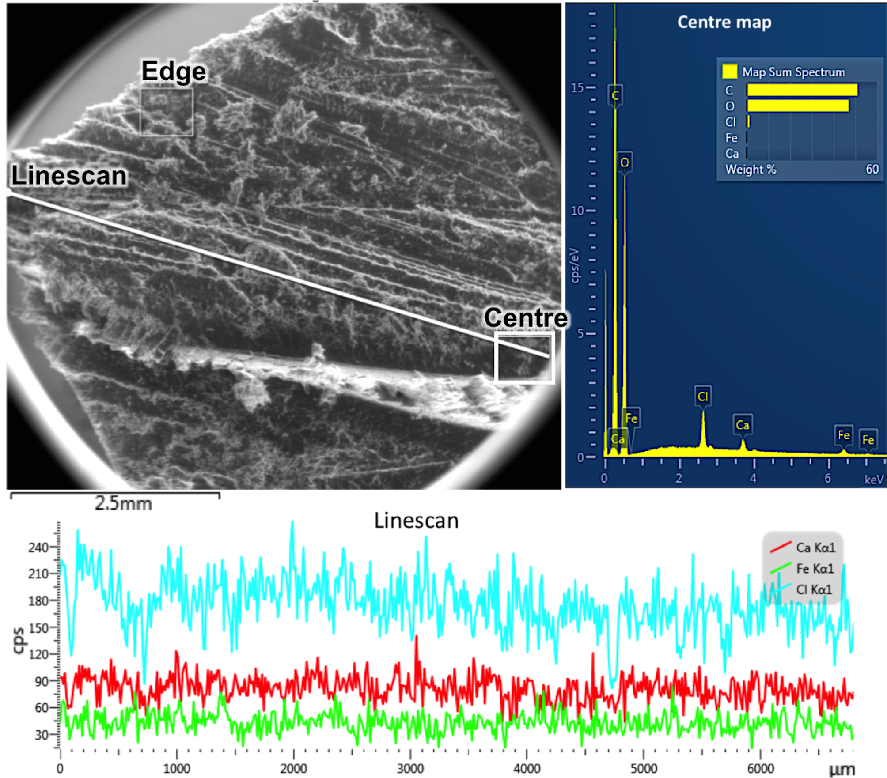
Figure S1: SEM image of inner face of one Fe-2Ca sample, along with EDS linescan from the edge (0 μm) to the centre of the face and EDS map from the centre, showing Fe, Ca and Cl distributed throughout.

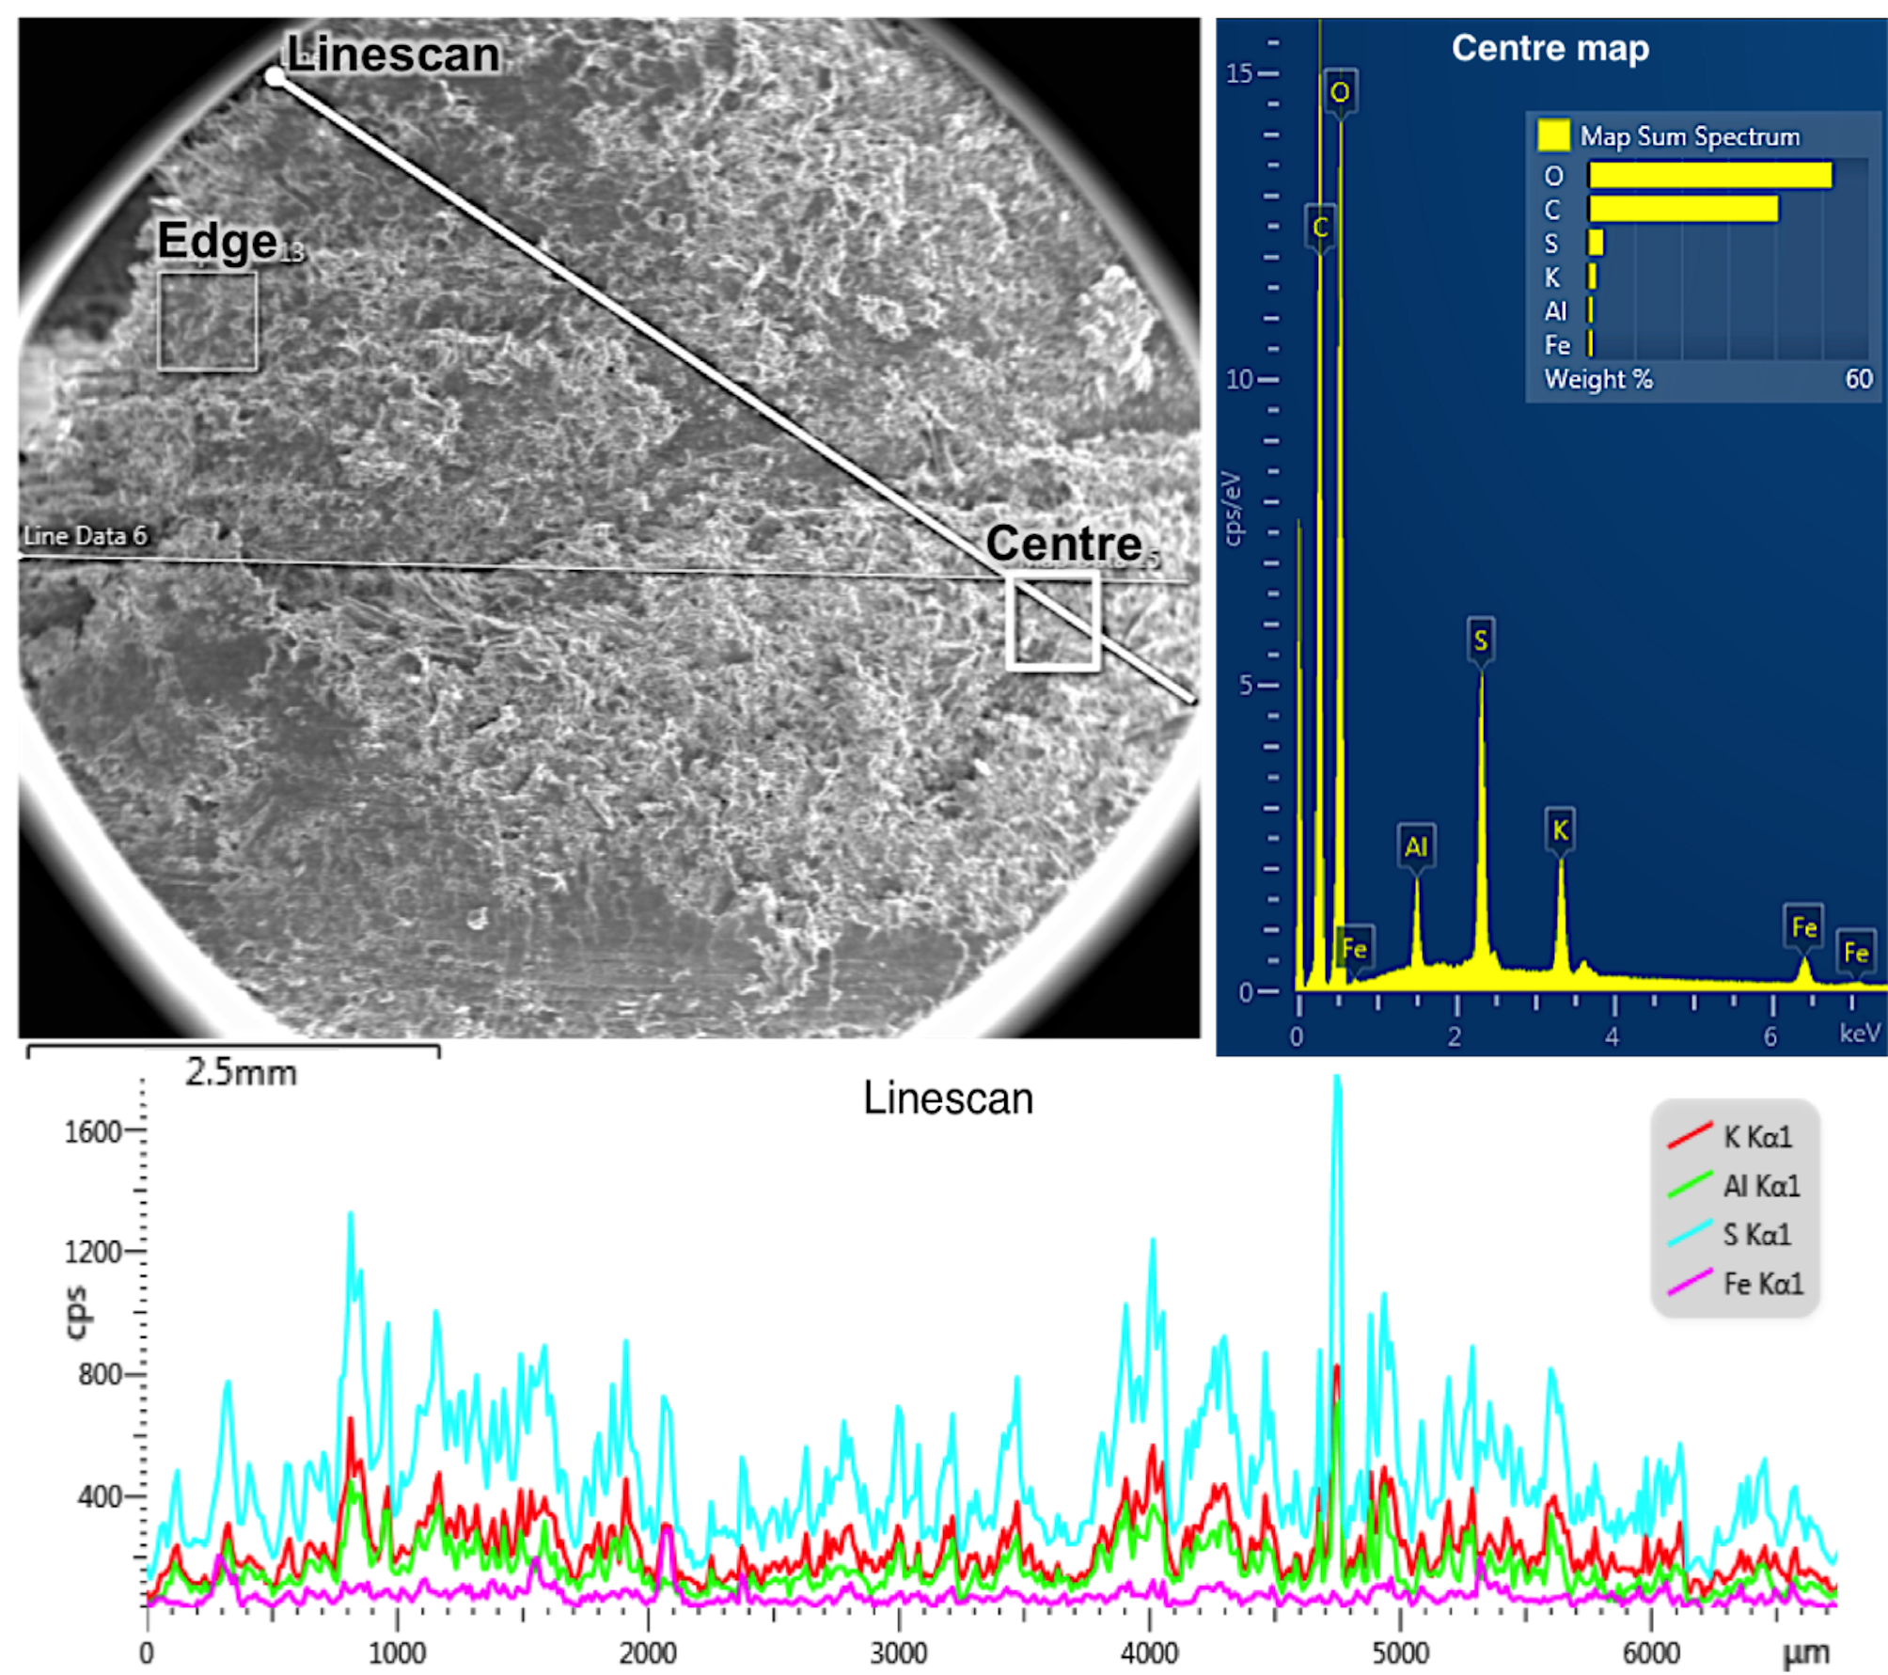
Figure S2: SEM image of inner face of one al-Fe0.5 sample, along with EDS linescan from the edge (0 μm) to the centre of the face and EDS map from the centre, showing K, Al, S and Fe distributed throughout.

Standard and reference ICP-OES solutions
According to the expected concentrations and the method developed in this study, we prepared a multi-elemental standard and reference solutions by suitably diluting 1000 mg/L aluminium, calcium, iron, and potassium standard bulk solutions for ICP (TraceCERT, Fluka) in 2% (w/w) HNO₃ in Ultra Pure Water (UPW). Their composition is reported in Table S1.

Table S1: Composition of the standard and reference solutions used for the calibration and the determination of the figures of merit with the developed ICP-OES method.
Element | Standard (mg/L) | Reference (mg/L)
Al | 50 | 20
Ca | 0.5 | 0.2
Fe | 1 | 0.5
K | 50 | 20

Analytical figures of merit of the ICP-OES method
Table S2 provides the main analytical figures of merit of the developed ICP-OES method for the measurements carried out for this study. Note that the reported closeness of agreement is a measurement of the trueness of the method.

Table S2: Selected spectral lines, view mode, percentage deviation between the measured and the expected concentrations of the reference solution reported in Table S1 (five samples from the same reference solution were spilled), and obtained Limits of Detection (LODs) and Limits of Quantification (LOQs) (n_{blanks} = 3).
Element | Spectral line (nm) | View Mode | Closeness of agreement | LOD (μg/L) | LOQ (μg/L)
Al | 308.215 | Axial | 3.8% | 7 | 23
Ca | 317.993 | Axial | 3.9% | 4 | 13
Fe | 259.940 | Axial | 0.08% | 0.2 | 0.7
K | 769.896 | Radial | 0.5% | 143 | 476

