Additional file 1

Fig. S1.
The papier mâché board, hemisphere and rope mock-up samples and Addendum in the background (A). Papier mâché board control (B) and with artificial soiled applied (C).

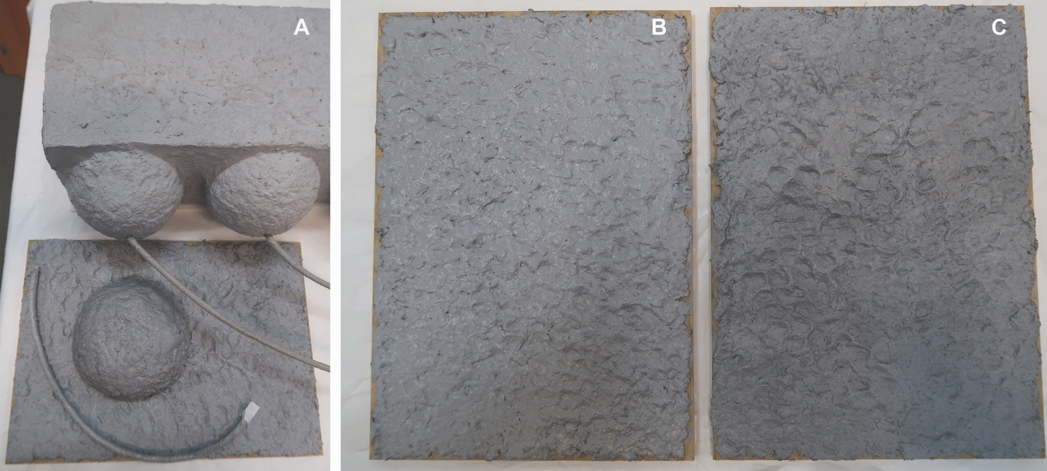

Table S1.
List of criteria and description of star diagram rating scales used to evaluate free-cleaning fluid options on Addendum.

Parameter | Rating
Parameter | 1 (inadequate/poor) | 2 | 3 | 4 | 5  (appropriate)
Dirt removal efficacy | No effect | Little effect | Moderate | Moderately effective | Complete removal
Pigment pickup | Unacceptable pigment pickup | Minor pigment visible with stain | Faint stain | Very faint stain | No pigment / stain
Swelling | Extreme, visible swelling | Moderate swelling, visible | Slight sensation of swelling, not visible | Very slight sensation of swelling, not visible | No swelling
Foaming | Extreme foaming | Moderate foaming | Minimal foaming | Trace foaming | No foaming
Surface integrity (gloss) | Unacceptable  change | Change visible in normal light | Change visible in raking light | Very slight shift | No visible change

Table S2.
List of criteria and description of the star diagram rating scales used to evaluate the suitability of gels and emulsifiers on both mock-up samples and Addendum.

Parameter | Rating
Parameter | 1 (inadequate/poor) | 2 | 3 | 4 | 5  (appropriate)
Dirt removal efficacy | No effect | Minimal soil removal (~ 30% of the surface appears cleaned) | Moderate soil removal  (~ 50% of the surface appears cleaned) | Satisfactory soil removal (~ 70% of the surface appears cleaned) | Complete removal
Pigment or coating pickup | Unacceptable pigment pickup | Moderate pigment pickup visible with stain | Minimal pigment pickup - faint stain | Trace pigment pickup - fragments only | No pigment / stain
Surface Integrity | Significant change | Change visible in normal light | change only visible in raking light | Slight shift | No visible change
Visible  Cleaning System Residue | Surface covered by visible gel/emulsifier residue | Surface partially covered by easily visible gel/emulsifier residue | Some gel/emulsifier residue-like material present | Possible presence of gel/emulsifier/cleaning solutions residues, if clearance procedure is not performed appropriately | No visible gel/emulsifier residue
Ease of application | Difficult application and removal/clearance and spreading of the treatment site.  poor surface contact (≤ 10%) | Difficult application and removal/ clearance.  minimal surface contact (≤ 30%) | Difficult to remove/clear completely.  moderate surface contact (~ 50%) | Easy application and removal/clearance. good surface contact (≥ 70% gel) | Very easy application and removal/clearance. complete surface contact
Practicability  (ease of preparation) | Difficult/time-consuming preparation, special procedures/ instruments required. Expensive, difficult to procure. | Time consuming preparation may require special procedures/instruments. | Requires time to prepare but takes multiple simple steps. | Easy to prepare, (i.e. making the gel + uploading step) | Ready to use (i.e. only uploading step)
Health & Safety | Highly toxic/dangerous components. full PPE, fume cupboard, careful handling and disposal | Full PPE and fume cupboard due to hazardous fumes, storage and disposal precautions | Some PPE and fume cupboard due hazardous fumes | Some PPE, special storage and/or waste precautions | Minimal PPE, no hazardous storage or disposal, no fume cupboard

Table S3.
Key observations after trial of non-confined cleaning solutions (10-swab roll applications) on both papier mâché and ropes mock-ups and Addendum. Clearance strategies are reported in Table 2.
N.B: For all tests performed on the rope section of Addendum, the surface appeared very brittle and sensitive to mechanical action.

Free-liquid system | Tailored options | Mock-ups (after clearance) |  | Addendum (after clearance)
Free-liquid system | Tailored options | Papier-mâché: [p(EA-MMA) + PVAc] | Ropes: [p(EA-MMA) + PVAc + p(nBA-MMA] | Papier-mâché: [p(EA-MMA) + PVAc] | Ropes: [p(EA-MMA) + PVAc + p(nBA-MMA]
Aqueous free-liquids | Deionised water  (DI) | Moderate cleaning efficacy.  Slight swelling towards the end of the test (i.e. 10 double rolls), not visible. | Minimal cleaning efficacy.  Very slight sensation of swelling towards the end of the test, not visible. | Minimal cleaning efficacy.  Very slight sensation of swelling towards the end of the test, not visible. | Minimal cleaning efficacy.  Very slight sensation of swelling towards the end of the test, not visible.
Aqueous free-liquids | MES buffered water  (pH 6) | Moderate cleaning efficacy. | Moderate cleaning efficacy. | Minimal cleaning efficacy. Very sight sensation of swelling towards the end of the test, not visible. | Poor cleaning efficacy.
Aqueous free-liquids | Bis-Tris buffered water (pH 6.5) | Moderate cleaning efficacy.  Potential very slight sensation of swelling towards the end of the test, not visible. | Moderate cleaning efficacy.  Possibly very slight sensation of swelling towards the end of the test, not visible. | Minimal cleaning efficacy. | Poor cleaning efficacy.
Silicone and hydrocarbon solvents as free-liquids | D5 | Poor cleaning efficacy; straight after the test the surface appears darker due to saturation with low volatility solvent; after solvent evaporation the surface appears slightly shinier and smoother. | No cleaning efficacy. | Poor cleaning efficacy; straight after the test the surface appears darker due to saturation with low volatility solvent; after solvent evaporation the surface appears slightly shinier and smoother. | No cleaning efficacy.
Silicone and hydrocarbon solvents as free-liquids | Shellsol®D40 | Minimal cleaning efficacy. | Minimal cleaning efficacy.  Very slight sensation of swelling, not visible | Minimal cleaning efficacy. | No cleaning efficacy. Potential very slight sensation of swelling towards the end of the test, not visible.
Silicone and hydrocarbon solvents as free-liquids | Shellsol®A | Poor cleaning efficacy. | Poor cleaning efficacy.  Removal of the coating layer. | Not tested. | Not tested.
Silicone and hydrocarbon solvents as free-liquids | Stoddard | Poor cleaning efficacy. | Poor cleaning efficacy. | Not tested. | Not tested.
Aqueous-based solutions, as free liquids | TAC (0.5 - 2% w/w.) prepared with DI water | Moderate cleaning efficacy, improvement with higher concentration.  Very slight sensation of swelling, not visible. | Minimal cleaning efficacy.  Very slight sensation of swelling, not visible. | Moderate cleaning efficacy, improvement with higher concentration.  Very slight sensation of swelling, not visible. | Moderate-low cleaning efficacy, improvement with higher concentration.  Very slight sensation of swelling, not visible.
Aqueous-based solutions, as free liquids | ECOSURF™ EH6 (0.5 - 1% w/w.) prepared with adjusted water 6:6) | High cleaning efficacy, improvement with highest concentration; further cleaning effects with clearance. Minimal foaming with highest concentration. | High cleaning efficacy, improvement with highest concentration; further cleaning effects with clearance. | Moderate cleaning efficacy.  Trace of foaming with highest concentration. | Moderate cleaning efficacy; improvement with highest concentration;  Very slight sensation of swelling, not visible.
Aqueous-based solutions, as free liquids | ECOSURF™ EH9 (0.5 - 1% w/w.) prepared with adjusted water 6:6) | Moderate-high cleaning efficacy, improvement with highest concentration; further cleaning effects with clearance.  Minimal foaming with highest concentration. | Moderate-high cleaning efficacy, improvement with highest concentration. further cleaning effects with clearance. | Minimal cleaning efficacy.  Trace of foaming with highest concentration. | Minimal cleaning efficacy; improvement with highest concentration;  Very slight sensation of swelling, not visible.
Aqueous-based solutions, as free liquids | Pluronic® F-127 (0.5 - 1% w/w.) prepared with adjusted water 6:6) | Moderate-high cleaning efficacy, improvement with highest concentration.  Trace of foaming with highest concentration. | Moderate-high cleaning efficacy, improvement with highest concentration. further cleaning effects with clearance. | Minimal cleaning efficacy.  Trace of foaming with highest concentration. | Minimal cleaning efficacy.  Very slight sensation of swelling, not visible.
Aqueous-based solutions, as free liquids | Blend of TAC - ECOSURF™ EH6  (0.5 - 1% w/w. - prepared with DI water) | Moderate-high cleaning efficacy, improvement with highest concentration; further cleaning effects with clearance.  Minimal foaming with highest concentration. | Moderate-high cleaning efficacy. | Trace of foaming with highest concentration. | Moderate cleaning efficacy, improvement with highest concentration.  Very slight sensation of swelling, not visible.
Aqueous-based solutions, as free liquids | Blend of TAC - ECOSURF™ EH9  (0.5 - 1% w/w. - prepared with DI water) | Moderate-high cleaning efficacy, improvement with highest concentration; further cleaning effects with clearance.  Minimal foaming with highest concentration. | Moderate-high cleaning efficacy. | Trace of foaming with highest concentration. | Minimal cleaning efficacy.  Very slight sensation of swelling, not visible.
Aqueous-based solutions -  prepared accordingly to MCP | EDTA (prepared with MES buffered water, pH6) | Moderate cleaning efficacy.  No swelling. | Moderate cleaning efficacy.  No swelling. | Moderate cleaning efficacy. | Minimal cleaning efficacy.
Aqueous-based solutions -  prepared accordingly to MCP | EDTA- ECOSURF™ EH9 (prepared with MES buffered water, pH6) | Moderate-high cleaning efficacy. | Moderate-high cleaning efficacy. | Moderate-high cleaning efficacy. | Minimal cleaning efficacy.
Aqueous-based solutions -  prepared accordingly to MCP | EDTA- SURFONIC® JL-80X (prepared with MES buffered water, pH6) | Moderate cleaning efficacy. | Moderate cleaning efficacy. | Minimal cleaning efficacy.  Trace of foaming. | Minimal cleaning efficacy.
Aqueous-based solutions -  prepared accordingly to MCP | EDTA- SURFONIC® JL-80X (prepared with Bis-Tris buffered water, pH6.5) | High cleaning efficacy.  No swelling. | Moderate cleaning efficacy.  No swelling. | Minimal cleaning efficacy.  Trace of foaming. | Minimal cleaning efficacy.
Aqueous-based solutions -  prepared accordingly to MCP | DTPA (prepared with Bis-Tris buffered water, pH6.5) | Moderate-high cleaning efficacy.  Slight sensation of swelling, not visible | Moderate cleaning efficacy. | Moderate cleaning efficacy. | Minimal cleaning efficacy.
Aqueous-based solutions -  prepared accordingly to MCP | DTPA- ECOSURF™ EH9  (prepared with Bis-Tris buffered water, pH6.5) | High cleaning efficacy. | Moderate cleaning efficacy. | Moderate cleaning efficacy. | Minimal cleaning efficacy.
Aqueous-based solutions -  prepared accordingly to MCP | DTPA- SURFONIC® JL-80X (prepared with Bis-Tris buffered water, pH6.5) | Moderate-high cleaning efficacy.  Slight sensation of swelling, not visible. | Moderate cleaning efficacy. | Minimal cleaning efficacy.  Trace of foaming. | Minimal cleaning efficacy.
Aqueous-based solutions -  prepared accordingly to MCP | DTPA- Brij™ S100  (prepared with Bis-Tris buffered water, pH6.5) | Moderate-high cleaning efficacy.  Very slight sensation of swelling, not visible. | Moderate cleaning efficacy. | Minimal cleaning efficacy.  Trace of foaming. | Minimal cleaning efficacy.
Water-in-oil microemulsion  (mineral spirits-based microemulsions) | Series 2-2 | Moderate soil removal.  Gloss change (the surface appears more matt). | High cleaning efficacy. | Not tested. | Moderate soil removal.  Very slight sensation of swelling, not visible.  Slight change in the surface appearance.
 | Series 2-15 | Moderate soil removal. | Moderate soil removal. | Not tested. | Moderate soil removal.  Very slight sensation of swelling, not visible.  Slight change in the surface appearance, possible coating removal.
 | Series 3b-8 | Moderate soil removal.  Slight sensation of swelling, not visible.  Potential coating removal. | Moderate soil removal.  Slight sensation of swelling, not visible.  Potential coating removal. | Not tested. | Not tested.
 | Series 3b-24 | Moderate soil removal.  Slight sensation of swelling, not visible.  Potential coating removal. | Moderate soil removal.  Slight sensation of swelling, not visible.  Potential coating removal. | Not tested. | Not tested.

Fig. S2.
Application method of a strip of Nanorestore Gel® Peggy 6 wrapped in spiralling fashion around a rope mock-up (A), with various strategies to ensure its constant contact with the substrate, including cling film wrapped both at the end of the gel as well as around the entire gel strip (B); a small clamp used to fix and keep the gels’ ends in position when applied on the ropes (C); a small piece of plumbing, cut in half and lined with Plastazote foam and Melinex (D) used to keep the gel in place during the treatment (E).

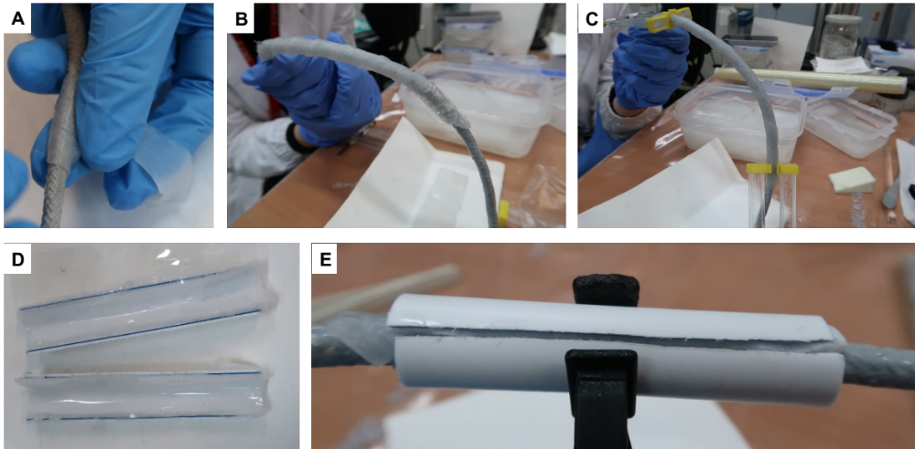

Table S4.
Key observations for tests on the mock-up samples with additional hydrogels named TT series, prepared as modification of the Nanorestore Gel® Peggy 5 (PVA/PVP-based hydrogels). This set of gels was specifically synthesized for use on the rope replica, with on option (TT16 thick) designed for the high-textured papier mâché.

Gel name | Observations for preliminary trials on mock-up samples
Gel name | Papier mâché | Ropes
TT13 thin | – | Less retentive than the Nanorestore Gel® Peggy series, requires more blotting before application. No liquid was observed on the rope, either visible swelling of the coating/paint layers or of the rope itself.  Adheres well to the rope and to itself, and picks up soil, even removal of dirt around the circumference of the rope.
TT13 thick | – | Less retentive than the Nanorestore Gel® Peggy series and requires more blotting before application. It also feels stickier and mouldable; however, it does not adhere to itself or the ropes and requires clamping as Nanorestore Gel® Peggy 6. If clamped, it releases liquid on the ropes’ surface with consequent slightly visible swelling of the coating/paint layers.
TT14 thin | – | Very thin, compared to the Nanorestore Gel® Peggy series and the other option in TT series, and sticky; offers excellent adhesion with the rope surface and remains attached to the rope and to itself for an extended period (tested up to 10 minutes). Exhibits moderate-high cleaning efficacy, offering an even soiling removal around the circumference of the rope.
TT15 thin | – | Very sticky and remains attached to both the Evolon tissue or blotting paper; breaks up easily when peeled off the blotting paper; does not adhere to the rope by itself and would require clamping.
TT15 thick | – | Very sticky and remains attached to both the Evolon tissue or blotting paper; breaks up easily when peeled off the blotting paper, leaving residues; does not adhere to the rope by itself and would require clamping.
TT16 thin | – | Sticky and less retentive than the Nanorestore Gel® Peggy series; conforms well to the rope’s surface and remains attached to the rope and to itself; however, it releases liquid on the ropes’ surface with consequent slightly visible swelling of the coating/paint layers.
TT16 thick | The gel is very thick and feels "heavy" and soft; hence it conforms perfectly to the high texture surface of the papier mâché replica. However, it is not retentive and leaves significant amounts of liquid on the surface. | –

Fig. S3.
Star diagram for cleaning tests performed on rope mock-ups, optimised aqueous fluid (i.e. ECOSURF™ EH-6 / TAC blend at 1% w/w. and 2% w/w. respectively) loaded into 4 containing systems: Xanthan gum; Shin-Etsu KSG350z; Nanorestore Gel® Peggy 6; TT14 thin.

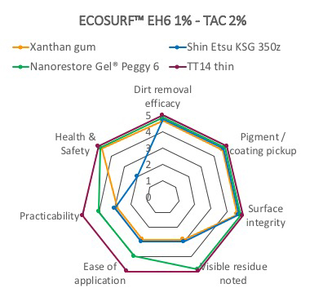

Fig. S4.
FTIR 2D mapping of mock up sample, showing a control area with artificial soil applied (A, B), a control unsoiled area (C, D), and areas cleaned using an ECOSURF™ EH-6 / TAC blend at 1% w/w. and 2% w/w. w/w. respectively, applied through various confining systems, i.e. Xanthan gum (E, F), Shin-Etsu KSG 3500z (G, H) and TT14 thin gel (I, J). For each area, the image besides the visible map shows the corresponding 2D FTIR Imaging map, where the intensity of the band between 1083-960 cm⁻¹ (assigned to the Si-O stretching of kaolin) was imaged. The corresponding FTIR spectra are shown in the right panel; each spectrum relates to a single pixel (5 x 5 µm²) of the corresponding 2D imaging map. All maps have dimensions of 700 x 700 µm².

