Additional Information

Discovery of Vespasiano Bignami paintings at the National Theatre of Costa Rica through technical photography and UV-Vis spectroscopy

Geraldine Conejo-Barboza^{1,2,3}, Eduardo Libby^{1,2,}, Carmen Marín⁴ and O.A. Herrera-Sancho ^{2,3,5,6,*}

¹ Escuela de Química, Universidad de Costa Rica, 2060 San Pedro, San José, Costa Rica
² Centro de Investigación en Ciencia e Ingeniería de Materiales (CICIMA), Universidad de Costa Rica, 2060 San Pedro, San José, Costa Rica
³ Instituto de Investigaciones en Arte (IIARTE), 2060 San Pedro, San José, Costa Rica
⁴Teatro Nacional de Costa Rica, 5015-1000, San José, Costa Rica
⁵ Escuela de Física, Universidad de Costa Rica, 2060 San Pedro, San José, Costa Rica
⁶Centro de Investigación en Ciencias Atómicas Nucleares y Moleculares (CICANUM), Universidad de Costa Rica, San José 2060, Costa Rica

∗ corresponding author: oscar.herrerasancho@ucr.ac.cr

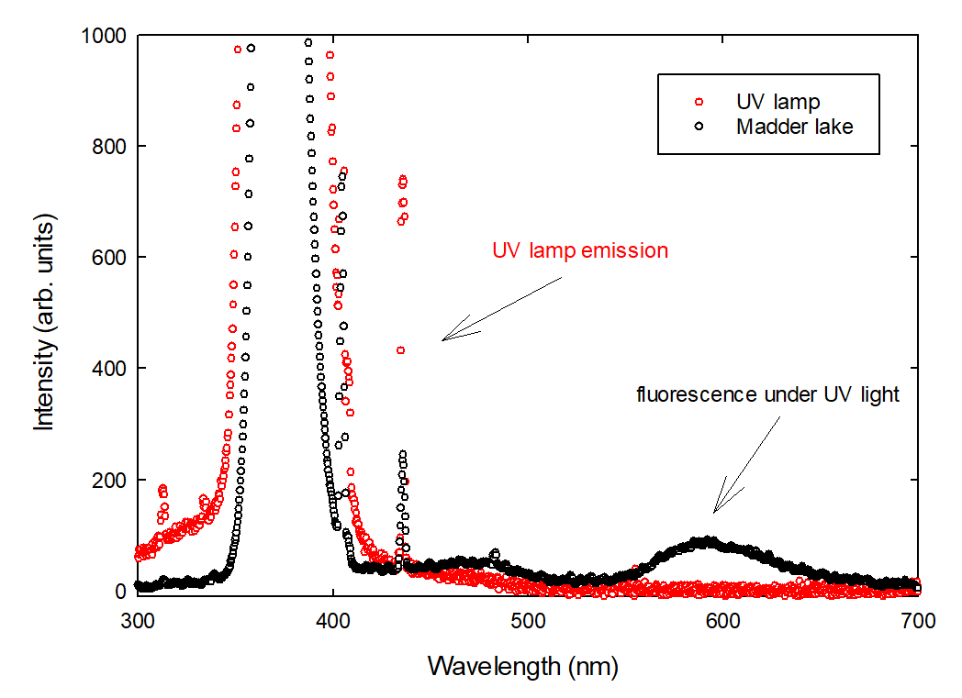
Figure S1. Experimental data showing the UV lamp emission spectra (red circles) along with the fluorescent pigment (black circles).

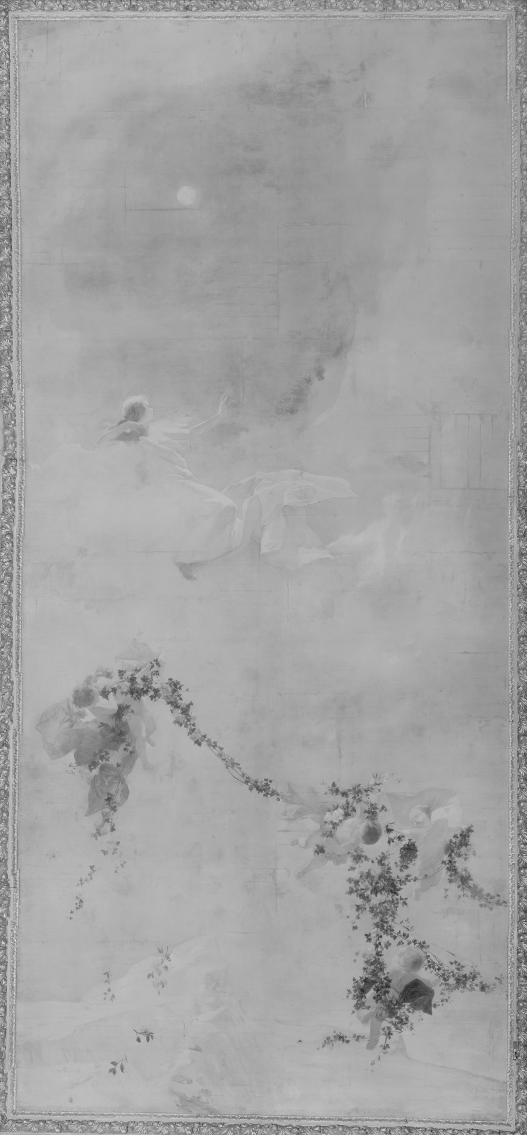
Figure S2. Panorama of The Poetry in the IR region.
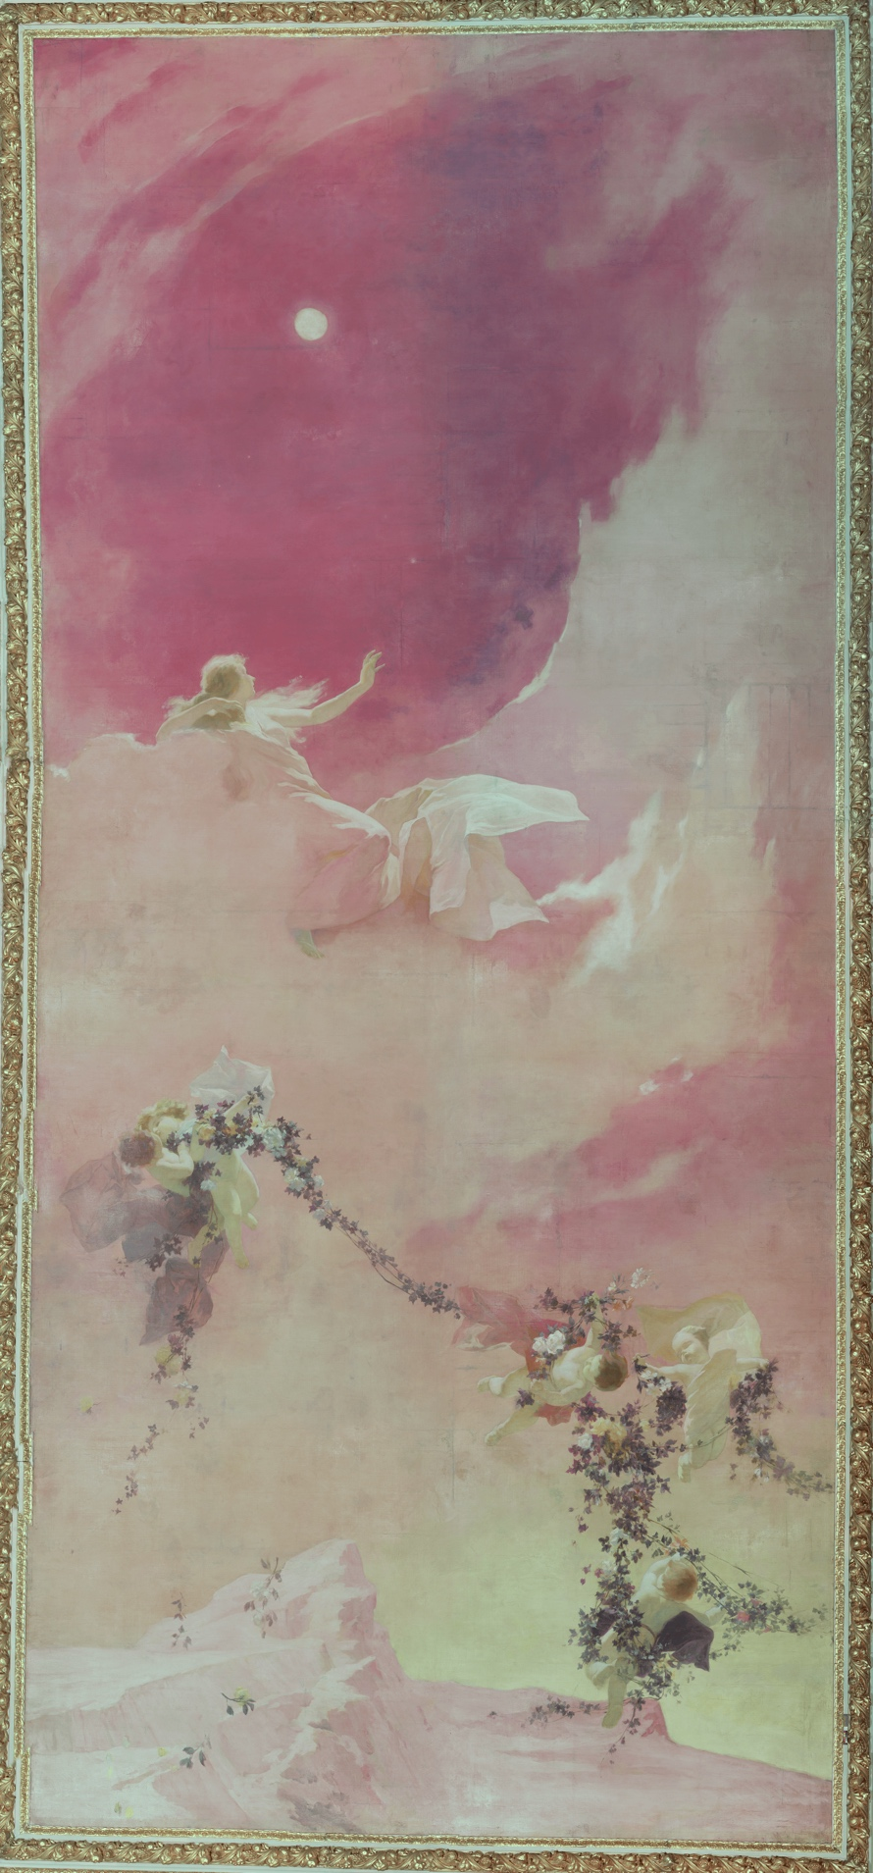
Figure S3. Panorama of The Poetry in IRFC.
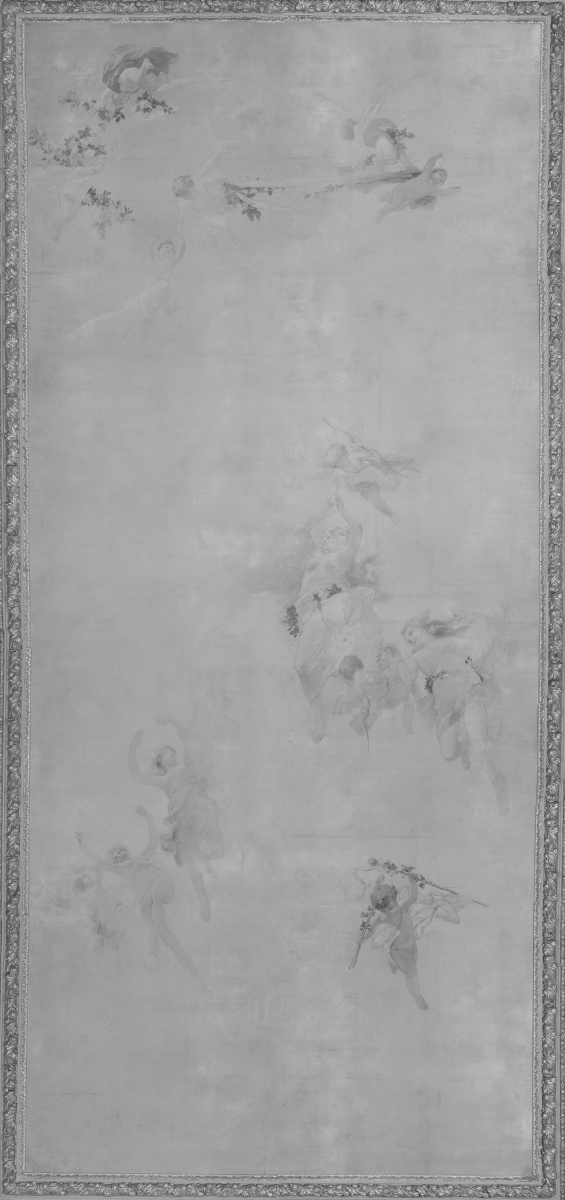
Figure S4. Panorama of The Dance in the IR region.
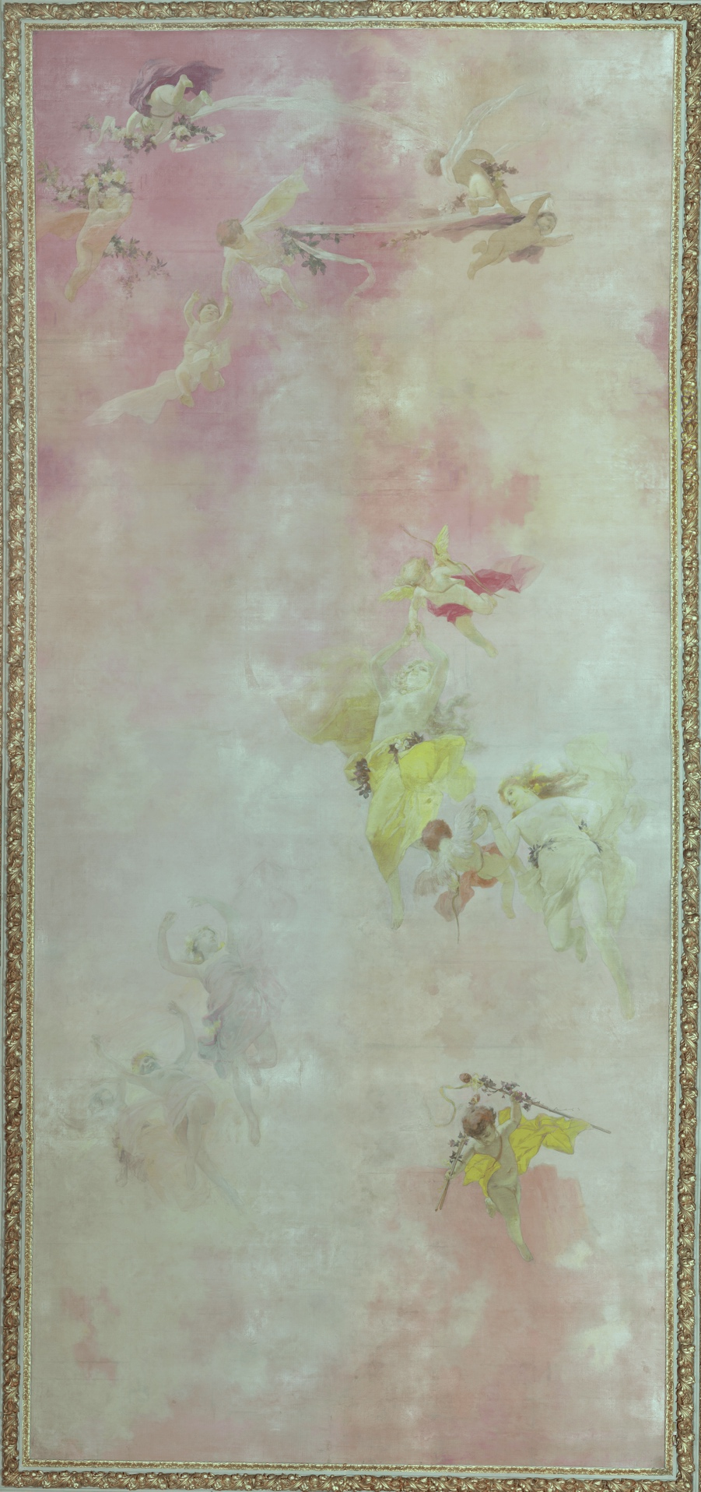
Figure S5. Panorama of The Dance in IRFC.

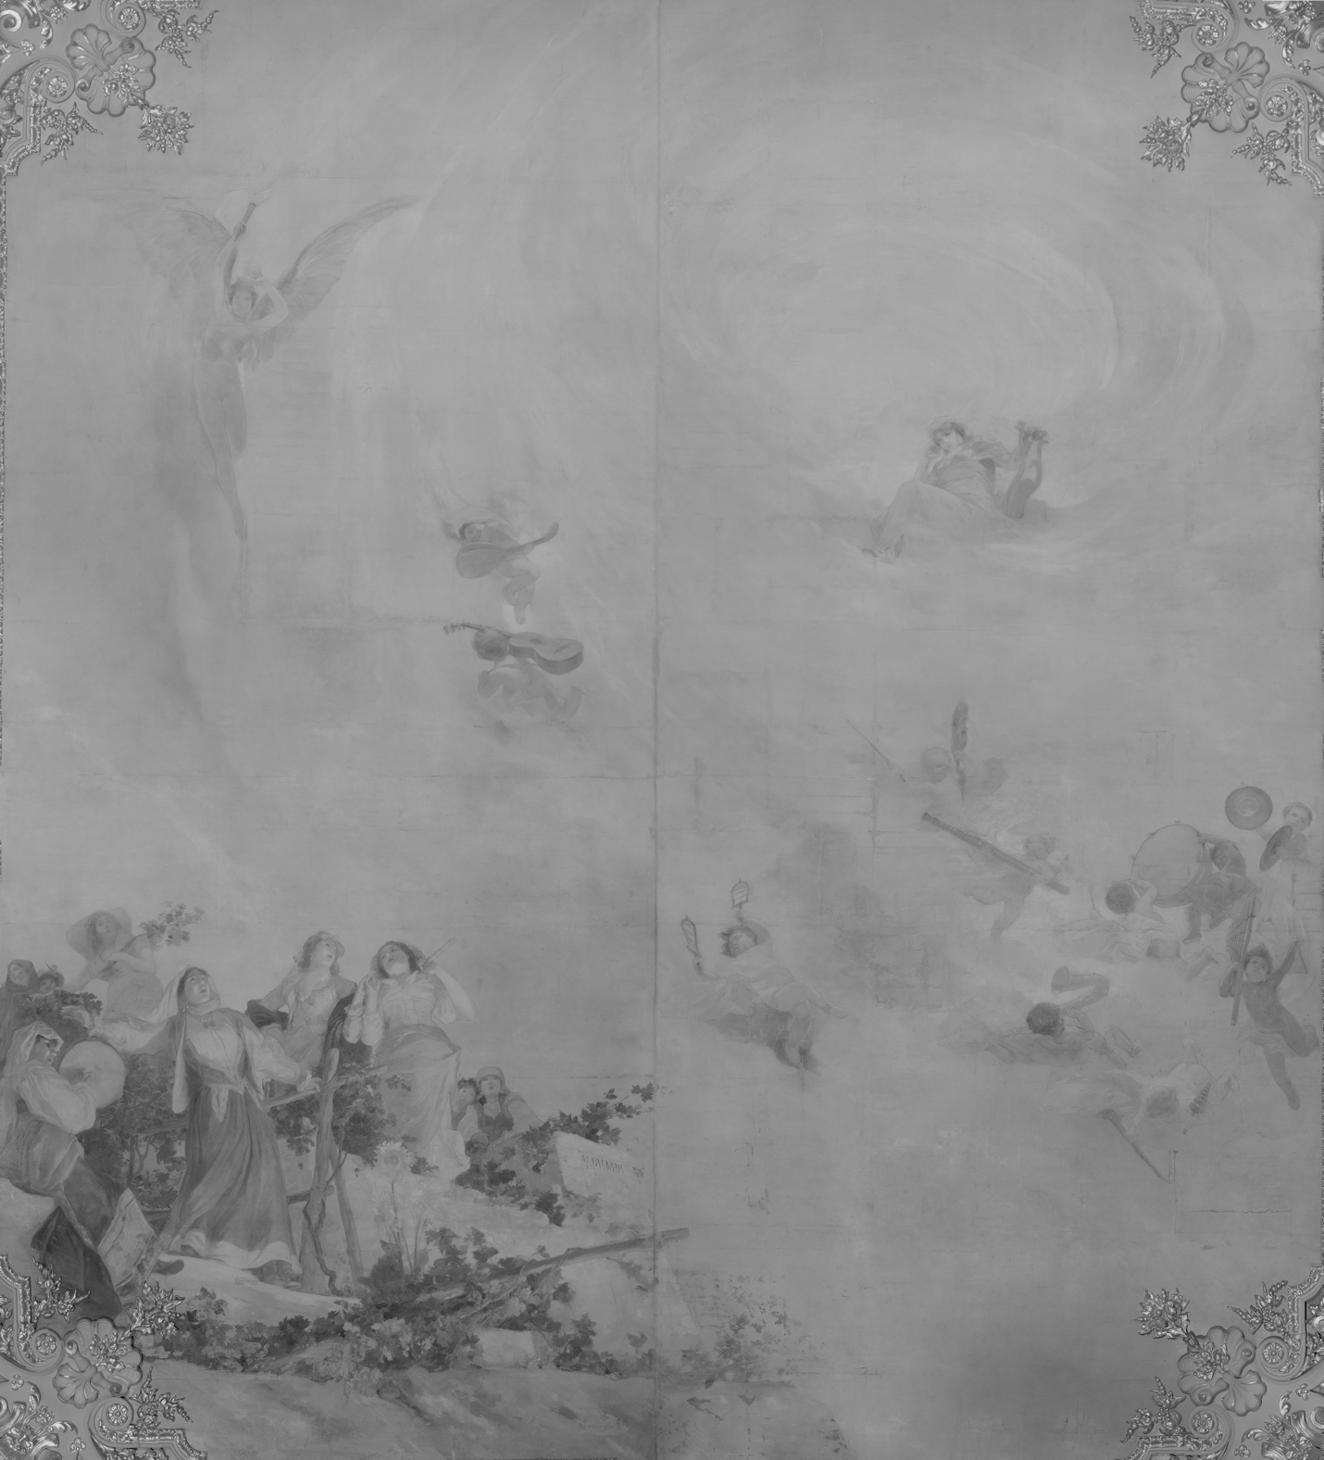

Figure S6. Panorama of The Music in the IR region.

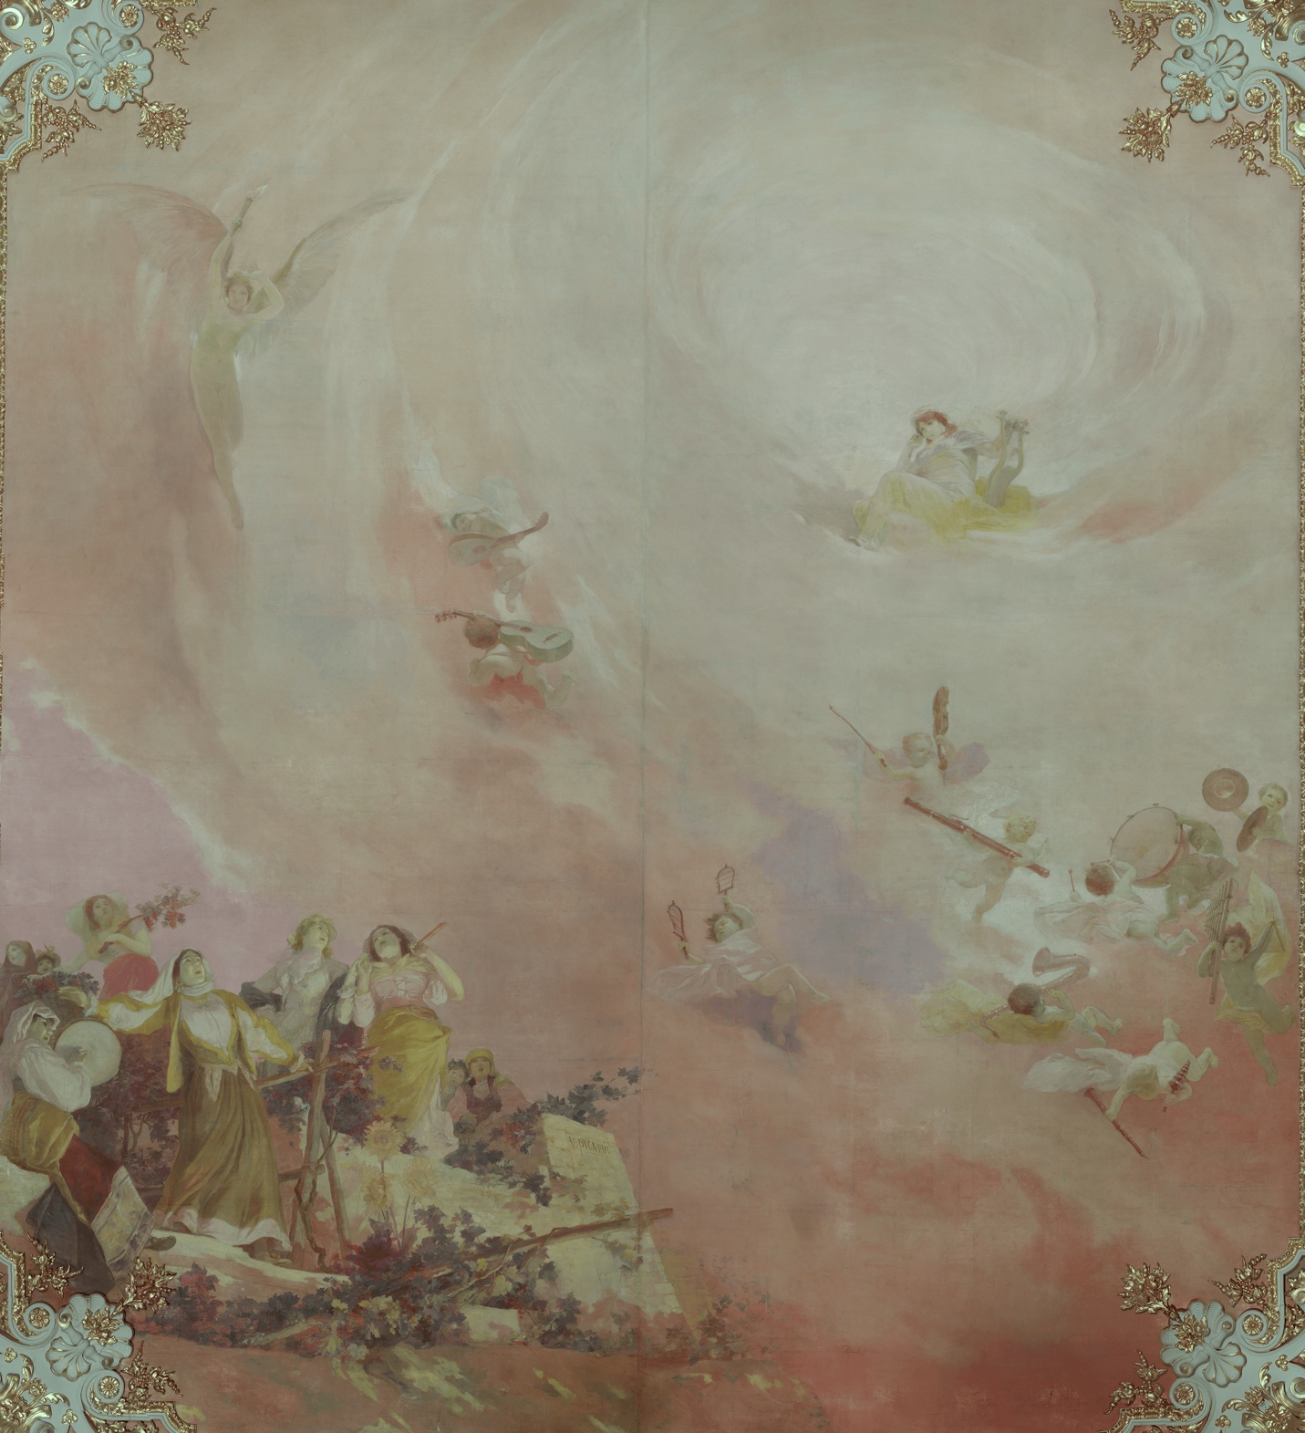

Figure S7. Panorama of The Music in IRFC.

