Heritage Science

Fracture saturation in paintings makes them less vulnerable to environmental variations in museums

Łukasz Bratasz^{1,2}*, Kiraz Goze Akoglu¹, Patrick Kékicheff³
¹Institute for the Preservation of Cultural Heritage, Yale University, New Haven, CT, USA.
²Jerzy Haber Institute of Catalysis and Surface Chemistry Polish Academy of Sciences. 30-239 Kraków, Poland.
³Institut Charles Sadron, Université de Strasbourg, CNRS-UPR22, 67034 Strasbourg, France.

*Correspondence: ncbratas@cyf-kr.edu.pl

Additional File 1

Note 1
Gesso preparation
Historical recipe and procedure were adopted after Cennino Cennini [1] to prepare gessoes of varying PVC. 14-weight percent (wt%) solution obtained by dissolving rabbit skin glue in water of temperature of 60 ºC for 60 minutes was used to prepare gesso of PVC of ca. 92%. A ‘chalk from Bologna’ from Kremer Pigments GmbH, which is a 1:1 mixture of calcium carbonate and calcium sulphate, was slowly added to the glue solution until no liquid was visible. Wet gesso was sieved by fine nylon fabric (15 DEN tights) and heated again to 60 ºC. Following the same procedure, gessoes of PVC of 85, 89 and 95% were prepared, using various concentrations of glue solutions – 10, 11 and 16 wt%, respectively.
- d’Andrea Cennini C. Il libro dell'arte, ca.1400. 3d edition. New Haven, CT: DV Thompson; 1972.

Note 2
Determining mechanical and moisture related properties of gessoes
In order to determine interlaminar fracture energy of the gesso in the opening mode I, G_{IC}, the ASTM D5528 – 13 [1] standard test was adopted. During the test, double cantilever beam (DCB) specimens (Fig. 1) are split in tensile tests. The DCB specimens imitating panel paintings were designed and prepared to reflect traditional techniques used by artists in the past and currently by conservators. Two boards made of softwood of thickness h=4 mm were cut to the required standard geometry (length l=200 mm and width of 25 mm). One face of each specimen was sized with solution of rabbit skin glue from Kremer Pigments. A 10-weight percent (wt%) solution was prepared by dissolving the rabbit skin glue in water of temperature of 60 ºC for 60 minutes. The solution was applied with a brush. Wooden supports were dried and conditioned at 25 ºC and 75% rh. After at least one day of drying and conditioning, a warm gesso was applied with a syringe in the centre of the sized face. Immediately, two 0.015 mm thick aluminium foils were placed at the one end and precisely positioned to create a pre-crack of length approximately a₀=60mm in a precisely controlled way. Additional few drops of the gesso was applied on the top aluminium foil to ensure presence of gesso from both sides of the pre-crack. It was verified by complete splitting of the specimens after the test that gesso did not penetrate space between the foils. The uniform thickness of the gesso layer was ensured by positioning 0.5 mm thick spacers 10 mm from both sides of the specimens. At the end of the procedure, the second wooden support was placed gently on the gesso layer and slightly pressed with a flat metal cube of length larger than length of the sample. After initial setting, gesso released on both sides of the DBC specimen was removed with a sharp tool leaving thin white and flat surface. This enabled tracing of crack growth on flat surface much more efficiently. When 24 specimens were prepared, they were placed in the press and left under pressure of approximately 0.5 MPa for 14 days at 25 ºC and 75% rh. Before the test, the specimens were released from the press, and loading blocks of width and height H=25 mm were attached with cyanoacrylate glue and moved to environmental chamber to equilibrate at 25 ºC to the required RH of 30, 50, 75 or 90% for 14 days.
Opening forces were applied to the DCB specimen by means of loading blocks bonded to one end of the specimen using Zwick/Roell Z2.5 TN Universal Testing Machine (UTM) with 2.5kN load cell Xforce P of grade 1 accuracy. The UTM was placed in the environmental chamber stabilizing temperature at 23 ºC and RH at the level at which the given group of samples were stabilized. The UTM operated in a displacement control mode with a constant displacement rate of 0.5 mm/min. The load and opening displacement measured from the crosshead position were recorded by a computer controlling the UTM and synchronized with a video-extensometer from Messphysik Materials Testing GmbH. The video-extensometer was adjusted to observe the DBC specimen with the attached ruler starting few mm before the pre-crack. The field of view of the video-extensometer was ca. 600 mm and its resolution 30 μm. A video of crack propagation in the gesso layer during the test was recorded by the testXpert II software. In a post-test procedure, the user marked loads at which the crack tip reached intervals defined by the standard. The uncertainty of crack tip positioning was 0.2 mm. The software calculated the mode I interlaminar fracture toughness for an individual DCB specimen using a modified beam theory according to the standard with correction for non-perfectly built-in double cantilever beam [2]. Typical examples of crack growth and load versus displacement relationships for selected gesso samples are shown in Fig. 2.
To determine gesso stiffness, larger blocks of gesso were cast in moulds of dimensions 20x150x100 mm³ prepared using aluminium foil. The blocks were dried at room conditions for 30 days and machined to bars of dimensions 6x6x80 mm³. Then the samples were glued to flex socket adapters from McMaster-Carr that enabled determination of gesso stiffness and moisture related strain using the UTM placed in the environmental chamber. Use of flex socket adapters was critical as slight misalignment of a sample in UTM grips always caused sample breaking during mounting. The stiffness was measured at 23 ºC and RH 30, 50, 75, 90% The sample was equilibrated at a given RH for 7 hours, stretched to a strain of 0.003% at a rate of 0.01 mm/minute, and released.
- ASTM D5528-13, Standard Test Method for Mode I Interlaminar Fracture Toughness of Unidirectional Fiber-Reinforced Polymer Matrix Composites, ASTM International, West Conshohocken, PA, 2013.
- Hashemi S, Kinloch AJ, Williams JG. Corrections needed in double cantilever beam tests for assessing the interlaminar failure of fiber composites. J Mater Sci Lett. 1989;8:125–9.

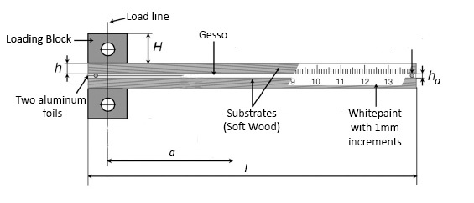Fig. 1. Diagram of a double cantilever beam specimen.

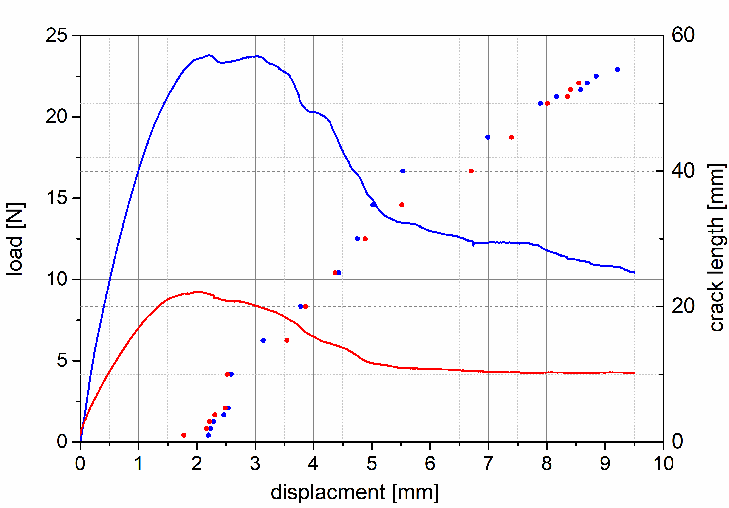
Fig. 2. Crack growth and load versus displacement relationships for gesso samples. The relationships - crack growth (dots), load (lines) - were determined for gesso samples of PVC 89% (blue) and 95% (red) at RH=90%.

