Additional file for
Different low-cost materials to prevent the alteration induced by formic acid on unstable glasses
Rodrigo Arévalo¹, Jadra Mosa², Mario Aparicio², Teresa Palomar^{2*}
¹ Dpto. Ciencias. Univ. Autónoma de Madrid. Campus de Cantoblanco. Avda. Tomás y Valiente, 7. 28049 Madrid, Spain
² Instituto de Cerámica y Vidrio (ICV-CSIC), c/ Kelsen 5, Campus de Cantoblanco, 28049 Madrid, Spain
*Corresponding author, e-mail: t.palomar@csic.es

This document contains:
- Supp. Fig. 1
- Supp. Fig. 2
- Supp. Fig. 3
- Supp. Table 1

Supp. Fig. 1. Distribution inside each desiccator during the a) First test: selection of the best formic sink, b) Second test: Optimization of silica gel.

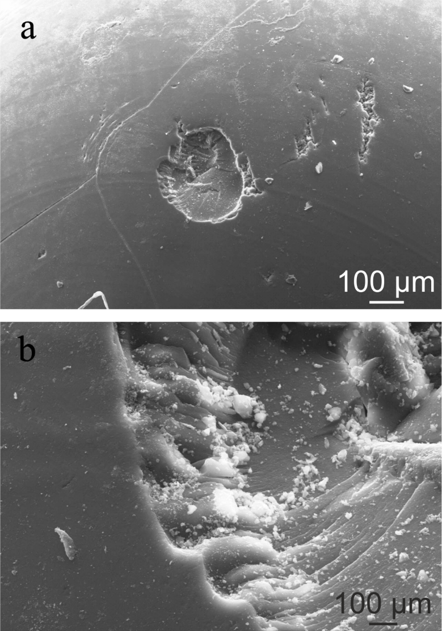
Supp. Fig. 2. SEM image of (a) the silica gel surface and (b) the deposits formed.

Supp. Fig. 3. SEM image of the steel (a) before the test and (b) after the test.

Supp. Table 1. Assignment of FTIR-ATR bands for silica gel.
Compound | Wavenumber (cm⁻¹) | Assignation | Reference
Water | 3300 | ν (OH) stretching | ^{34,35}
 | 2170 | δ (H-O-H) bend + libration | ³⁷
 | 1640 | δ (H-O-H) scissors bending | ³⁵
Formate | 2870 | ν (CH) stretching | ^{34,36}
 | 2713 | δ (CH) bending vibration | ³⁶
 | 1739 | ν (COO⁻) stretching asymmetric | ⁴⁴
 | 1580 | ν (COO⁻) of Na stretching asymmetric | ^{34,36,39}
 | 1370 | ρ (COO⁻) rocking | ^{34,39}
 | 1350 | ν (COO⁻) of Na stretching symmetric | ^{34,36,39}
 | 1064 | ρ (COO⁻) rocking | ^{34,41}
 | 750 | δ (COO⁻) bending | ^{35,36,39,41}
Carbonate | 1425 | ν (COO⁻) stretching asymmetric | ^{35,37,40}
 | 1370 | ρ (COO⁻) rocking | ^{34,39}
 | 1064 | ρ (COO⁻) rocking | ^{34,41}
 | 880 | ν (COO⁻) stretching symmetric | ^{35,37}
 | 750 | δ (COO⁻) bending | ^{35,36,39,41}
Bicarbonate | 1362 | ν (HCO₃⁻) stretching asymmetric | ⁴⁰
 | 1010 | ν (C-OH) stretching | ³⁷
Silanol | 3300 | ν (OH) stretching | ^{42,43}
 | 962 | ν (Si-OH) stretching | ^{42,45}
Silica gel | 1073 | ν (Si-O-Si) stretching asymmetric | ^{42,43,45}
 | 789 | ν (Si-O-Si) stretching symmetric | ^{42,43}
 | 411 | ρ (Si-O-Si) rocking | ⁴²

