Additional file 1

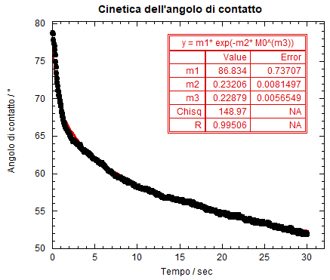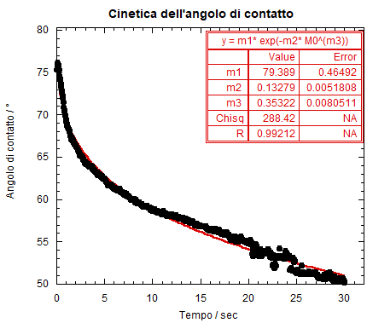

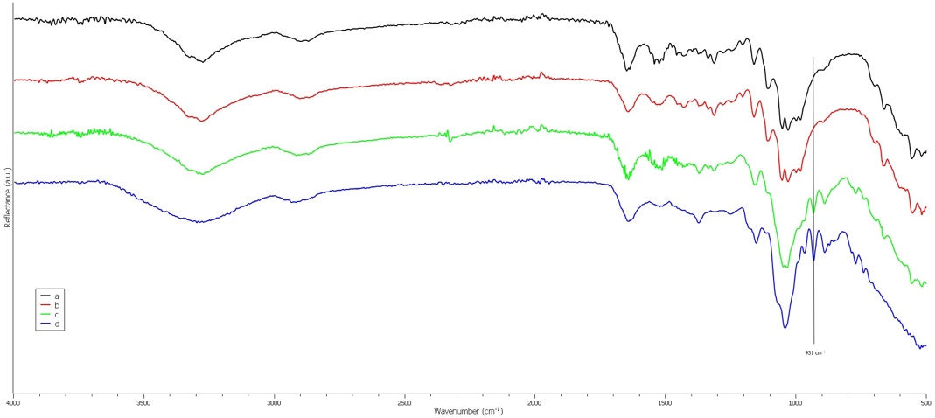
Figure S1. ATR-FTIR spectra of paper specimens. Paper non treated (a), paper after Agar Spray (b), paper after Agar in semi solid state (c) and Agar (d) itself.

