Neighbors and Friends: A Comparative Study between Matisse's Red Studio and its Inhabitants

Additional File 1: Supplementary Materials

Abed Haddad¹*, Gianluca Pastorelli², Annette S. Ortiz Miranda², Loa Ludvigsen², Silvia A. Centeno³, Isabelle Duvernois⁴, Caroline Hoover¹, Michael Duffy¹, Anny Aviram¹, Lynda Zycherman¹

- The Museum of Modern Art, 11 West 53rd St, New York, NY 10019, USA
- Statens Museum for Kunst, Sølvgade 48-50, 1307 København K, Denmark
- Department of Scientific Research, The Metropolitan Museum of Art, 1000 Fifth Avenue, New York, NY 10028, USA
- Department of Paintings Conservation, The Metropolitan Museum of Art, 1000 Fifth Avenue, New York, NY 10028, USA

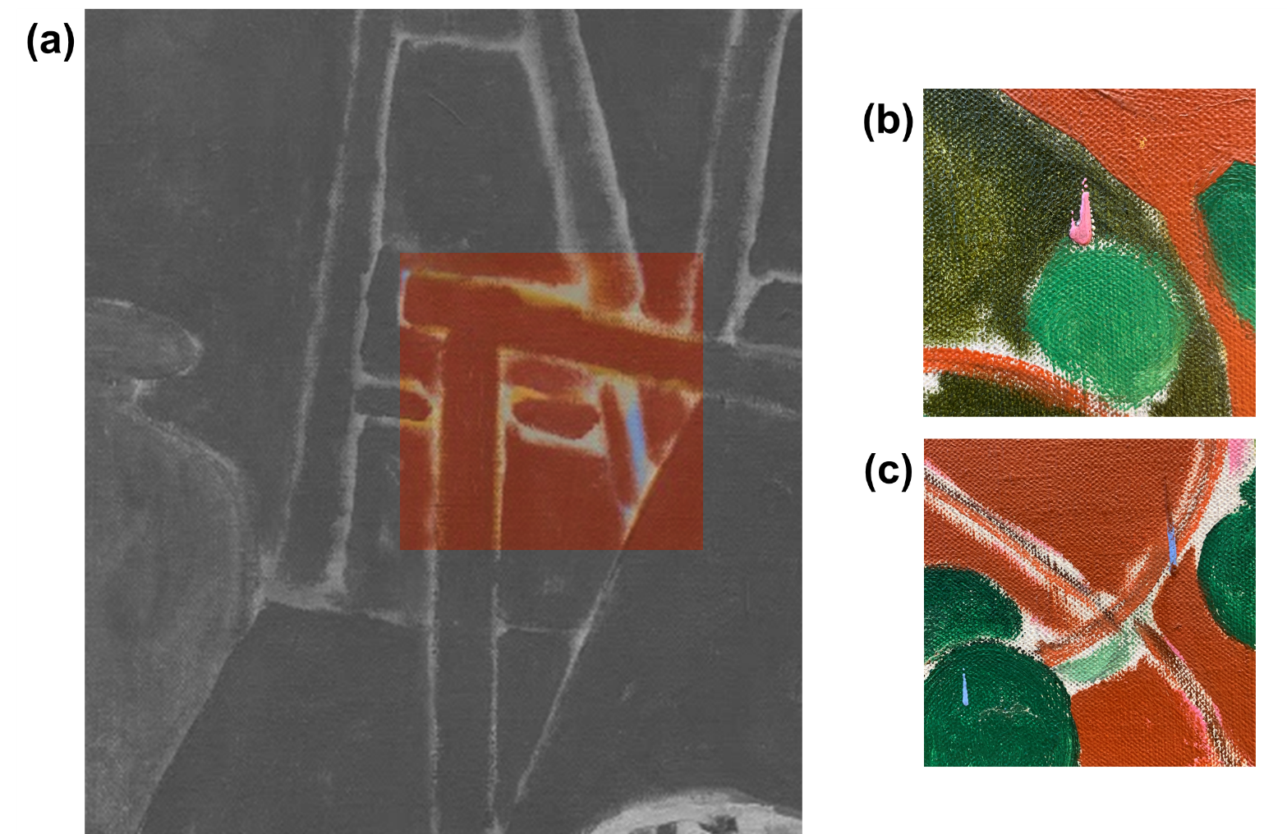

Figure S1. A detail (a) from The Red Studio shows the presence of a gray-colored layer beneath the blue wall; drips from (b) pink and (c) blue paint over some objects in the composition indicate that this gray layer was laid in first.

Figure S2. A µ-FTIR spectrum that shows the presence of a natural resin varnish in a sample taken from The Red Studio.

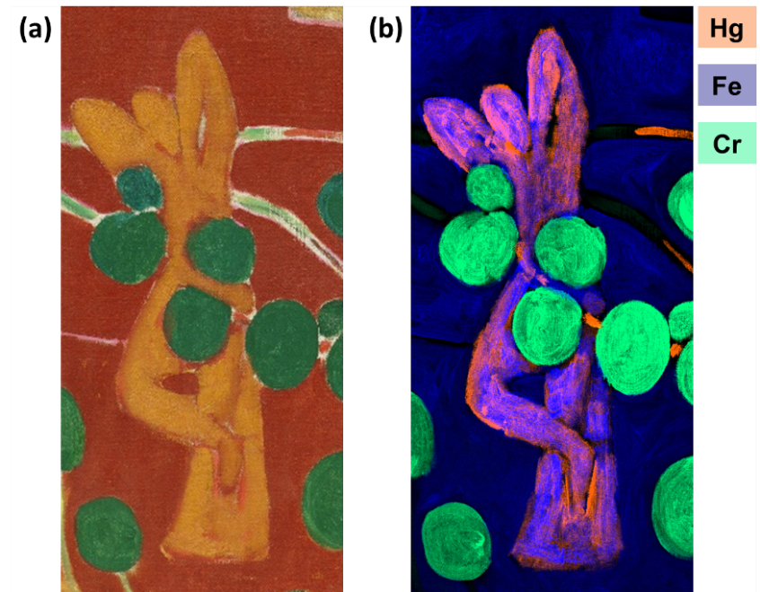

Figure S3. A detail (a) from The Red Studio that shows the depiction of Upright Nude with Arched Back and elemental distribution maps (b) for vermilion (Hg), iron-based earth pigments (Fe), and viridian (Cr) that show Matisse overpainting the originally orange-hued sculpture with a yellow ochre paint.

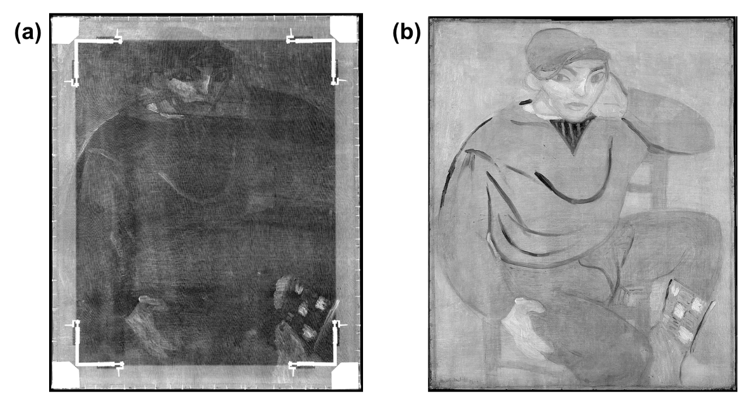

Figure S4. (a) X-radiograph and (b) infrared reflectogram taken of Young Sailor II.

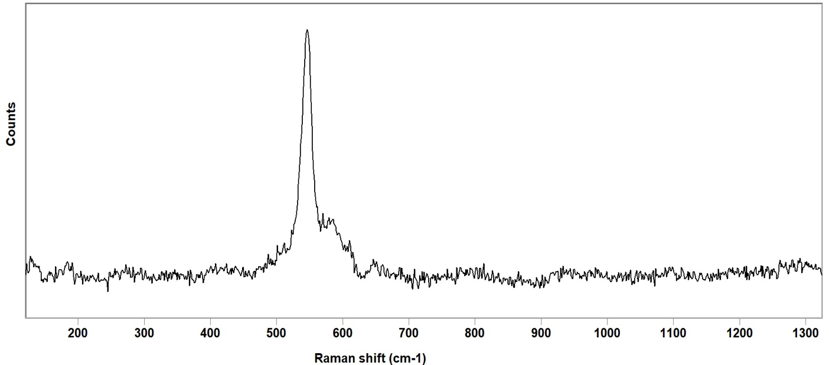
Figure S5. A Raman spectrum that shows the presence of ultramarine blue in a sample taken from Young Sailor II.

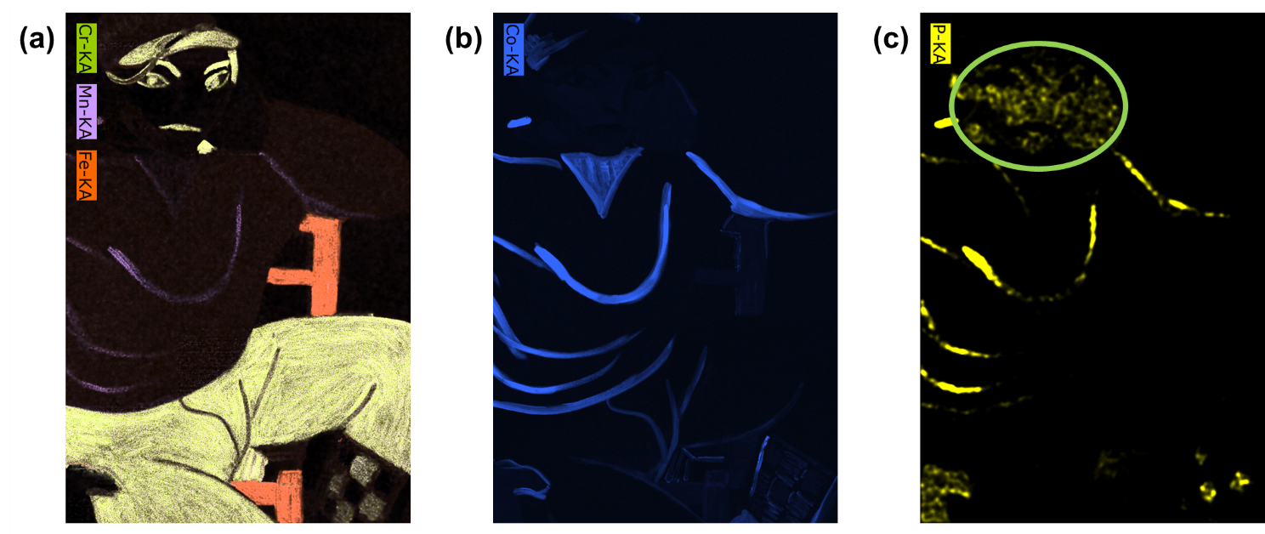

Figure S6. Elemental distribution maps from a section of Young Sailor II: (a) combined chrome (Cr, yellow), manganese (Mn, violet), and iron (Fe, orange); (b) cobalt (Co, blue); and (c) phosphorus (P, yellow); the green ellipse indicates the location of an artifact in the calculated map. The presence of manganese, phosphorous, and cobalt in the sweater’s stripes strongly suggests that a mixture of manganese violet (manganese phosphate) and cobalt blue was used by Matisse, however, this does not preclude the additional presence of a cobalt (II) phosphate violet pigment.

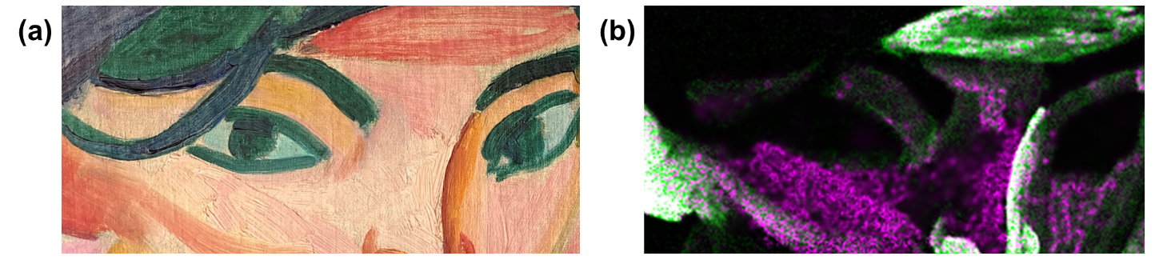
Figure S7. Detail of the sitter’s face in (a) Young Sailor II and (b) combined mercury (HgL_{α}: 9.980 KeV, green) and bromine (BrK_{α}: 11.902 KeV, pink) distribution maps for the same area.

Figure S8. An X-radiograph of Bathers. The curved striations in the ground preparation show that the painting was not commercially primed, but rather primed with a palette knife.
Figure S9: FORS spectra acquired from Bathers that show the range of pigments identified by the technique.
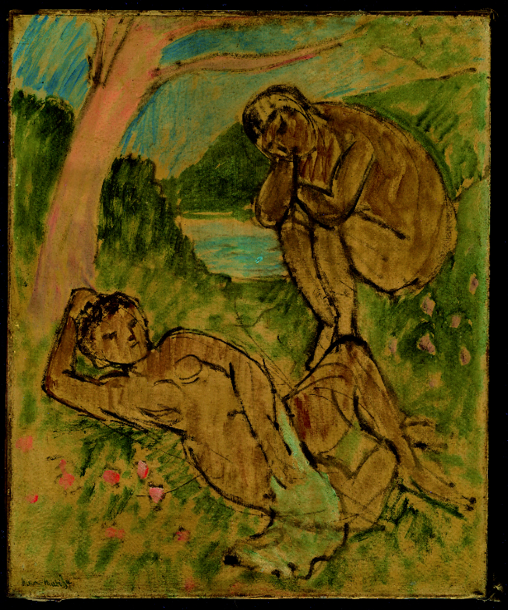

Figure S10. A UVF image of Bathers that shows the occurrence of tin-treated cochineal lake marked by intense pink fluorescence.
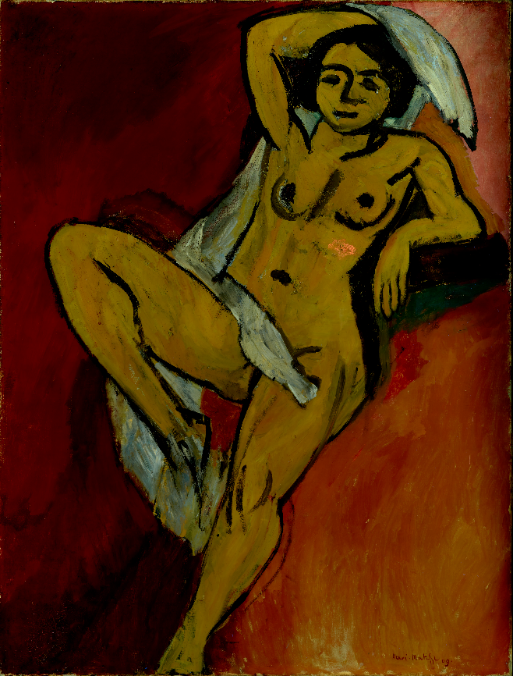
Figure S11. FORS spectra acquired from Nude with White Scarf that show some pigments identified by the technique.

Figure S12. UVF imaging indicated the presence of an organic lake pigment in the top-right quadrant of the picture due to pink fluorescence.
Figure S13. A Raman spectrum that confirms the presence of a madder lake pigment in a red sample taken from Nude with White Scarf.

Figure S14. Raman spectra that show the presence of viridian, ultramarine, and orpiment in Le Luxe II.

Figure S15. FORS spectra acquired from Le Luxe II that show some pigments identified by the technique.
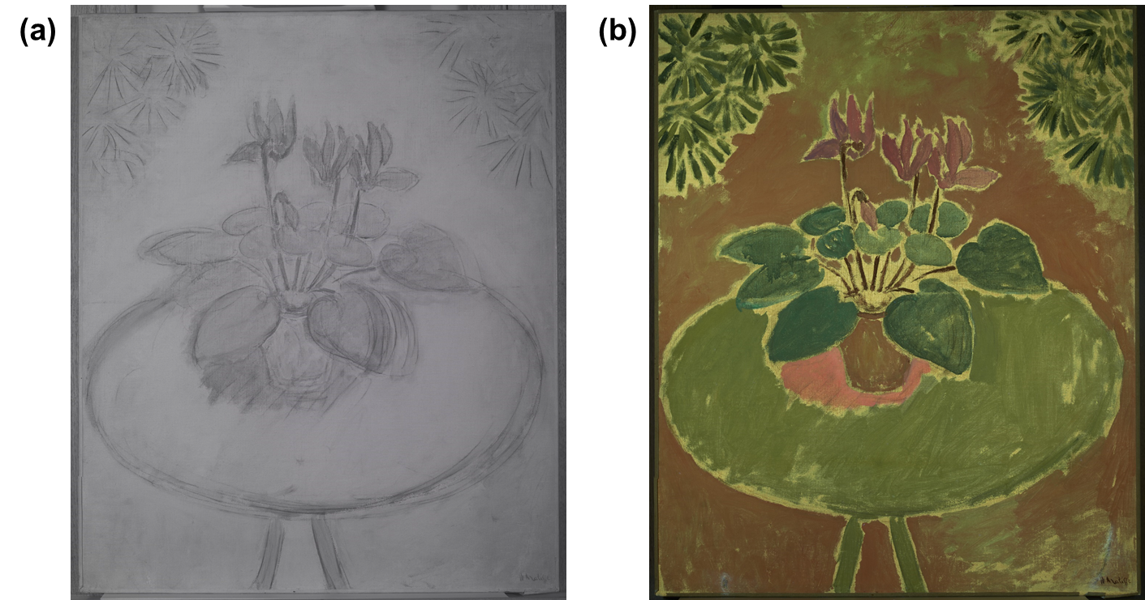

Figure S16. (a) Infrared reflectogram and (b) UVF image taken of Cyclamen.

